

September 11, 2009

Advice No. 3661T

David Danner

Executive Director and Secretary

1300 S. Evergreen Park Dr. S.W.

P.O. Box 47250

Olympia, Washington 98504-7250

Dear Mr. Danner:

Qwest Corporation is forwarding for filing the sheets listed on Attachment A.

This filing eliminates the Qwest Connections Guide Program. This residential-only marketing program allowed the Company to work with realtors, mortgage and moving company representatives and other move-related professionals to market Qwest services to residential customers in the process of establishing new service or moving their existing service to a new address. Customers who subscribed to a Qwest service(s) received a $25.00 gift card that could be used for various purchases including other Qwest services. The Qwest Connections Guide Program was only used briefly in Arizona in 2005; consequently, there are no Washington move professionals or residential customers impacted by this program elimination.

Qwest respectfully requests an effective date of October 12, 2009. If you have any questions concerning this filing please contact me.

Sincerely,

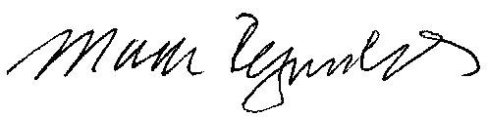

Mark Reynolds

Attachments

Attachment A

Advice No. 3661T

**EXCHANGE AND NETWORK SERVICE**

**WN U-40**

|  |  |  |
| --- | --- | --- |
| **SECTION** | **SHEET** | **REVISION** |
| 1 | 6 | 5th |
| 1 | 22 | 11th |
| 5 | Index 2 | 15th |
| 5 | 59.3 | 1st |
| **Pages Canceled by this Job:** | | |
| 5 | 59.4 | Original |