June 16, 2014

Steven V. King, Executive Director and Secretary
Utilities and Transportation Commission
1300 S. Evergreen Park Dr. SW
P.O. Box 47250
Olympia, WA 98504-7250

RE: Washington Utilities and Transportation Commission v. NSO Entertainment LLC

Commission Staff’s Response to Application for Mitigation of Penalties TE-141070

Dear Mr. King:

On May 27, 2014, the Utilities and Transportation Commission issued a $1,000 Penalty Assessment in Docket TE-141070 against NSO Entertainment LLC for 10 violations of Washington Administrative Code (WAC) 480-30-071, which requires charter and excursion carriers to furnish annual reports to the commission no later than May 1 each year.¹

On June 5, 2014, NSO Entertainment LLC wrote the commission requesting mitigation of penalties (Mitigation Request).² In its Mitigation Request, NSO Entertainment LLC does not dispute that the violation occurred. The company states, “I turned in my regulatory fees earlier this year but I didn’t know they separated schedule 1 & 2 to be turned in separately.”

It is the company’s responsibility to ensure that the regulatory fee is paid and the annual report is filed by the May 1 deadline. On February 28, 2014, Annual Report packets were mailed to all regulated charter and excursion companies. The instructions for annual report completion page of the annual report informed the regulated company that it must complete the annual report form, pay the regulatory fees, and return the materials by May 1, 2014, to avoid enforcement action.

On June 6, 2014, NSO Entertainment LLC filed the 2013 annual report and timely paid the required regulatory fees on December 20, 2013. The company permit was issued on October 12, 2009. No previous violations of WAC 480-30-071 are on commission record. The UTC also recently adopted new rules requiring the annual report to be filed by May 1 while the regulatory fees remained due on December 31. Despite the commission communication regarding these
UTC Annual Reports
June 16, 2014
Page 2

filing changes to all regulated charter and excursion companies, commission staff supports the company’s request for mitigation. Staff recommends a reduced penalty assessment of $200.

If you have any questions regarding this recommendation, please contact Amy Andrews, Regulatory Analyst, at (360) 664-1157, or aandrews@utc.wa.gov.

Sincerely,

Sondra Walsh, Director
Administrative Services

ATTACHMENT A
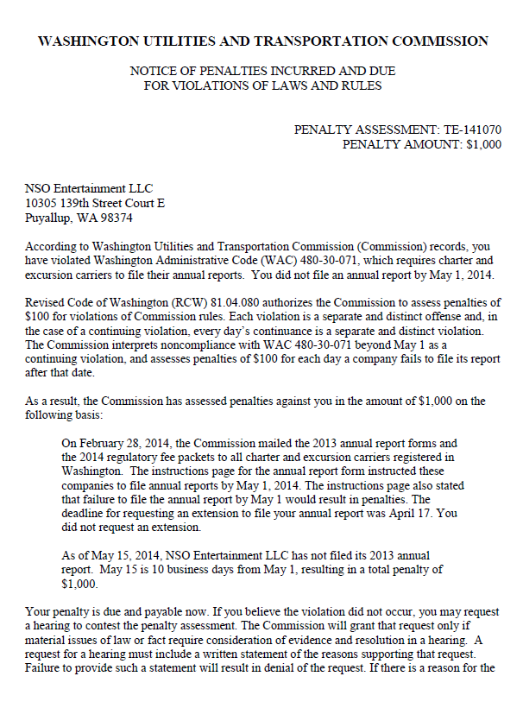
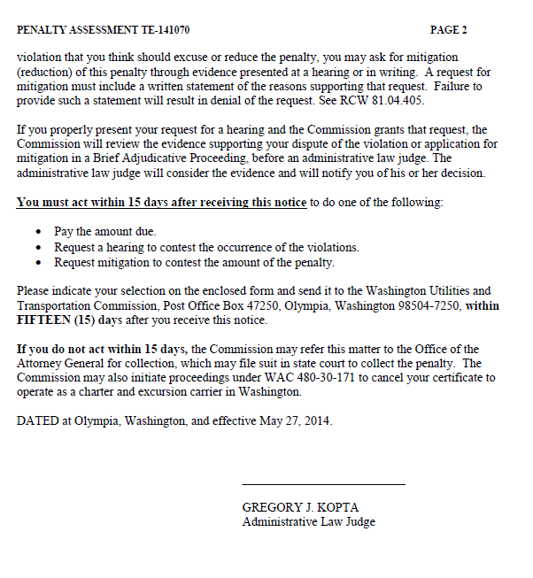

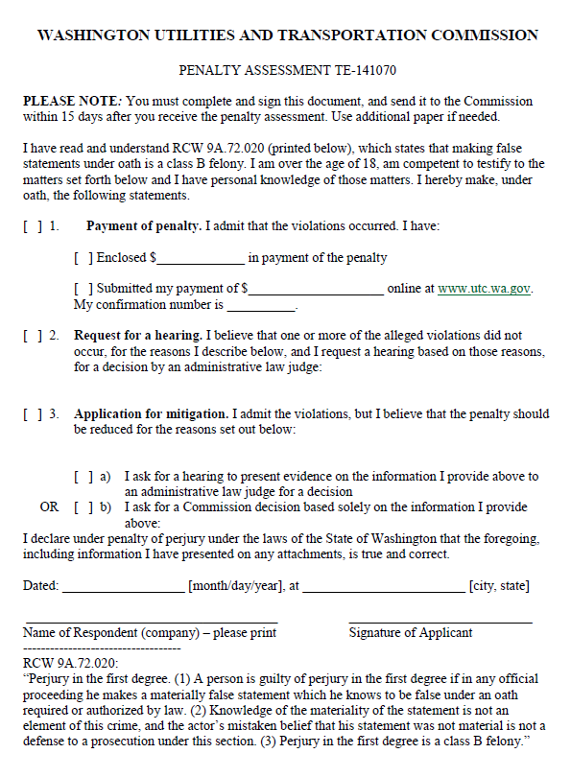

ATTACHMENT B
