Report to the Washington Utilities and Transportation Commission

## Electric Service Reliability - Major Event Report

# Event Date: December 12-13, 2015

Date Submitted: February 8, 2016

Primary Affected Locations: Sunnyside, Walla Walla, and Yakima

Primary Cause: Weather

Exclude from Reporting Status: Yes

Report Prepared by: April Brewer

Report Approved by: Heide Caswell / David O’Neil / Chad Ooten / Michael Gavin / Ron Duren / Kevin Putnam

**Event Description**

During the month of December, several severe wind and rain storms impacted areas across the Northwest, impacting electric reliability. On December 12, 2015, several large outages occurred due to the weather across Pacific Power’s Washington service area. Rain and wind resulted in significant outages. Of them, pole fire-related outages[1] accounted for approximately 83 percent of all customer outages, affecting more than 5,200 customers, with a total of over 1,300,000 customer minutes lost.

During the storm there were two significant outages causing the majority of customer interruptions. Equipment was damaged due to a pole fire-caused outage in Sunnyside that affected 2,645 customers fed from the Sulphur Creek Substation. Interruptions lasted between 2 hours and 16 minutes and 7 hours 12 minutes, and totaled 754,800 customer minutes lost. In Walla Walla, circuit 5W323, feed from the Dayton Substation, experienced isolated three pole fire-caused outages, affecting 1,046 customers; all customers were restored within 11 hours. Numerous other small outages were also experienced that resulted in extensive restoration activities across the state.

|  |  |
| --- | --- |
| **Event Outage Summary** | |
| **# Interruptions (sustained)** | 18 |
| **Total Customer Interrupted (sustained)** | 6,424 |
| **Total Customer Minutes Lost** | 1,391,154 |
| **State Event SAIDI Impact** | 10.13 Minutes |
| **CAIDI** | 217 |
| **Major Event Start** | 12/12/15 3:15pm |
| **Major Event End** | 12/13/15 3:15pm |

**Restoration Summary**

During the event all available employees were dispatched. While additional resources would have been helpful, across Washington and into northern Oregon storm activities had all available personnel engaged in outage response. A large number of the repairs required modifications to electrical structures, generally adding pole top extensions and new cutouts. Power was restored to all customers by 6:42 am on December 13, 2015.

There were no company or commission customer complaints made regarding the major event.

**Restoration Intervals**

|  |  |  |  |
| --- | --- | --- | --- |
| **Total Customers Sustained** | **< 3 Hrs.** | **3 - 24 Hrs.** | **24+ Hrs.** |
| **6,424** | **3,053** | **3,371** | **0** |

**Restoration Resources**

|  |  |
| --- | --- |
| **Resources** | |
| **Journeyman** | 28 |

|  |  |
| --- | --- |
| **Materials** | |
| **Cutouts** | 10 |
| **Insulators** | 12 |
| **Crossarms** | 11 |
| **Transformers** | 2 |
| **Pole top extension** | 7 |
| **Conductor** | 600ft |

**State Estimated Major Event Costs**

|  |  |  |  |
| --- | --- | --- | --- |
| **Estimate $** | **Labor** | **Materials** | **Total** |
| **Capital** | $4,600 | $5,025 | $9,625 |
| **Expense** | $30,647 | $10,315 | $40,962 |
| **Total** | **$35,247** | **$15,340** | **$50,587** |

**Major Event Declaration**

Pacific Power is requesting designation of this event and its consequences to be classified as a “Major Event” for exclusion from network performance reporting with the IEEE 1366-2003/2012. This major event exceeded the company’s current Washington threshold of 1,299,474 customer minutes lost (9.46 state SAIDI minutes) in a 24-hour period.

**Event Detail**

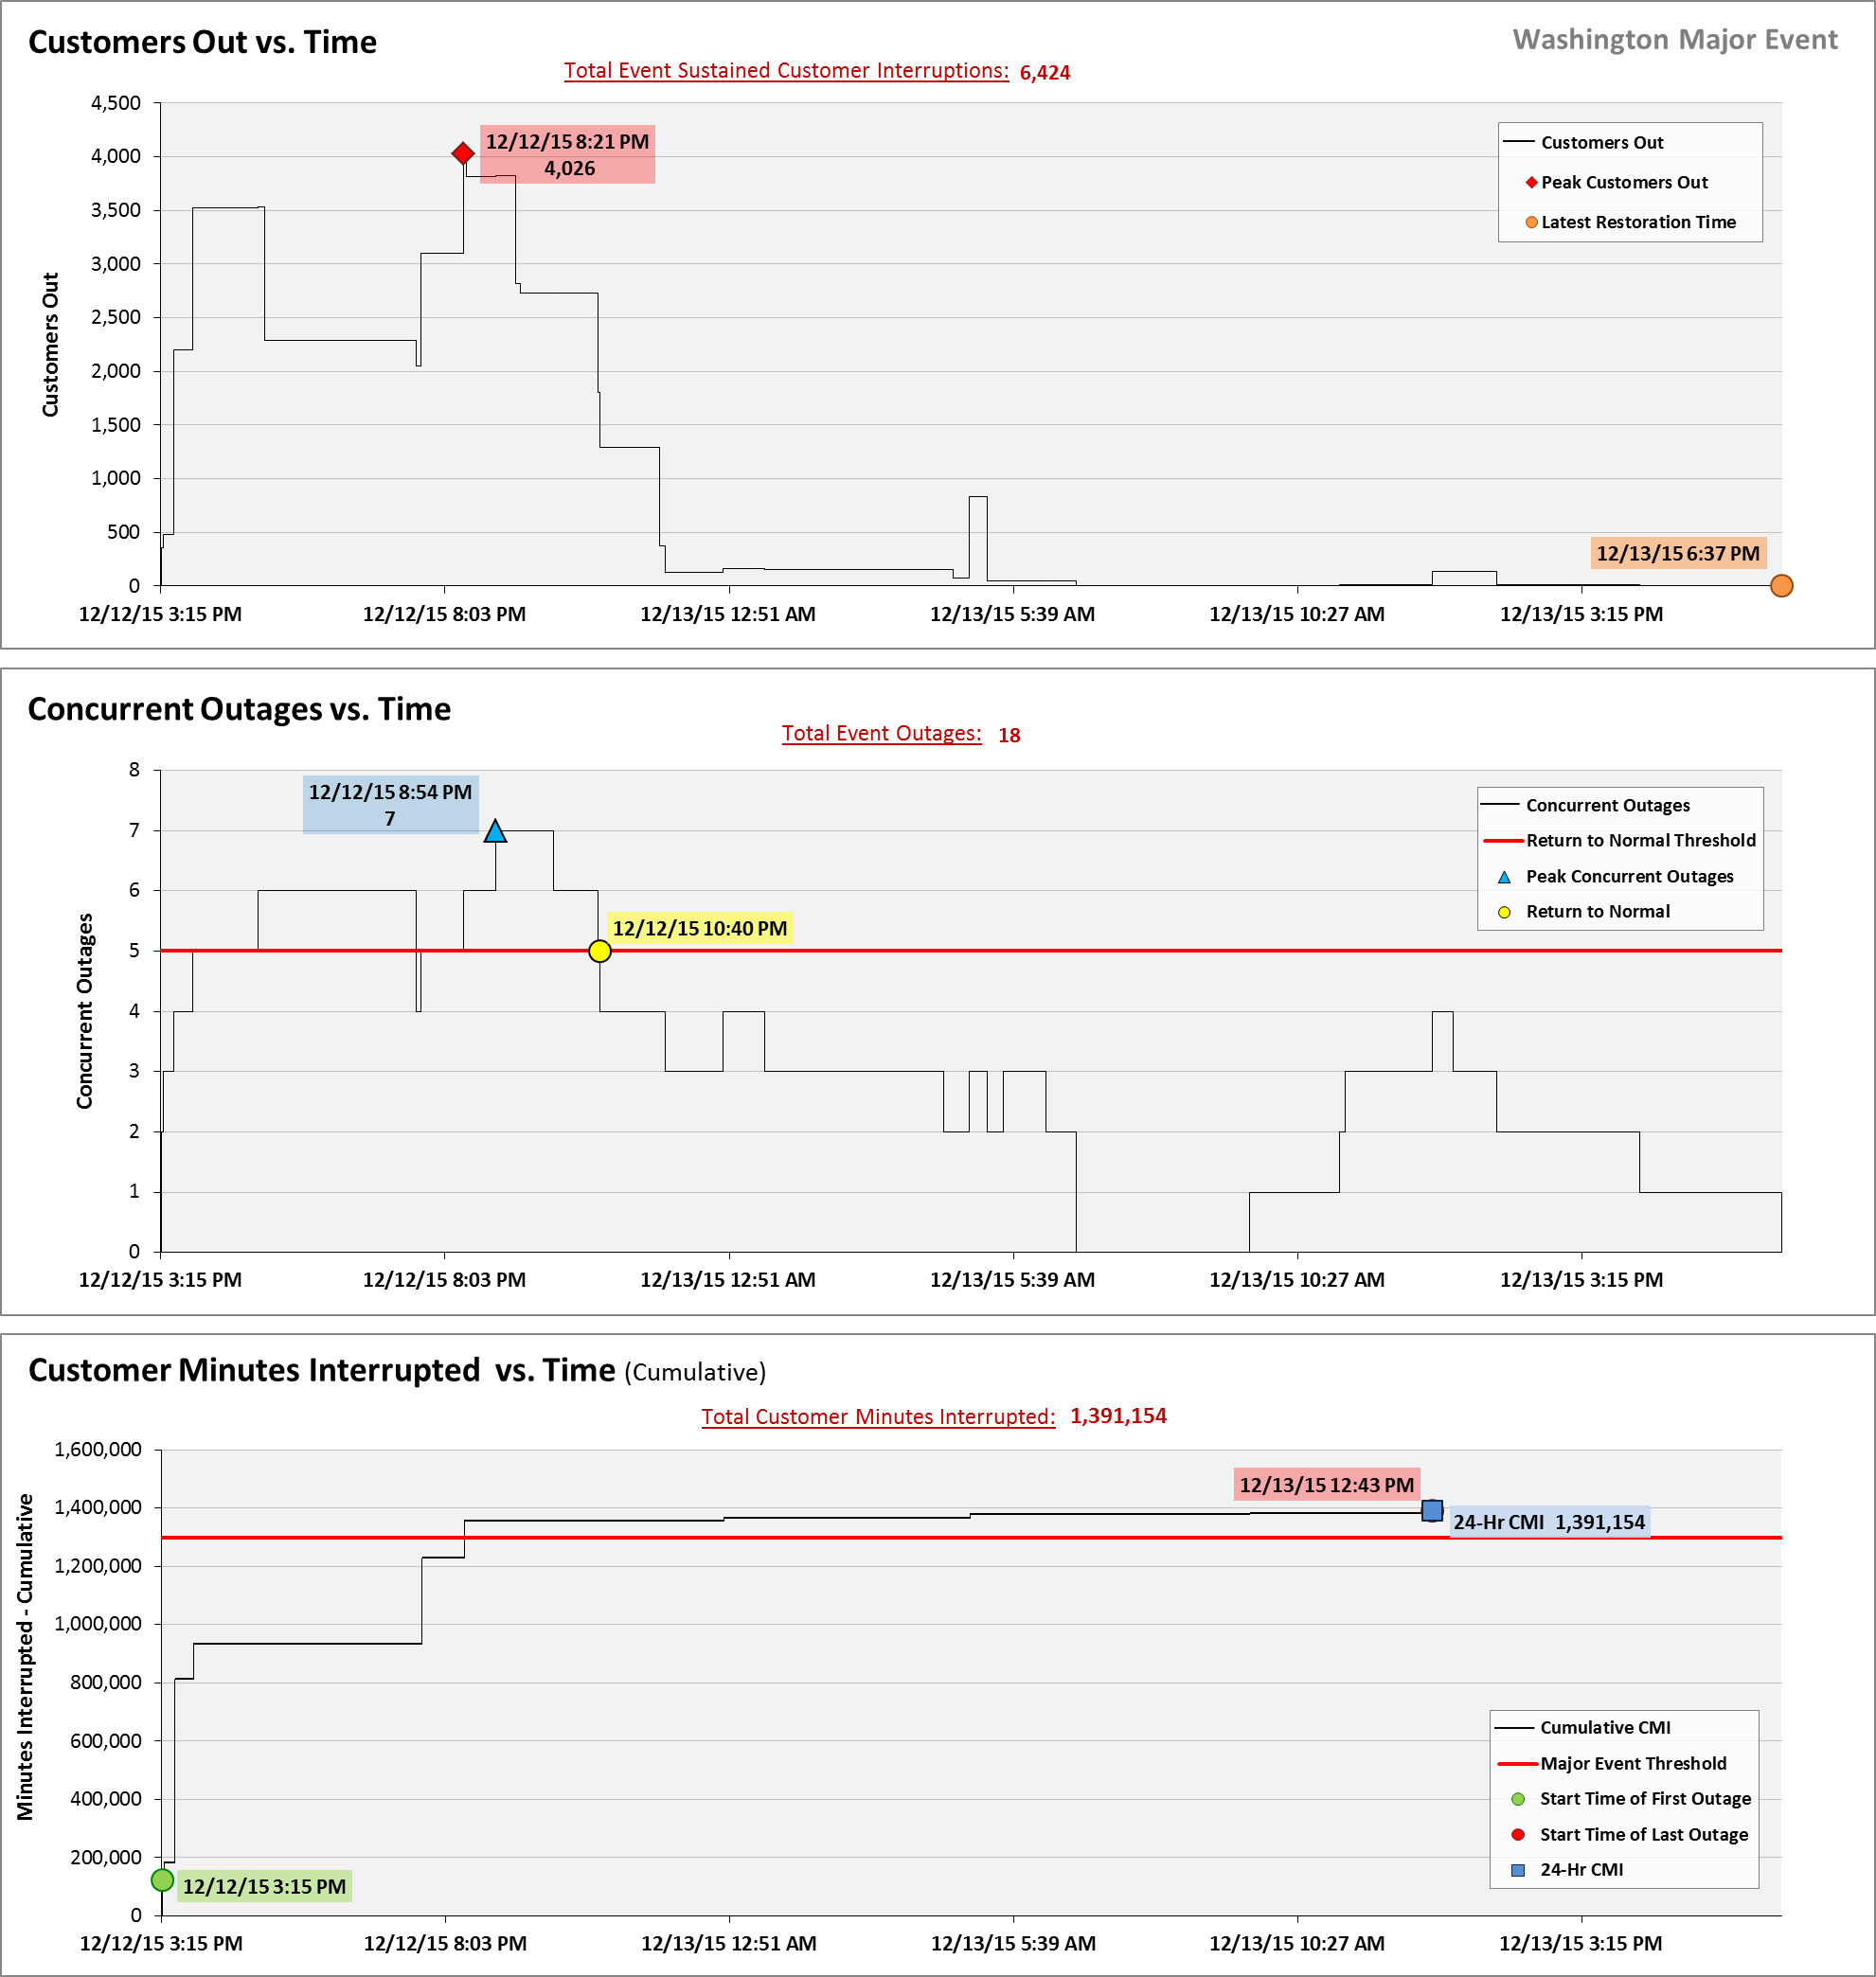

**SAIDI, SAIFI, CAIDI by Reliability Reporting Region**

Please see the attached system-generated reports.

1. Pole fires may result from a number of different causes. They can occur when atmospheric conditions exist with light misting rain that bonds with contaminants resulting in a breakdown of insulation, which leads to leakage current. A pole fire may also result from leakage current caused by an equipment failure such as a failed dead-end insulator, or a broken cutout. If the leakage current passes through a dry wood pocket on its path to ground, it can ignite the crossarm or pole.