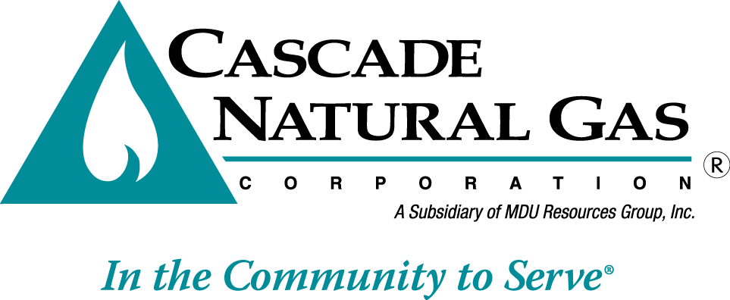 | 8113 W. GRANDRIDGE BLVD., KENNEWICK, WASHINGTON 99336-7166  TELEPHONE 509-734-4500 FACSIMILE 509-737-7166  www.cngc.com

VIA ELECTRONIC MAIL
records@utc.wa.gov

August 12, 2016

Records Center
Washington Utilities and Transportation Commission
1300 S. Evergreen Park Drive SW
Olympia, WA 98504

Re: UG-160967, Supplemental Filing
Advice No. CNG/W16-07-01

On July 29, 2016, Cascade Natural Gas Corporation’s (Cascade or Company) submitted Advice No. W16-07-01. The Company now supplements this filing with the follow replacement sheets, which are stated to become effective September 1, 2016:

Tenth Revision of Sheet No. 12
First Revision of Sheet No. 12-A
First Revision of Sheet No. 12-B

This replaces all the sheets in the initial July 29, 2016, filing.

The changes made herein correct margin codes and a header.

If you have any questions regarding this report, please contact Jennifer Gross at (509) 734-4635.

Sincerely,

Michael Parvinen
Director, Regulatory Affairs

