October 17, 2023

DER Forecasting Methodology

Prepared for Avista Utilities

**Developed For**

Avista Utilities

East 1411 Mission Ave.

Spokane, WA 99202

**Developed By**

Cadeo Group

3506 N Vancouver Ave

Portland, OR 97227

# Contributors

Fred Schaefer (Cadeo Group)

Kseniya Husak (Cadeo Group)

Dr. Cecilia Arzbaecher (AEG)

Eli Morris (AEG)

William Marin (Verdant Associates)

Dr. Jean Shelton (Verdant Associates)

Collin Elliot (Verdant Associates)

Please refer questions to:

Fred Schaefer

fschaefer@cadeogroup.com

503-660-4215

# Table of Contents

Contributors 2

Table of Contents 3

Section 1 Introduction 4

Section 2 Data Sources 5

2.1 Avista Data Sources 5

2.2 External Data Sources 8

Section 3 Overview of AdopDER Framework 13

3.1 Input Development 13

3.2 DER Forecast 14

3.3 Scenarios 18

Section 4 Electric Vehicles and Charging 20

4.1 Technology Scope 20

4.2 Current Stock 20

4.3 Adoption Curves 24

4.4 Load Impacts 38

Section 5 New Generation and Storage 41

5.1 Technology Scope 41

5.2 Current Stock 41

5.3 Adoption Curves 42

5.4 Load Impacts 44

Section 6 Description of Output Files 46

6.1 Adoption Output Structure 46

6.2 Load Impact Output Structure 46

# Introduction

Avista Utilities (Avista) contracted with AEG, Cadeo, and Verdant (‘the team”) to forecast the potential load impacts from distributed energy resources (DER) adoption in its Washington (WA) service territory through 2050. As the markets for electric vehicles, on-site renewable generation, and energy storage mature, it is essential to understand these technologies' effects on the electric system and how they will impact the available capacity. The DER load impact estimates will help Avista gain insight into the opportunities and challenges of increasing DER adoption in its Washington distribution system.

Specifically, the DER forecast will allow Avista to understand where DERs are likely to appear on its distribution system and lay a foundation for other distribution system planning efforts to determine the associated risks, potential costs to both the utility and its customers, and opportunities to influence this adoption to provide maximum benefit to the utility system and customers under different scenarios.

This document outlines the team’s proposed methodology for its DER forecast in Avista’s Washington service territory. As a next step of the project, the team will collaborate with Avista to finalize the method before developing the forecast itself.

The team has organized the remaining sections of this document as follows:

* **Section 2 Data Sources describes the data from Avista and external sources that the team will use to characterize Avista customers and develop assumptions for the** DER forecast.
* **Section 3 AdopDER Modeling Framework** provides an overview of the AdopDER software the team will use in its forecast.
* **Section 4 Electric Vehicles and Charging** describes the team’s approach to developing AdopDER input data for electric vehicles (EV) and electric vehicles service equipment (EVSE).
* **Section 5 New Generation and Storage** describes the team’s approach to developing AdopDER input data for customer-owned solar photovoltaic (solar PV), wind, and storage resources.

# Data Sources

The team provides a high-level description of the data sources it will use to develop its DER forecast in this section. As is typical of a potential study, the team's sources are numerous and diverse. Avista provided some data sources in response to the team’s data request at the project's outset (2.1 Avista Data Sources). The team identified additional data sources to supplement the Avista-provided sources (2.2 External Data Sources).

The team describes how it uses Avista and external data sources to derive DER-specific model inputs in Sections 4 and 5.

## Avista Data Sources

The team began this study by providing a comprehensive data request to Avista. This section describes the data Avista shared with the team and how the team intends to use it.

### Customer-Specific Data Sources

Avista provided customer-level data that the team will use to establish the universe of service points[1] and inform the DER potential associated with each site for this project. The team describes how it will use these data below:

* **Premise and service point identifiers** determine which premises and service points to use in the modeling framework and join data files received from Avista.
* The **rate schedule** associated with each service point determines whether it is residential or non-residential.
* The **latitude and longitude** for each service point allow the team to link to external geospatial data sources as needed.
* The **billed kilowatt-hours (kWh) and peak kilowatts (kW)** allow the team to calculate the maximum amount of solar PV the service point is eligible for on Avista’s net metering tariff.
* Avista engaged with Bidgely to identify **current service points with electric vehicle charging**, as determined by their load profiles.
* The **existing DERs** tell the team which service points have interconnected solar and wind generation as of June 2023 and the nameplate capacity of each system.
* Avista has purchased **household-level demographics and building characteristics** from Acxiom, which the team will use to characterize the building stock for residential customers.
* Avista has provided **non-residential customer names** that the team will use to identify potential fleets of vehicles.
* Avista has provided **data from its transportation electrification program** that describes the EVSE type and count for its 829 participants. In addition, these data provide a count of battery electric vehicles (BEVs) and plug-in hybrid electric vehicles (PHEVs) for the program participants.

### Customer Forecasts

The team has received two sources of customer forecast data from Avista.

#### Service Territory Forecast

First, Avista has provided a service territory-level customer forecast through 2027 that aligns with the customer forecast provided for its concurrent Conservation Potential Assessment.[2] To extend this forecast through 2050, the team will trend the last year in the forecast with an average annual growth rate. This customer forecast will inform the total number of new service points in Avista’s service territory each year of the forecast.

#### Known Developments

Additionally, Avista has provided a geographic information system (GIS) shape file of known developments for distribution planning. This shape file includes approximately 400 future developments with expected completion dates through 2032. The team has used GIS software to assign these developments to a 2020 census block. It will use these data to place a specific number of customers at specific locations on Avista’s distribution system. The developments include residential, commercial, industrial, and EVSE installations.

The team will filter the data to include only developments with the following criteria:

* In a Washington census block
* Confidence > 50
* Known, expected completion date in calendar year 2023 or later.

### Named Communities

The team has identified the Named Communities as any Avista service point for which one or more of the following is true:

* **Highly Impacted Population:** in a census tract with a WA Department of Health.[3] “EHD v2.0 Overall Rank” score of 9 or 10.
* **Vulnerable Population:** in a census tract with a composite score of 9 or 10 in the sensitive population or socioeconomic subcategories, as identified by the WA Department of Health’s Environmental Health Disparities Map.[4]
* **Tribal Land:** in a tribal land identified by an Avista-provided GIS shape file.[5]

### 2022 Annual Transportation Electrification Report

The team will use Avista’s 2022 Annual Transportation Electrification Report[6] (Avista TE Report) as a data source for EVSE load impacts. The Avista TE Report analyzes charging infrastructure, characterizes charging load profiles, and provides anecdotal data about transportation electrification activities within the Avista service territory.

### Fleet Survey

Avista conducted a multi-modal (i.e., web and phone surveys) fleet survey from a sample frame of approximately 1,600 non-residential accounts in the area between US Interstate 90 and the Spokane River (Figure 1 shows a dark gray circle for each service point associated with these accounts).

Figure 1. Sample Frame for Fleet Data Collection Survey

For the fleet survey, the team drafted a brief survey instrument for Avista to collect the following information for this study.

* Does the account have a fleet that operates in Eastern Washington?
* Number of LDVs in the fleet.
* Number of MDVs in the fleet.
* Number of HDVs in the fleet.
* Street address(s) where the fleet is located.
* The percentage of fleet that will be electrified in 2, 5, and 10 years.

## External Data Sources

In addition to the data Avista provided for this study, the team acquired data from other sources. This section describes those sources and how the team intends to use each to supplement Avista’s data.

### United States Census Bureau TIGER Shapefiles

The team’s DER forecast will be at the census block level. To facilitate this level of detail and join Avista’s customer data to other sources, the team mapped each Avista service point to its census block using geographic information system (GIS) shapefiles for the 2020 decennial census from the United States Census Bureau.[7] The census block “GEOID” identifier is a 15-digit code identifying the state, counties, census tracts, and census block group.[8]

### Tax Parcel Databases

Cadeo has obtained tax parcel data from two sources for this study.

* **Washington Current Parcels.[9]** This data, published by the WA State Office of the Chief Information Officer, contains a standardized “land use code”[10] that indicates the economic use of each tax parcel. The team matched the latitude and longitude of each Avista service point to the parcel boundaries defined by the GIS shape file.
* **Spokane County Assessor Database.[11]** The Spokane County assessor’s office publishes property tax and valuation data on its website. Spokane County accounts for over 70% of Avista’s WA service territory customers. Thus, the team elected to use these data files to supplement the land use codes with parcel data that includes building vintage, building size, and the presence of a garage or parking areas for a large portion of Avista’s customer base. These data share a parcel identifier with the current parcel source described above.

For this project, the team will use the tax assessor data from Spokane County to extrapolate building characteristics (e.g., building vintage, presence of a garage) to the other, smaller counties in the Avista service territory. The team chose this path because each county curates this information differently, requiring bespoke, high-effort approaches to acquire similar data to Spokane County. Third parties, such as First American Data Tree, aggregate and standardize such data and make it available for a fee; however, their terms of use are restrictive for consulting engagements.

### 2021 American Community Survey

The team used 2021 American Community Survey (ACS) 5-year data[12] to obtain demographic data for each census block group in Avista’s WA service territory to develop a propensity score for customer solar PV adoption. Specifically, the team collected the following variables for each block group:

* Total Population
* Median Age
* Median Household Income
* Percentage of Dwelling Units by Housing Type: single-family detached, single-family attached, multifamily (5 or more units), or manufactured.
* Percentage of Dwelling Units by Tenure: owner- or renter-occupied

The team will use these data to develop a propensity score that rank-orders customer solar PV adoption rates for each census block group in Avista’s WA service territory.

### Washington Department of Licensing Vehicle Registration

Cadeo purchased a dataset from the Washington Department of Licensing (WA DOL) that contains data for approximately 600,000 vehicles registered in the counties covered by Avista’s WA service territory in 2022. The dataset includes the following:

* Vehicle Identification Number
* Model Year
* Vehicle Type
* Vehicle Primary Use
* Fuel Primary Use
* Fuel Secondary Use
* Gross Vehicle Weight Rating (GVWR) Class
* Electrification Level
* Owner Type
* County
* Postal Code
* Census Tract (2020)

### ATLAS Public Policy Washington Vehicle Fleet Inventory

ATLAS Public Policy conducted a 2020 study for the WA State Legislature Joint Transportation Committee on public vehicle electrification that included an inventory of the public vehicles in the state. One of the project’s deliverables is a dashboard of vehicles that shows counts by public agency, vehicle type, and county.[13] The team will use this dashboard, among other sources, to characterize the vehicle stock in Avista service territory.

Figure 2. Screenshot of ATLAS Public Policy Washington Vehicle Fleet Inventory

### ATLAS Public Policy Electrification Assessment

In addition to the database of vehicles described above, ATLAS Public Policy produced a written report, “Electrification Assessment of Public Vehicles in Washington”[14] (ATLAS report), that characterizes the trends in public fleet electrification in WA. The team uses many of the findings in this report in its analysis of electric vehicle adoption curves.

### Federal Highway Administration NextGen OD Data.

The team obtained an origin-destination dataset from the Federal Highway Administration (FHA OD Data). FHA’s documentation for these data indicates that they are derived from truck data providers ATRI and INRIX and include FHA vehicle classes 5 through 13.[15] The team notes that FHA’s classification system is not the gross vehicle weight rating (GVWR) class 1-8 system used for this study. Still, classes 5 through 13 are analogous to GVWR classes 3 through 8 (10,001 pounds or higher gross vehicle weight) with buses excluded.

The dataset tracks the number of trips and their associated mileage by origin metropolitan statistical area (MSA) and destination MSA. Figure 3 illustrates these data, showing the total origin and annual trips terminating in the Spokane-Spokane Valley MSA.

Figure 3. FHA OD Data Illustration

### US Department of Energy’s Alternative Fuels Data Center Database

The team used the US Department of Energy’s Alternative Fuels Data Center (AFDC) “alternative fuel stations” API[16] to obtain data (location and count of ports by charger type) for approximately 110 current public charging locations in Avista’s Washington service territory. For this study, where the team will produce a census block-level forecast of DER adoption, the team mapped each site identified by AFDC to the closest non-residential service point in Avista territory.[17]

### US Department of Agriculture Rural-Urban Commuting Area

The team will use the US Department of Agriculture Rural-Urban Commuting Area (RUCA) data file[18] to determine which service points are in urban and rural areas. The RUCA urban/rural assignments are for 2010 vintage Census Tracts and are scored on a 10-point scale where 1 represents the most metropolitan areas, and 10 means the most rural areas.

### Washington Electric Vehicle Coordinating Council

The Interagency Electric Vehicle Coordinating Council (EV Council) is a group that develops transportation electrification (TE) strategies, manages TE funding, and leads TE-related outreach for WA.[19] The team will use data from EV Council-sponsored studies to inform its electric vehicle adoption forecasts.

### CarrierSouce

CarrierSource[20] is a marketing website aggregating listings and ratings for freight carrier fleets. It also includes a fleet size. The team will use this site to identify and size private HDV fleets in Avista’s service territory.

# Overview of AdopDER Framework

AdopDER is a software application written in Python that Cadeo developed with Portland General Electric (PGE) for use in PGE’s integrated resource planning and distribution system planning activities. AdopDER can estimate site-level adoption of over 40 DERs[21] and develop long-term, hourly load impacts from those DERs at a granular level across a utility distribution system.

Figure 4. AdopDER process flow diagram

Figure 4 shows AdopDER’s process flow diagram; it uses a consistent framework to forecast the adoption and load impacts for each DER in the scope of this study. In the remainder of this section, the team describes the framework shown in Figure 4 in more detail. In Section 4 and Section 5 of this document, the team describes approaches to create input data for the specific DERs.

## Input Development

The first step in our forecasting process is input development. AdopDER relies heavily on the customer and market data described in Section 2 of this document to characterize distributed energy resource adoption and electrification.

The team will analyze, summarize, and load data from the sources described in Section 2 into AdopDER’s input data structure illustrated in Figure 4. AdopDER’s input data structure includes the following:

* **Initial Site Characteristics** describe the existing stock of buildings at each service point in Avista’s service territory. This data includes the presence of existing DERs, the 2020 census block group, whether the service point is in a Named Community, and the building type (economical use), vintage, and presence of parking, as sourced from tax parcel databases. These characteristics can change over time in the DER forecast.
* **Customer Forecast** describes how the number of service points in Avista’s service territory changes over time.
* **Customer Intelligence** includes location and year of specific customer growth from the Known Developments source that Avista provided.
* **Adoption Curves** describe the time-variant proportion of eligible service points that the team expects to adopt each DER in each year.
* **DER Load Impacts** describe the expected hourly load impacts (in kWh) from each DER at each service point.

After collecting, analyzing, and standardizing input data sources described above, the team will conduct quality control steps to verify data integrity and that the ranges and distributions of values are consistent with the team’s expectations.

## DER Forecast

The team describes the three discrete steps of AdopDER’s forecasting workflow in this section.

### Stock Assessment

AdopDER’s stock assessment creates a service-point DER adoption forecast using stochastic, site-level process flow that repeats for each site, DER, and year. Relative to the high-level diagram shown in Figure 4, Figure 5 and the subsequent text describes that process flow in further detail.

Figure 5. Stock Assessment Detail

**Update Site Characteristics.** As described above, we begin with the initial characteristics of each service point in the base year of the forecast (2022). Then, for each subsequent year of the forecast horizon, we update the equipment stock based on a stock turnover mechanism and assumed measure adoption from previous years. For example, a single vehicle presence in the year 2024 is a function of the type of vehicle (internal combustion [ICE], BEV, or PHEV) that was present in 2022, a lifetime function,[22] and whether our stock turnover function retired the system in 2022 or 2023.

**Check Eligibility.** After updating the site characteristics for each subsequent year of the 20-year forecast horizon, we update the eligibility of each DER at each service point. For a study such as this one, the primary purpose of this step is to check for the retirement of vehicles, which makes the eligibility to adopt a BEV time variant. The eligibility criteria for other DERs in this study (solar, storage, and wind) are tied to the physical characteristics of the service point rather than the replacement of end-use equipment and thus are time invariant. If eligible, AdopDER determines a random number X that it will compare against a probability specified by an adoption curve.

**Adoption.** We simulate adoption by using measure-specific adoption curves (also known as ramp rates) that determine the probability that an eligible service point adopts a DER that it is eligible for in the current year. Tactically, AdopDER makes the adoption decision by comparing the random number X described above to the adoption probability P from the adoption curve and assumes that the site adopts the DER if X < P. Upon adoption, AdopDER also calculates the size units of each DER, which allows it to calculate the hourly load impacts in a subsequent step. For the DERs in this project’s scope, the size units are tied to nameplate ratings, such as direct current kW (kW-DC) for solar PV and kW for EVSE.

**Time Step.** After each year, we increment the time step and run through the same process described above for each service point and DER.

**Pass to Load Impacts.** After simulating DER adoption using the above process, the stock assessment module passes the following service point-level data to the load impact module:

* Site and location identifiers that include the service point and census block for each adopter.
* Segmentation variables that include any variable needed to assign the adopter to its load impact segment.
* Size units for each adopter.

### Load Impacts

AdopDER passes service point DER adoption and sizing assumptions from the stock assessment module to the load impact module, where we apply unitized load impacts for each DER. This section uses illustrations to describe the data processing steps within the load impact module; the team describes the sources and segmentation for each DER load impact in Section 3.

The load impact module first assigns a load impact shape to each adopter for each DER. AdopDER allows load impact shapes to vary by customer segment. For example, AdopDER can give unique direct current fast-charging (DCFC) EVSE profiles to public charging locations, warehouses, and schools, as illustrated by Figure 6.

Figure 6. Illustration of Load Impact Segmentation

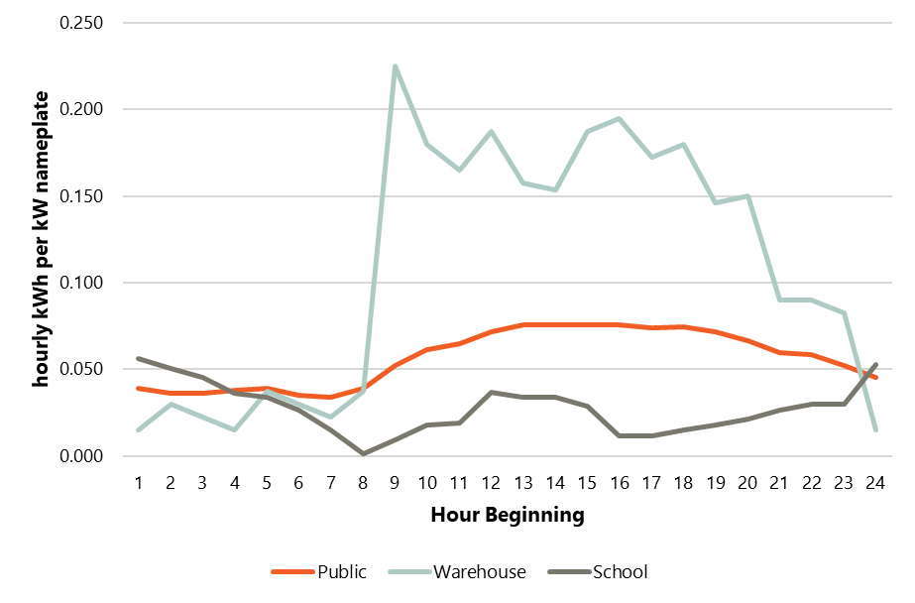

Avista requires that the team’s forecast include only new DER impacts over and above what currently exists in Avista’s service territory. To accomplish this, the team will create load impact segmentation so that the load impact for any already installed DER is 0 kWh every hour to remove the load impact of existing DERs, such as existing PV systems.

After assigning load impact segments, the load impact module calendarizes the input shapes. AdopDER allows the parameterization of each load impact shape to vary by DER, though the interpretation of each shape is consistent: hourly impact (in kWh per hour) per size unit of DER adoption. Figure 7 and Figure 8 show illustrations of different parameterizations of load impact shapes. Figure 7 shows an example of solar PV impact shape, where an 8760-hour time series is necessary since solar generation varies along a diurnal pattern and throughout the year. In this case, AdopDER copies the 8760-hour input shape to each year in the forecast horizon.[23]

Figure 7. Illustration of Hourly DER Load Impacts for Solar PV, July 1-7

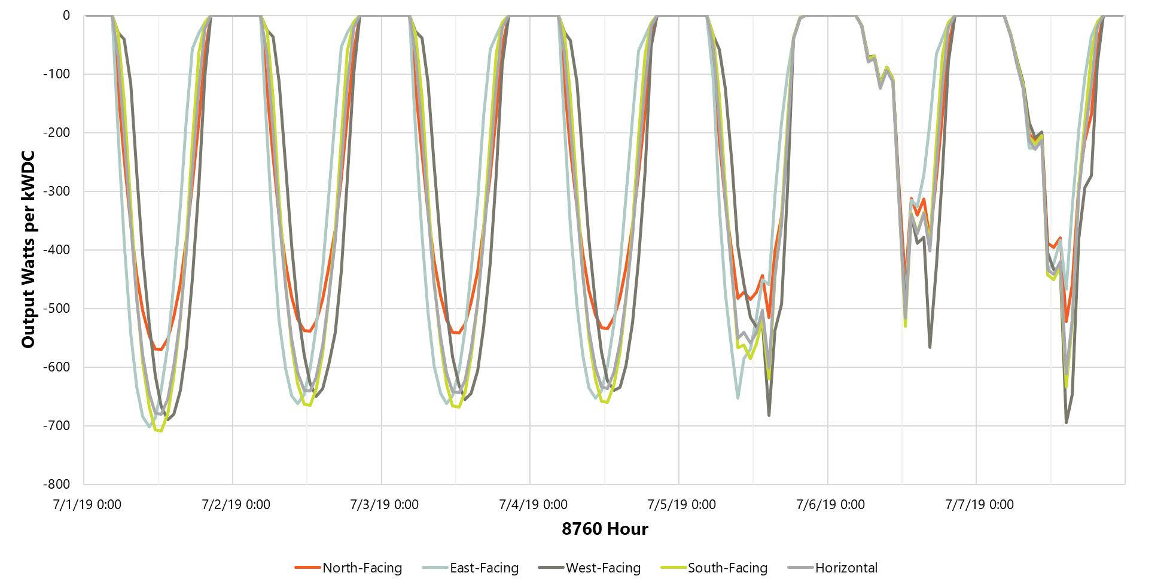

Figure 8 shows an example of a residential level 2 (L2) EVSE load impact shape, where the daily usage patterns vary by day of the week. In this example, AdopDER will construct an 8760 shape for each year in the forecast horizon by applying the 24-hour weekday and weekend shapes to each day by the calendar for each year in the forecast horizon.

Figure 8. Illustration of Hourly DER Load Impacts for Residential L2 EVSEA graph showing the time and the hour beginning

Description automatically generated with medium confidence

### 8760 Forecast

In this final step, AdopDER combines the adoption and size units created in the stock assessment module with the calendarized, 8760-hourly load impacts to create an 8760-hourly forecast of the load impacts for each census tract and each DER for the entire forecast horizon. Equation 1 shows the formula with which AdopDER generates this forecast, where the hourly kWh from DER is a function of adoption (number of service points), the size units, and the hourly load impact (kWh) per size unit.

Equation 1. AdopDER 8760 Forecasting Formula

Where:

* *l* represents each census block within Avista service territory,
* *d* represents each DER,
* *s* represents the load impact segment for DER *d*,
* *y* represents each year in the forecast horizon, and
* *h* represents the hour within each year

## Scenarios

In this study, we will execute scenarios to show how load impacts differ under two plausible future outcomes. We will simulate each scenario by constructing alternate sets of model inputs and adoption pathways for specific measures in the AdopDER model. Below, we describe our scenario approach,

### Reference Scenario

The team’s reference scenario represents the most likely future outcome, where we simulate adoption with knowledge of current incentive programs and typical “s-curve” based changes in market share. In other words, under the reference forecast, we do not assume the existence of to-be-determined future programs, incentives, and interventions that promote DER adoption, whether these interventions come from the utility, state, or federal level.

### High Incentive Scenario

Under the high incentive scenario, we model more aggressive DER adoption from the hypothetical impact of the incremental incentives for customers in Named Communities areas. Tactically, the team will adjust applicable adoption curves to simulate the effect of these incentives in AdopDER. By forecasting adoption using these alternate adoption curves, the team will be able to evaluate how additional incentives may affect DER adoption in Named Communities. We expect that with higher incentives, the adoption rates would also be higher for customers in Named Communities. However, the nature of this scenario is such that the increased incentives only apply to some resources in the study (i.e., the high incentive scenario impacts the adoption curves for residential solar PV, residential wind, and residential EV and EVSE).

# Electric Vehicles and Charging

The team describes the scope, stock data sources, adoption curves, and load impacts for electric vehicle (EV) and electric vehicle service equipment (EVSE) in this section.

## Technology Scope

Table 1 summarizes the EV and EVSE technologies the team will model in the forecast.

Table 1. EV and EVSE Technology Scope

|  |  |  |
| --- | --- | --- |
| Sector | Technology | Eligibility |
| Residential | Light Duty (GVWR Class 1-2), Battery Electric Vehicle (BEV) | End-of-life internal combustion engine (ICE) vehicle. |
| Light Duty (GVWR Class 1-2), Plug-In Hybrid Electric Vehicle (PHEV) | End-of-life ICE vehicle. |
| Medium Duty (GVWR Class 3-6), BEV | End-of-life ICE vehicle. |
| Level 1 (L1) EVSE | The service point has BEV or PHEV and parking. |
| L2 EVSE | The service point has BEV or PHEV and parking or is a multifamily building. |
| Non-Residential | Light Duty (GVWR Class 1-2) BEV | End-of-life ICE vehicle |
| Light Duty (GVWR Class 1-2) PHEV | End-of-life ICE vehicle |
| Medium Duty (GVWR Class 3-6) BEV | End-of-life ICE vehicle |
| Heavy Duty (GVWR Class 7-8) BEV | End-of-life ICE vehicle |
| L1 EVSE | Service point has Class 1 or 2 BEV or PHEV and parking. |
| L2 EVSE | Service point has a fleet of vehicles or parking for public charging infrastructure. |
| DCFC EVSE | Service point has a fleet of vehicles or parking for public charging infrastructure. |

## Current Stock

Our modeling process begins with the current stock. As Sections 1.2.4 and 1.2.5 described, we will use WA DOT vehicle registration data, the ATLAS Public Policy Washington Vehicle Fleet inventory, and the Avista customer fleet vehicle survey results to evaluate existing EVs at the service point level.

### Electric Vehicles

Figure 9 shows the team's framework for segmenting and characterizing the vehicle stock in Avista’s service territory. In a forecast such as this, it is essential to describe the future vehicle stock, not just today’s electric vehicles.

Figure 9. Vehicle Stock Segmentation

|  |  |  |  |  |
| --- | --- | --- | --- | --- |
|  | | **Ownership Type** | | |
| **Personal** | **Public Fleet** | **Private Fleet** |
| **Weight Class** | **LDV** | WA DOL Vehicle Registration | ATLAS Vehicle Inventory | Avista Fleet Vehicle Survey, WA DOL Vehicle Registration |
| **MDV and HDV** | Avista Fleet Vehicle Survey, FHA OD Data |

#### Personal Vehicles

As a global assumption, the team will equate the “personal” vehicle segment in Figure 9 shows the team's framework for segmenting and characterizing the vehicle stock in Avista’s service territory. In a forecast such as this, it is essential to describe the future vehicle stock, not just today’s electric vehicles.

Figure 9 with vehicles owned by Avista’s residential customers. Using the following steps, the team will use multiple sources within the residential sector to characterize the vehicle stock within Avista’s service territory.

* Assign known electric vehicles to service points based on Bidgely’s analysis and Avista’s transportation electrification program data.
* Determine the total number of personal vehicles in Avista territory by filtering the WA DOL registration dataset to include the following vehicles:
  + Owner Type = “Individual”, and
  + Registered in census tracts in Avista’s Washington service territory.
* After filtering, determine the total number of remaining vehicles (WA DOL vehicles less the known electric vehicles) by fuel type and GVWR weight class within each census tract.
* Assign the remaining vehicles in the WA DOL registration dataset to Avista SPIDs such that the total number of vehicles in each census tract aligns with the census tract-level totals in the WA DOL registration dataset. In doing this,
  + Allocate electric vehicles in the WA DOL registration dataset to single-family service points only.
  + Allocate other fuel types to any residential service point (i.e., single-family, manufactured, or multifamily).

#### Non-Residential, Public Fleets

The team will use ATLAS to determine the number of vehicles by county for publicly owned vehicles. While ATLAS does not explicitly track weight class, it does have descriptions for each vehicle (see Figure 10) that will allow the team to map the descriptions to a GVWR weight class.

Figure 10. Screenshot of Counts by Category in ATLAS[24]

Though ATLAS does not explicitly state each vehicle's owner, it lists the number of vehicles associated with each department, district, or agency (DDA, see Figure 11). Thus, the team will cross-reference the DDA list against the customer names associated with each Avista service point and allocate vehicles to service points with a match.

Figure 11. Department/District/Agency listing in ATLASA screenshot of a computer

Description automatically generated

#### Non-Residential, Private Fleets

Non-residential, private fleets are the segment of vehicles for which a stock characterization can be fraught. Frequently, these vehicles are operated in different locales in which they are registered. Thus, the current industry-standard approach combines multiple sources for location-specific characterization of non-residential fleet vehicles.

The team explored numerous options in search of data sources that would allow it to characterize non-residential, private fleets.

* Avista executed a multi-modal (i.e., web and phone surveys) fleet survey for its non-residential customers to collect information about fleet size and location.
* The WA DOL source the team uses for personal vehicles also includes vehicles of all weight classes registered to businesses. These data may undercount the number of non-residential vehicles in operation in Avista territory but do not have a systematic way to assess the degree of that bias.
* The Federal Highway Administration’s origin-destination data allows the team to estimate the total annual mileage driven on trips that terminate in the Spokane area from MDV and HDV trucks. When paired with the annual vehicle miles traveled assumption, these data allow the team to estimate the number of medium and heavy-duty trucks in Avista territory.
* EPRI is developing a heatmap dataset that indicates the geospatial location of the longest dwell time and the number of daily miles driven by MDV and HDV vehicles. It expects to make these data available to its member utilities in the calendar year 2023 or 2024.[25]
* Washington has issued a mandate that requires commercial vehicle fleets for businesses with over five vehicles or more than $50 million in revenue to register their vehicle fleets with the Department of Ecology. This registration effort is ongoing, and the team expects data to be available in late 2024 (and after the completion of this study).
* CarrierSource is a website that lists private carrier fleets and their sizes.
* S&P Mobility,[26] formerly IHS Markit, is a third-party data provider that sells access to detailed vehicle registration data. Due to the WA DOL source's availability, the team did not pursue vehicle registration data from S&P Mobility.

The project team expects to use the above sources to estimate the size and location of non-residential fleets in Avista service territory in two ways.

First, the team will assign the vehicles from known fleets to service points. These include fleet survey respondents, fleets identified on CarrierSource, and other known large fleets (i.e., UPS, FedEx, Reddaway).

Then, the team will analyze the survey results and extrapolate the findings to all remaining Avista non-residential service points. To do this, the team will first determine the survey response rate to infer the probability of having a fleet. The team will use the survey to determine each respondent's average number of vehicles by weight class. Next, the team will extrapolate the remaining service points by simulating the existing fleet from the survey-based probability and assigning the average number of vehicles from survey responses.

### Electric Vehicle Service Equipment

The team will use the approach described in this section to characterize the existing stock of EVSE in Avista’s service territory.

#### Residential

To characterize the existing stock of residential EVSE, the team will use the following approach:

* Assign L2 charging to service points that have either participated in Avista’s transportation electrification program or that Bidgely has identified as having an electric charging profile. Avista’s recent transportation electrification report indicates that at the end of 2022, there were approximately 3,000 electric vehicles and about 2,000 service points in the service territory.
* Assign L1 charging to any remaining service point with an electric vehicle.

#### Non-Residential

To characterize the existing stock of non-residential EVSE, the team will use the following approach:

* If the team can map a charging location identified by AFDC to a service point, we will assign the charging type from AFDC (i.e., L1, L2, or DCFC).
* Assign L2 EVSE to service points that have either participated in Avista’s transportation electrification program or that Bidgely has identified as having an electric charging profile.

## Adoption Curves

In this section, the team describes its approach to determining the adoption curves for electric vehicles and EVSE. In general, the team’s experience is that electric vehicles require detailed segmentation, each with bespoke methods to determine an adoption curve.

### Electric Vehicles

Electric vehicles on the road today are attributed mainly to early adopters, whose purchase decisions are influenced by customer behaviors, limited model availability, and various economic factors (vehicle list prices, operating costs, fuel prices, and federal incentives). In the future, federal, state, and local policies that incentivize EV adoption will play a more significant role in electric vehicle adoption than the historical trend.

To accurately model adoption, we will develop unique adoption curves for the segments in Table 2, defined by ownership and GVWR weight class combinations. As the team describes in this section, these adoption curves account for barriers and opportunities in electric vehicle adoption.

Table 2. Adoption Curve Segments

|  |  |  |
| --- | --- | --- |
| Personal LDV | Public Fleet | Private Fleet |
| Personal LDV  Personal LDV, Named Communities | Public Fleet LDV  Public Fleet MDV  Public Fleet HDV  School Bus  Transit Bus | Private Fleet LDV  Private Fleet MDV  Private Fleet HDV |

#### **Personal LDV**

Figure 12 shows the team’s adoption curves for personal, light-duty vehicles (GWVRweight class 1 and 2, BEV and PHEV). An EV Council study estimates the sales share of light-duty vehicles[27] in response to Washington’s requirement that all new, light-duty vehicles sold within the state meet Zero-Emission Vehicle (ZEV) Program standards by 2035.[28] To construct the curves in Figure 12, the team used the EV Council’s baseline scenario, which considers existing policies and standard economic assumptions, reflecting a moderate perspective on EV cost trends.

Figure 12. Market LDV Adoption Curves for (Reference Scenario)

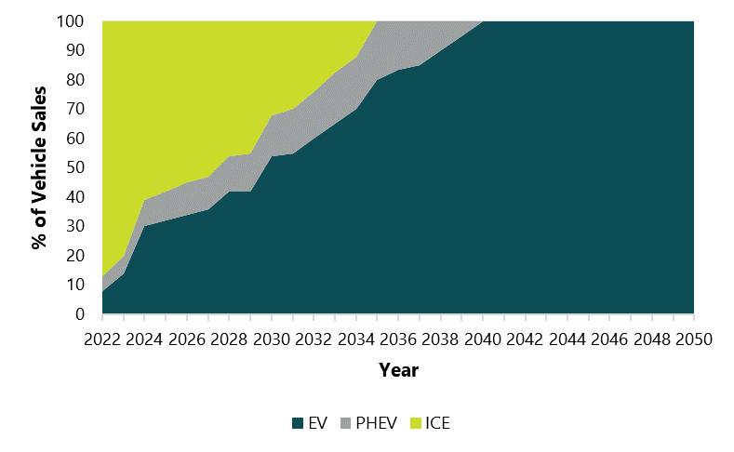

To make the adoption curves from the EV Council study applicable to this study for Avista (Figure 12), the team has added the following:

* Extended the forecast through 2050 to align with this study’s time horizon.
* Assumed that BEV will entirely supplant PHEV in LDV sales by 2040. The team anticipates that advancements in EV technology, such as increased driving range, reductions in battery prices, and an overall policy landscape, will make PHEVs obsolete by 2040.
* The team will calibrate the BEV and PHEV share in the initial year of this curve (2022) to those observed in the WA DOL dataset within the counties that Avista serves.

#### **Personal LDV, Named Communities**

Socio-economic factors influence the adoption of electric vehicles. The higher up-front cost of EV models on the market is a significant deterrent for many drivers, especially those in Avista’s Named Communities. Although WA currently offers rebates specifically for ZEV purchases,[29] none are substantial enough to address the up-front cost barrier.[30] To account for the difference in adoption rates within Named Communities, the team created the adoption curve in Figure 13 from an analysis of a University of California, Davis study that forecasted EV adoption in California across socio-economic segments.[31] To derive the Named Community curve for Avista, the team applied the ratio of the low-income adoption curve to the moderate and high-income adoption curve in the University of California, Davis study to its market level curve in Figure 13 shows the team's reference scenario LDV adoption curve, which implicitly assumes that Named Communities have no significant financial incentives to subsidize EVs' purchase price.

Figure 13. Named Community LDV Adoption Curve (Reference Scenario)

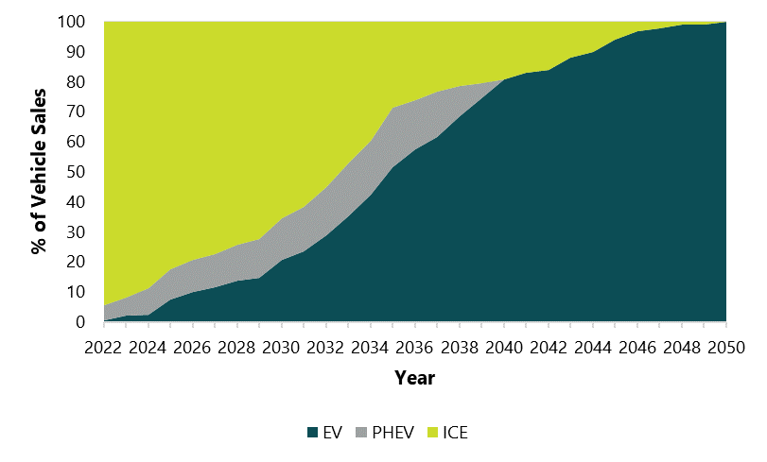

Generally, the adoption curve shape for Named Communities is very similar to that of the general market, with the latter reaching 100% EV market share approximately ten years earlier than the former. This result aligns with the team’s expectation that EVs will become more cost-competitive due to technological advancements and increased model availability. After 2035, the team expects EV adoption in Named Communities to accelerate.

For the high incentive scenario, the team’s adoption curve assumes the existence of incentive programs that will provide significant funding to accelerate the adoption of EVs in Named Communities across the state, bringing them closer to matching the general population in EV adoption rates. The Washington Department of Commerce[32] is currently creating EV incentive programs to address the issue of EV cost for historically disadvantaged communities, including a point-of-sale incentive program.[33] To reflect the impact of this funding, the team modified the general population curve in Figure 12 to reflect initial low adoption in Named Communities, followed by a sharp increase in adoption post-funding, matching available market adoption levels (Figure 14).

Figure 14. Named Community LDV Adoption Curve (High Incentive Scenario)

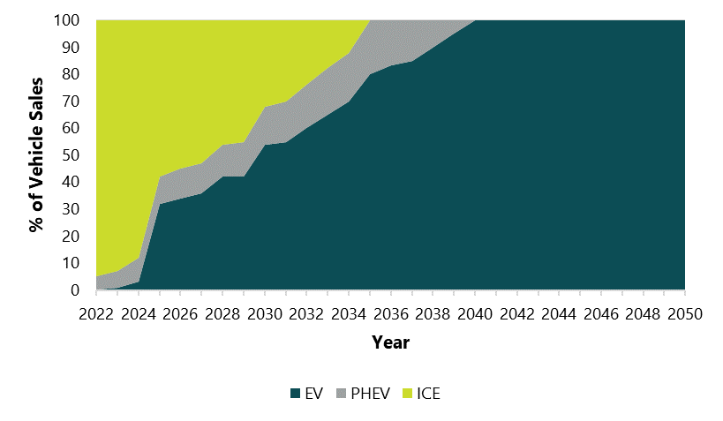

The team relied on the following assumptions:

* Substantial state incentives will be offered specifically to Named Communities starting in 2025, which will ramp up the adoption of EVs in this population, matching general population adoption rates.
* Until the incentives become available, adoption will remain low.

With an increase in EV adoption across Named Communities, we will also model a proportional rise in Residential and Public charging.

#### **Public Fleets**

**The team expects public fleets to electrify at different rates than private fleets due to two factors. First, public fleets are subject to Washington State’s Executive Order 21-04,**[34] **which requires local and state vehicle fleets to achieve 100% adoption of BEVs for LDVs by 2035 and MDVs by 2045. Additionally, WA state agencies prioritize purchasing BEVs to replace ICE vehicles due to their lower lifecycle costs. To model adoption for public fleets, we relied on the ATLAS study, the Seattle City Light Electrification Assessment (SCL study),**[35] **and McKinsey’s “Powering the transition to zero-emission trucks through infrastructure” report (the McKinsey study).**

##### Light-Duty Vehicles

Figure 15 shows the team’s adoption curve for public fleet LDV. The team used the “Electrify Selectively” scenario from the ATLAS study to construct this curve**, which models public fleet electrification potential under Washington's current policy environment.**[36]

Figure 15. Public Fleet LDV Adoption Curve (Reference Scenario)

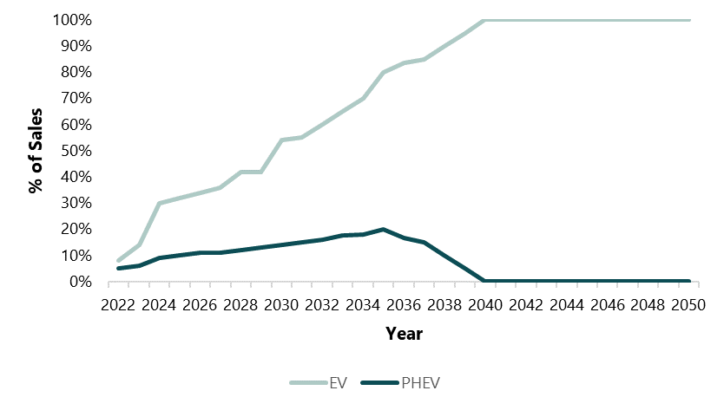

**To make the ATLAS study curve applicable to this study for Avista, the team made two additional assumptions:**

* The **ATLAS** study goes through 2035; the team extended the forecast through 2050 to align with this study’s time horizon.
* Public fleets will comply with the 2035 100% BEVs for LDV class, so adoption post-2035 is set to 100%.
* The adoption curve includes only BEVs due to limited information about PHEVs and the current procurement and policy focus on BEVs.

##### Medium- and Heavy-Duty Vehicles

**Like the LDV segment above, the team used the ATLAS, SCL, and McKinsey studies for MDV and HDV segments.** According to the **ATLAS** study, converting MDVs within state agency fleets to electric power is expected to be less economically efficient than HDVs and LDVs.[37] The MDV adoption curve in Figure 16 reflects this slower adoption rate through 2030. After that point, the team expects the electric MDV adoption rate to increase significantly, primarily due to reduced upfront costs and the 100% BEV state mandate.[38] In the short term, the total cost of ownership (TCO) analysis is more favorable for the HDV segment, with the share of vehicles that meet electrification criteria as high as 90% by 2030[39]. However, McKinsey projects much milder adoption rates, noting that HDVs are not expected to reach TCO parity with diesel vehicles until around 2030. The team assesses that the ATLAS report estimate is overly optimistic for this vehicle weight class, and thus, adoption will more closely align with McKinsey’s forecast.

Figure 16. Public Fleet MDV and HDV Adoption Curve (Reference)

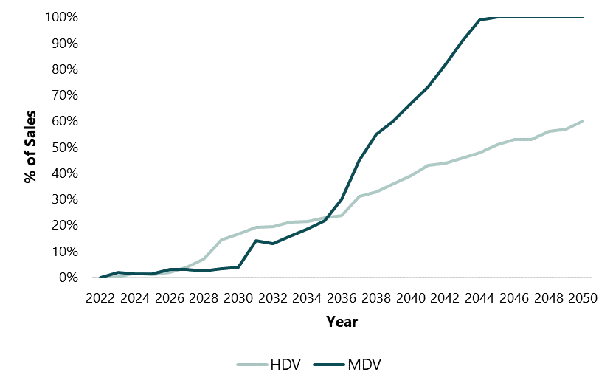

To make the **curves in** Figure 16 **applicable to this study, the team made three additional assumptions:**

* Extended the forecast through 2050 to align with this study’s time horizon.
* Public fleets will comply with 100% BEVs for medium-duty weight class requirement, reaching 100% of electric MDV sales in 2045.
* The adoption curve includes only BEVs due to limited information about PHEVs and the current procurement and policy focus on BEVs.

##### School Buses

In 2020, school districts across Washington committed to deploying at least 40 buses. With new dedicated funding[40] to back up these efforts, cost reductions from advancements in battery technology increased manufacturing volumes, and a wide EV school bus model availability, the team expects robust adoption in this vehicle segment. To derive the adoption curve for school buses (Figure 17), we relied on forecasts from the SCL and the Atlas Public Policy studies.

SCL’s Moderate Electrification scenario estimates that electric school buses will reach 20% of all new sales in 2030 and up to 80% by 2040. Based on the Atlas Public Policy assessment, electric school buses will make up over 30% of all stock in the state by 2035 and 50% of all new sales. Although we expect the adoption to start somewhat slowly, partly because of limited charging infrastructure and some financial limitations for rapid conversion,[41] we believe it is reasonable to assume an accelerating adoption rate as we get to 2030 and beyond. Along with improved charging infrastructure, this result reflects projections for the manufacturing cost of heavy-duty electric school buses to decrease significantly over the next decade due to innovations in battery technology and manufacturing volumes.

Figure 17. School Bus Adoption Curve (Reference Scenario)

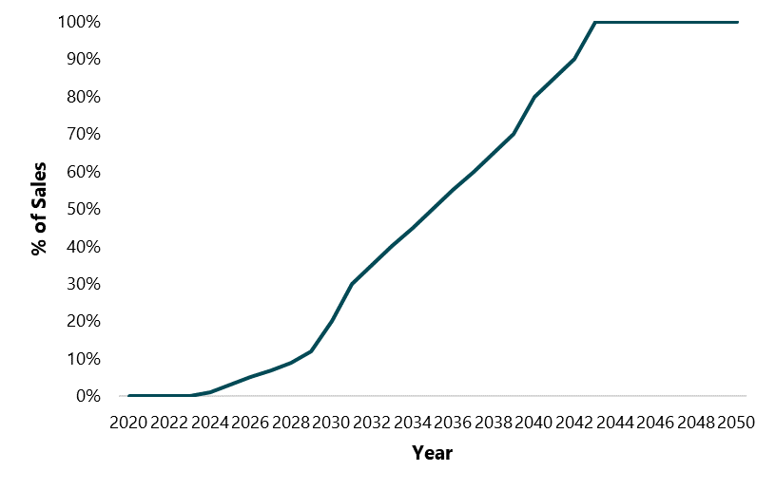

In deriving this curve, the team made the following assumptions:

* Through 2035, we used the ATLAS study adoption forecast for HDV electric school buses.
* After 2035, we use SCL’s Moderate Electrification scenario for school buses, though we modified the curve to reach 100% adoption sooner (in the year 2042).

##### Transit Bus

Washington State has the country's second-largest electric transit bus fleet, and the market is quickly approaching maturity, which means the outlook on adopting electrified buses is highly positive. [42] Heavy-duty transit buses become economically competitive at high electrification levels more rapidly than any other technology, even under unfavorable policy, technology, and deployment conditions. Electric buses are already on the roads in Avista’s territory. Spokane Transit recently added battery-electric buses to its fleet.[43]

We relied on forecasts from the SCL and ATLAS studies to derive the adoption curve for electric transit buses (Figure 18). According to the ATLAS study, by 2030, over 90% of the state’s bus fleet is expected to meet the electrification threshold. Under the Moderate Market Advancement scenario, SCL forecasts that 20% of all new bus sales in 2030 will be battery-electric, reaching 80% by 2040. Although charging infrastructure and funding will pose some constraints in the short-term, we expect robust electrification once these factors are addressed in the coming decade, with an increase in adoption past 2030.

Figure 18. Transit Bus Adoption Curve (Reference Scenario)

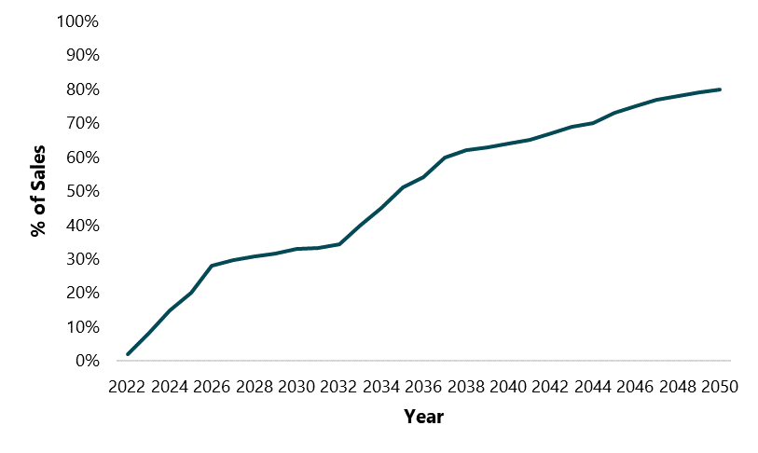

To derive this curve, the team:

* Through 2035, relied on the forecast from the ATLAS Study.
* Relied on SCL’s forecast beyond 2035.

#### **Private Fleets**

WA aims to achieve a target of 30% zero-emission medium- and heavy-duty truck and bus sales by 2030, with a long-term goal of 100% sales by 2050.[44] Thus far, the adoption of electric trucks has faced challenges stemming from factors like constrained availability and substantial cost disparities compared to conventional trucks. Although the economic viability of electric trucks is anticipated to strengthen as battery costs decrease, technology advances occur, and production processes become more efficient, reaching the sales targets established by the state may remain an ambitious endeavor.

##### **Light-Duty Vehicles**

The team reviewed the EV Council’s baseline scenario adoption forecast and the SCL study to develop the adoption curves for private fleet light-duty vehicles.[45] To construct the curves in Figure 19, the team used the EV Council’s Baseline scenario, which considers existing policies and standard economic assumptions, reflecting a moderate perspective on EV cost trends.

Figure 19. Private Fleet LDV Adoption Curve (Reference Scenario)

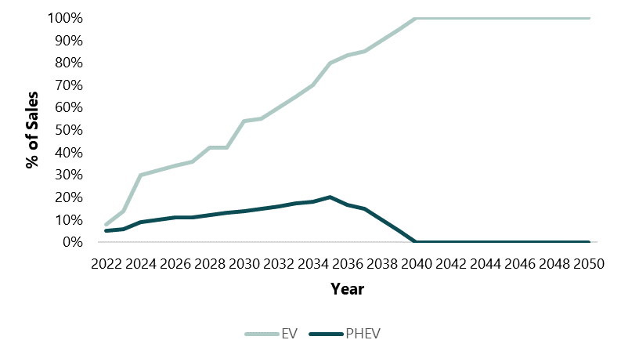

Furthermore, the team:

* Assumed the private fleet LDVs will follow closely the adoption patterns of private LDVs.
* Extended the forecast through 2050 to align with this study’s time horizon.
* Assumed that BEV will entirely supplant PHEV in LDV sales by 2040. The team anticipates that advancements in EV technology, such as increased driving range, reductions in battery prices, and an overall policy landscape, will make PHEVs obsolete by 2040.
* Will calibrate the BEV and PHEV share in the initial year of this curve (2022) to those observed in the WA DOL dataset within the counties that Avista serves.

##### **Medium- and Heavy-Duty Vehicles**

In developing the adoption curves for medium- and heavy-duty vehicles, the team reviewed the EV Council’s baseline scenario adoption forecast,[46] the SCL, and McKinsey.[47] Generally, the limitation in charging infrastructure availability will hinder the pace of adoption in this vehicle-weight class despite the increasing accessibility of electric MDV and HDV models.[48] Electrification of MDVs, however, is expected to be less constrained by charging infrastructure, with sales reaching 100% electric by 2042.[49] Our overall projections align with McKinsey's estimates, which anticipate a substantial increase in the percentage of zero-emissions trucks in active use, rising from less than 1% in 2023 to over 75% by 2050 across all medium- and heavy-duty trucks.

Figure 20. Private Fleet MDV and HDV Adoption Curve (Reference Scenario)

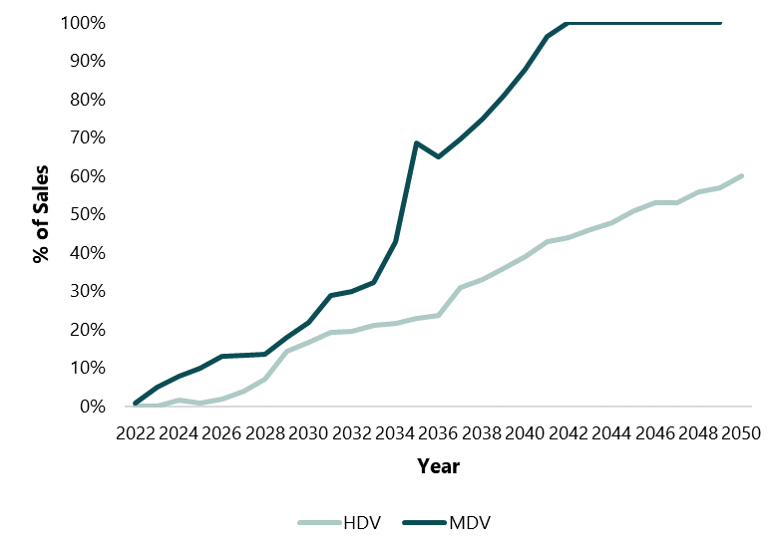

To make the adoption curves in Figure 20 applicable to this study, the team:

* Used EV Council’s preliminary results as a starting point for adoption by vehicle-weight class through 2035.
* Extended the forecast through 2050 to align with this study’s time horizon by using the post-2035 adoption estimates in SCL’s study for each weight class.[50]
* Excluded PHEV from the forecast because we lacked reliable forecasting data about PHEV in these GVWR weight classes; the adoption curves are for battery electric vehicles only.

### Electric Vehicle Service Equipment

Our approach to modeling EVSE differs from that of EVs. Instead of relying on adoption curves, the team will construct a set of rules to place EVSE in response to EV adoption. These rules account for customer segments, GVWR weight class, associated charging behavior, and other circumstances that might impact EV charging (Table 3).

Table 3. EVSE Adoption Segmentation

|  |  |  |
| --- | --- | --- |
| **Residential Charging** | **Public Charging** | **Fleet Charging** |
| Single Family (L1, L2)  Multifamily (L2) | Level 2  DC Fast Charge | LDV  MDV  HDV  School Bus  Transit Bus |

#### **Residential Charging**

**For residential customers in single-family homes, EV charging overwhelmingly happens at home, provided a dedicated parking space or garage exists. As such, when we model EVSE for this sector, we will assign an L2 or an L1 EVSE to any service points that adopt an EV if they have dedicated parking.**

**Home charging becomes more complicated for customers in multifamily buildings who adopt EVs. Dedicated parking might not be available, as is the case in urban areas. With dedicated, property management may not install EVSE due to infrastructure upgrades and additional costs. Thus, these EV owners might need to rely on chargers at their workplace or public charging. For these customers, at-home charging will depend on the availability of dedicated parking and the property owner's discretion. These customers are also much more likely to rely on L2 than L1 because of the uncertainty of dedicated parking. Increasingly, building codes are starting to account for the need for EV charging in multifamily buildings.**

Table 4. Residential EVSE Allocation

|  |  |  |
| --- | --- | --- |
| Customer Segment | EVSE Type | Ratio: Vehicles per EVSE Port |
| Single-Family | L1 | 1:1 |
| L2 (6.6 kW) | 1:1 |
| Multifamily | L2 (6.6 kW) | 4:1 |

#### **Public Charging**

**Public charging infrastructure plays a vital role in facilitating widespread EV adoption. It addresses the requirements of long-distance travel, easing concerns about limited range, and offers charging to EV owners without access to at-home charging. The team anticipates that personal EVs will drive most public charging demand; therefore, it will determine how much public charging will be needed based on its unique LDV EV forecast.**

**We will utilize** the National Renewable Energy Laboratory’s (NREL’s) Electric Vehicle Infrastructure Projection Lite (EVI-Pro Lite)[51] modeling tool to estimate the number of public L2 and DCFC charging ports through 2050 based on the forecast of personal LDV. After assessing the total number of public charging ports, we will allocate them across Avista’s service territory as follows:

* First, assign charging locations based on Avista’s Regional Charging Buildout Plan.[52]
* **Then, ensure that at least 40% of remaining chargers to census blocks overlap with Named Communities, reflecting Washington state’s approach**[53] **to supporting equitable outcomes in transportation electrification.**[54] **In this step, chargers will be distributed to census blocks in proportion to each block's total count of personal vehicles (including all fuels).**
* **Allocate the remaining chargers to census blocks with at least one commercial customer, distributing them based on the total count of electric vehicles (EVs) in each block.**

#### **Fleet Charging**

**To develop EVSE assignment rules for commercial fleets, we utilized the Atlas study.**[55]Table 5 **describes these rules, where the EVSE type and vehicle ratio per EVSE port depend on vehicle class and category.**

Table 5. Commercial EVSE Allocation

|  |  |  |
| --- | --- | --- |
| Vehicle Class | EVSE Type | Ratio: Vehicles per EVSE Port |
| LDVs | L2 (11.5 kW) | 2:1 |
| DCFC (50 kW) | 5:1 |
| MDVs | L2 (11.5 kW) | 1:1 |
| DCFC (50 kW) | 5:1 |
| School Buses | L2 (15.4 kW) | 1:1 |
| DCFC (50 kW) | 5:1 |
| Transit Buses | DCFC (50 kW) | 1:1 |
| HDVs | DCFC (150 kW) | 5:1 |

**To develop these rules, the team made the following assumptions:**

* **Most charging events will occur in depots (i.e., no need for public or on-route charging).**
* **Space-constrained depots**[56] **and depots that frequently charge vehicles (such as police departments) will be assigned a DCFC (50 kW) charger.**
* **School buses can meet most charging needs with high-powered L2 chargers; the team will assign DCFC chargers for depots in urban areas.**

## Load Impacts

AdopDER incorporates customer segment-specific load impacts and load shapes to capture different use cases and patterns in EV charging. AdopDER assigns the charging load to EVSE at fixed locations across the distribution system rather than giving the charging load to mobile vehicles as a simplifying assumption. Thus, the team models the charging load using load profiles for each charger type.

Table 6 provides an overview of the EVSE segments for which we will develop unique load profiles and the source of raw data for the profile. The team prefers Avista-specific shapes rather than those from sources in a different locale or a national authority. The two external sources the team will use for EVSE load impacts include a California Energy Commission (CEC)-sponsored report[57] that simulates medium- and heavy-duty electric vehicle load shapes and the EVI-Pro Lite tool.

Table 6. EVSE Load Impact Segmentation

|  |  |  |  |
| --- | --- | --- | --- |
| **Segment** | **Sub-Segment** | **EVSE Types** | **Raw Source** |
| Residential | Single-Family | L1, L2 | Avista TE Report |
| Multifamily | L2 | Avista TE Report |
| Fleet | LDV | L2, DCFC | Avista TE Report |
| MDV | L2, DCFC | CEC |
| HDV | DCFC | CEC |
| Bus (Transit and School) | L2, DCFC | Avista TE Report |
| Public | L2 | L2 | EVI-Pro Lite |
| DCFC | DCFC | Avista TE Report |

The team illustrates its approach for calculating a load profile for a specific EVSE segment with an example for fleet MDV charging with DCFC. While the calculations may vary with available data, the steps below aim to transform a raw charging profile into an hourly, per-nameplate kW utilization curve that keeps the raw shape (the percentage of total daily consumption). AdopDER will scale the hourly, per-nameplate kW utilization curve by the assumed nameplate kW of the EVSE.

1. Begin with available data, such as a chart showing private fleet charging load from Figure 26 of the Avista TE report (Figure 21).
2. Calculate the percentage of the total load in each hour.
3. Determine vehicle miles traveled (VMT) assumption for the typical vehicle that uses that charger. For example, the team assumes a fleet MDV travels 12,453 miles annually.[58]
4. Determine the proportion of the typical vehicle’s charging that happens at the charger. In this case, we assume that 100% of fleet MDV charging occurs in Depot.
5. Determine vehicle-to-port ratio. For medium-duty trucks using DCFC, we assume five vehicles to 1 DCFC charging port (see Table 5 in this document).
6. Calculate the total miles the charging port needs to serve; this is the product of steps 3, 4, and 5 (VMT per vehicle * proportion of miles served * ports per vehicle).
7. Determine the average energy consumption per mile (kWh/mile) for the typical vehicle.[59]
8. Calculate the daily kWh per charger port; this is the product of steps 6 and 7 7 (kWh per port * Miles per kWh / 365)
9. Calculate hourly kWh; this is the product of step 1 and step 8 (hourly utilization * daily kWh)
10. Calculate hourly utilization for the assumed nameplate kW. In this case, we take a 50 kW DCFC, so the utilization is the hourly kWh from step 8 divided by 50 kW. This result is shown in Figure 22.

Figure 21. Private Fleet Load Profile in Avista's Territory

Figure 22. Fleet MDV Charging Load Profile - 50 kW DCFC

# New Generation and Storage

In this section, the team discusses the technology scope and its approach for characterizing the current stock, forward-looking adoption rates, and load impacts for new generation and storage.

## Technology Scope

Table 7 lists the technologies in the team’s modeling scope and describes the characteristics that make a service point eligible to adopt each technology.

Table 7. New Generation and Storage Technology Scope

|  |  |  |
| --- | --- | --- |
| Sector | Measure | Eligibility Criteria |
| Residential | Behind-the-Meter Solar PV | Any single-family (attached or detached) service point. |
|  | Behind-the-Meter Storage | Any single-family (attached or detached) service point. |
|  | Behind-the-Meter Wind | Any rural single-family service point. |
| Non-Residential | Customer Solar PV | Any non-residential service point |
|  | Customer Storage | Any non-residential service point |
|  | Customer Wind | Any rural non-residential service point |

In addition to the technologies listed in Table 7, the team considered other generation technologies, such as Combined Heat and Power and biomass, for inclusion in this study. The team’s experience with these technologies suggests that their payback periods in Avista’s service territory are such that they are not economically viable today, nor will they be financially feasible in the foreseeable future. As such, the team and Avista elected to exclude them from the scope of this study.

## Current Stock

The team will use the following assumptions to describe the existing stock of new generation and storage:

* **Solar and Wind.** Avista has provided a dataset of currently interconnected solar and wind generation resources. This dataset includes a service point identifier, the type of DER, and its nameplate capacity (in kW).
* **Storage.** Based on the team’s discussion with Avista and the lack of available data, the team assumes there is no currently interconnected battery storage in the Avista service territory.

## Adoption Curves

The team will use the following approaches to determine the adoption curves for new generation and storage resources.

### Customer Solar

The team will use NREL’s dGen[60] to develop a reference scenario and service territory-level adoption curve for customer solar in Avista’s territory. dGen is an agent-based model that simulates the adoption of customer solar as a function of a customer’s electric consumption, energy costs, and technology costs. NREL provides dGen users with a pre-generated, state-level agent file for Washington. Each agent is a representative utility customer with building characteristics and consumption profiles that NREL has generated from its local building stock data analysis.

For this project, the team will modify the NREL’s agent files as follows:

* Filter available agents in Avista’s service territory (Residential n=39, Non-Residential n=755).
* Generate additional agents from existing residential agents to increase the granularity of dGen’s forecasting. The team’s experience is that dGen runs most effectively with at least 250 agents.
* Adjust the agent weights such that they are representative of Avista’s customers in WA. Specifically, the team will review the split between small and large commercial rates.

In addition, the team will also set the dGen policy inputs to align with Washington’s net-energy metering (NEM) law, federal tax incentives, and Washington’s sales tax exemption from solar purchase, all of which impact the economics of customer solar. Washington’s NEM law directs electric utilities to offer net metering to eligible customer-generators until 2029 or a generating capacity threshold is met. [61] The 2022 Inflation Reduction Act (IRA) provides a 30% tax credit incentive for customer solar installed between the years of 2022 and 2032, a 26% tax credit for systems installed in 2033, and a 22% tax credit for systems installed in 2034 before the program sunsets in 2035.[62] The IRA also has provisions for additional credits to low-income communities. In both cases, the team will sunset the economic incentives according to the timelines described above in dGen.

After setting up the dGen inputs described above, the team will run the dGen model and extract the adoption curves – one for residential and one for commercial from the result set. The team does not expect these adoption curves to align with the existing state of customer solar (i.e., the total installed MWdc) in Avista territory. Thus, the team will calibrate to the current state of customer solar by scaling the dGen curves up and down while preserving the shape of the curve.

Finally, to account for the geospatial differences across the service territory, the team will develop a propensity score for each census block group[63] using data from the 2021 American Community Survey. The propensity score will be the fitted census block group solar PV adoption rate from a regression model with demographic information such as income and home ownership as independent variables. Tactically, this propensity score gives the team a way to rank-order adoption; it will use the score to scale the residential adoption curve from dGen up or down for each census block group based on its observed, historic adoption rate.

For the high incentive scenario, the team will adjust the propensity scores described above such that the adoption rates for residential service points in Named Communities are at parity with the rates for other customers after controlling for building type (i.e., single-family or multifamily).

### Customer Storage and Wind

The team will also utilize NREL’s dGen model to develop service territory-level adoption curves for customer battery storage and wind in Avista’s territory. As with solar, the team will update dGen’s assumptions to represent better the economic choices faced by Avista’s customers:

* Include Federal investment (ITC) and production (PTC) tax credits from the IRA (30%-50% ITC and $0.0275/kWh to $0.0305/kWh PTC)
* Use Avista-specific electricity rates.

Adoption models typically assume customers choose to install measures to reduce their energy bills and improve their energy service. Customer wind generation will be modeled in dGen to reduce customer bills. Battery storage, however, will not mitigate customer bill amounts, given Avista’s current tariffs. The team, however, will implement scenarios with time-of-use (TOU) tariffs to estimate how TOU rates could impact battery storage adoption in the future (high incentive scenario).

The team will model battery storage in dGen to provide customers with added backup power or resilience, improving their energy service. dGen includes a monetary estimate of the resiliency value provided by battery storage systems based on a Lawrence Berkeley National Laboratory (LBNL) report on the importance of service reliability.[64] dGen combines the technology cost information with information on outages from the U.S. Energy Information Administration’s EIA-861 data, which includes information on service reliability, which results in an estimate of the value of backup power for Avista’s residential customers that range from $6 to $15 per year. The value of backup power for commercial customers varies from $780 to $2620 per year and $21,560 to $54,940 for the industrial sector.

NREL notes in its report that its method of calculating backup power has limitations, including that it may need to reflect the value for customers who experience longer or more frequent outages. Verdant recently completed a study of California residential customers’ willingness to pay for resiliency provided by battery storage, finding that many California customers have a much higher value for resiliency than is represented within the NREL model.[65] To address these limitations, we will consider scenarios with higher values for backup power.

For the high incentive distributed wind scenario, the team will adjust the adoption rates for residential service points in Named Communities to be at parity with the rates for other customers after controlling for building type (i.e., single-family or multifamily). For distributed storage, we will model high-differential TOU rates as discussed above and adjust propensity scoring accordingly.

## Load Impacts

The team will use the following approaches to determine the per-unit load impacts for new generation and storage resources.

### Solar PV

Cadeo will utilize NREL’s PVWatts tool to develop customer solar load profiles. PVWatts is a publicly available tool that produces hourly generation profiles for solar PV based on a user input geographic location, tilt, and azimuth. The team will use PVWatts to create an 8760 hourly generation profile for a premium (21% efficient) 1 kW panel using default settings and representative tilt and azimuth values.

Customer solar load impacts for each service point will include the following assumptions:

* The team will randomly draw a tilt and azimuth from the distribution of tilt and azimuth in dGen’s input data files.
* The size (kWdc) for each service point will be determined by its building vintage. For existing construction, the team will sample kWdc from a distribution of currently installed solar PV in Avista territory, subject to the maximum kWdc allowed under the net metering tariff. This approach will typically estimate a size of 5 to 9 kW. The team will use the same method for new construction, but the team’s analysis indicates that new construction often has small solar panels to satisfy state code requirements (typically, 2-3 kW).

Avista has a large service territory; rather than use a single, representative location, the team acquired PVWatts profiles from four areas and will assign one of these four profiles to Avista customers based on their counties.

Table 8. Mapping of Solar PV Load Profiles to Avista Counties

|  |  |
| --- | --- |
| PVWatts Location | Applicable Counties |
| Clarkson, WA | Asotin, Whitman |
| Colville, WA | Stevens, Ferry |
| Othello, WA | Adams, Lincoln |
| Spokane, WA | Spokane |

### Storage

Customer storage load profiles are not applicable for customers performing exclusive backups. Verdant will use its optimal dispatch model against Avista’s TOU rate to develop representative shapes for the case with TOU rates.

### Distributed Wind

The team will model distributed wind load impacts using typical weather and power curves based on standard hub height.

# Description of Output Files

AdopDER produces detailed results for the adoption and load impacts of electric vehicles, charging, new generation, and storage. The team will deliver two model output files to Avista, as described in this section. These model output files will be significant; the team will provide a CSV file format rather than a spreadsheet document subject to Microsoft Excel’s row limits.

## Adoption Output Structure

The team will produce an adoption output file with the following structure:

* **Scenario.** Reference or High Incentive.
* **Year.** The calendar year.
* **Census Block.** The Census Block from the 2020 decennial census
* **State.** Washington State.
* **Customer Class.** Residential, non-residential.
* **DER Measure.** LDV BEV, LDV PHEV, MDV BEV, HDV BEV, Level 1 EVSE, Level 2 EVSE, DCFC EVSE, Solar PV, Storage, or Wind.
* **Number Adopted.** The count of service points that adopt the DER measure for each combination of the segments above.
* **Size Adopted.** The total size of the DER Measure adopted (i.e., nameplate kW) for each variety of the segments above.

## Load Impact Output Structure

The team will produce a file with load impact output file with the following structure:

* **Scenario.** Reference or High Incentive.
* **Year.** The calendar year.
* **Month.** Month of the year.
* **Day Type.** Weekday or Weekend.
* **Hour Ending.** Hour of Day, 1-24.
* **Census Block.** The Census Block from the 2020 decennial census
* **State.** Washington State.
* **Customer Class.** Residential, non-residential.
* **DER Measure.** LDV BEV, LDV PHEV, MDV BEV, HDV BEV, Level 1 EVSE, Level 2 EVSE, DCFC EVSE, Solar PV, Storage, or Wind.
* **kWh.** The average number of hourly kWh for each combination of the segments.
* **Ancillary services kW.** Hourly kW for ancillary services for each variety of the segments.

1. Generically, the term “service point” is approximately equivalent to an electric meter. Specifically, Avista’s customer data includes a service point identifier that the team will use as the lowest level of resolution for this study.
2. AEG is currently working with Avista to conduct a conservation potential assessment that includes energy efficiency and demand response resources. This study is expected to be completed in mid-2024. Grant Forsyth, Avista Chief Economist, provides the customer forecast.
3. “Instructions for Utilities to Identify Highly Impacted Communities.“ Washington State Department of Health, accessed September 22, 2023. <https://doh.wa.gov/data-statistical-reports/washington-tracking-network-wtn/climate-projections/clean-energy-transformation-act/ceta-utility-instructions>. The team used the most recent score available, created in August 2022.
4. Available at <https://fortress.wa.gov/doh/wtn/WTNIBL/>. Sensitive population and socioeconomic composite scores accessed on August 21, 2023.
5. Tribal land GIS shapefile provided to AEG team by Avista on August 16, 2023.
6. "Electric Transportation." Avista Utilities, accessed September 19, 2023. <https://www.myavista.com/energy-savings/electric-transportation>.
7. “TIGER/Line Shapefiles.” US Census Bureau, accessed September 22, 2023. <https://www.census.gov/geographies/mapping-files/time-series/geo/tiger-line-file.html>
8. “Standard Hierarchy of Census Geographic Entities.” Census Bureau, accessed September 22, 2023. <https://www2.census.gov/geo/pdfs/reference/geodiagram.pdf>.
9. “Current Parcels.” Washington Geospatial Open Date Portal, Accessed September 22, 2023. <https://geo.wa.gov/datasets/wa-geoservices::current-parcels/explore>.
10. “Stratification of assessment rolls—Real property.”, Washington State Legislature, Accessed September 22, 2023. <https://apps.leg.wa.gov/wac/default.aspx?cite=458-53-030>.
11. “Property Information Downloads.” Spokane County Treasurer, Accessed September 22, 2023. <https://www.spokanecounty.org/4123/Property-Information-Downloads>
12. “American Community Survey 5-Year Data (2009-2021)” US Census Bureau, Accessed September 22, 2023. <https://www.census.gov/data/developers/data-sets/acs-5year.html>..
13. “Washington Vehicle Fleet Inventory.” ATLAS Public Policy, accessed September 22, 2023. <https://atlaspolicy.com/washington-vehicle-fleet-inventory/>
14. “Electrification Assessment of Public Vehicles in Washington.” ATLAS Public Policy, accessed September 22, 2023. <https://atlaspolicy.com/electrification-assessment-of-public-vehicles-in-washington/>.
15. “Traffic Monitoring Guide, Appendix C.“ Federal Highway Administration, accessed September 22, 2023. <https://www.fhwa.dot.gov/policyinformation/tmguide/tmg_2013/vehicle-types.cfm>
16. “Alternative Fuel Stations.” National Renewable Energy Laboratory, accessed September 22, 2023. <https://developer.nrel.gov/docs/transportation/alt-fuel-stations-v1/>
17. The team used a distance threshold of approximately 100 meters for this mapping, that is, it matched an AFDC site to the closest Avista service point only if it is within a 100-meter radius.
18. “Rural-Urban Commuting Area Codes” United States Department of Agriculture, accessed September 22, 2023. <https://www.ers.usda.gov/data-products/rural-urban-commuting-area-codes/>.
19. Washington State Department of Commerce. "Electric Vehicle Coordinating Council." Accessed on September 4, 2023. <https://www.commerce.wa.gov/growing-the-economy/energy/clean-transportation/ev-coordinating-council/>.
20. CarrierSoruce. Accessed on November 14, 2023. https://www.carriersource.io/trucking-companies/united-states/washington/spokane.
21. The team designed AdopDER to forecast adoption and hourly load impacts for a wide range of DERs including building electrification, transportation electrification, solar, storage, demand response, and flexible loads.
22. The team uses a Weibull distribution for vehicle lifetimes, a statistical distribution that is typically used for simulating lifetimes of equipment.
23. For leap years, AdopDER creates an 8784 hourly shape by copying the February 28 hourly shape to February 29.
24. The screenshot shows a partial listing of the possible values for vehicle categories.
25. The team met with EPRI staff on July 14, 2023. An example of these data are available on page 8 of “Distribution Planning for Electric Vehicle Fleets”, available at <https://www.esig.energy/download/session-2-distribution-planning-for-electric-vehicles-fleets-jeremiah-deboever/?wpdmdl=10295&refresh=6490810bbf1a21687191819>.
26. “S&P Global Mobility”. S&P Global, accessed September 21, 2023. <https://www.spglobal.com/mobility/en/index.html>.
27. Note, currently only preliminary draft outputs have been made public. The EV council expects final output to be available in December of 2023.
28. Municipal Research and Services Center (MRSC). "Planning for Electric Vehicles." Accessed on September 4, 2023. <https://mrsc.org/explore-topics/environment/sustainability/planning-for-electric-vehicles>.
29. "Washington State Department of Ecology, 'Clean Vehicles Public Comment,' Washington State Department of Ecology, September 7, 2022, <https://ecology.wa.gov/About-us/Who-we-are/News/2022/Sept-7-Clean-Vehicles-Public-Comment>.
30. New zero-emission vehicles (ZEVs) bought in Washington for under $45,000 and used ZEVs acquired under $30,000 receive full or partial exemptions from state sales taxes. Beginning in 2023, the federal Inflation Reduction Act, passed in August, will provide consumers with a tax incentive of as much as $4,000 for purchasing a used ZEV and up to $7,500 for a new ZEV.
31. University of California, Davis, Electric Vehicle Research Center. “PEV Adoption Model for California Based on Heterogeneity in Single and Multi-Vehicle Households”, Trisha Ramadoss, Jae Hyun Lee, Adam Wilkinson Davis, Scott Hardman, Gil Tal. <http://evs36.com/wp-content/uploads/finalpapers/FinalPaper_Ramadoss_Trisha.pdf>
32. Washington State Legislature, 'Senate Bill 5187 - Passed Legislature,' Washington State Legislature, Accessed on September 19, 2023, <https://lawfilesext.leg.wa.gov/biennium/2023-24/Pdf/Bills/Senate%20Passed%20Legislature/5187-S.PL.pdf>.
33. Based on the RFP, the EV incentive programming will be allocated $50,000,000; priority in implementing the program will be given to underserved and low-income individuals (from RFP No. 56105-1-2023). See ESSB 5187, Sec. 132, Proviso 2.
34. “Executive Order 21-04, Zero Emission Vehicles.” State of Washington, accessed September 19, 2023. <https://governor.wa.gov/sites/default/files/exe_order/21-04%20-%20Zero%20Emission%20Vehicles.pdf>.
35. Electric Power Research Institute, ”Seattle City Light Electrification Assessment”, January 2022.

    <https://powerlines.seattle.gov/wp-content/uploads/sites/17/2022/01/Seattle-City-Light-Electrification-Assessment.pdf>
36. The study analyzed various factors, including electricity prices, EV model offerings, charging infrastructure, and public policies to determine if vehicles met the criteria for electrification as defined in WAC 194-28, which requires EV alternatives to have a total cost of ownership (TCO) within 5% of an ICE vehicle to qualify for electrification. Electrify Selectively scenario included vehicles with TCO values ranging from 10% lower to 5% higher than ICE vehicles.
37. Many electric MDV options had a total cost of ownership (TCO) that was over 100 percent higher than their internal combustion counterparts.
38. Any savings the state can secure through incentives, vehicle choices, price reductions, or strategic planning for charging infrastructure can significantly impact the feasibility of cost-effective electrification for a substantial number of these vehicles. As such, we expect that adoption will be relatively minimal in the near future but will pick up once barriers, such as limited model availability at competitive price point and lack of charging infrastructure, are addressed.
39. Electric HDVs have a relatively smaller initial cost differences compared to electric MDVs. This reduced upfront cost premium, combined with their substantial annual mileage, frequently enabled heavy-duty EVs generate sufficient operational cost savings to meet the electrification threshold of five percent.
40. Summary of Ecology Publication: 22-02-018. Accessed September 19, 2023. <https://apps.ecology.wa.gov/publications/SummaryPages/2202018.html>.
41. "Spokane Public Schools Switches Bus Provider for 2023-2024 School Year." Accessed September 19, 2023. <https://www.spokesman.com/stories/2023/mar/09/spokane-public-schools-switches-bus-provider-for-2/>.
42. "Electrification Draft Final Report." Alternative Fuels Data Center, Accessed September 19, 2023. <https://afdc.energy.gov/files/u/publication/Electrification_draftfinalreport.pdf?664d99e453>.
43. “City Line Bus FAQ”. Spokane Transit Authority, March 2023. <https://www.spokanetransit.com/wp-content/uploads/2023/03/20220217-City-Line-Bus-FAQ.pdf>.
44. Atlas Public Policy, “Electrification Assessment of Public Vehicles in Washington”, by Charles Satterfield, Nick Nigro, Eric Wood, Jim Jensen, Conner Smith, Ranjit Desai, and Yanbo Ge, 2020, <https://afdc.energy.gov/files/u/publication/Electrification_draftfinalreport.pdf?664d99e453>.
45.
46. In the Baseline Scenario, approximately 23% of MHDV stock is made up of zero-emission medium- and heavy-duty vehicles. The mix is heavily dominated by EVs with a small share of heavy-duty fuel cell EVs beginning in early 2030s. We used this stock forecast result to derive annual sales by weight class, assuming a 10-year useful life, yielding an adoption curve through 2035.
47. McKinsey & Company, "Powering the Transition to Zero-Emission Trucks Through Infrastructure," Accessed on September 19, 2023, <https://www.mckinsey.com/industries/travel-logistics-and-infrastructure/our-insights/powering-the-transition-to-zero-emission-trucks-through-infrastructure#/>
48. The 2021 Bipartisan Infrastructure Investment and Jobs Act designated $7.5 billion for charging infrastructure development across the United States. Additionally, the 2022 Inflation Reduction Act introduced tax credits for commercial zero emission truck purchases and charging infrastructure installation, along with grants to assist existing vehicle manufacturers in retrofitting their facilities with Zero Emission Vehicle (ZEV) manufacturing equipment.
49. SCL study projects light and short-haul trucks to reach 100% electric sales by 2030 under the Rapid Market Advancement scenario, and around 20% under the Moderate Scenario. Our projections strike a balance between a highly optimistic and pessimistic scenarios.
50. We relied on projections under Rapid Market Advancement scenario as we expect technological progress along with widespread availability of charging to spur adoption at an accelerated rate post 2035.
51. "EVI Pro Lite." Alternative Fuels Data Center, Accessed September 19, 2023. <https://afdc.energy.gov/evi-pro-lite>.
52. "Electric Transportation." Avista Utilities, Accessed September 19, 2023. <https://www.myavista.com/energy-savings/electric-transportation>.
53. ACEEE Database. Accessed on September 21, 2023. <https://database.aceee.org/state/washington>.
54. Washington state’s low-carbon fuel standard (HB 1091) and Cap & Invest (Climate Commitment Act, SB 5192) programs require that a minimum of 30% and 40%, respectively, of all program revenues be directed towards underserved communities to ensure equitable implementation of transportation electrification. These programs have established funding targets, both legislatively and programmatically, aimed at boosting EV adoption and expanding EV charging station deployment.
55. Washington fleet managers provided input to identify the intended and existing charging setups for light-duty vehicles, transit buses, and school buses. Since the state does not possess electric trucks at the moment, and they weren't considered in the existing charging infrastructure plans, the study relied on vehicle characteristics like battery capacity, driving range, and annual mileage to estimate likely charging configurations for these trucks. To provide a broader spectrum of possible charging scenarios beyond the current plans, they selected options based on vehicle class and usage, considering factors such as potential charging requirements, battery capacities, average vehicle miles traveled (VMT), and potential downtime for charging the vehicles.
56. The team will use urban census tracts as a proxy for space-constrained depot locations.
57. Noel Crisostomo, “Medium and Heavy Duty Vehicle Load Shapes.” California Energy Commission, accessed September 22, 2023. <https://www.energy.ca.gov/sites/default/files/2021-09/5%20LBNL-FTD-EAD-HEVI-LOAD%20Medium-%20and%20Heavy-Duty%20Load%20Shapes_ADA.pdf>.
58. "Alternative Fuels Data Center - Electric Vehicle Charging Infrastructure Deployment." Alternative Fuels Data Center, Accessed September 19, 2023. <https://afdc.energy.gov/data/10309>.
59. “Average Fuel Economy by Major Vehicle Category”. Alternative Fuels Data Center. Accessed on September 9, 2023 .<https://afdc.energy.gov/data/10310>.
60. National Renewable Energy Lab. “The Distributed Generation Market Demand Model (dGen): Documentation.” Accessed on September 19, 2023. <https://www.nrel.gov/docs/fy16osti/65231.pdf>
61. Washington State Legislature. "Engrossed Second Substitute Senate Bill 5223." Accessed September 19, 2023. <https://lawfilesext.leg.wa.gov/biennium/2019-20/Pdf/Bills/Session%20Laws/Senate/5223-S2.SL.pdf?cite=2019%20c%20235%20%C2%A7%203>.
62. “Homeowner’s Guide to the Federal Tax Credit for Solar Photovoltaics.” Office of Energy Efficiency and Renewable Energy, accessed September 22, 2023. <https://www.energy.gov/eere/solar/homeowners-guide-federal-tax-credit-solar-photovoltaics>.
63. Block group is smallest level of resolution for which demographic statistics are available.
64. Sullivan, Michael H., Josh Schellenberg, and Marshall Macdonald Blundell. 2015. *Updated Value of Service Reliability Estimates for Electric Utility Customers in the United States*. Berkeley, Ca: Lawrence Berkeley National Laboratory. LBNL-6941E. <https://doi.org/10.272/1172643> .
65. California’s installed capacity of behind-the-meter, customer storage currently exceeds dGen’s 2050 capacity forecast, potentially reinforcing the importance of higher resiliency valuation for customers adopting storage.