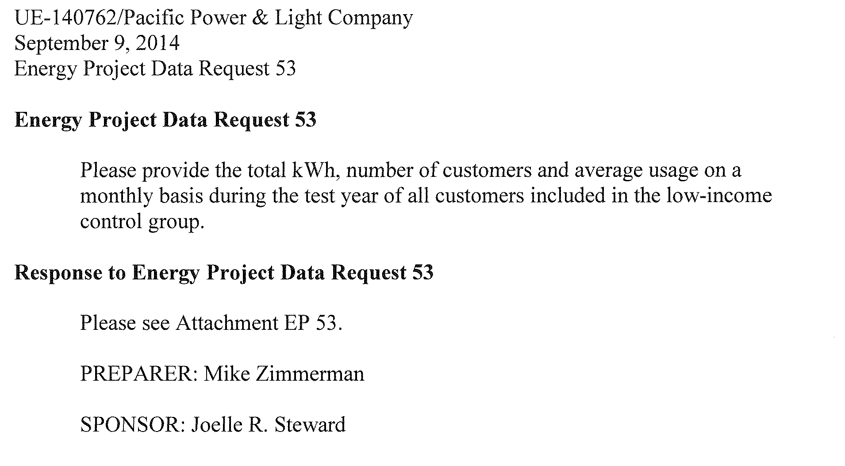

Attachment EP 53

|  |  |  |  |  |
| --- | --- | --- | --- | --- |
| Low Income Proxy Group | |  |  |  |
|  |  |  |  |  |
|  |  |  |  | Average |
|  |  |  |  | Monthly Usage |
| Year/month | KWH | Customers |  | kWh |
| 201301 | 13,306,054 | 6,064 |  | 2,194 |
| 201302 | 11,564,611 | 6,095 |  | 1,897 |
| 201303 | 9,313,005 | 6,105 |  | 1,525 |
| 201304 | 7,068,580 | 6,072 |  | 1,164 |
| 201305 | 5,771,193 | 6,043 |  | 955 |
| 201306 | 5,142,205 | 6,006 |  | 856 |
| 201307 | 5,804,030 | 5,986 |  | 970 |
| 201308 | 6,310,325 | 5,913 |  | 1,067 |
| 201309 | 5,654,641 | 5,859 |  | 965 |
| 201310 | 5,303,147 | 5,805 |  | 914 |
| 201311 | 7,060,968 | 5,747 |  | 1,229 |
| 201312 | 12,398,671 | 5,684 |  | 2,181 |
| Grand Total | 94,697,430 | 71,379 |  | 1,327 |