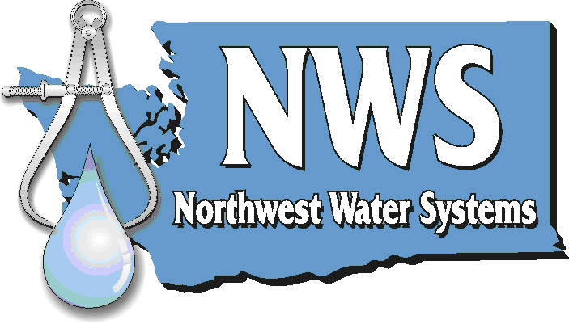

**Planning • Management • Engineering**

**P.O. Box 123 • Port Orchard, WA 98366 • 888-881-0958 • 360-876-0958**

December 21st, 2010

Country Meadows East #2 Customers

Re: **IMPORTANT NOTICE OF REQUEST FOR RATE INCREASE**

Country Meadows East #2 (CME#2) has filed for approval from the Washington Utilities and Transportation Commission (commission) of a rate increase. If approved, the rates shown on the second page of this notice will be effective on February 1st, 2011.

**Overall impact of rate increase**

The overall system annual revenue must increase by 96% to meet the operating costs of the water system. The increases are due to increased fees, operations, and management costs, as well as a more complete accounting of the costs associated with operating the water system.

The water system delivers treated water. The costs of treatment are proportional to the water supplied; therefore CME#2 will adopt a usage based billing system. This will change the billing structure so that the heaviest users will pay an equitable portion of the system’s cost. The rate structure that is proposed is designed to establish an average water bill of $68.40 per month. The change in individual bills will vary depending on usage.

If you have questions about the proposed rate increase, or any other questions regarding the water system, please contact Northwest Water Systems, Inc. at (360)876-0958 or toll free (888)881-0958.

The commission has the authority to set final rates that may be either lower or higher from the company’s request, depending on the results of its investigation. Commission staff will make a recommendation to the commissioners at an open meeting in Olympia, which is scheduled for 9:30 a.m. on January 27th, 2011. You will have an opportunity to comment in person at this meeting. If you are unable to attend the open meeting, the commission has a bridge line, which enables you to participate or listen by telephone. Call 360-664-1234 for instructions the day before the open meeting. You can also comment by using the “Public Comment” feature at the commission’s web site at ‘utc.wa.gov’, or by using the contact information below.

Washington Utilities and Transportation Commission

1300 S. Evergreen Park Drive SW

P.O. Box 47250, Olympia, WA 98504-7250

E-mail: [comments@utc.wa.gov](mailto:comments@utc.wa.gov)

Telephone: 1-888-333-WUTC (9882)

Current and proposed rates are on the back of this notice.

Sincerely,

NORTHWEST WATER SYSTEMS, INC.

**Rates Filed with Tariff**

**Proposed Metered Service Charges:**

|  |  |  |  |  |  |  |  |  |
| --- | --- | --- | --- | --- | --- | --- | --- | --- |
| **Meter Size** | **Meter Size Factor** | **Base Rate** | **1st Block (gal.)** | **1st Usage Rate** | **2nd Block (gal.)** | **2nd Usage Rate** | **3rd Block (gal.)** | **3rd Usage Rate** |
| ¾-inch | 1 | $28.75 | 0 – 10,000 | $2.50 | 10,001 – 40,000 | $3.00 | Over 40,000 | $3.50 |

Comparison of new rates to old:

|  |  |  |
| --- | --- | --- |
| Product or Service | Old Rate | New Rate |
| Flat Rate Service | $34.83 | $68.40 |
| Metered Rate | Not Available | See Table Above |
| Ready To Serve Service | Not Available | $28.75 |
| Service Connection Charge (3/4” service) | Not Available | $750.00 |
| New Service Meter assembly (including meter) | Not Available | $500.00 |
| Cross Connection Control | Not Available | By Customer 3rd party contractor |
| Public Utility Tax |  | 5.029% |
| Disconnection Visit Charge | $50.00 | $85.00 |
| Reconnection Visit Charge | $50.00 | $85.00 |
| Service Visit Charge |  | $85.00 |
| Late Payment Charge of Unpaid Balance or Minimum Charge | 2% or $1.00 minimum | 2% or $1.00 minimum |
| Account Set-up Charge | $30.00 | $40 |
| NSF Charge (each check) | $25.00 | $40 |
| Water Availability Letter Charge | $50.00 | $50 |
| Backflow Assembly Testing and Inspection | Not Available | By Customer 3rd party contractor |
| Damage and Repairs Charge | Not Available | By Customer 3rd party contractor |