Report to the Washington Utilities and Transportation Commission

## Electric Service Reliability - Major Event Report

# Event Date: November 25-26, 2015

Date Submitted: January 27, 2016

Primary Affected Locations: Yakima

Primary Cause: Windstorm

Exclude from Reporting Status: Yes

Report Prepared by: April Brewer

Report Approved by: Heide Caswell / David O’Neill / Steve Henderson / Kevin Putnam

**Event Description**

On November 25, 2015, the Yakima area experienced a highly localized wind event. Wind gusts were so strong they broke poles at the ground level, taking down facilities, including a two-pole regulator bank structure, four adjacent pole structures (2-pot bank pole; single transformer pole; tangent pole and single phase tap pole) and damaged crossarms on 2 additional poles. The damaged facilities involved a double-circuit distribution feeder served out of the Hopland Substation.

|  |  |
| --- | --- |
| **Event Outage Summary** | |
| **# Interruptions (sustained)** | 8 |
| **Total Customer Interrupted (sustained)** | 4,622 |
| **Total Customer Minutes Lost** | 2,086,025 |
| **State Event SAIDI Impact** | 15.19 Minutes |
| **CAIDI** | 451 |
| **Major Event Start** | 11/25/15 1:16pm |
| **Major Event End** | 11/26/15 1:16pm |

**Wind Gust November 24-26, 2015**

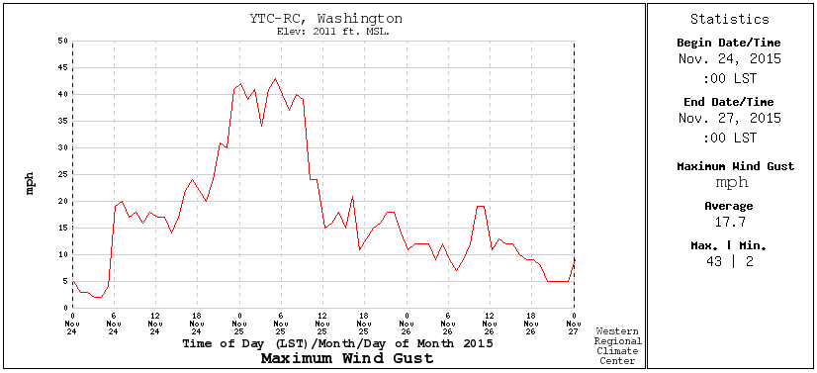 http://www.raws.com

**Restoration Summary**

The event began at 1:16 pm, causing a loss of power to 3,106 customers. Emergency action support (which involves management, logistics, and enables shifting of resources rapidly) was brought into the response actions immediately and all local crews were immediately re-deployed to support the restoration and reconstruction. Over 30 employees supported the major event, including flaggers, logistics, substation operations, and engineers. Additional crews from Hood River, Pendleton, Walla Walla, and Portland were called in to assist with the restoration. At approximately 4:20 pm crews were able to isolate part of the outage enabling restoration of power to 1,496 customers. Personnel worked through the night in below-freezing temperatures to complete repairs. Restoration of the remaining 1,610 customers was completed between 7:04 am and 7:47 am the following morning. An additional planned emergency damage repair outage occurred between 6:17 am and 7:04 am for the 1,496 customers whose power had been restored the previous day. Additional work and cleanup continued until 1pm that afternoon.

There were no company or commission customer complaints made regarding the major event.

**Restoration Intervals**

|  |  |  |  |
| --- | --- | --- | --- |
| **Total Customers Sustained** | **< 3 Hrs.** | **3 - 24 Hrs.** | **24+ Hrs.** |
| **4,622** | 1,495 | 3,127 | 0 |

**Restoration Resources**

|  |  |
| --- | --- |
| **Personnel Resources** | |
| **Journeyman** | 24 |
| **Collectors** | 2 |
| **Estimators** | 1 |
| **General Foreman** | 1 |
| **Other** | 3 |
| **TOTAL** | **31** |

|  |  |
| --- | --- |
| **Materials** | |
| **Poles** | 3 |
| **Crossarms** | 1 |
| **Transformers (pole mounted)** | 1 |
| **Transformer platform** | 1 |
| **Switches (bypass)** | 1 |
| **Cutouts** | 1 |
| **Insulators** | 16 |
| **Line regulator** | 1 |
| **Lightning arrestor** | 4 |

**State Estimated Major Event Costs**

|  |  |  |  |
| --- | --- | --- | --- |
|  | **Labor** | **Materials** | **Total** |
| **Estimate $** | $61,030 | $66,220 | $127,250 |

**Major Event Declaration**

Pacific Power is requesting designation of this event and its consequences to be classified as a “Major Event” for exclusion from network performance reporting with the IEEE 1366-2003. This major event exceeded the company’s current Washington threshold of 1,299,474 customer minutes lost (9.46 state SAIDI minutes) in a 24-hour period.

**Event Detail**

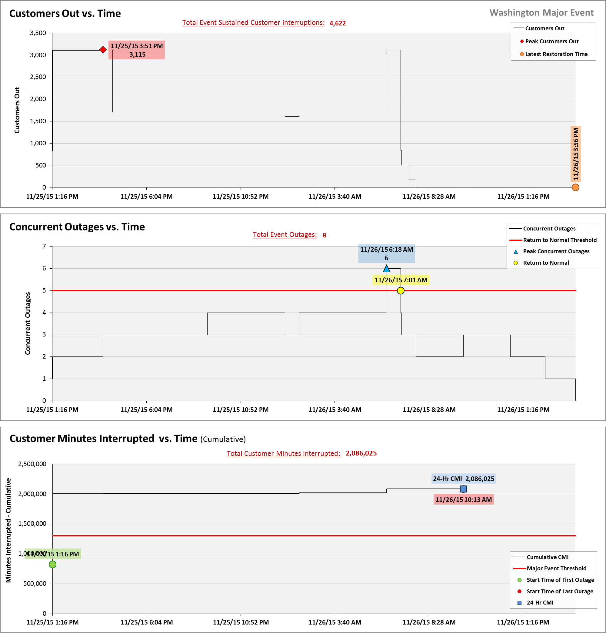

**SAIDI, SAIFI, CAIDI by Reliability Reporting Region**

Please see the attached system-generated reports.