INTERCONNECTION OF ELECTRIC GENERATING FACILITIES

For Generating Facilities up to 20 MW

Interconnecting to the Electrical Distribution System

Chapter 1 - Purpose and Scope**.**

1. The purpose of this chapter is to establish rules for determining the terms, conditions, technical requirements, processes and charges governing the interconnection of electric generating facilities with a nameplate rating of no greater than 20 Megawatts to the electric distribution system of a utility over which the Commission (Governing Board) has jurisdiction.
2. These rules govern the terms and conditions under which the applicant's generating facility will interconnect with, and operate in parallel with, the utility's electric system. These rules apply only to the physical interconnection of a generating facility to a utility’s electrical system. They do not govern, or grant the right to sell or purchase, or deliver any power generated by the applicant's generating facility.
3. The specifications and requirements in these rules are intended to mitigate possible adverse impacts caused by a generating facility on utility equipment and personnel and on other customers of the utility. They are not intended to address protection of the Interconnection Customer’s generating facility, facility personnel, or internal load. It is the responsibility of the Interconnection Customer to comply with the requirements of all appropriate standards, codes, statutes and authorities to protect its own facilities, personnel, and loads.

# Chapter 2 - Application of Rules

1. These rules include various requirements applicable to the utility, the applicant, the Interconnection Customer and the generating facility.
2. These rules modify, if necessary, any existing interconnection rules of the utility, including but not limited to, rules implementing chapter 80.60 RCW, Net Metering of Electricity.
3. These rules do not apply to interconnection of standby or backup generators that are not intended to operate in parallel with a utility’s system. Such interconnections will be negotiated on a case-by-case basis with the utility and such generators shall only be interconnected on terms and conditions prescribed by the utility.

# Chapter 3 - Definitions

**"Applicant"** means any person, corporation, partnership, government agency, or other entity applying to interconnect a generating facility to the utility's electric system pursuant to this chapter. Upon final approval, interconnection and operation of a facility, the applicant becomes the Interconnection Customer, unless otherwise approved by the utility.

**"Application"** means the written notice, on a form prescribed by the utility, provided by the applicant to the utility that initiates the interconnection process.

“**Automatic sectionalizing device**” means equipment which operates to change the topology of the electrical system (usually in response to abnormal conditions) without operator intervention. Generally this does not include fused cutouts on lateral taps serving a few customers. **“Business day”** means Monday through Friday excluding official federal and Washington state holidays.

**"Certificate of completion"** means the form prescribed by the utility and completed by the applicant or Interconnection Customer. The certificate of completion shall include certification by the electrical inspector having jurisdiction over the installation of the facilities indicating completion of installation and inspection of the interconnection.

**"Commission"** means the Washington Utilities and Transportation Commission

**"Electric system"** means all electrical wires, equipment, and other facilities owned or provided by the utility that are used to distribute electricity to customers.

For UTC rule only “**Electrical Company**” means any public service company, as defined by RCW 80.04.010, engaged in the generation, distribution, sale or furnishing of electricity and subject to the jurisdiction of the commission

**"Generating facility"** means the source of electricity and all ancillary and interconnection facilities, located on the applicant’s or Interconnection Customer’s side of the point of common coupling which an applicant requests to interconnect, or an Interconnection Customer interconnects to the utility's electric system.

“Governing Board” means_______

**"Grid network distribution system"** means electrical service from a distribution system consisting of two or more primary circuits from one or more substations or transmission supply points arranged such that they collectively feed secondary circuits serving more than one location and more than one utility customer.

**"Initial operation"** means the first time the generating facility is in parallel operation with the utility’s electric system.

**"In-service date"** means the date on which the generating facility and any related facilities are complete and ready for service, even if the generating facility is not placed in service on or by that date.

**"Interconnection"** means the physical connection of a generating facility to the electric system so that parallel operation may occur.

**“Interconnection Agreement”** means an agreement between a utility and the interconnection customer which outlines the interconnection requirements, costs and billing agreements, and on-going inspection, maintenance and operational requirements. An executed interconnection agreement is required before the generating facility may generate electricity into and operate in parallel with a utility’s electric system. Contents of an interconnection agreement may vary based upon the tier under which the generating facility applies and is qualified for interconnection. The utility may establish model interconnection agreement(s). In the case where the Interconnection Agreement does not constitute an agreement with the utility to purchase or deliver output from the Generating Facility, the Interconnection Customer is responsible for separately making all necessary agreements for the purchase, sale, or transport of electricity from the utility.

**“Interconnection Customer”** means the person, corporation, partnership, government agency, or other entity that has executed an Interconnection Agreement with the utility and: 1. that owns a generating facility interconnected to the utility’s electric system; 2. for net-metered facilities, is a customer-generator as defined in RCW 80.60.010(2); or 3. that is otherwise allowed by law. The interconnection customer is responsible for the generating facility, and may assign to another party responsibility for compliance with the requirements of this rule only with the express written permission of the utility.

**"Interconnection facilities"** means the electrical wires, switches and other equipment used to interconnect a generating facility to the utility’s electric system.

**"Model interconnection agreement"** means standardized terms and conditions that govern the interconnection of generating facilities pursuant to these rules. The model interconnection agreement may be modified to accommodate terms and conditions specific to individual interconnections, subject to the conditions set forth in these rules.

**"Net metering"** has the same meaning as RCW 80.60.010(9)

**“Nameplate rating”** means the manufacturer’s output rating of the generating facility. For a system which uses an inverter to change DC energy supplied to an AC quantity, the nameplate rating will be the DC rating of the storage system or energy conversion apparatus (e.g. photovoltaic panels).

**"Parallel operation"** or **"operate in parallel"** means the synchronous operation of a generating facility while interconnected with a utility's electric system.

**"Point of common coupling"** or **"PCC"** means the point where the generating facility's local electric power system connects to the utility's electric system, such as the electric power revenue meter or at the location of the equipment designated to interrupt, separate or disconnect the connection between the generating facility and utility.

**"Spot network distribution system"** means electrical service from a distribution system consisting of two or more primary circuits from one or more substations or transmission supply points arranged such that they collectively feed a secondary circuit serving a single location (e.g., a large facility or campus) containing one or more utility customer(s).

“Utility” means an electrical company [Consumer owned utilities – delete the words “electrical company” and insert the name of your utility here] which owns and operates the electrical distribution system, or the electrical distribution system itself, onto which the applicant seeks to interconnect a generating facility, and with which an Interconnection Customer has an Interconnection Agreement.

## Chapter 4 - Application for Interconnection

1. A standard application form shall be made available on the utility’s web site and, where practicable, allow for electronic submission.
2. When an applicant requests interconnection from the utility, the applicant shall be responsible for conforming to the rules and regulations that are in effect and on file with the utility. The utility will designate a point of contact and publish a telephone number or web site address for the purpose of providing information concerning applicable rules and regulations. The applicant seeking to interconnect a generating facility under these rules must fill out and submit, electronically or otherwise, a signed application form to the utility. Information must be accurate, complete, and approved by the utility; however approval of the application as complete does not constitute approval to interconnect.

1. If a project is to be installed in a phased manner, the applicant may choose to submit application for approval of the final project size, or may choose to submit applications at each stage of the project. Each application will be evaluated based on the nameplate rating stated on the application.
   1. If the final project size is applied for and the requirements are met, then the applicant must notify the utility as additional units are added.
   2. If applications are submitted for different stages of a project, the size may not be increased beyond that approved.
2. **Application processing charge**. The nonrefundable interconnection application processing charge is set by the utility according to facility size (or tiers in this rule) and shall be:
   1. 0 – 25 kW _____________.
   2. 26 – 500 kW ___________.
   3. 501 kW – 20 MW________.
3. **Non-Discrimination**. All generating facility interconnection applications pursuant to this chapter will be processed by the utility in a non-discriminatory manner, consistent with other service requests and in a manner that does not delay other service requests.

1. **Application evaluation**. All generating facility interconnection requests pursuant to this chapter will be reviewed by the utility for compliance with the rules of this chapter. If the utility in its sole discretion finds that the application does not comply with this chapter, the utility may reject the application. If the utility rejects the application, it shall provide the applicant with written or electronic mail notification stating its reasons for rejecting the application.

# Chapter 5 – Project Tiers, Related Procedures and Technical Requirements

Because most utility distribution systems were not originally designed with the intent of interconnecting generating facilities, the impacts of such an interconnection, if not carefully managed, can be detrimental to the safe and reliable operation of the system. Unless specifically permitted by the utility, generating facilities are not allowed to operate in an “islanded” condition (generating energy that flows onto the utility system) with other utility customers when the portion of the utility system serving the generating facility is de-energized.

In order to facilitate the interconnection process for both the applicant and the utility, these rules classify interconnections based on shared characteristics. Because smaller facilities with appropriate interconnection technologies are expected to have a much lower impact on the utility’s system, expedited processes and standardized interconnection requirements are applied to these interconnections. Larger generating facilities using different generating and interconnection technologies can have more significant impacts on the utility’s system, such that more in-depth review is required and additional technical requirements may apply.

Tiers 1, 2, and 3 listed below contain initial applicability tests that will determine which tier process an applicant and utility will utilize, along with process descriptions, technical requirements and completion criteria for each Tier. For Tier 3 facilities, a list of studies and other requirements are included. Additionally, all facilities must meet the appropriate requirements of Chapter 6, General Terms, Conditions, and Technical Specifications, and the rules and standards adopted by reference in Chapter 8.

Note that the interconnection requirements listed are for protection of the utility system. The applicant and Interconnection Customer are responsible for providing protection for their own equipment; typically, these are two very different sets of functions.

**Attachment 1** contains a flow chart describing the applicability for the Tier Process.

## Tier 1

### Tier 1 - Applicability

Interconnection of a generating facility will utilize Tier 1 processes and technical requirements if the proposed generating facility meets all of the following:

1. Uses inverter-based interconnection equipment which is certified by an independent, nationally recognized testing laboratory to meet the requirements of UL1741;
2. Is single phase and has a nameplate rating of 25 kW or less;
3. Is connected through a single phase transformer on a radial distribution circuit;
4. Is proposed for interconnection at secondary voltages (600 V class);
5. Does not require construction of new or upgrade of existing utility facilities, other than meter changes;
6. If proposed to be interconnected on single-phase shared secondary, the aggregate generating capacity on the shared secondary, including the proposed generating facility, shall not exceed the lesser of the service wire capability or the nameplate of the transformer;
7. If proposed to be interconnected on a center tap neutral of a 240 volt service, its addition shall not create an imbalance between the two sides of the 240 volt service of more than 5 kVA; and
8. The aggregated nameplate rating of all interconnected generating facilities, including that of the proposed generating facility, on any line section does not exceed 15 % of the line section annual peak load as most recently measured or calculated for that  line section, or 15% of the circuit annual peak load as most recently measured or calculated for the circuit.  A line section is that portion of a utility’s electric system connected to the generating facility and bounded by automatic sectionalizing devices or the end of the distribution line.

### Tier 1 - Application Process

The following application timelines are intended to be consistent with, and not cause delays in, other service request applications of the utility.

1. Notice of receipt of an application shall be sent by the utility to the applicant by electronic mail within 5 business days if the applicant provides and electronic mail address; otherwise no notice of receipt will be provided to the applicant.
2. Response to application completeness or incompleteness will be provided to applicant within 10 business days after notice of receipt of application and will identify areas of deficiency.
3. When an incomplete application notice is sent to an applicant, the applicant shall provide a complete application to the utility within 60 business days of the notice of incomplete application. The utility may, but is not required to grant an extension beyond the 60 days notice of an incomplete application. After the end of the incomplete application period an application expires.
4. Within 20 business days after a complete application notice is sent to an applicant, the utility shall make its best effort to approve, approve with conditions, or deny the application with written justification. If delays will result due to unforeseen circumstances, customer variance requests, or other incentive program approval requirements, the customer will be notified.
5. An applicant has one year from the date of approval of the application to interconnect and begin operation of the generating facility, or the application expires, unless extended by the utility in writing. Such extension shall be at the utility’s sole discretion. Denied applications automatically expire on the one year anniversary of the approval of the application unless extended.

### Tier 1 - Technical Requirements

The purpose of the protection required for Tier 1generating facilities is to prevent islanding and to ensure that inverter output is disconnected when the utility source of electricity is de-energized. Inverters certified by an independent nationally recognized testing laboratory to meet the requirements of UL1741 must use undervoltage, overvoltage, and over/under frequency elements to detect loss of utility power and initiate shutdown.

An interrupting device must be provided which is capable of safely interrupting the maximum available fault current (typically the maximum fault current is that supplied by the utility).

The generating facility must operate within the voltage and power factor ranges specified by the utility. Variance may be allowed based on specific requirements, and charges may be incurred for losses.

Visible lockable disconnect

1. Except as provided in subsections c, d and e of this section, the generating facility must include a UL listed AC disconnect switch, accessible to utility personnel at any time of the day, that provides a visible break, is lockable in the open position, and is located between the production meter and the sub-panel or other connection to the generating facility.
2. The utility shall have the right to disconnect the generating facility at the disconnect switch to meet utility operating safety requirements.
3. At the utility’s sole discretion, an Interconnection Customer installing and operating inverter-based systems less than 5 kW in nameplate rating that are interconnected through a self contained socket-based meter of 320 amps or less may not be required to install a visible, lockable AC disconnect switch.
4. To maintain utility operating and personnel safety in the absence of an external disconnect switch, the Interconnection Customer shall agree that the utility has the right to disconnect electric service through other means if the generating facility must be physically disconnected for any reason, without liability to the utility. These other actions to disconnect the generating facility (due to an emergency or maintenance or other condition on the utility’s system) will result in loss of electrical service to the customer’s facility or residence for the duration of time that work is actively in progress. This duration of outage may be longer than it would otherwise have been with an AC disconnect switch. If the Interconnection Customer is a different entity than the electric utility customer receiving service through the meter that may be used for disconnection or that may have a loss of electric service due to a need to disconnect the generating facility, the Interconnection Customer shall obtain these agreements and permissions from all other entities affected by such disconnection.
5. In the absence of an external disconnect switch, the Interconnection Customer is required to operate and maintain the inverter in accordance with the manufacturer’s guidelines, annually test the performance of the inverter, and retain documentation demonstrating compliance. Interconnection Customer further agrees that in the absence of such documentation, and at the Interconnection Customer’s expense, to allow the utility, at the utility’s sole discretion, to test, or cause to be tested, the inverter to ensure its continued operating and protection capability. Should the inverter fail the performance test, the utility may disconnect the generating facility without notice, and may require at Interconnection Customer’s expense either replacing the inverter or installation of a visible lockable AC disconnect switch as described in subsection (a), or both, and charge the Interconnection Customer for any reconnection and other utility costs.

### Tier 1 - Completion Process

The interconnection process is complete, the generating facility can begin operation, and the applicant becomes the Interconnection Customer if and only if:

1. The applicant and the utility execute an Interconnection Agreement;
2. The certificate of completion showing inspection of the system by the electrical inspector having jurisdiction over the installation has been provided to the utility;
3. All documentation demonstrating compliance with these interconnection requirements has been provided to the utility; and
4. The witness test, if required by the utility, is successfully completed; and
5. All requirements and conditions of the Interconnection Agreement have been satisfied and approved by the utility and permission is granted by the utility to proceed with commercial operation.

## Tier 2

### Tier 2 - Applicability

Interconnection of a generating facility will utilize Tier 2 processes and technical requirements if the proposed generating facility meets the following:

1. It does not qualify for Tier 1 interconnection applicability requirements;

1. Has a nameplate rating of 500 kW or less;
2. Is proposed for interconnection to either a radial distribution circuit, or to a spot network distribution circuit limited to serving one customer;
3. Is proposed for interconnection to an electric system distribution facility operated at or below 38 kV class;
4. If an inverter is utilized, the inverter must be certified by an independent, nationally recognized testing laboratory to meet the requirements of UL1741;
5. Is not a synchronous generator;

1. If it is proposed to be interconnected on a shared secondary, the aggregate generating capacity on the shared secondary, including the proposed generating facility, shall not exceed the lesser of the service wire capability or the nameplate of the transformer;

1. Is single-phase and is to be interconnected on a center tap neutral of a 240 volt service, its addition shall not create an imbalance between the two sides of the 240 volt service of more than 5 kW;
2. The aggregated nameplate rating of all interconnected generating facilities, including that of the proposed generating facility, on any line section does not exceed 15 % of the line section annual peak load as most recently measured or calculated for that  line section, or 15% of the circuit annual peak load as most recently measured or calculated for the circuit.  A line section is that portion of a utility’s electric system connected to the generating facility and bounded by automatic sectionalizing devices or the end of the distribution line;
3. Any upgrades required to the utility’s system must fall within subsection 1 of the Tier 2 Technical Requirements Section;
4. For interconnection of a proposed generating facility to the load side of spot network protectors, the proposed generating facility must utilize an inverter-based equipment package which is certified by an independent, nationally recognized testing laboratory to meet the requirements of UL1741 and, together with the aggregated other inverter-based generating facilities, shall not exceed the smaller of 5 % of a spot network's maximum load or 50 kW;
5. The aggregated nameplate rating of existing and proposed generating facilities must not contribute more than 10% to the distribution circuit’s maximum fault current at the point on the primary voltage distribution line nearest the point of interconnection;
6. The generating facility’s point of interconnection must not be on a circuit where the available short circuit current, with or without the proposed generating facility, exceeds 87.5% of the interrupting capability of the utility’s protective devices and equipment (including substation breakers, fuse cutouts, and line reclosers);

1. If the generating facility is proposed for interconnection at primary (>600 V class) distribution voltages, the connection of the transformer(s) used to connect the generating to the system must be the utility’s standard connection. This is intended to limit the potential for creating overvoltages on the utility’s system for a loss of ground during the operating time of any anti-islanding functions.
2. For primary-voltage connections to three-phase, three-wire systems, the transformer primary windings must be connected phase to phase.
3. For primary-voltage connections to three-phase, four-wire systems, the transformer primary windings must be connected effectively grounded, phase to neutral.

### Tier 2 - Application Process

The following application timelines are intended to be consistent with, and not cause delays in, other service request applications of the utility

1. Notice of receipt of an application shall be sent by the utility to the applicant by electronic mail within 5 business days if the applicant provides an electronic mail address; otherwise no notice of receipt will be provided to the applicant.
2. Response to application completeness or incompleteness with identified areas of deficiency will be provided to applicant within 20 business days of notice of receipt of application.
3. When an incomplete application notice is sent to an applicant, the applicant shall provide a complete application to the utility within 60 business days of the notice of incomplete application. The utility may, but is not required to grant an extension beyond the 60 business day notice of an incomplete application. Absent a response by the applicant to complete the application, an application expires at the end of the incomplete application period.
4. Within 30 business days after a complete application notice is sent to an applicant, the utility shall make its best effort approve, approve with conditions, or deny the application with written justification. If delays will result due to unforeseen circumstances, customer variance requests, Balancing Authority or transmission provider approvals, or incentive program approval requirements, the customer will be notified.
5. An applicant has one year from the date of approval of the application to interconnect and begin operation of the generating facility, or the application expires, unless extended by the utility in writing at the utility’s discretion. An application automatically expires on the one-year anniversary date of approval.

### Tier 2 - Technical Requirements

In all cases, the interconnection facilities must isolate the generating facility from the utility’s electric system when power is disconnected from its electrical system source, including but not limited to, before any reclosing (automatic or manual) takes place. The Interconnection Customer shall prevent its generating facility equipment from automatically re-energizing the electric system. For inverter-based systems, this requirement is satisfied by compliance with UL 1741 requirements. For non-inverter based systems a separate protection package will be required to meet IEEE 1547 requirements.

1. If the generating facility fails to meet the characteristics for Tier 2 applicability, but the utility determines that the generating facility could be interconnected safely if minor modifications to the transmission or distribution system were made (for example, changing meters, fuses, or relay settings), then the utility may offer the applicant a good-faith, non-binding estimate of the costs of such proposed minor modifications. Modifications are not considered minor under this subsection if the total cost of the modifications exceeds $10,000. If the applicant authorizes the utility to proceed with the minor modifications and agrees to pay the entire cost of the modifications, then the utility may approve the application using Tier 2 processes and technical requirements.
2. For proposed generating facilities 50 kW and greater, three-phase connection is required.
3. No construction of facilities by the utility on its own system shall be required to accommodate the Tier 2 generating facility except as allowed in subsection 1 of this section.
4. For three-phase induction generator interconnections, the utility may, in its sole discretion, specify that ground fault protection must be provided. Use of ground overvoltage or ground overcurrent elements may be specified, depending on whether the utility uses three-wire or effectively grounded four-wire systems.

1. The Interconnection Customer is required to operate and maintain the inverter in accordance with the manufacturer’s guidelines, annually test the performance of the inverter, and retain documentation demonstrating compliance. Interconnection Customer further agrees that in the absence of such documentation, and at the Interconnection Customer’s expense, to allow the utility, at the utility’s sole discretion, to test, or cause to be tested, the inverter to ensure its continued operating and protection capability. Should the inverter fail the performance test, the utility may disconnect the generating facility without notice, and may require either replacing the inverter or installation of a visible lockable AC disconnect switch accessible to utility personnel, or both, and charge the Interconnection Customer for any reconnection and other utility costs.
2. Visible lockable disconnect
3. The generating facility the system must include a UL listed AC disconnect switch, accessible to utility personnel at any time of the day, that provides a visible break, is lockable in the open position, and is located between the production meter and the sub-panel or other connection to the generating facility.
4. The utility shall have the right to disconnect the generating facility at the disconnect switch to meet utility operating safety requirements.
5. The Interconnection Customer is required to test and maintain the inverter in accordance with the manufacturer’s guidelines and retain documentation demonstrating compliance. Interconnection Customer further agrees that in the absence of such documentation, and at the Interconnection Customer’s expense to allow the utility, at the utility’s sole discretion, to test, or cause to be tested, and certify the inverter, to ensure its continued operating and protection capability. Should the inverter not be certified by the utility, the utility may disconnect the generating facility without notice, may require, at the Customer expense either replacing the inverter or installation of a visible lockable AC disconnect switch as described in subsection (i) of this section, or both, and charge the Interconnection Customer for any reconnection and other utility costs.

### Tier 2 - Completion Process

The interconnection process is complete, the generating facility can begin operation, and the applicant becomes an Interconnection Customer, if, and only if:

1. The applicant and the utility execute an Interconnection Agreement;
2. The certificate of completion showing inspection of the system by the electrical inspector having jurisdiction over the installation has been provided to the utility;
3. All documentation demonstrating compliance with the technical requirements for interconnection has been provided to the utility;
4. All required agreements with the Balancing Authority having jurisdiction, and all agreements covering the purchase, sale or transport of electricity and provision of any ancillary services have been completed and signed by all parties;

1. The witness test, if required by the utility, is successfully completed; and
2. All requirements and conditions of the Interconnection Agreement have been satisfied and approved by the utility with permission granted by the utility to proceed with commercial operation.

**Tier 3**

The Tier 3 Application, Approval and Completion Processes and Technical requirement are necessarily different from Tiers 1 and 2 due to the unique and more complex characteristics of these generating facilities and associated interconnection requirements. Neither the applicant nor the utility should expect streamlining or certainty in the timelines associated with these processes, but both should expect to apply due diligence and good faith in arriving at project approval.

### Tier 3 - Applicability

A utility and applicant will use Tier 3 processes and requirements to interconnect a generating facility if the proposed generating facility does not qualify for Tier 1 or Tier 2.

### Tier 3 - Application Process (still under review by the Workgroup)

1. Notice of receipt of an application[1] shall be sent by the utility to the applicant by electronic mail within 10 business days if the applicant provides an electronic mail address; otherwise no notice of receipt will be provided to the applicant.
2. Response to application completeness or incompleteness with identified areas of deficiency, except for potential studies listed below, will be provided to applicant within 45 business days of receipt of application.
3. When an incomplete application notice is sent to an applicant, the applicant shall provide a complete application to the utility within 75 business days of the notice of incomplete application. The utility may, but is not required to grant an extension beyond the 75 business day notice of an incomplete application. All extensions shall be in writing by the utility. Changes to previously completed information on an application will be considered a new application and shall be accompanied by a new application fee. An application expires at the end of the incomplete application period.
4. A utility will approve a complete application that is complete in all aspects of the application requested from the applicant.
5. After a complete application notice is sent to an applicant, and applicant has accepted and made payment arrangements with the utility for the listed studies, the utility shall make its best effort to complete the required studies, consistent with time requirements for the studies and other service requests of a similar magnitude. Based the results of the studies, the utility and applicant may agree to modify the previously complete application without penalty to the applicant. Such modified application shall be considered an approved final application.
6. The utility will make its best effort to offer an Interconnection Agreement to the applicant within 30 business days of approval of the final application or after completion of all required studies, whichever is later.

1. Other than modifications to the complete application described in subsection 5 of this section, changes by the applicant to a previously approved completed application will be considered a new application and shall be accompanied by a new application fee. Denied applications expire on the date of denial.
2. An applicant has sixty days from the date of approval of the final application to execute an Interconnection Agreement and must begin operation of the generating facility within two years of the effective date of the Interconnection Agreement, or both the application and subsequent Interconnection Agreement automatically expire. Any extension of the two year expiration shall be in writing by the utility, at the utility’s sole discretion.

### Tier 3 - Technical Requirements

1. In all cases, the interconnection facilities must isolate the generating facility from the utility’s electric system when power is disconnected from its electrical system source, including but not limited to, before any reclosing (automatic or manual) takes place. The Interconnection Customer shall prevent its generating facility equipment from automatically re-energizing the electric system.
2. The system design must be such that no single point of failure shall lead to loss of protective functions. This can be achieved by installing multiple discrete-function relays providing the required functions as a set, or by installing redundant multi-function devices, each of which provides all of the required functions.
3. Ground fault protection must be provided, unless waived by the utility in writing. Use of ground overvoltage or ground overcurrent elements may be specified, depending on whether the utility uses three-wire or effectively grounded four-wire systems.

Breaker failure detection must be provided, and secondary action initiated in the event that the interconnection breaker fails to clear for the trip condition, consistent with utility practice. This may require installation of dual generator breakers tripped by similar interconnection relays, or a main and backup relay with the same functions and zones of protection, one of which trips the generator breaker and one which trips the main incoming breaker.

1. In addition, the utility will evaluate the application for interconnection and may require at the applicant’s cost any of the following studies prior to final approval of the application. Additional studies, beyond those on this list, may be necessary as determined by the utility. An estimate of the costs for completing each or all of the studies will be provided by the utility and a deposit against that cost or other payment arrangement with the utility will be required. The applicant may request that studies be combined.

* Feasibility Study
* System Impact Study
* Facilities Study

These studies are intended to quantify the impacts of the generating facility on the utility system, and may include analysis of the following.

* Power flow
* Stability
* Metering
* Relay/Protection
* Communications/Telemetry

Acceptance of the results of these analyses by the applicant will be required as a condition of final approval of the application and provide the basis for the detailed technical requirements for interconnection.

### Tier 3 - Completion Process

The interconnection process is complete, the generating facility can begin operation, and the applicant becomes an Interconnection Customer, if, and only if:

1. The applicant and the utility execute an Interconnection Agreement;
2. The certificate of completion showing inspection of the system by the electrical inspector having jurisdiction over the installation has been provided to the utility;
3. All documentation demonstrating compliance with the technical requirements for interconnection has been provided to the utility;
4. All required agreements with the Balancing Authority having jurisdiction and all agreements covering the purchase, sale or transport of electricity and provision of any ancillary services have been completed and signed by all parties;

1. The witness test, if required by the utility, is successfully completed; and

1. All requirements and conditions of the Interconnection Agreement have been satisfied and approved by the utility, and permission is granted by the utility to proceed with commercial operation.

# Chapter 6 - General Terms, Conditions and Technical Requirements for All Interconnections.

The terms and conditions, and technical requirements in this section shall apply to the applicant and Interconnection Customer and their generating facility throughout the generating facility’s installation, testing, commissioning, operation, maintenance, decommissioning and removal. The utility may verify compliance at any time, with reasonable notice.

Any generating facility proposing to be interconnected with the utility's electric system or any proposed change to a generating facility that requiring modification of an existing interconnection agreement must meet all applicable terms, conditions and technical requirements as set forth in the appropriate Tiers and this chapter and the regulations and standards adopted by reference in Chapter 8.

The terms, conditions and technical requirements in this section are intended to mitigate possible adverse impacts caused by the generating facility on utility equipment and personnel and on other customers of the utility. They are not intended to address protection of the generating facility itself, generating facility personnel, or its internal load. It is the responsibility of the generating facility to comply with the requirements of all appropriate standards, codes, statutes and authorities to protect its own facilities, personnel, and loads.

1. The applicant and Interconnection Customer shall comply with and are responsible for the generating facility meeting the requirements in (a), (b) and (c) of this subsection. However, at its sole discretion, the utility may approve, in writing, alternatives that satisfy the intent of, and/or may excuse compliance with, any specific elements of these requirements except local, state and federal building codes.
   1. **Codes and standards.** Among these are the National Electric Code (NEC), National Electric Safety Code (NESC), the Institute of Electrical and Electronics Engineers (IEEE), American National Standards Institute (ANSI), and Underwriters Laboratories (UL) standards, and local, state and federal building codes. The Interconnection Customer shall be responsible for obtaining all applicable permit(s) for the equipment installations on its property.
   2. **Safety**. All safety and operating procedures for joint use equipment shall be in compliance with the Occupational Safety and Health Administration (OSHA) Standard at 29 CFR 1910.269, the NEC, Washington Administrative Code (WAC) rules, the Washington Division of Occupational Safety and Health (DOSH) Standard, and equipment manufacturer's safety and operating manuals.
   3. **Power quality**. Installations will be in compliance with all applicable standards including IEEE Standard 519 Harmonic Limits, or more stringent harmonic requirements of the utility.
2. Any electrical generating facility must comply with these rules to be eligible to interconnect and operate in parallel with the utility's electric system. These specifications and standards shall apply to all interconnecting generating facilities that are intended to operate in parallel with the utility's electric system irrespective of whether the applicant intends to generate energy to serve all or a part of the applicant's load; or to sell the output to the utility or any third party purchaser.
3. In order to ensure system safety and reliability of interconnected operations, all interconnected generating facilities shall be constructed, operated and maintained by the Interconnection Customer in accordance with these rules, with the Interconnection Agreement, with the applicable manufacturer’s recommended maintenance schedule and operating requirements, good utility practice, and all other applicable federal, state, and local laws and regulations.
4. Prior to initial operation, all Interconnection Customers must submit a completed certificate of completion to the utility, execute an appropriate Interconnection Agreement with the utility The Interconnection Agreement between the utility and Interconnection Customer outlines the interconnection standards, cost allocation and billing agreements, insurance requirements, and on-going maintenance and operation requirements.
5. Separate agreements may be required with the utility, the Balancing Area Authority or transmission provider, or other party but not necessarily with the utility, for power purchase, for the sale, delivery and scheduling of output from the generating facility, for integration or other ancillary services. All required agreements must also be executed prior to initial operation.
6. Applicant or Interconnection Customer shall promptly furnish the utility with copies of such plans, specifications, records, and other information relating to the generating facility or the ownership, operation, use, or maintenance of the generating facility, as may be reasonably requested by the utility from time to time.
7. For the purposes of public and working personnel safety, any non-approved generating facility interconnections discovered will be immediately disconnected from the utility system without any liability to the utility. Such disconnection of non-approved interconnection may result in disconnection of electric service to customers of the utility other than the owner of the generating facility.
8. To ensure reliable service to all utility customers and to minimize possible problems for other customers, the utility will review the need for upgrades to its system, including a dedicated transformer. If the utility requires upgrades, the applicant or Interconnection Customer shall pay for all costs of those upgrades.

1. The utility may require, and will provide the reasoning in writing, a transfer trip system or an equivalent protective function for a generating facility, that cannot: 1. Detect distribution system faults (both line-to-line and line-to-ground) and clear such faults within two seconds; or 2. Detect the formation of an unintended island and cease to energize the utility’s distribution system within two seconds.
2. Metering.
   1. **Net metering** for facilities as set forth in chapter 80.60 RCW: The utility shall install, own and maintain a kilowatt-hour meter, or meters as the utility may determine, capable of registering the bi-directional flow of electricity at the point of common coupling at a level of accuracy that meets all applicable standards, regulations and statutes. The meter(s) may measure such parameters as time of delivery, power factor, voltage and such other parameters as the utility shall reasonably require. The applicant shall provide space for metering equipment. It will be the applicant's responsibility to provide the current transformer enclosure (if required), meter socket(s) and junction box after the applicant has submitted drawings and equipment specifications for utility approval. The utility may approve other generating sources for net metering but is not required to do so.
   2. **Production metering**: The utility may require separate metering for production. This meter will record all generation produced and may be billed separately from any net metering or customer usage metering. All costs associated with the installation of production metering will be paid by the applicant.
3. Common labeling, at Interconnection Customer’s expense, furnished or approved by the utility and in accordance with NEC requirements must be posted on meter base, disconnects, and transformers informing working personnel that a generating facility is operating at or is located on the premises.
4. No additional insurance will be necessary for a net metered facility that is a qualifying generating facility under chapter 80.60 RCW. For other generating facilities permitted under these standards but not a qualifying facility under chapter 80.60 RCW, additional insurance, limitations of liability and indemnification may be required by the utility.
5. Prior to any future modification or expansion of the generating facility, the Interconnection Customer will obtain utility review and approval. The utility reserves the right to require the Interconnection Customer, at the Interconnection Customer's expense, to provide corrections or additions to existing electrical devices in the event of modification of government or industry regulations and standards, or major changes in the utility’s electric system which impacts the interconnection.
6. Chapter 80.60 RCW, Net Metering of Electricity, currently allows a utility to limit interconnection of generation for net metering to 0.25% of the utility's peak demand during 1996, increasing to 0.50% on January 1, 2014. However, the utility may, if indicated by engineering, safety or reliability studies, restrict or prohibit new or expanded interconnected net metered generation capacity or number of net metered customers on any feeder, circuit or network.
7. Charges by the utility to the applicant or Interconnection Customer in addition to the application fee, if any, will be compensatory and applied as appropriate. Such costs may include, but are not limited to, transformers, production meters, and utility testing, qualification, studies and approval of non-UL 1741 listed equipment. The Interconnection Customer shall be responsible for any costs associated with any future upgrade or modification to its interconnected system required by modifications in the utility's electric system.
8. This section does not govern the settlement, purchase, sale or delivery of any power generated by applicant's generating facility. The purchase, sale or delivery of power, including net metering of electricity pursuant to chapter 80.60 RCW, and other services that the applicant may require will be covered by separate agreement or pursuant to the terms, conditions and rates as may be from time to time approved by the Commission. Any such agreement shall be complete prior to initial operation and filed with the Commission.
9. Interconnection Customer may disconnect the generating facility at any time; provided that the Interconnection Customer provides reasonable advance notice to the utility.
10. Interconnection Customer shall notify the utility prior to the sale or transfer of the generating facility, the interconnection facilities or the premises upon which the facilities are located. The applicant or Interconnection Customer shall not assign its rights or obligations under any agreement entered into pursuant to these rules without the prior written consent of utility, which consent shall not be unreasonably withheld.
11. All generating facilities must have an electrical permit and pass electrical inspection before they can be connected or operated in parallel with the utility's electric system. Applicant shall provide written certification to the utility that the generating facility has been installed and inspected in compliance with the local building and/or electrical codes.
12. If the Interconnection Customer is a different entity than the owner of the real property on which the generating facility is located, the Interconnection Customer shall indemnify the utility for all risks to the owner of the real property, including disconnection of service. In addition the Interconnection Customer shall obtain all legal rights and easements requested by the utility for the utility to access, install, own, maintain, operate or remove its equipment and the disconnect switch, if installed, on the real property where the generating facility is located, at no cost to the utility.

# Chapter 7 - Filings

The utility shall maintain on file for inspection at its place of business, the charges, terms and conditions for interconnections pursuant to this chapter. Such filing shall include model forms of the following documents and contracts:

1. Application.
2. Model interconnection agreement.
3. Sample Certificate of completion (electrical inspector’s form may be used).

# Chapter 8 - Adoption by Reference

In this chapter, the utility adopts by reference all or portions of regulations and standards identified below. They are available for inspection at the utility’s office or as otherwise indicated. The publications, effective date, references within this chapter, and availability of the resources are as follows:

1. The National Electrical Code is published by the National Fire Protection Association (NFPA).
   1. The utility adopts the version published in 2005 latest is 2011.
   2. The National Electrical Code is a copyrighted document.
   3. Copies are available from the NFPA at 1 Batterymarch Park, Quincy, Massachusetts, 02169 or at internet address http://www.nfpa.org.
2. National Electric Safety Code (NESC).
   1. The utility adopts the version published in 2002 latest is 2012.
   2. Copies of the National Electric Safety Code are available from the Institute of Electrical and Electronics Engineers at http://standards.ieee.org/nesc.
3. Institute of Electrical and Electronics Engineers (IEEE) Standard 1547, Standard for Interconnecting Distributed Resources with Electric Power Systems.
   1. The utility adopts the most recent version adopted by IEEE. Latest is 2008
   2. Copies of IEEE Standard 1547 are available from the Institute of Electrical and Electronics Engineers at http://www.ieee.org/web/standards/home.
4. American National Standards Institute (ANSI) Standard C37.90, IEEE Standard for Relays and Relay Systems Associated with Electric Power Apparatus.
   1. The utility adopts the most recent version is 2005.
   2. Copies of IEEE Standard C37.90 are available from the Institute of Electrical and Electronics Engineers at http://www.ieee.org/web/standards/home.
5. Institute of Electrical and Electronics Engineers (IEEE) Standard 519, Recommended Practices and Requirements for Harmonic Control in Electrical Power Systems.
   1. The utility adopts the version published in 1992 latest.
   2. Copies of IEEE Standard 519 are available from the Institute of Electrical and Electronics Engineers at http://www.ieee.org/web/standards/home.
6. Underwriters Laboratories (UL), including UL Standard 1741, Inverters, Converters, and Controllers for Use in Independent Power Systems.
   1. The utility adopts the version published in 2005 UL has made it virtually impossible to determine publication dates.
   2. UL Standard 1741 is available from Underwriters Laboratory at http://www.ul.com.
7. Occupational Safety and Health Administration (OSHA) Standard at 29 CFR 1910.269.
   1. Copies of Title 29 Code of Federal Regulations are available from the U.S. Government Online Bookstore, http://bookstore.gpo.gov/, and from various third-party vendors.
8. Washington Division of Occupational Safety and Health (DOSH) Standard, chapter 296-155 WAC.
   1. The DOSH Standard is available from the Washington Department of Labor and Industries at P.O. Box 44000, Olympia, WA 98504-4000, or at internet address <http://www.lni.wa.gov>.
9. American National Standards Institute (ANSI)/Institute of Electrical and Electronics Engineers (IEEE) Standard C62.92, IEEE guide for the application of neutral grounding in electrical utility systems.
   1. The utility adopts the version published in 2000.
   2. Copies of IEEE Standard C62.92 are available from the Institute of Electrical and Electronics Engineers at <http://www.ieee.org/web/standards/home>.
10. Institute of Electrical and Electronics Engineers (IEEE) Standard 1453, IEEE Recommended Practice for Measurement and Limits of Voltage Fluctuations and Associated Light Flicker on AC Power Systems
    1. The utility adopts the version published in 2008.
    2. Copies of IEEE Standard 1453 are available from the Institute of Electrical and Electronics Engineers at <http://www.ieee.org/web/standards/home>.

**Attachment 1**

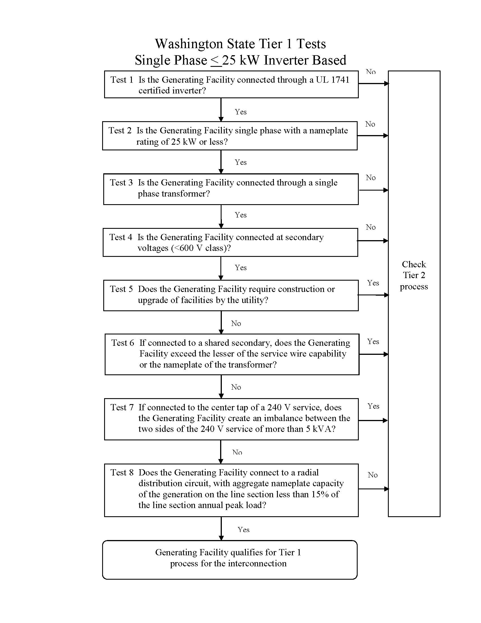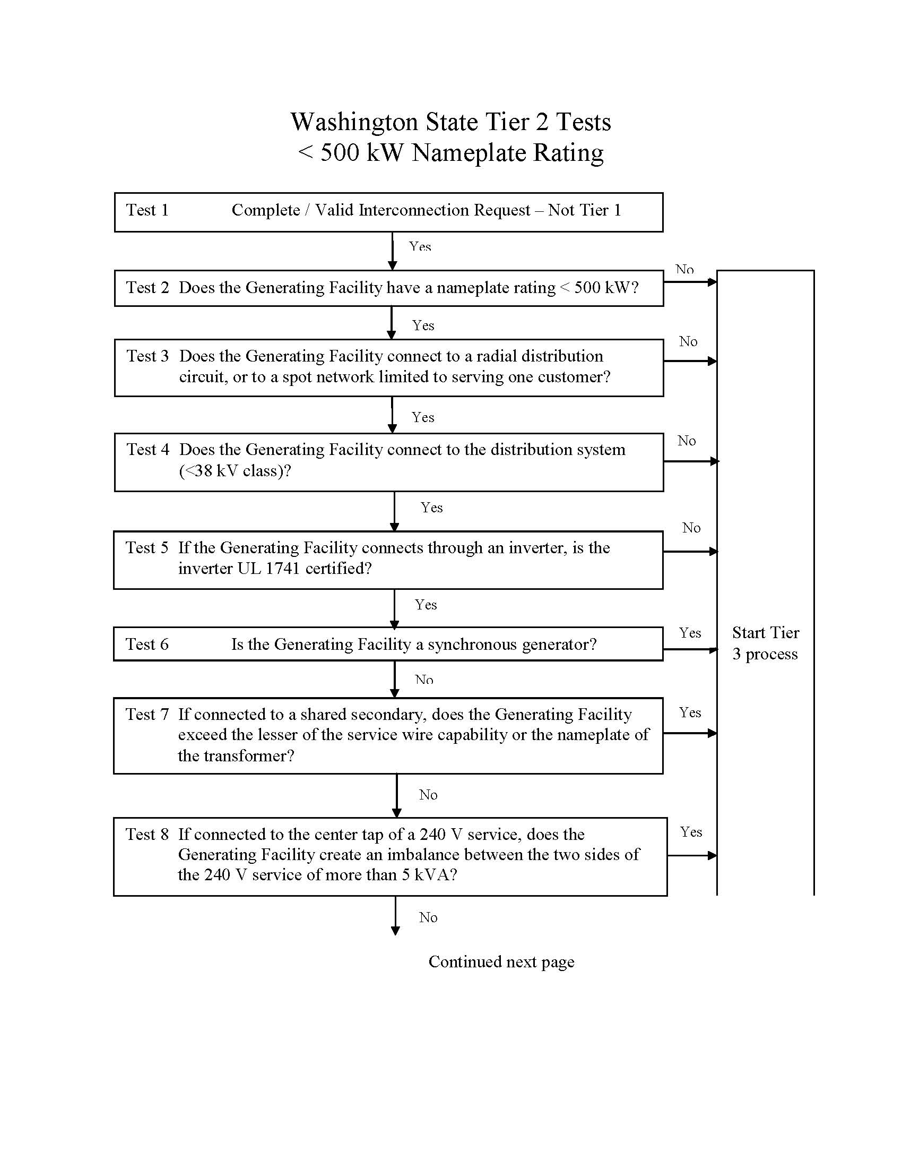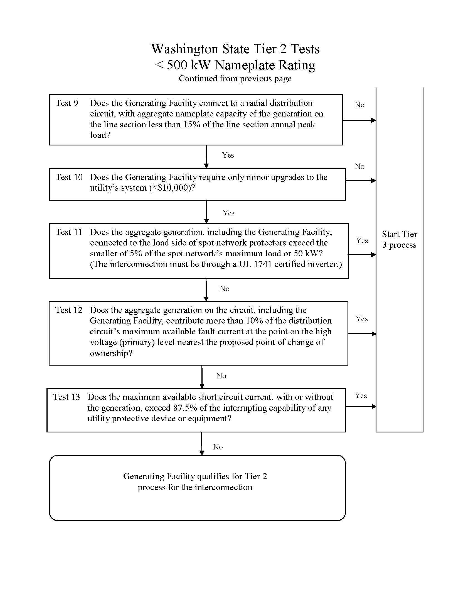

1. If an applicant has applied for interconnection as a Tier 1 or Tier 2 project, and the utility has determined that the application has failed the screen for either or both Tier 1 or Tier 2 and placed it in a Tier 3 process, the clock should be reset for both parties to start the Tier 3 process.