July 28, 2014

Steven V. King, Executive Director and Secretary

Utilities and Transportation Commission

1300 S. Evergreen Park Dr. SW

P.O. Box 47250

Olympia, WA 98504-7250

RE: *Washington Utilities and Transportation Commission v. Bens Moving & Delivery Services, Inc.*

Commission Staff’s Response to Application for Mitigation of Penalties TV-140944

Dear Mr. King:

On June 4, 2014, the Utilities and Transportation Commission issued a $1,000 Penalty Assessment in Docket TV-140944 against Bens Moving & Delivery Services, Inc. for 10 violations of Washington Administrative Code (WAC) 480-15-480, which requires household goods carrier companies to furnish annual reports to the commission no later than May 1 each year.1

On June 12, 2014 Bens Moving & Delivery Services, Inc. submitted a request for a hearing but failed to provide a written statement.2 On July 7, 2014 the commission issued a notice denying the request for hearing, but allowed for opportunity to submit reason(s) in support for application for mitigation within one week of the service date.3 In its Mitigation Request4 which was received by the commission on July 14, 2014, Bens Moving & Delivery Services, Inc. does not dispute that the violation occurred. The company provided a statement regarding financial hardship and foreclosure and claims “nothing to report except our loss”.

It is the company’s responsibility to ensure that the regulatory fee is paid and the annual report is filed by the May 1 deadline. On February 28, 2014, Annual Report packets were mailed to all regulated household goods companies. The instructions for annual report completion page of the annual report informed the regulated company that it must complete the annual report form, pay the regulatory fees, and return the materials by May 1, 2014, to avoid enforcement action.

UTC Annual Reports

July 28, 2014

Page 2

As of July 25, 2014, Bens Moving and Delivery Service, Inc. has yet to file the 2013 Household Goods Annual Report. The company has been active since September 5, 2013. No previous violations of WAC 480-15-480 are on commission record. Due to the significant financial hardship described by the company, staff supports the company’s request for mitigation. Staff recommends a reduced total assessed penalty of $200 with the requirement the completed 2013 Household Goods Annual Report is submission to the commission within ten (10) business days.

If you have any questions regarding this recommendation, please contact Amy Andrews, Regulatory Analyst, at (360) 664-1157, or [aandrews@utc.wa.gov](mailto:aandrews@utc.wa.gov).

Sincerely,

Sondra Walsh, Director

Administrative Services

ATTACHMENT A

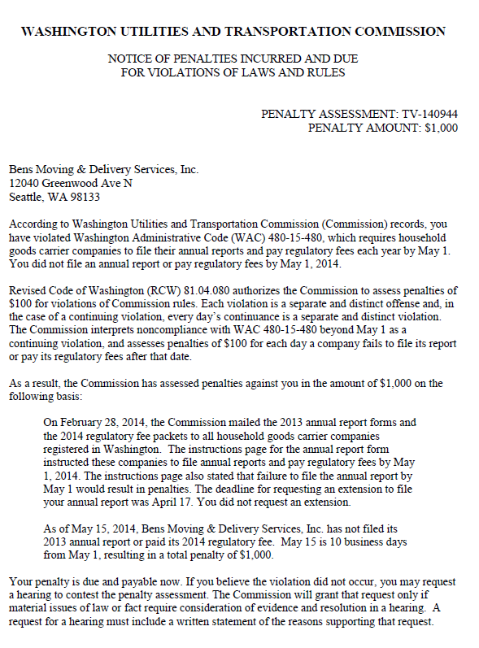

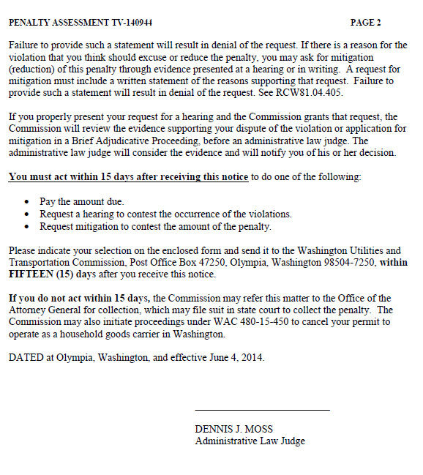

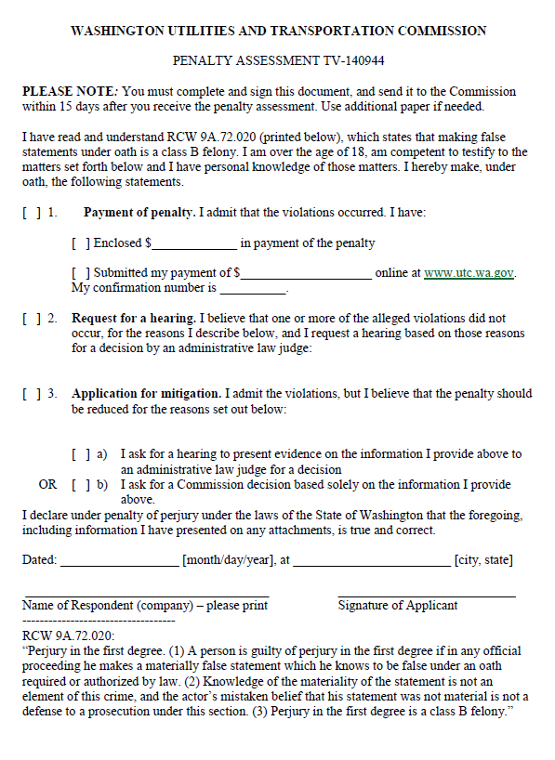

ATTACHMENT B

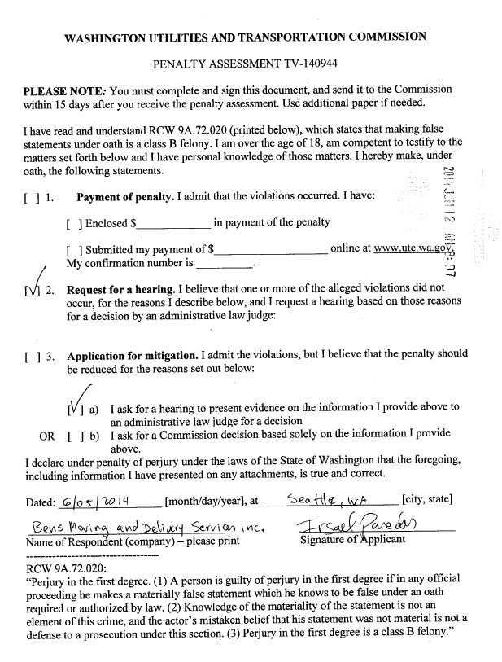

ATTACHMENT C

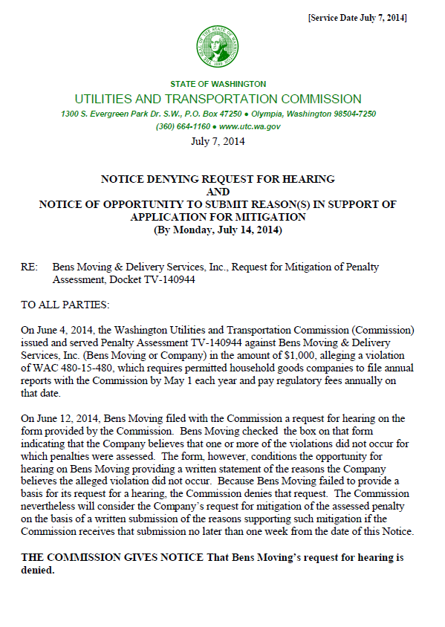

ATTACHMENT D

