

**STATE OF WASHINGTON**

UTILITIES AND TRANSPORTATION COMMISSION

***1300 S. Evergreen Park Dr. S.W., P.O. Box 47250 ● Olympia, Washington 98504-7250***

***(360) 664-1160 ● www.utc.wa.gov***

June 10,2015

Steven V. King, Executive Director and Secretary

Utilities and Transportation Commission

1300 S. Evergreen Park Dr. SW

P.O. Box 47250

Olympia, WA 98504-7250

RE: *Washington Utilities and Transportation Commission v. Tri Valley Construction.*

Commission Staff’s Amended Response to Application for Mitigation of Penalties

Docket DG-144100

Dear Mr. King:

On April 13, 2015, the Utilities and Transportation Commission (commission) issued a $4,000.00 Penalty Assessment in Docket DG-144100 against Greg Huylar, d/b/a Tri Valley Construction (Tri Valley Construction) for three violations of RCW 19.122.030(1)(a), for failing to request a dig ticket prior to performing an excavation on three separate occasions. RCW 19.122.055(1)(a) states, in part, that any excavator who fails to notify a one-number locator service and causes damage to a hazardous liquid or gas facility is subject to a civil penalty of not more than ten thousand dollars for each violation.

On April 28, 2015, Tri Valley Construction wrote the commission requesting mitigation of the penalties. In its mitigation request, Tri Valley Construction identified each violation and gave their reason why the violation should be mitigated. Commission staff has outlined the company’s mitigation request on each violation and has responded below:

**First Violation:** Tri Valley Construction states, in part, that they had a valid locate on file prior to the damage incident and referenced ticket #1319741[1], which was requested on July 30, 2013. Tri-Valley also stated that the digging took place on September 8, 2013, which according to the calendar was a Sunday.

**Staff Response:** RCW 19.122.030(6)(c) states, facility operator's markings of underground utilities expire forty-five calendar days from the date that the excavator provided notice to a one-number locator service. For excavation occurring after that date, an excavator must provide additional notice to a one-number locator service pursuant to subsection (1) of this section.

All records provided by Cascade Natural Gas (CNG) to commission staff indicate the damage to the company’s facilities occurred on Wednesday, September 18, 2013. Staff reviewed locate ticket #13197411, provided by Tri Valley Construction and confirm it was requested on July 30, 2013, making the last day to legally dig on that ticket September 13, 2013. For this reason, staff does not support mitigation of this violation.

**Second Violation:** Tri Valley Construction states, in part, that they were working with the general contractor who requested they dig alongside of some existing power for them to install another conduit. Tri Valley Construction claims they were doing them a “favor” by renting them their excavator and operator so they could get the work done.

**Staff Response:** RCW 19.122.030(1)(a) states in part, before commencing ***any excavation***, an excavator must provide notice of the scheduled commencement of excavation to all facility operators through a one-number locator service. As Tri Valley Construction was the actual excavator, staff does not support mitigation of this violation.

**Third violation:** Tri Valley Construction states, in part, that the line was hit by their subcontractor, Russell Crane Service. Tri Valley Construction additionally states that the violation should go to their subcontractor, especially in light of the second violation in the penalty assessment where they state that they were working under a general contractor.

**Staff Response:** The damage incident on July 2, 2014, was reported to the commission by CNG, and through staff’s investigation was again verified by CNG that the company who damaged their facilities was Tri Valley Construction. CNG informed commission staff that the vehicles on-site at the time of the incident had Tri Valley Construction logos and that the employee they spoke to regarding the damage identified himself as a Tri Valley Construction employee.

Staff also found through a corporations search on the Secretary of State website at www.sos.wa.gov that Russell Crane Service, Inc. and Tri-Valley Construction, Inc. appear to be owned by, and list the same three governing persons: Greg G. Huylar, Joy M. Delorme, and Jodee L. Huylar[2]. As it appears that Tri Valley Construction is attempting to transfer the blame to another company owned by the exact same people who own Tri Valley Construction, staff does not support mitigation of the third violation.

Commission staff finds that the penalty of $1,000 for each violation is appropriate based on consideration of the following factors:

1. **How serious or harmful the violation is to the public.**  The violations are serious and potentially harmful to the public. Companies that dig without first obtaining an underground utility locate are putting their employees, the public and the facility operator’s employees at risk. All three damage incidents could have resulted in fire or an explosion.
2. **Whether the violation is intentional.** Considerations include:
   * Whether the Company ignored Staff’s previous technical assistance; and
   * Whether there is clear evidence through documentation or other means that show the Company knew of and failed to request underground utility locates.

In response to each damage incident, the commission mailed Tri Valley Construction a technical assistance letter with important information about Washington’s dig law. The letter emphasized becoming familiar with the law, the importance of following it closely, and the possibility of penalties being assessed. In addition, CNG informed staff that they also provided technical assistance to Tri Valley by sending a certified letter. The letter included a safety brochure and a Washington Guide to Safe Digging booklet, which provides information on the importance of calling for underground utility locate before digging, safe digging practices, and the language in RCW 19.122.

1. **Whether the Company self-reported the violation.**  Tri Valley Construction self-reported all three incidents to CNG when they discovered the damage.
2. **Whether the Company was cooperative and responsive.** Staff spoke to the owners of Tri Valley Construction who were cooperative and responsive.
3. **Whether the Company promptly corrected the violations and remedied the impacts.** The owner of Tri Valley Construction told staff that moving forward locates will be requested.
4. **The number of violations.** There are three violations.
5. **The number of customers affected.** Two customers were affected by the damaged natural gas service.
6. **The likelihood of recurrence.** As a result of technical assistance provided by CNG and the commission, and payment of damage charges to CNG, staff believes the likelihood of recurrence is low. As of the last damage incident, the company has placed 57 underground utility locate requests.
7. **The Company’s past performance regarding compliance, violations, and penalties.**The company had no previous history with the commission.
8. **The Company’s existing compliance program.**The commission is not aware of a compliance program in place, however, the company owner told staff that their policy for calling for locates had been changed.
9. **The size of the Company.** The commission has no information on the size of the company.

Based on the potential harm to the public, as well as the fact the company was provided information about the requirement to call before you dig on a number of occasions by both commission staff and CNG, staff recommends the commission uphold the original penalty recommendation of $4,000.

If you have any questions regarding this recommendation, please contact Lynda Holloway at (360) 664-1118, or lhollowa@utc.wa.gov.

Sincerely,

David D. Lykken

Pipeline Safety Director

**Attachment A**

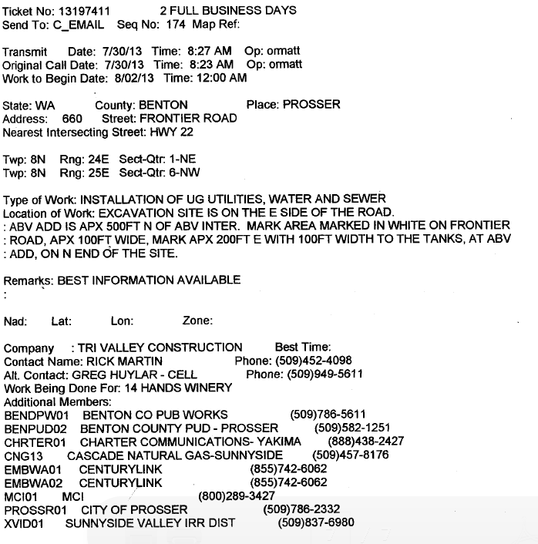

**Attachment B**

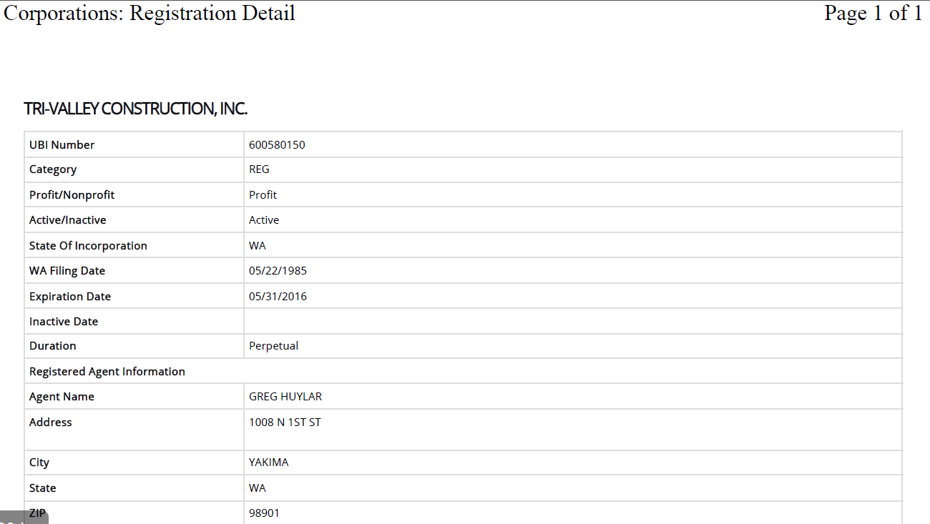

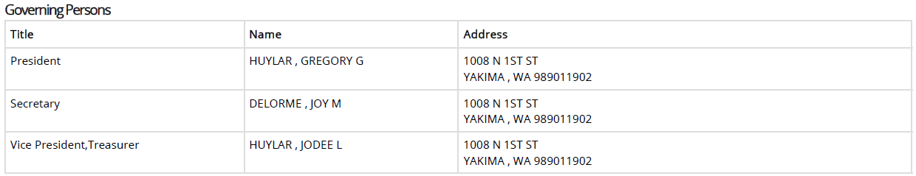

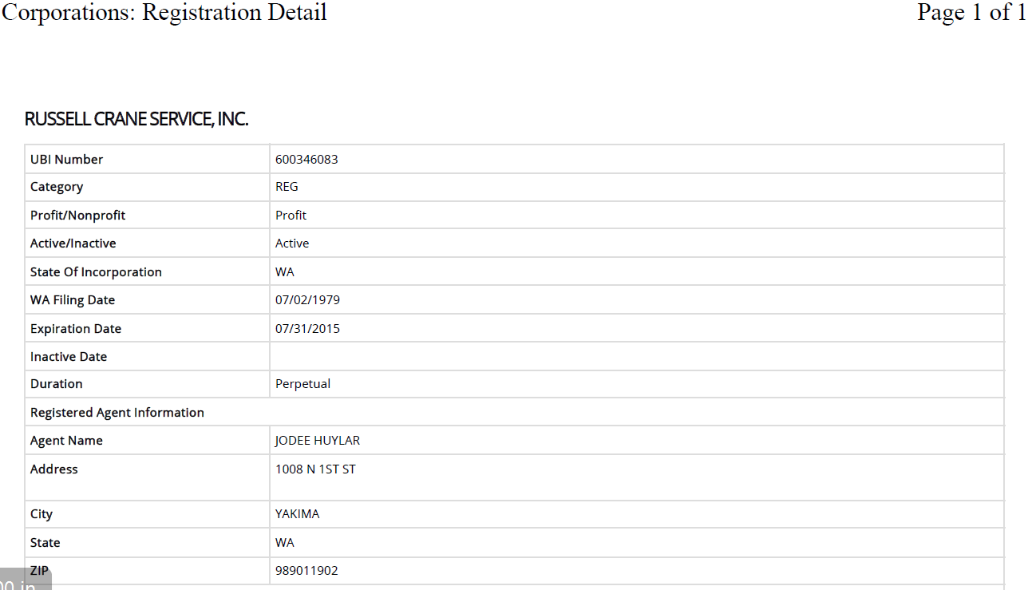

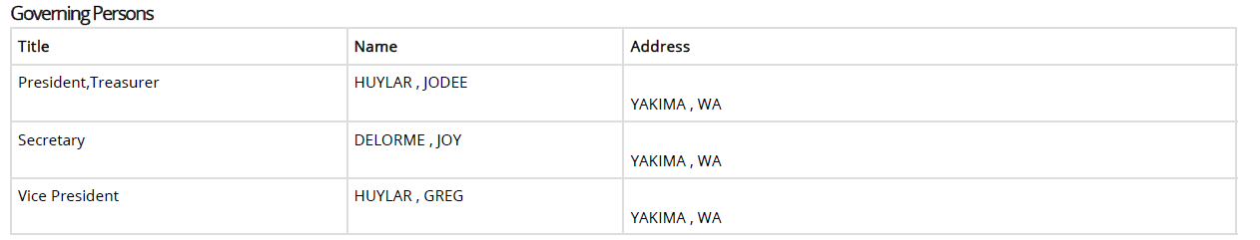

1. See Attachment A – Utility locate ticket #13197411.
2. See Attachment B – Corporate registrations for Tri-Valley Construction, Inc. and Russell Crane Service, Inc.