

|  |  |
| --- | --- |
| Avista Corp.  1411 East Mission P.O. Box 3727  Spokane. Washington 99220-0500  Telephone 509-489-0500  Toll Free 800-727-9170 |  |

July 18, 2012

***VIA: Electronic Mail***

David Danner

Executive Director and Secretary

Washington Utilities & Transportation Commission

1300 S. Evergreen Park Drive S. W.

P.O. Box 47250

Olympia, Washington 98504-7250

Re: In the Matter of the Petition of Puget Sound Energy, Inc. For Declaratory Order on the Meaning of Conservation in Chapter 19.285 RCW, Docket No. U-121165

Dear Mr. Danner,

Pursuant to the Commission’s “Notice of Receipt of Petition for Declaratory Order and Opportunity to Submit Statements of Fact and Law,” dated July 12, 2012, Avista Corporation (“Avista”) herby submits its request to be placed upon the Commission’s service list in the event of further proceedings.

If you have any questions regarding this request, please contact Bruce Folsom at 509-495-8706, [bruce.folsom@avistacorp.com](mailto:bruce.folsom@avistacorp.com) or myself at 509-495-4975.

Sincerely,

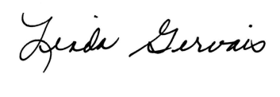

Linda Gervais

Manager, Regulatory Policy

Avista Utilities

509-495-4975

[linda.gervais@avistacorp.com](mailto:linda.gervais@avistacorp.com)