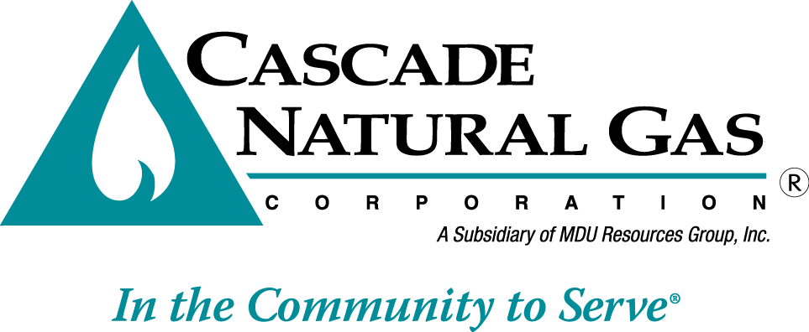 | 8113 W. GRANDRIDGE BLVD., KENNEWICK, WASHINGTON 99336-7166  TELEPHONE 509-734-4500 FACSIMILE 509-737-7166  www.cngc.com
VIA ELECTRONIC MAIL
records@utc.wa.gov

August 24, 2015

Records Center
Washington Utilities and Transportation Commission
1300 S. Evergreen Park Drive SW
Olympia, WA 98504

Re: UG-151309 Revised Tariffs
Advice No. CNG/W15-06-01

Please find enclosed revised tariffs adjusting Cascade’s requested increase to the level determined by Staff, upon completion of an extensive review, to be appropriate.

Fifty-Third Rev. Sheet No. 502 Canceling Fifty-Second Rev. Sheet No. 502
Fifty-Eighth Rev. Sheet No. 503 Canceling Fifty-Seventh Rev. Sheet No. 503
Forty-Second Rev. Sheet No. 504 Canceling Forty-First Rev. Sheet No. 504
Forty-First Rev. Sheet No. 505 Canceling Fortieth Rev. Sheet No. 505
Fifty-Eighth Rev. Sheet No. 511 Canceling Fifty-Seventh Rev. Sheet No. 511
Thirty-Eighth Rev. Sheet No. 512 Canceling Thirty-Seventh Rev. Sheet No. 512
Fifty-Fifth Rev. Sheet No. 541 Canceling Fifty-Fourth Rev. Sheet No. 541
Fifty-Second Rev. Sheet No. 570 Canceling Fifty-First Rev. Sheet No. 570
Forty-Ninth Rev. Sheet No. 577 Canceling Forty-Eighth Rev. Sheet No. 577
Second Revision Sheet No. 597 Canceling First Revision Sheet No. 597
Fifteenth Revision Sheet No. 663 Canceling Fourteenth Revision Sheet No. 663

The substitute tariffs produce a revenue increase of $1.25 million or .5%. This equates to a 2.12% increase to margin rates as the increase is applied on an equal percent of margin.
The impact on an average residential customer using 53 therms a month is $.30.

If you have any questions regarding this report, please contact me at (509) 734-4593.

Sincerely,

Michael Parvinen
Director, Regulatory Affairs

