### Agenda Date: September 30, 2010

Item Number: C1

**Docket: A-042090**

Company Name: Auto Transportation – General

Commercial Ferries – General

Household Goods – General

Solid Waste - General

Staff: Anne Solwick, Director – Regulatory Services

David Gomez, Deputy Assistant Director - Transportation and Water  
 Roger Kouchi – Consumer Protection Staff

**Recommendation**

Rescind Order 02, Docket No. A-042090, dated April 27, 2005, which authorized the Secretary of the Utilities and Transportation Commission (commission) to order temporary fuel surcharges for auto transportation, commercial ferry and household goods companies, effective November 30, 2010.

**Background**

On April 27, 2005, the commission issued Order 02, which simplified and expedited the process for petitioning and granting a fuel surcharge. Order 02 authorized the secretary, pursuant to RCW 80.01.030, to order temporary fuel surcharges for auto transportation, commercial ferry and household goods companies on less than statutory notice and without notice to customers provided the companies filed required documents to support the calculation of the proposed fuel surcharge.

A similar simplified process was informally adopted for solid waste companies at an open meeting held on October 26, 2005.

**Discussion**

The process allowed in Order 02 and informally following the open meeting held on October 26, 2005, for granting fuel surcharges simplified the administrative burden for both the companies and the Commission. The rationale for the simplification was that, in 2005, rates charged by the companies could not keep pace with rapidly rising and fluctuating fuel prices.

Since 2006, the commission has approved over 700 separate fuel surcharge petitions under the simplified process. The majority of filings, two-thirds, were from solid waste companies followed by auto transportation with 33 percent. Commercial ferry companies comprise the remaining two percent of fuel surcharge filings.

In Table 1, for the year 2010 up to September 14, the date that notice of this proposed rescinding was issued, we show that a total of 16 solid waste and auto transportation companies filed for a fuel surcharge. Of those 16, only four have filed a general rate case within the last five years.

|  |  |  |  |  |  |
| --- | --- | --- | --- | --- | --- |
| **Fuel Surcharges** | | | | | |
| **Industry** | **2006** | **2007** | **2008** | **2009** | **2010** |
| **# of companies/dockets** | | | | |
| Commercial Ferries | 1/1 | 1/3 | 2/16 | 0/0 | 0/0 |
| Solid Waste | 15/20 | 22/129 | 35/225 | 10/30 | 11/52 |
| Auto Transportation | 5/8 | 6/63 | 7/68 | 5/45 | 5/41 |
| Household Goods | 0/0 | 0/0 | 0/0 | 0/0 | 0/0 |
| **Total** | **21/29** | **29/195** | **44/309** | **15/75** | **16/93** |

Table 1, Fuel Surcharge Dockets (2006 to Present)

With the passage of over five years, staff is concerned that continued granting of short-term fuel surcharges results in rates and fares that may not be fair, just, reasonable and sufficient. Historically, fuel costs equal around seven to nine percent of companies’ total operating expenses. Without periodic examination of those operating expenses, single-item adjustments to rates may result in rates that are not in the public interest.

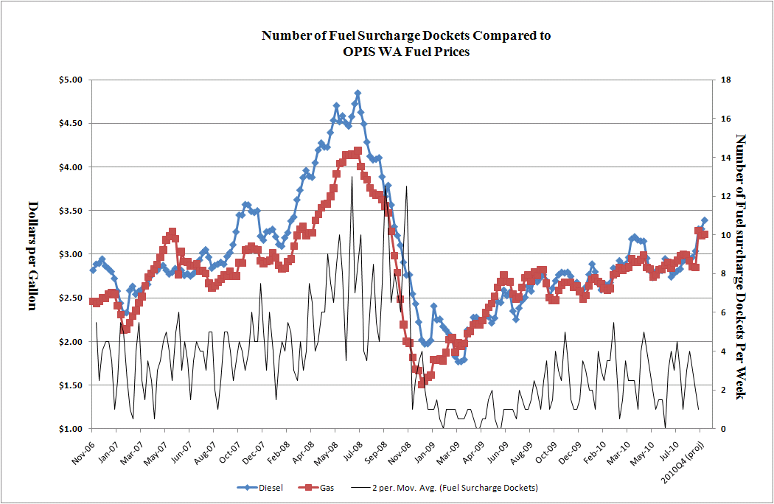

Figure 1, Fuel Surcharge Dockets versus Price Comparison

Fuel prices have remained steady since June 2009 and are predicted to remain so for the foreseeable future, given current economic conditions and weaker demand. Figure 1 illustrates that the steep month-to-month changes that were seen from January 2007 through June 2009 are no longer present. These steep increases were the impetus for creating the simplified process back in 2005. Consequently, the need for a simplified process to grant fuel surcharges by delegating the authority to the secretary no longer exists.

In the absence of the simplified process companies wishing to increase rates must show that the proposed rates are just, fair, reasonable, and sufficient as required by RCW 81.28.010. Solid waste companies may file for a general rate increase by providing the minimum information required by WAC 480-07-520. The minimum requirements for a general rate increase requested by an auto transportation company are found in WAC 480-30-426. Alternatively, any company may petition the commission for an exemption to the rules as allowed in WAC 480-07-110. In order to allow affected companies sufficient time to plan, staff recommends that the expedited process remain in place through November 30, 2010.

**Public Comment**

On September 14, 2010, commission staff notified affected companies by mail and electronic mail of proposed changes to the fuel surcharge process. The commission received two company comments on the filings; one opposed and one undecided.

Consumer Protection staff advised customers that they may access company documents about this rate case at [www.utc.wa.gov](http://www.utc.wa.gov), and that they may contact Roger Kouchi at 1-888-333-9882.

**Business Practice Comments**

* Consumer wanted a copy of all the documentation regarding staff’s review.
* **Staff Response**

Staff provided the requested documents to the company. Staff also provided an explanation of a general rate case process.

**General Comments**

* Company opposed any changes to the current fuel surcharge process. The company believes that the current fuel charge process is working satisfactorily and reverting back to the process of submitting petitions or general rate requests would be burdensome.
* **Staff Response**

State law requires rates to be fair and reasonable, and sufficient to allow the company the opportunity to recover reasonable operating expenses and earn a reasonable return on investment. Staff provided company background documentation of the fuel surcharge expedited process and a summary of the rate making process. Staff informed the company of the public comment process and the date of the open meeting.

**Conclusion**

Staff recommends that the delegation of authority to approve fuel surcharge requests is no longer necessary and that the commission rescind Order 02, Docket No. A-042090, dated April 27, 2005, effective November 30, 2010. Staff further recommends that the simplified process informally adopted for solid waste companies no longer be offered.