June 30, 2014

Steven V. King, Executive Director and Secretary
Utilities and Transportation Commission
1300 S. Evergreen Park Dr. SW
P.O. Box 47250
Olympia, WA 98504-7250

RE: Washington Utilities and Transportation Commission v. Roche Harbor Water System

Commission Staff’s Response to Application for Mitigation of Penalties UW-140853

Dear Mr. King:

On June 9, 2014, the Utilities and Transportation Commission issued a $1,000 Penalty Assessment in Docket UW-140853 against Roche Harbor Water System for 10 violations of Washington Administrative Code (WAC) 480-110-505, which requires water companies to furnish annual reports to the commission no later than May 1 each year.¹

On June 16, 2014, Johnson & Shute, P.S. wrote the commission on behalf of Roche Harbor Water Systems requesting mitigation of penalties (Mitigation Request).² In its Mitigation Request, Roche Harbor Water System does not dispute that the violation occurred. The company statement provided information regarding the filing of the extension request being filed on May 1 instead of prior to May 1. Further, the company contacted commission staff on April 29th regarding the extension request deadline as the annual report form referenced April 17 as the extension request filing deadline. The company was told by commission staff, “we could still file the extension if it included the payment…if the payment was received by May 1st, she did not expect that the extension would be denied.”

It is the company’s responsibility to ensure that the regulatory fee is paid and the annual report is filed by the May 1 deadline. On February 28, 2014, Annual Report packets were mailed to all regulated water companies. The instructions for annual report completion page of the annual report informed the regulated company that it must complete the annual report form, pay the regulatory fees, and return the materials by May 1, 2014, to avoid enforcement action.

UTC Annual Reports
June 30, 2014
Page 2

On June 3, 2014, Roche Harbor Water System filed its completed annual report and paid the regulatory fees due on May 1, 2014. There are no prior violations of WAC 480-110-505 with regard to the late filing of the annual report or prior extension requests. Staff supports the company’s request for mitigation and recommends the penalty be waived due to conflicting information provided by commission staff which contradicted the commission rule and past filing compliance.

If you have any questions regarding this recommendation, please contact Amy Andrews, Regulatory Analyst, at (360) 664-1157, or aandrews@utc.wa.gov.

Sincerely,

Sondra Walsh, Director
Administrative Services

ATTACHMENT A
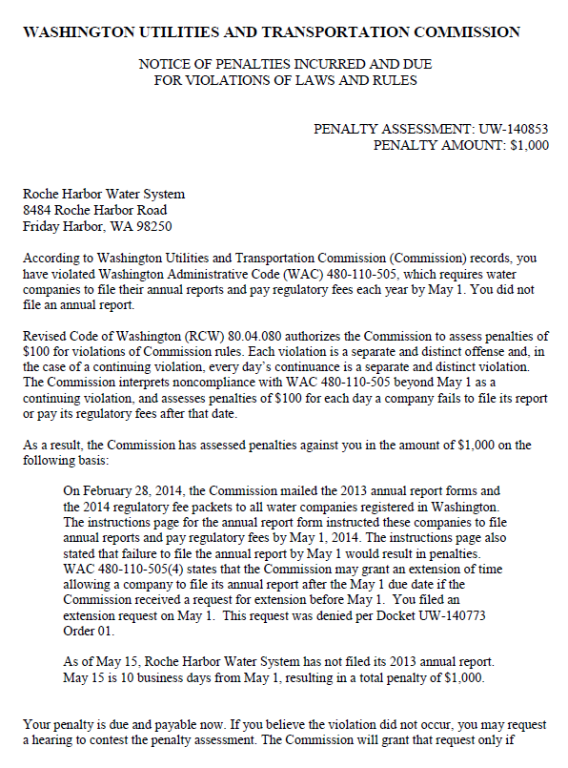

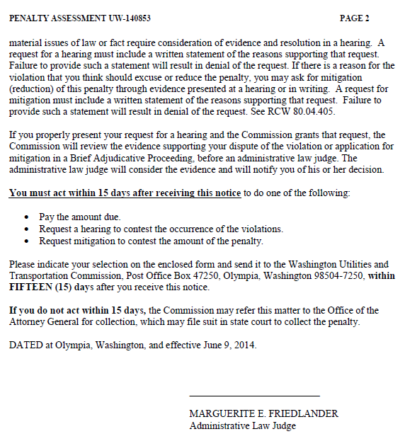

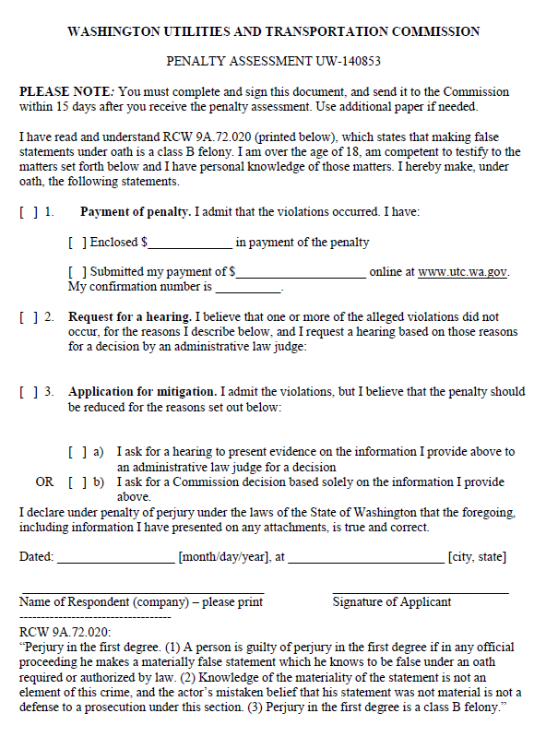

ATTACHMENT B
