October 22, 2012

David W. Danner, Executive Director and Secretary

Washington Utilities and Transportation Commission

1300 S. Evergreen Park Dr. SW

P. O. Box 47250

Olympia, Washington 98504-7250

RE: *Washington Utilities and Transportation Commission v. Jonathon Sheridan*

Commission Staff’s Response to Application for Mitigation of Penalties

Docket TV-120943

Dear Mr. Danner:

On July 24, 2012, the Washington Utilities and Transportation Commission issued a $450 Mitigated Penalty Assessment in Docket TV-120943 against Jonathon Sheridan d/b/a JFS Transport for 18 violations of Washington Administrative Code (WAC) 480-15-480, which requires permitted household goods companies to furnish annual reports to the commission no later than May 1 each year.

On August 17, 2012[1], Jonathon Sheridan d/b/a JFS Transport (Jonathon Sheridan) wrote the commission requesting mitigation of penalties (Mitigation Request). In its Mitigation Request, Jonathon Sheridan does not dispute that the violation occurred. The company states, “We apologize this statement is late as we were on vacation from July 18-July 31st in California. I was on vacation and did not file on time. I was unaware we had to file until an email was sent by Lynn, Carnes who then collected the report and we paid the fee of $110.00. She did not advise me their would be any late fees at that time. We apologize for late report. We were unaware it had to be submitted. When we received email from Lynn, we immediately filled out report and turned in the same day, as we were unaware it was past due.”

It is the company’s responsibility to ensure that the regulatory fee and the annual report are filed by the May 1 deadline. On February 29, 2012[2], Annual Report forms and Regulatory Fee packets were mailed to all regulated permitted household goods companies. In addition to other information, the cover letter informed the regulated company it must complete the annual report form, pay any regulatory fees and return the material by May 1, 2012, to avoid enforcement action. On May 15, 2012[3], the commission mailed a letter to those companies that had not yet filed an annual report notifying them that, to date, they had incurred a penalty of $900. The letter went on to explain that companies who filed their annual reports no later than May 25, 2012, would receive mitigated penalties of $25 per day, with an additional $25 per day for each instance in the previous five years that the company received a penalty for filing a late report.

Jonanthon Sheridan attended the October 12, 2011, household goods training[4]. Training was provided regarding annual reports and regulatory fee requirements. Jonathon Sheridan signed a form, indicating he received training on annual reports and regulatory fees.

Jonathon Sheridan filed its annual report on May 25, 2012, which is 18 business days past the deadline of May 1, 2012. The penalty was mitigated from $100 per day to $25 per day for a total of $450. Jonathon Sheridan has held permanent household goods authority since October 2010 and never received a penalty for filing a delinquent annual report in the past.

Despite receiving previous training on annual reports and regulatory fees, staff supports mitigating the assessed penalty from $450 to $225, which represents a 50 percent reduction because this is Jonathon Sheridan’s first late filing.

If you have questions regarding this recommendation, please contact Mathew Perkinson, Compliance Investigator, at (360) 664-1105 or at mperkinson@utc.wa.gov.

Sincerely,

Sharon Wallace, Assistant Director

Consumer Protection and Communications

**Attachment A**

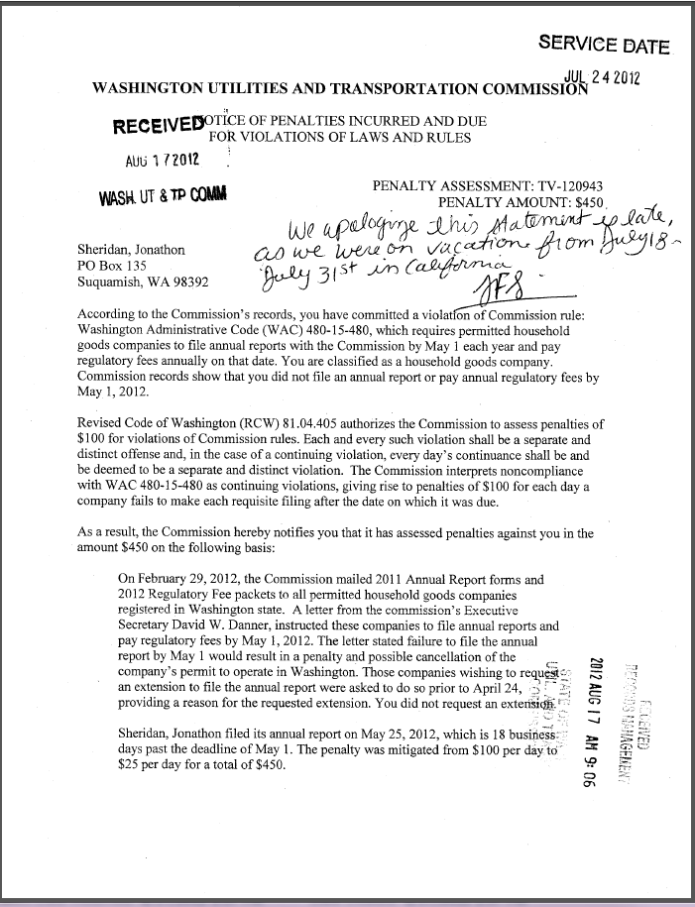

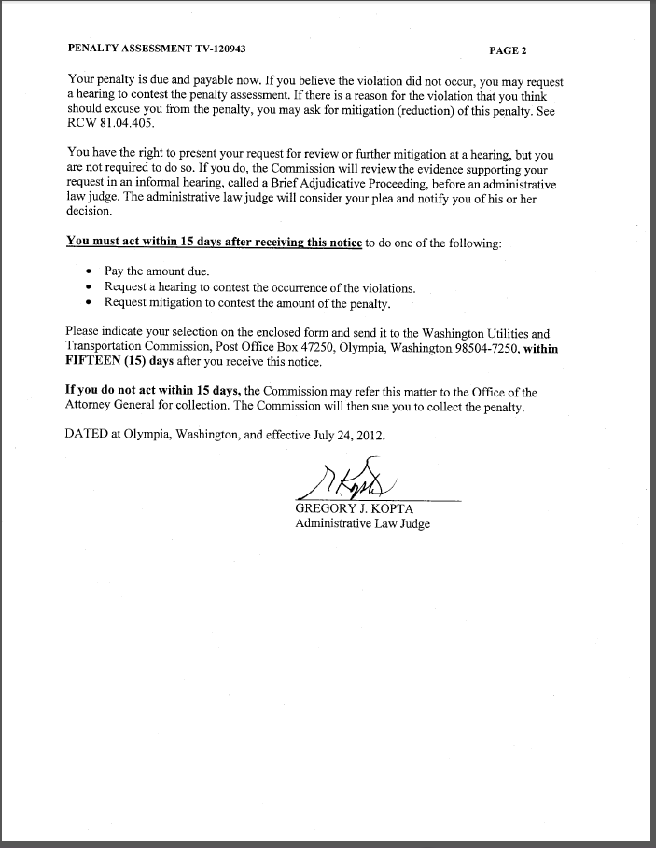

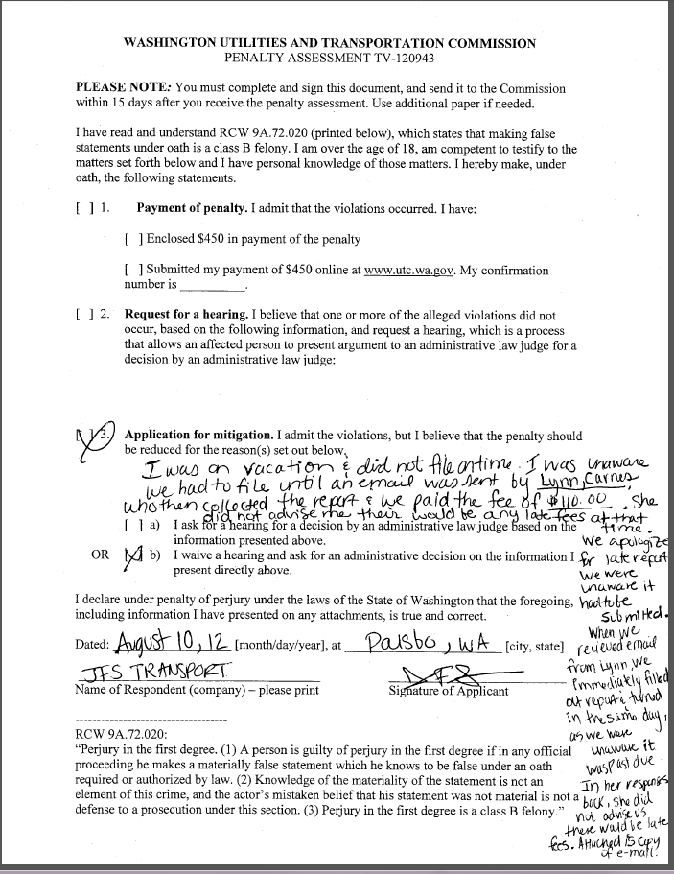

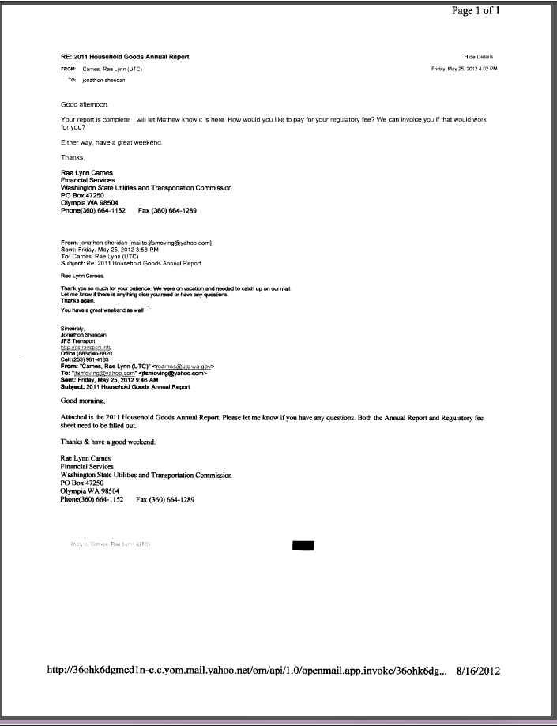



**Attachment B**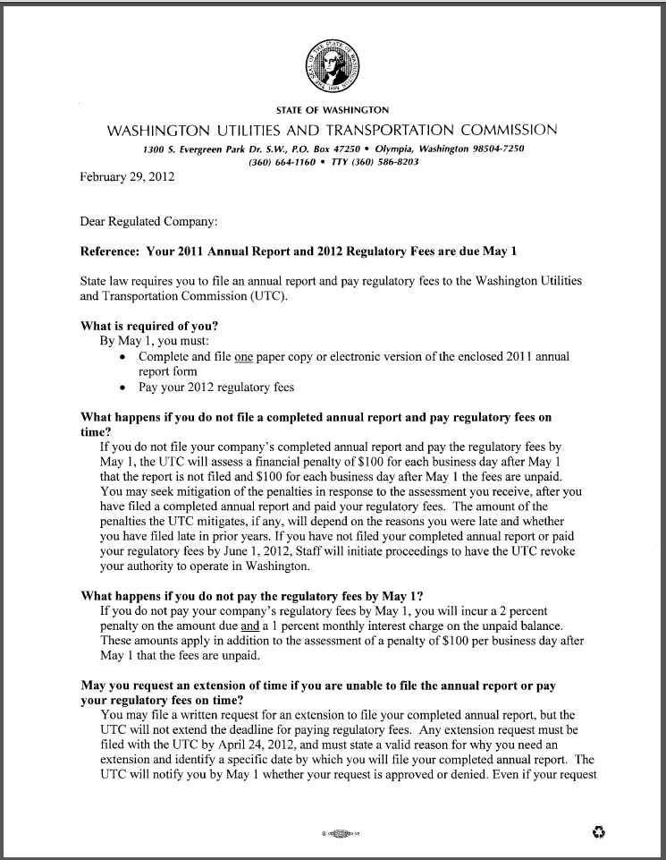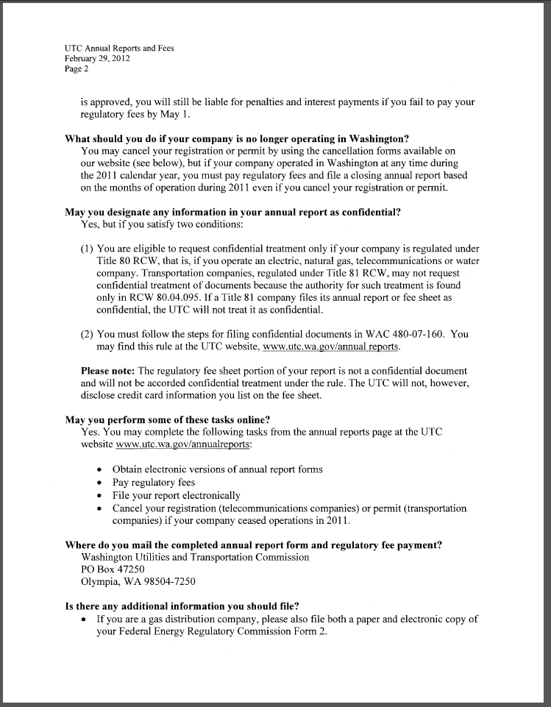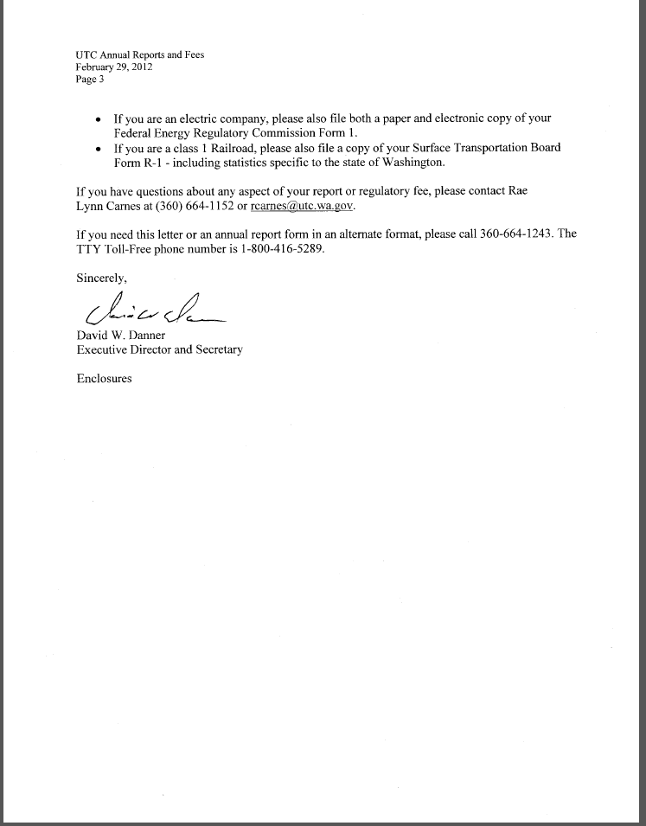

**Attachment C**

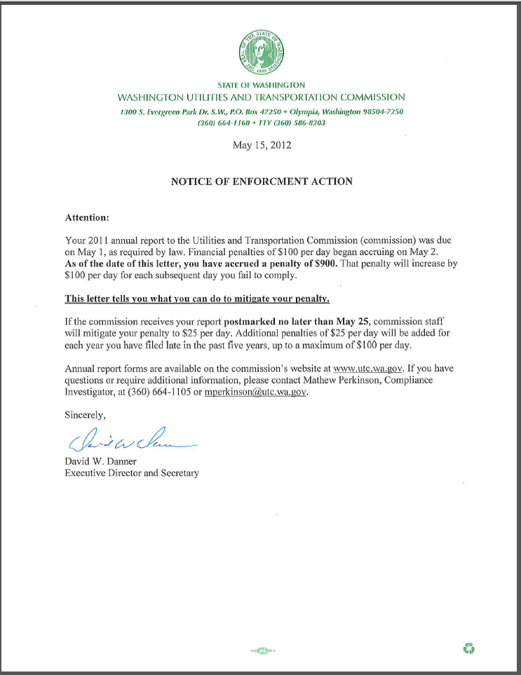

**Attachment D**

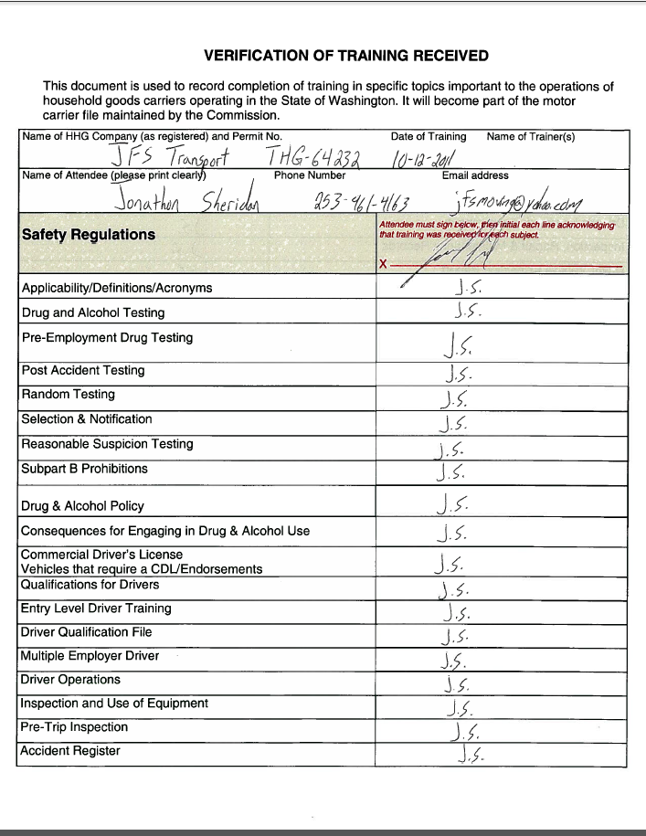

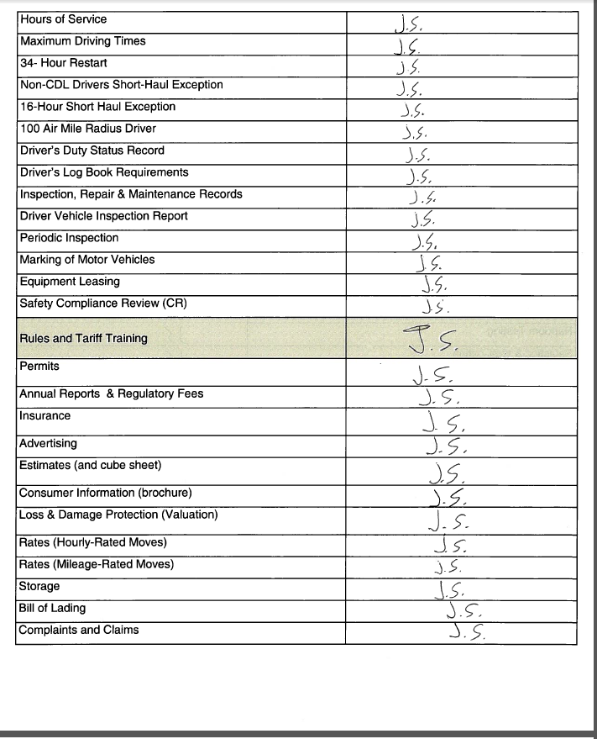

1. See attachment A for a copy of Jonathon Sheridan’s Mitigation Request.
2. See attachment B for a copy of the letter sent to all regulated companies on February 29, 2012.
3. See attachment C for a copy of the enforcement letter sent to the company on May 15, 2012.
4. See attachment D for a copy of the training verification, signed by Jonathan Sheridan.