|  |  |
| --- | --- |
| Avista Corp.  1411 East Mission P.O. Box 3727  Spokane, Washington 99220-0500  Telephone 509-489-0500  Toll Free 800-727-9170 |  |

March 19, 2013

***VIA: Electronic Mail***

Steven V. King

Acting Executive Director and Secretary

Washington Utilities & Transportation Commission

1300 S. Evergreen Park Drive S. W.

P.O. Box 47250

Olympia, Washington 98504-7250

Re: Docket No. UG-121501 – Supplemental Comments of Avista Corporation

Dear Mr. King:

On March 8, 2013, Avista Corporation (“Avista”) filed comments in response to Staff’s report with the Commission in this docket. On March 8, 2013, Public Counsel also submitted comments along with a report titled “Natural Gas Procurement Practices of Avista Corporation”. These comments are in reply to Public Counsel.

**PGA Process**

At the outset, Avista wishes to voice continuing support for the current PGA process which provides for Staff and Commission full review and approval of the current year’s natural gas costs (deferral account) and the subsequent year’s projected gas costs (PGA). Per WAC 480-90-233, a Deferral Report is sent to Staff monthly, and is available for all parties to review current year status prior to the filing of the annual PGA. When the annual PGA filing is made, it consists of the support and documentation for the Company’s existing supply obligations and proposed forward looking commodity and transportation costs, as well as for the prior period amortization of those same PGA components, all of which is available for review by Staff, Public Counsel, and other interested parties.

Public Counsel, however, suggests a list of criteria that it states are “clearly lacking” in the PGA process. (p. 14) Avista, in fact, provides the information that Public Counsel believes is “lacking” through the annual PGA filing, the monthly Deferral Reports and any subsequent informal data requests. It is also provided in its semi-annual presentation of the Company’s Procurement Plan and results to Commission Staff (the most recent being held on October 15, 2012). Substantive current year Procurement Plan modifications are communicated immediately to Staff to keep them apprised of any changing market conditions and how those changes relate or affect natural gas Procurement Plan strategies. Further, the Company has also hosted Commission Staff in several on-site meetings to actively discuss natural gas procurement, pipeline transportation, segmentation, hedging, optimization and general market dynamics and fundamentals. In fact, members of the Commission Staff have even sat with our natural gas group and witnessed how Avista procures its natural gas supply and optimizes its system resources. Avista appreciates the interest and involvement of Staff and hopes to continue these discussions in the future.

Longer term forecasts and other data that Public Counsel would like to have included in the PGA process are fully disclosed and discussed with the Technical Advisory Committee as part of the Company’s Integrated Resource Plan (acknowledged by the Commission in Docket UG-111588) where the Company evaluates longer term supply side resources to meet future demand requirements. Public Counsel is invited to participate in these TAC meetings; however, they did not attend a single meeting for the Company’s 2012 Integrate Resource Plan.

Avista is supportive of the current PGA process as it provides the Staff and Commission with the information needed to make decisions relating to the previous year’s deferral account and the upcoming PGA filing. The review of the annual Procurement Plan is yet another avenue for procurement discussions in which interested parties are invited to participate.

Even though Avista believes the existing process for review is sufficient, Avista would not object to further workshops or technical conferences to explore the various topics, questions and procedural processes presented. The Company, however, strongly urges that any findings or recommended changes that may ultimately result from the CR 101 process be implemented on a prospective basis and not be applied retroactively. We understand this to be Staff’s position as well.

**Suspension of Hedging Transactions**

Avista does not support Public Counsel’s recommendation on page 4 of their Report to suspend all hedging activity until an “appropriate hedging program” can be established. Avista has an appropriate hedging program in place – one that has evolved over time and is working well. In fact, even the report prepared by Schneider Electric for Commission Staff, at page 19, states that “Avista achieved a realized result nearly 20 cents better than our ‘best case’ scenario.” (emphasis added) The structure and performance of our Procurement Plan, which includes a certain level of hedging in addition to index purchases and storage, has led to these results.

Public Counsel indicated at page 12 of their Report that they were perplexed as to why Avista would employ the same strategies year over year. Quite simply, we do not. Avista’s Procurement Plan is dynamic, in that it evolves not only between PGA years, but also within the PGA year. Avista utilizes a blend of fixed price (both short-term and long-term), index[1] and storage in the design of its Procurement Plan. Utilization of these three components creates a more balanced and diversified portfolio and provides a level of price certainty for our customers. In a downward-trending market, index will reflect a lower market price, which can help offset previous fixed priced hedges, and in an upward-trending market, those fixed priced hedges will help to mitigate a rising index price.

As the fundamentals in the natural gas market shift, Avista makes adjustments to its Procurement Plan. For example, due to rapidly declining market prices brought on from improved horizontal drilling technology, the Plan’s long-term hedging price targets were adjusted down (thereby establishing lower, more aggressive target levels) and the corresponding volumes to be transacted at fixed prices were also reduced. Regarding the prompt-year hedging component, in the last two Procurement Plans, Avista reduced the overall level of prompt-year hedging. In 2010, the Procurement Plan was designed to provide 30% of natural gas supply mix at a market index price. In 2012, the index portion was increased to 40%. Further, in May 2011 the capacity at Jackson Prairie available for customers increased by approximately 3,000,000 Dth of storage, increasing the percentage of natural gas from storage from 12% to 21%. This increased capacity provides an even more flexible winter natural gas supply at summer prices.

Finally, Public Counsel’s own comments even highlighted evidence of the dynamic nature of the Procurement Plan, by observing at Page 7 of their Report that Avista had shifted where it obtains natural gas supply, noting that in 2011-2012, the supply resources were more heavily weighted towards AECO than the Rockies. This shift was deliberate and based on the fundamental change in Rockies pricing caused by the startup of the Ruby Pipeline[2]. As prices in the Rockies increased, Avista shifted more of our supply to the lower priced basin – AECO. Avista is committed to procuring reliable supply from the lowest cost supply basin available. Avista does have a dynamic and responsive Procurement Plan that includes an appropriate hedging program that should not be suspended. Indeed, if it were suspended, Avista’s customers would lose the ongoing benefits of a mature hedging strategy that addresses pricing volatility.

**There Should Be No Disallowance**

Public Counsel is recommending that the Commission disallow a portion of Avista’s natural gas costs based on the conclusion that Avista “entered into fixed price financial hedges within three months from the start of the 2011-2012 PGA year, when clear evidence existed from prior months that cash spot market prices were more advantages than forward hedge prices.” (Public Counsel’s Report at page 4) Public Counsel uses Table 4 in its report, at page 13, as the basis for their proposed disallowance, arguing that “(m)ost of the evidence pointed to a significant differential between the cash spot market and the future prices that the Company eventually locked in.” (p. 13)

Public Counsel’s argument of a significant price differential has no basis in fact. Table 4 on page 13 of Public Counsel’s report shows the “Cash Spot Market” in comparison to the time periods of “Nov’13-Mar’14”, Nov’14-Mar’15, and “Nov’15-Mar’16”, not to the period being hedged as part of the defined Procurement Plan. Their comparison should have been made to the 2011/12 hedging period - the actual period in the Procurement Plan (the prompt year) that was hedged. Using the correct time period (as seen in Illustration 1(winter) and Illustration 2 (summer) below), during the three months prior to the 2011/12 hedging period, the AECO cash spot market price was in fact very similar in price to the future 2011/12 prices that the Company hedged.

**Illustration 1 – 2011/2012 Winter Forward Price vs. Cash Prices (AECO)**

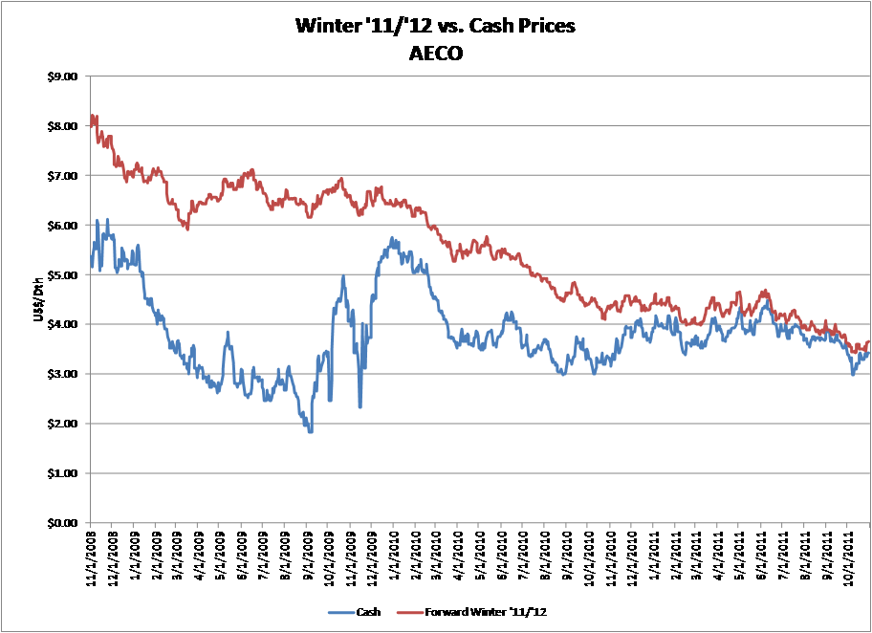

**Illustration 2 – 2012 Summer Forward Price vs. Cash Prices (AECO)**

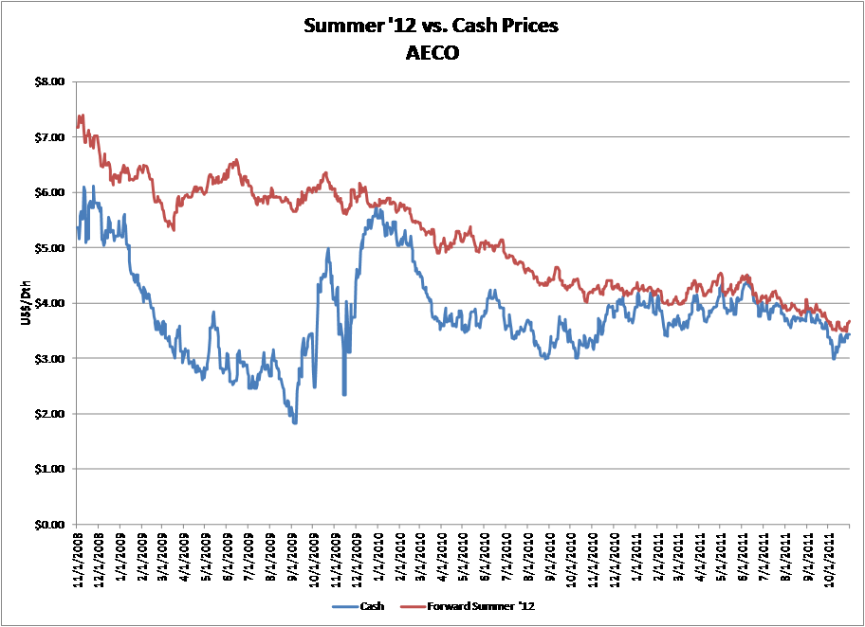

In fact, there were times when the forward future price was lower than the cash spot market price. Contrary to Public Counsel’s assertion, and as can be seen in Illustrations 1 and 2, the price differential was actually the narrowest it had been in years. During the three months before the start of the 2011/12 PGA year, there was not a “significant differential” as Public Counsel contends; indeed, and at times there was no price differential at all. In short, there is no basis for Public Counsel’s recommended disallowance. The broader point, however, is this: the purpose of any hedging program is not to precisely predict the market or take a market position; rather it is to mitigate the risk of unanticipated pricing fluctuations by providing a level of price certainty. In this regard, Avista’s program has worked well.[3]

If you have any questions regarding these comments, please contact Steve Harper, Director of Natural Gas Supply at 509-495-2076 or myself at 509-495-8620.

Sincerely,

Patrick Ehrbar

Manager, Rates and Tariffs

1. Index used in this document will reference Gas Daily, pricing at the respective receipt point – a daily market clearing price.
2. Ruby Pipeline began operations in 2011 and can transport up to 1.5 billion cubic feet per day from the Rockies supply basins to Northern California. With an increase in demand came a commensurate increase in price, making other basins less costly by comparison.
3. While Avista, in this letter, is addressing Public Counsel’s specific recommendations it has made to the Commission, Public Counsel also made certain assertions in their Report that need to be responded to. First, Public Counsel’s Report stated that off-system sales may have resulted in fixed price purchases being sold at a loss because of excess supplies during the year. Avista does not hedge volumes above load requirements. The losses implied in their Report did not occur. Most off-system sales Avista enters into are not for load management but are for transport optimization. These transactions offset fixed costs and are a benefit to customers. Second, as it relates to capacity releases, most of the long-term capacity held by Avista was acquired through the mandated open access process of FERC Order 436. Long term transportation agreements that are not required now but will be required to meet future demand can then be monetized through the capacity release market until needed. The vast majority of Avista’s transportation releases are at the highest allowable rate through FERC order 636. Additionally, Avista is able to maintain certain long-term releases at full pipeline tariff rates due to segmentation of pipeline capacity which results in no-cost transport demand charges for Avista’s customers. Short-term capacity releases are at or above market value and seek to recover demand charges on unutilized capacity.