Agenda Date: February 23, 2012

Item Number: B1

**Docket: TG-120073**

Company Name: Harold LeMay Enterprises, Inc., G-98, d/b/a Pierce County Refuse

Staff: Dave Gomez, Deputy Assistant Director

**Recommendation**

Issue a Complaint and Order Suspending the Tariff Revisions filed by Harold LeMay Enterprises, Inc., d/b/a Pierce County Refuse on January 13, 2012, as revised on January 30, 2012, and allow the monthly recyclable commodity revenue adjustments and fifty percent revenue sharing to become effective on March 1, 2012, on a temporary basis, subject to refund or credit.

**Discussion**

On January 13, 2012, Harold LeMay Enterprises, Inc., d/b/a Pierce County Refuse (LeMay or company) filed with the Washington Utilities and Transportation Commission (commission) revisions to its currently effective Tariff No. 9, designated as pages 1 and 21. The stated effective date is March 1, 2012. The company serves approximately 43,000 customers in Pierce County (county).

In its filing of January 13, 2012, LeMay proposed to increase the amount it pays to customers for the value of the recyclable materials that the company collects in its residential recycling collection service. The monthly credit for customers would increase from $0.91 to $1.97.

On January 30, 2012, LeMay filed a substitute revised page 21 reducing the proposed credit from $1.97 to $1.75, to reflect $139,812 less in commodity sales proceeds received from LeMay’s recycling processor, SP Recycling. The January 30, 2012, filing and supporting spreadsheets originally reflected this amount which LeMay billed, but had not received payment from, SP Recycling.[1] On November 15, 2011, SP Recycling, under case number 11-13651 in the United States Bankruptcy Court for Delaware, filed for protection from its creditors under Chapter 11 of the U.S. Bankruptcy Code. LeMay’s receipt of proceeds from the second half of November 2011, owed by SP Recycling is dependent on action by the Court in approving a plan for unsecured creditors. When and if that money is received from SP Recycling, as authorized by the Bankruptcy Court, LeMay proposes to include it in the company’s next annual true-up scheduled to go into effect on December 1, 2012. LeMay is under contract with SP Recycling and payments for recyclable commodities have since resumed.

On January 13, 2012, the company and the county filed a revenue sharing report for the 2011-2012 plan period showing the amount of revenue retained and the amount of money spent on the activities identified in LeMay’s recycling and revenue sharing plan with the county and the effect the activities had on increasing recycling. The company reported it had retained $490,499 (44 percent) out of $1,114,771 in recyclable commodity revenues and spent $226,547 of what it retained on plan activities.

During the 2011-2012 plan period, the company spent the majority of the $226,547 on wages, benefits and community outreach expenses for two of its employees. The total amount expended in this category was $133,072 during the plan year. In addition, the company made a $67,000 payment to the county to fund headcount employed at the Pierce County Public Works and Utilities, Solid Waste Division. The company also included as plan expenditures, $13,931 in legal fees. The remaining $12,544 was spent on glass recycling hauling, donated services and the company’s annual membership in the Washington State Recycling Association (WSRA).

Table 1 below, summarizes the final percentage awarded by the county based on a maximum final retention amount for the 2011-2012 plan period of fifty percent.[2] The company failed to meet some of the agreed upon objectives contained in Plan Elements C and D and, as a result, the overall retention amount (out of a total maximum eligible of fifty percent) was reduced by six percent resulting in revenue retention of 44 percent.[3] In Table 1, because objectives for elements C and D were not met, the retained percentage for those two elements were reduced by four percent and 12 percent, respectively, however, in the overall weighting of the revenue retention results, the overall reduction in revenue retention is six percent. The company has included the six percent reduction in its credits to customers along with $74,441 in credits from the unused portion of moneys retained by the company during the 2011-2012 plan year. The company proposes to keep $189,511 in unspent retained revenues from 2011-2012.

Table 1, LeMay 2011-2012 Recycling Plan Scorecard Summary

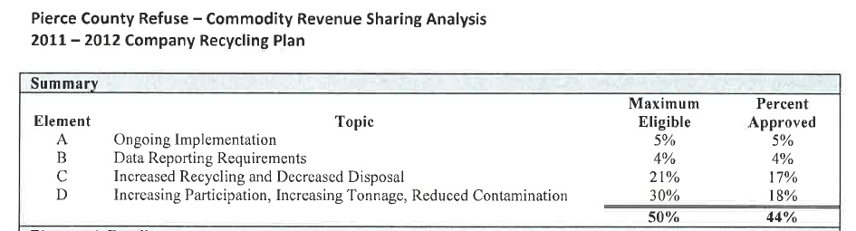

RCW 81.77.185 states that the commission shall allow a solid waste collection company collecting recyclable materials from residential single family and multi-family customers to retain “up to fifty percent of the revenue paid” to the company for the material if the company submits a plan to the commission that is certified by the appropriate local government authority as being consistent with the local government solid waste plan and that demonstrates how the revenues will be used to increase recycling. The remaining revenue must be passed through to residential single and multi-family customers.

On January 27, 2012, the county and the company filed their revenue sharing plan for the upcoming 2012-2013 period. Stephen C. Wamback, Solid Waste Administrator, Pierce County Public Works and Utilities, Solid Waste Division, certified the plan is consistent with the local government solid waste plan and demonstrates how the retained revenues will be used to increase recycling. The county recommends the commission approve retention of fifty percent of the revenue from the sale of recyclable materials for the upcoming 2012-2013 plan year.

The 2012-2013 plan is divided into four elements, each are assigned a share of the fifty percent retained recyclable commodity revenues (see Table 2 below):

**Element A – Continued Improvement of the Single-Cart Recycling Program** – This element involves the county and the company working together on community outreach and looking for ways to expand the types of materials recycled. This element’s share of retained revenues is 12 percent.

**Element B – Data Reporting – Meeting or exceeding data reporting requirements** - This element’s share of retained revenues is 4 percent.

**Element C – Direct Support for County Sustainability Positions** – Payment by the company to the county for headcount. This element’s share of retained revenues is 13 percent.

**Element D – Achieving Performance Objectives** – The county has outlined performance objectives for the company to meet during the plan year. This element’s share of retained revenues is 21 percent.

Table 2, LeMay 2012-2013 Recycling Plan Scorecard Summary

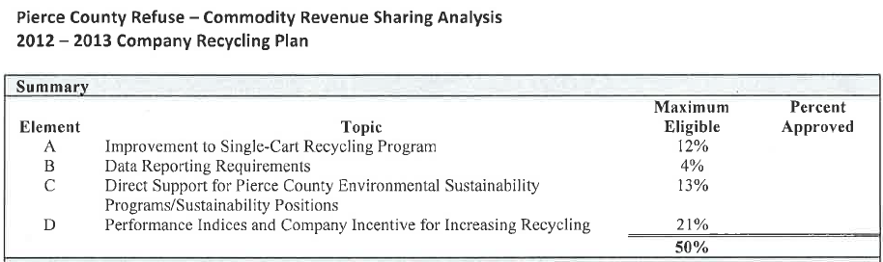

Not included as part of the company’s plan is a budget with projected expenditures for the upcoming 2012-2013 period. Staff estimates that the company will spend no more than 16 percent to 20 percent of the total recyclable commodity revenue received during the plan year.

Staff is concerned with the company’s net retention of $189,511 in unspent retained revenues for the 2011-2012 plan period. The commission is considering this issue in three other suspended dockets involving other operating divisions of the company’s parent, Waste Connections of Washington, Inc. Staff recommends that the commission allow recyclable commodity revenue adjustments and revenue sharing to go into effect on a temporary basis, subject to refund or credit.

**Conclusion**

Issue a Complaint and Order Suspending the Tariff Revisions filed by Harold LeMay Enterprises, Inc., d/b/a Pierce County Refuse on January 13, 2012, as revised on January 30, 2012, and allow the monthly recyclable commodity revenue adjustments and fifty percent revenue sharing to become effective on March 1, 2012, on a temporary basis, subject to refund or credit.

1. SP Recycling Corporation, a wholly owned subsidiary of SP Newsprint, LLC, headquartered in Atlanta, Georgia.
2. When added together, the “Maximum Eligible” column in Table 1 equals sixty percent. The sixty percent represents multiple paths within the plan for the company to earn the maximum fifty percent allowable by law.
3. The company did not meet the objectives of:

   Decreasing disposal on a per household basis;

   Increasing glass disposal sites by four (only added one site); and

   Targeted participation in alternate levels of service which further reduce disposal and increase recycling.