Renewable Northwest Project (RNP) and the NW Energy Coalition (NWEC) respectfully submit the following comments in response to the Commission’s June 24, 2011 Notice of Opportunity to File Written Comments in Docket No. UE-110667: Study of the Potential for Distributed Energy in Washington State. We did not respond to all questions posed by the Commission, but may engage in discussions of those additional issues at the July 25 work session.

A: General – Cross Cutting Issues

- What is the scope of current and anticipated distributed energy in the service territories of Washington investor-owned utilities, including technology type, size and capacity; distribution across service territory; application of feed-in tariffs or net metering; and any other relevant information? For each technology, what is its total technical resource potential (in contrast to the present, economically viable potential)? Is it concentrated within the state?

According to the Renewable Energy Atlas of the West, the total technical potential for various renewable resources in Washington are as follows:
  - The wind resource in Washington can produce an estimated 7,000+ aMW of energy, which is equivalent to approximately 22,000 MW of nameplate capacity. Currently there are around 3,000 MW of nameplate wind capacity installed or under construction in Washington. The best wind resources are concentrated in South-central, Southeastern, and the Western coastal region of Washington (see Appendix A).
  - The potential for solar photovoltaic (PV) generation in Washington is estimated to be 4,700 aMW. Assuming a 15% capacity factor, this represents approximately 31,000 MW of nameplate PV capacity. Although solar PV can be a viable option anywhere in the state, the best solar resource is concentrated east of the Cascade Mountains (see Appendix B).
  - The potential for electric generation from biomass is roughly 1,250 aMW. This includes agricultural and woody biomass sources. At a 50% capacity factor, this would represent 2,500 MW of nameplate capacity, while at an 80% capacity factor this would be roughly 1,560 MW of nameplate capacity. Biomass resources are distributed throughout the state, with a heavier concentration on the West side (see Appendix C).

- What is, or what is anticipated to be, the overall cost of integrating distributed energy resources to investor-owned utilities?

Assessing the costs associated with integrating distributed generation (DG) to investor owned utilities (IOUs) is a complex task that requires analyzing the effects of DG on the grid in a comprehensive manner. Foremost, it should not be assumed outright that the costs associated with integrating DG would result in increased revenue requirements for utilities. For example, in New York State, it is estimated that the total value to ratepayers of integrating distributed solar PV generating capacity ranges from $0.09-$0.25/kWh, while the costs associated with integration range from $0.00- $0.05/kWh (Table 1). When the economic, environmental, and social benefits of distributed PV are included, the combined value to ratepayers and taxpayers increases to between $0.15/kWh (assuming a $0.05/kWh penetration cost) and $0.41/kWh (assuming no penetration cost).

Any attempt to estimate the cost to IOUs of integrating DG would ideally be accomplished through a rigorous study that assesses the impact of DG in terms of not only its nameplate cost against the value of the electricity it is offsetting, but also in terms of the indirect benefits it brings to the grid such as capacity contributions, reduced electrical losses, fuel price mitigation, and grid security enhancement. In order to accomplish such a study, it would likely be the best option to contract with an independent and experienced consultant.

Table 1. Value Analysis of Distributed Solar PV Grid Integration
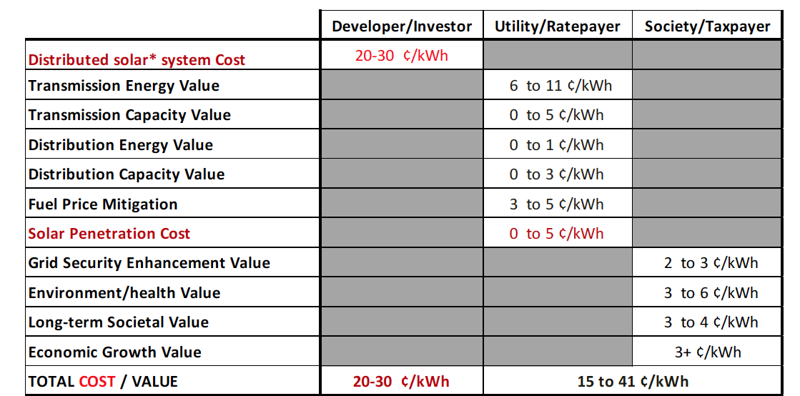

- Are there changes in state statutes or rules that would encourage technology-neutral development of distributed energy generally, such as changes to financial incentives? For example, would current interconnection standards need to be changed to accommodate more distributed energy or to accommodate different distributed energy technologies? Why?

When contemplating a policy that would encourage technology-neutral development of DG, the varying costs and scale of the DG technologies in question must be considered. Also, the meaning of “neutral” policy must be specifically defined. If the attempt is to encourage the least-cost technologies, then a single incentive level is appropriate. On its face, this incentive would be “neutral” by not identifying a single technology that it encourages, but in reality this incentive would promote only the technology or technologies that are made economically viable by the given incentive level. If the attempt is to encourage similar amounts of development of multiple technologies, then the incentive program must be structured based on technology and size-specific costs. Due to the multiple benefits associated with energy resource diversity, including complimentary resource profiles and increased grid stability and security, a DG incentive that encourages the development of multiple renewable technologies is preferable to one that encourages a single technology.

In general, the incentive level is more important in determining the extent of an incentive program’s neutrality, while the mechanism by which the incentive is delivered is less deterministic (e.g. cost-based incentive or production-based incentive). For example, distributed wind, solar, and biomass can and do function in incentive programs based on production (e.g. Federal Production Tax Credit, Washington Renewable Energy System Cost Recovery Program, or Oregon Solar Feed-in Tariff), cost (e.g. Federal Investment Tax Credit (ITC), Federal ITC Grant, or Oregon Residential/Business Energy Tax Credit), or a combination of both.

Although both production and cost-based incentives have been effective in encouraging renewable energy development in the US, the feed-in tariff (FIT) mechanism (i.e. production based incentive) has proven to be highly effective in incenting distributed solar PV across the globe. However, a FIT program does not need to focus on solar PV alone. For example, in 2009, NWEC’s Board signed a resolution endorsing the FIT model as an effective means for promoting the quick implementation of multiple forms of renewable technologies (see Appendix D).

In regards to interconnection, we refer to the comments submitted by the Interstate Renewable Energy Council (IREC) in this docket, which provide sound suggestions for improving current Washington interconnection standards. Additionally, IREC’s comments highlight the importance of allowing third-party ownership of DG systems, which should be incorporated into any DG incentive program (see response to Question C1, below).

8. If rates or incentives are established at the state level, would it violate or conflict with the federal law provisions in PURPA and the Federal Power Act? For example, if the Commission interprets PURPA to establish a feed-in tariff at the state level, is the
Commission obligated by federal law to establish a rate that does not exceed avoided cost?

Taxpayer-funded incentives are not affected by the Federal Power Act or PURPA, whether the incentives are delivered up front, as tax credits, or as production-based incentives akin to a feed-in tariff.

These federal laws restrict only incentives that are structured to set rates for sale of electricity to utilities, as classic ratepayer-funded feed-in tariffs do. Authority to set rates for sale of electricity to utilities—normally reserved exclusively to FERC by the Federal Power Act (FPA)—is granted to states pursuant to PURPA. PURPA requires utilities to acquire certain types of generation, including small renewable generation, and allows individual states to set the rate for that electricity at the utility’s avoided cost. States cannot set rates for sale of electricity that exceed the utility’s avoided cost.

However, FERC recently clarified that, when a state legislature has required utilities to procure a specific type of generation, the state can set a special avoided cost unique to that type of generation. See Cal. Pub. Util. Comm’n, Order Denying Reh’g, 134 F.E.R.C. ¶ 61,044 (Jan. 20, 2011). For example, if a state law requires utilities to acquire a certain amount of generation from solar facilities, the state is authorized to set a separate avoided cost rate for solar resources.

Net-metering is another way to establish a ratepayer-funded production-based incentive while avoiding FPA restrictions. Net-metered power offsets a customer’s generation, so is not a sale of electricity to a utility. A bid system, which lets the parties establish the rate, is another way in which the state can avoid setting the rate for sale of electricity; however, sellers may be required to obtain FERC permission.

9. Certain statutes and Commission rules require the UTC to review resource acquisition pursuant to least-cost planning. Would pursuing distributed energy conflict with those rules due to the nascent state of technology development and current cost to implement? How far, if at all, should the state depart from least-cost planning principles and rules?

Pursuing distributed energy is supported by statute and Commission rules regarding resource acquisition. In 2006, the Legislature enacted RCW 19.280, requiring utilities to develop integrated resource plans (IRP) with a focus on a portfolio of resources available at the “lowest reasonable cost.” The statute defines lowest reasonable cost as:

“…the lowest cost mix of generating resources and conservation and efficiency resources determined through a detailed and consistent analysis of a wide range of commercially available resources. At a minimum, this analysis must consider resource cost, market-volatility risks, demand-side resource uncertainties, resource dispatchability, resource effect on system operation, the risks imposed on the utility and its ratepayers, public policies regarding resource preference adopted by Washington state or the federal government, and the cost of risks associated with environmental effects including emissions of carbon dioxide.” (RCW 19.280.020(11)).

Prior to the enactment of the IRP statute, the Commission had updated its rule requiring least-cost planning to accomplish much of what the legislation ultimately required for investor-owned utilities. Important to note is a shift from the traditional notion of a least-cost plan, i.e., “a plan describing the mix of generating resources and improvements in the efficient use of electricity that will meet current and future needs at the lowest cost to the utility and its ratepayers.” While the current planning requirement still references a lowest cost mix of resources, it specifies that utilities must consider a variety of risks as well as public policy directives. In its final order adopting the rules, the Commission agreed with certain commenters that “a measure of risk should be weighed with the cost.”

Key components in the definition of lowest reasonable cost include analysis of a wide range of commercially available resources; risks; and public policies regarding resource preference. A host of distributed energy technologies, including solar PV, small wind turbines, and anaerobic digesters, are commercially available. Pursuit of these resources can reduce stress on the transmission and distribution system and enhance our energy security, both of which constitute risk reduction measures. In addition, distributed energy resources provide flexibility in response to changing market conditions, i.e., due to their small sizes and short construction lead times compared to most types of larger central power plants.

Further, Washington State has adopted various public policies favoring distributed energy resources, some of which are referenced here.
- In meeting the state’s renewable portfolio standard, RCW 19.285.040(2)(b) provides for a qualifying utility to “count distributed generation at double the facility's electrical output,” where distributed generation is defined as “an eligible renewable resource where the generation facility or any integrated cluster of such facilities has a generating capacity of not more than five megawatts.”
- RCW 80.60 requires utilities to make net metering available to eligible customer-generators with small-scale systems (renewable energy, fuel cells, and combined heat and power) up to 100 kW. The express intent of the law is to “encourage private investment in renewable energy resources,” stimulate economic growth, and “enhance the continued diversification of the energy resources used in this state.”
- RCW 82.08.962(1)(a) provides a sales and use tax exemption for “machinery and equipment used directly in generating electricity using fuel cells, wind, sun, biomass energy, tidal or wave energy, geothermal resources, anaerobic digestion, technology that converts otherwise lost energy from exhaust, or landfill gas as the principal source of power, or to sales of or charges made for labor and services rendered in respect to installing such machinery and equipment” provided the facility is capable of generating at least one kW of electricity.
- RCW 82.08.963 (1) provides a sales and use tax exemption for “machinery and equipment used directly in generating electricity using solar energy, or to sales of or charges made for labor and services rendered in respect to installing such machinery and equipment” provided the facility is capable of generating not more than ten kW of electricity.
- RCW 19.27A.150(1) directs the Department of Commerce to “develop and implement a strategic plan for enhancing energy efficiency in and reducing greenhouse gas emissions from homes, buildings, districts and neighborhoods.” The strategic plan must include, among other items, “state strategies to support research, demonstration, and education programs designed to achieve a seventy percent reduction in annual net energy consumption as specified in RCW 19.27A.160 and enhance energy efficiency and on-site renewable energy production in buildings.”
- In enacting the state’s cost recovery incentive mechanism for customer-generated electricity (later modified to also include community solar projects), the legislature found “that the use of renewable energy resources generated from local sources such as solar and wind power benefit our state by reducing the load on the state's electric energy grid, by providing nonpolluting sources of electricity generation, and by the creation of jobs for local industries that develop and sell renewable energy products and technologies. The legislature finds that Washington state has become a national and international leader in the technologies related to the solar electric markets. The state can support these industries by providing incentives for the purchase of locally made renewable energy products. Locally made renewable technologies benefit and protect the state's environment. The legislature also finds that the state's economy can be enhanced through the creation of incentives to develop additional renewable energy industries in the state. The legislature intends to provide incentives for the greater use of locally created renewable energy technologies, support and retain existing local industries, and create new opportunities for renewable energy industries to develop in Washington State."

Finally, PacifiCorp’s 2011 Integrated Resource Plan evaluates various forms of distributed generation using traditional utility planning principles. Several forms of distributed generation were found to be cost effective, including solar hot water and, with certain modeling assumptions, a Utah solar PV incentive program.

10. If the Commission were to change the avoided cost methodology for certain types of renewable resources, what criteria should we take into account as we do this? Should there be a total cap on the amount of resources to be acquired in this manner, and, if so, state-wide or by utility? Should there be a carve-out for certain technologies that are in a more nascent stage of development now, or should commercially available and emerging technologies be treated equally?

We are not presently in a position to comment on specific approaches to changing the avoided cost methodology for renewable resources. We note that various parties are analyzing the development of a generic renewable avoided cost in Oregon Public Utility Commission (OPUC) Docket No. 1396, and some principles discussed there may be helpful as the Washington Commission considers this issue.

Also, it should be recognized that, at this stage of developing FERC precedent, technology-specific avoided costs are likely permissible only if state laws require utilities to procure generation from those specific technologies. (See response to Question 8, above.) Under this logic, establishing a carve-out in the state’s renewable portfolio standard (RPS) for specific technologies, such as solar PV, could provide the basis for a technology specific avoided cost rate. Absent such laws, all renewable technologies would have to be treated equally in setting an avoided cost rate.

Finally, the Commission would need to consider what impact a change in the avoided cost methodology would have on the identification of cost-effective conservation.

11. Other policy incentives, both at the state and federal level, already exist for certain types of renewable resources, such as federal grants and state or federal tax benefits. How should these incentives be considered in to the calculation of avoided cost?

The avoided cost must reflect the amount the utility would spend to obtain the output and capacity from a market purchase or from developing its own generation facility. See 18 C.F.R. § 292.304. Therefore, there is an argument for offsetting the avoided cost rate for renewables with policy incentives. However, policy incentives are so volatile that an avoided cost rate that relied upon them would have to include an adjustment mechanism that automatically eliminated policy incentives from the rate upon their expiration.

13. What marginal costs are associated with the interconnection requirements for the connection of distributed energy systems? Are those costs material, and how should the costs be recovered (socialized or born by customer-owners of distributed resources)?

There are material costs associated with the interconnection of DG that can vary based on a project’s size or specific needs. Typically, the interconnection costs are minimal and the socialization of those costs can be justified by the added benefit brought to the grid by the DG system (see response to Question 2, above). If the cost is borne by the customer, an assumed integration cost should be included in the calculation of an appropriate incentive level. IREC has provided multiple solutions in its comments for decreasing the costs of DG interconnection and streamlining the process.

14. Should the current statutory restrictions on the size of distributed energy resources be changed? If so, please explain the reasons for the suggested change.

Distributed generation can be defined in terms of connection and location (e.g., generation units installed close to the load or at the customer side of the meter) or in terms of generation capacity (e.g., 1 kW to 20 MW or more). Washington statute does both:
- The Energy Independence Act (I-937) defines distributed generation as “an eligible renewable resource where the generation facility or any integrated cluster of such facilities has a generating capacity of not more than five megawatts.”
- The Net Metering statute includes certain facilities with “an electrical generating capacity of not more than one hundred kilowatts.”
- The Cost Recovery Incentive Mechanism does not cap the amount of production from a renewable energy system contributing to customer-generated electricity (instead placing a cap on the maximum amount of incentive paid annually to each customer-generator), but does cap a community solar project at 75 kW.
- The sales and use tax exemptions for machinery and equipment used in generating electricity from renewable energy sets a threshold of at least 1 kW, and a maximum for solar of 10 kW.
- The Emissions Performance Standard defines distributed generation as “electric generation connected to the distribution level of the transmission and distribution grid, which is usually located at or near the intended place of use.” No specific size limit is provided.
- RCW 35.92.360 and RCW 54.16.280 expand the definition of conservation for municipalities and public utility district financing purposes to include “the on-site installation of a distributed electricity generation system that uses as its fuel solar, wind, geothermal, or hydropower, or other renewable resource that is available on-site and not from a commercial source.” Again, no specific size limit is provided.

For simplicity and clarity, we believe the size threshold associated with distributed generation in I-937 is appropriate, and for consistency, we recommend raising the size of eligible net metering systems to 5 MW. In conjunction with that change, we recommend increasing the cumulative cap for all net-metered systems from the current level of 0.5% of the utility's 1996 peak demand to at least 5%. That modification is critical to ensure the potential for broad participation, and to ensure that larger commercial and industrial systems don't occupy all of the allotted capacity leaving residential systems stranded. We note that several states have placed no limits on the aggregate amount of net-metered systems (e.g., AZ, AK, CO, CT, FL, Iowa, LA, ME, MN, MT, NM, NC, ND, OH, OK, OR for IOUs, PA, WI, WY), an approach we prefer. We also recommend increasing the minimum allocation reserved for net -metered systems powered by renewables from one half of the total allotment to at least three-fourths of the total allotment with an increase in the size of net-metered systems.

15. Can each distributed energy resource be used to support emergency management practices in addition to electricity generation?

The ability of DG to support emergency management practices is another complex issue that should be informed through a comprehensive and robust analysis. It is quite possible that by contributing capacity at times of peak demand, DG systems could help to avoid grid blackouts. For example, because of the strong correlation between temperature, air conditioning load, and solar PV output, solar PV is well matched to help prevent blackouts during heat waves. It has been demonstrated that a sizeable amount of distributed PV could prevent the types of cascading power outages seen in both the Western System Coordinating Council (WSCC) blackouts in the summer of 1996 (which originated on BPA lines in Oregon) and the summer of 2003 blackout in the Northeast. The cascading failures that caused the Northeast blackout, which lasted multiple days and is estimated to have generated costs of nearly $8 billion, could have been avoided with 500MW of distributed PV in the region.

Due to its ability to alleviate market stresses and thereby prevent grid failures, the contribution made by DG to enhanced grid security should be appropriately valued as part of a comprehensive integration cost analysis (see response to Question 2, above).

B. Technology-Specific Issues

Distributed Solar

1. Not including the photovoltaic solar panels themselves, what is the cost of installation on a unit basis of solar panels in distributed energy applications? How does this compare to the per-unit cost of installation for utility scale applications?

The cost of installation for both DG and utility-scale solar PV systems has fallen significantly in the past several years. In the second quarter of 2011, the average cost of an installed residential system in Oregon was $6.30/Watt, while the average commercial (not utility-scale) system cost was $6.10/Watt. However, due to continuously falling costs, many residential and commercial systems are now being priced at closer to $5/Watt. Utility-scale PV systems (1 MW or larger) are reportedly being installed at an average cost of $4.50/Watt in the US, although a third of those systems are being installed for less than $4/Watt. Due to larger installation companies being able to take advantage of high-volume purchasing, it can be assumed that the cost of solar PV modules for DG applications is similar to that of utility-scale applications. Therefore, the difference between all non-module costs between DG and utility-scale PV projects appears to be on the order of $1-2/Watt.

2. Is the integration of the variable output of photovoltaic power production made easier or less expensive if it is distributed versus central plant photovoltaic production?

A growing body of research exists that demonstrates the considerable reductions in variability that arise from the aggregation of geographically diverse solar PV systems. Reductions in variability can occur through the aggregation of both small and utility-scale projects; the determining factor in both cases is the correlation of variability at the sites being aggregated. For example, the variability in solar radiation received by 100 solar PV systems distributed throughout 10 city blocks would likely have a higher correlation than the variability seen in 100 solar PV systems distributed throughout the state. Aggregating the systems with a higher correlation of variability would do less for reducing overall system variability because the power output of those systems would be fluctuating in unison. When sites with lower correlations of variability are aggregated, the variability of an individual site is offset by the variability of other sites, leading to less overall system variability. Therefore, the overall system variability resulting from the aggregation of the PV systems distributed throughout 10 city blocks would be greater than the overall system variability of the 100 systems distributed throughout the state. Likewise, the aggregate variability of utility-scale PV systems is reduced through the presence of systems with lower correlations in variability of solar radiation.

Another question that must be considered when analyzing the integration of solar PV is the net effect of the interaction between solar PV variability with other sources of variability already on the grid, including load and wind. This issue is typically addressed through a reserve requirement analysis, which identifies that amount of generating reserves that are necessary to accommodate the integration of a given amount of variable resources. RNP prepared a report that addresses issues associated with solar PV variability and integration and provides a review of current PV integration literature.

3. Are there lessons learned from Oregon’s tariff subsidies for solar installations? Is there a calculated subsidy per kWh for the Oregon program?

The main lesson learned from the Oregon solar FIT program is that the initial incentive rate was set too high. The unnecessarily high rate created an intense demand for the program that created hectic application processes during which available capacity for a six-month period was allocated in sometimes less than five minutes. This hectic process led some to the belief that the application system was being gamed by or used to the advantage of companies with access to sophisticated computer software capable of auto-filling the online application. Complaints over this issue led the OPUC to change the FIT program from a first-come first-served application process to a lottery-based application process. This change will likely have negative ramifications for the program and could lead to lower quality projects being awarded capacity allocations, resulting in a higher program attrition rate.

Other lessons learned include the importance of maintaining certainty and predictability in the program. Due to the poor structure and volatility of the Oregon FIT program, solar contractors have had a difficult time conducting business planning around the incentive. Contractors currently do not have certainty over the upcoming FIT rate or the ability to tell potential clients whether or not they will be able to secure a FIT allocation in the upcoming application process. However, as the rate continues to be adjusted downward, available capacity has begun to be allocated less quickly. This would have provided more certainty for prospective clients under the first-come first-served application process, but under the newly instituted lottery-based application process, contractors and their clients have even less certainty over which projects will be selected than they did previously. Another compounding factor is that application periods are held only once every six months, which has created a boom-bust cycle for the solar industry that adds considerable difficulty for business planning regardless of the type of application process.

As was recommended by a large group of solar industry representatives and advocates prior to the implementation of the program, the best methods for creating a stable and successful program include: setting an appropriate initial FIT rate that is not so high as to create overwhelming demand, establishing pre-determined FIT rates that decrease based on program subscription (not time), and the use of a first-come first-served application process rather than a lottery.

For the application window opening on October 3, 2011, the FIT rates are likely to range from $0.356/kWh to $0.421/kWh based on the system’s location and size. These rates have decreased significantly from the initial rates allocated on July 1, 2010, ranging from $0.55 to $0.65/kWh. The presumed rates for October 3, 2011, are much closer to an appropriate incentive level given current market rates, and had the first-come first-served application process been maintained, the application period would have likely had a longer duration and been less hectic for solar contractors and their clients.

4. Given the variety of tax and other financial incentives for solar manufacturers and consumers, are additional incentives needed?

Although the costs of solar PV have declined consistently and substantially over time, and especially in the past two years, state incentives additional to the Federal Investment Tax Credit (ITC) are still necessary to drive widespread adoption, especially in Washington. Besides Alaska, Washington has the poorest solar resource in the United States coupled with some of the nation’s lowest electricity prices. This combination makes it difficult for solar PV to compete with conventional energy sources. However, with an appropriate incentive level, PV could flourish; Germany has a poorer solar resource than Washington and has by far the greatest amount of solar PV installed than anywhere else in the world (Appendix E). As PV costs continue to fall and electricity costs rise, incentive levels can decrease over time. For example, in California, decreasing costs of PV and high costs of electricity have allowed the state incentive to diminish over time to the point where solar PV currently requires little or no additional state incentives to be viable.

Biogas

12. How are fuel mixtures accounted for, and are there fuel mixes with fuel components that do not qualify under the state renewable portfolio standard (RCW 19.285)?

The definition of renewable resources in I-937 includes landfill gas and gas from sewage treatment facilities; those resources are eligible to meet the renewable portfolio standard if they commenced operations after March 31, 1999, and are located in the Pacific Northwest. Biomass energy is also considered an eligible renewable resource, but municipal solid waste (and a few other sources, such as chemically treated wood) is excluded.

C. Financial Incentives

1. If the cost of building a distributed energy resource is not yet competitive, and a subsidy is recommended, what form of subsidy is best?

The most efficient forms of financial incentives are either an upfront cash incentive or a performance based cash incentive paid out over time. Tax credit incentives are less efficient than cash incentives because of the costs associated with monetizing a tax credit for individuals or organizations without sufficient tax liability to fully utilize the credit (e.g., non-taxpaying entities). Furthermore, participants in either an upfront incentive (UFI) or performance-based incentive (PBI) should be explicitly allowed to assign the incentive to a third-party. The third-party installation and financing model has proven to be a highly popular and effective method for driving the development of DG due to its ability to overcome the upfront capital cost barrier, which is the main hurdle for most potential DG customer-owners. In the case of either a UFI or a PBI, such as a feed-in tariff, the incentive can be funded by ratepayers or by taxpayers.

2. What effect would the subsidy have on encouraging the building of the resource versus research and development?

A DG incentive program that provides either a UFI or a PBI for the installation of a DG system will be effective in promoting the installation of DG resources, but will not directly subsidize research and development. It is possible that an indirect relationship could exist between an incentive program that promotes DG installation and the encouragement of further research and development in that DG technology, although the focus of a DG incentive program should be the successful deployment of DG resources – not research and development.

3. Should subsidies, incentives or renewable energy credits be paid or created for power generated through distributed resources while market prices are negative?

Prices on the energy spot market should not be considered as part of any DG incentive program. In order to encourage investment in DG, certainty surrounding future payments for energy produced is crucial. Furthermore, renewable energy credits (RECs) are automatically created through the tracking of power generation; disallowing REC creation would require curtailing DG systems. A DG incentive program with uncertainty surrounding future payments or possible curtailment would be highly unattractive for potential participants and businesses.

Appendix A. Wind Resource Potential in Washington
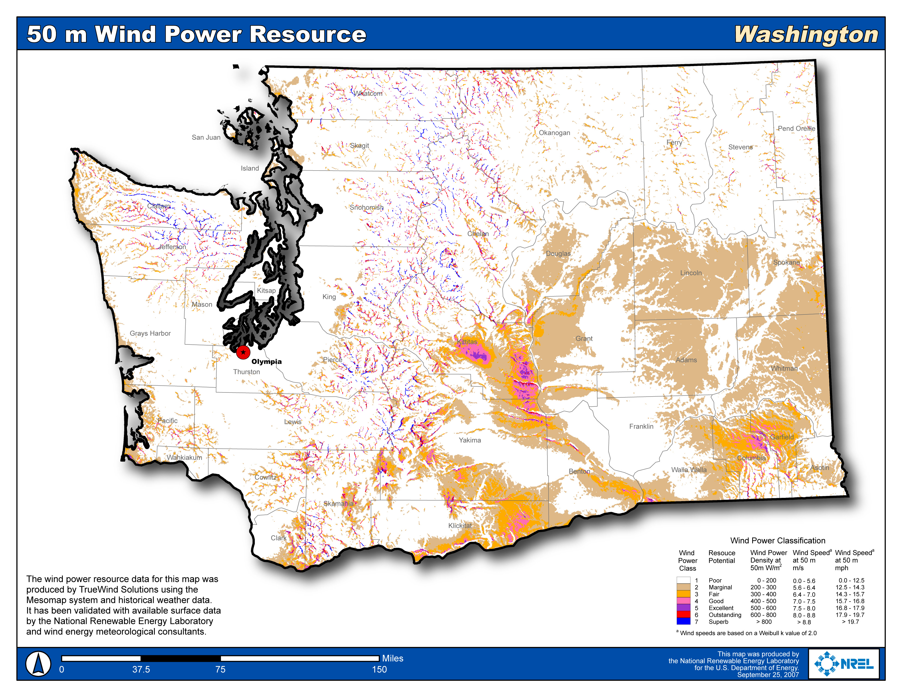
Appendix B. Solar Resource Potential in the Northwest
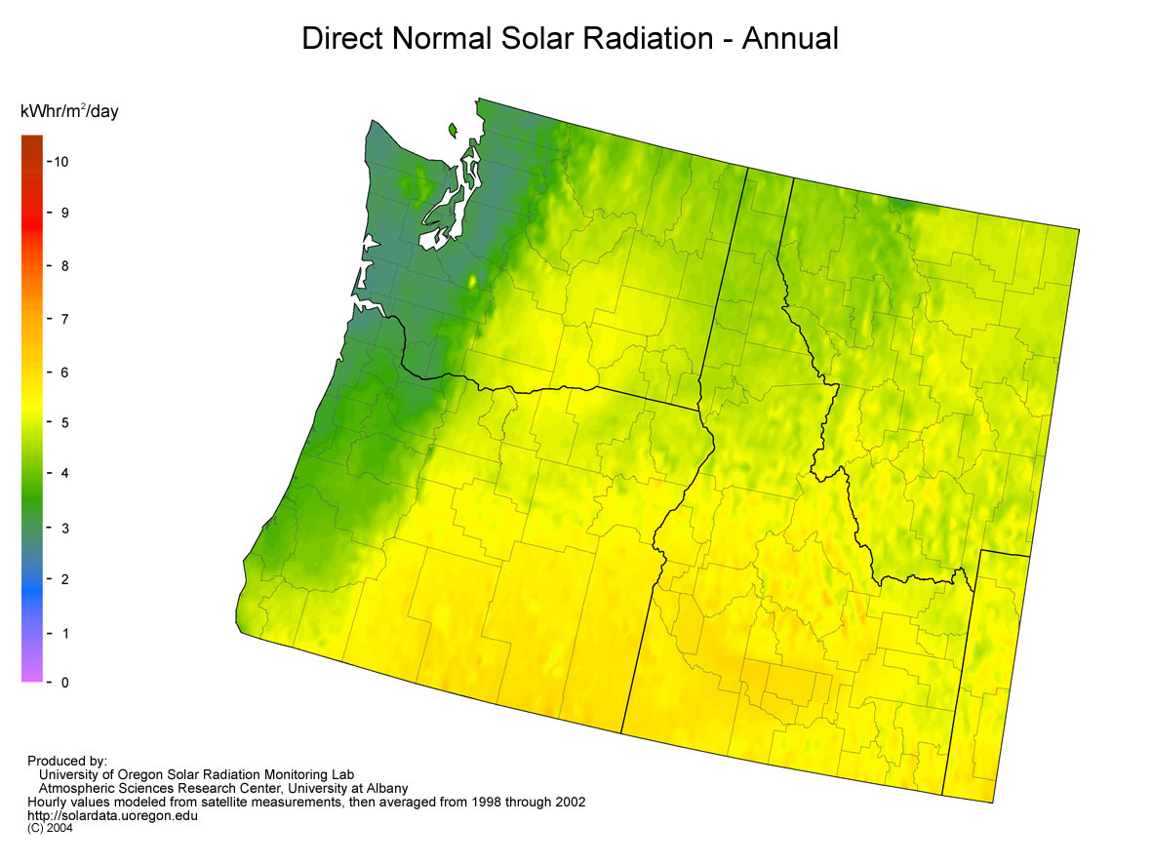
Appendix C. Biomass Resource Potential in Washington.
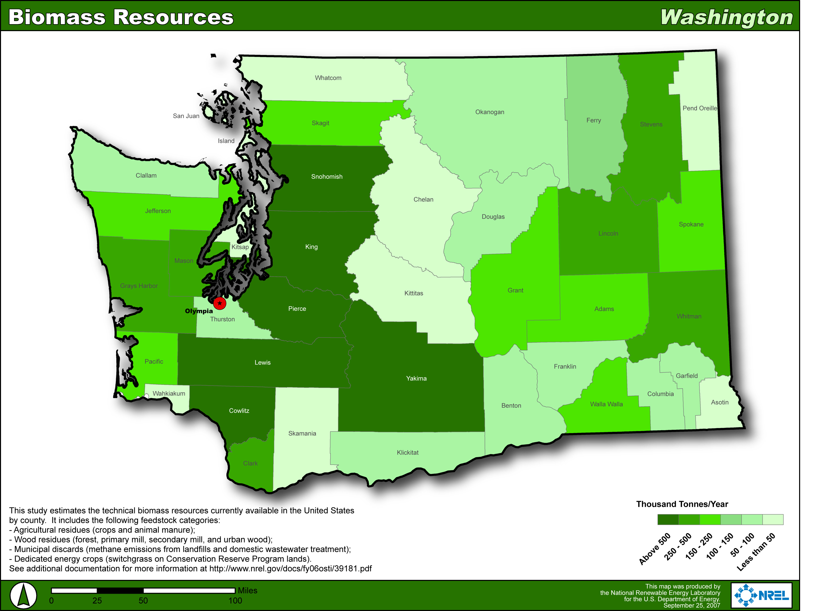

Appendix D. NW Energy Coalition Feed-In Tariff Resolution

NW Energy Coalition
Feed-in Tariff Resolution
November 14, 2009

Background
Feed-in tariffs are policy mechanisms designed to accelerate deployment of specified types of renewable energy production and to reduce greenhouse gas emissions. They require utilities to interconnect qualifying renewable energy resources and to pay producers a premium price for every kilowatt-hour (kWh) produced by the qualifying renewable energy resource.

Resolution
Whereas there is scientific consensus that the climate is changing due to greenhouse gas emissions; and

Whereas widespread development of renewable energy reduces the need for power from fossil fuels; and

Whereas feed-in tariffs have the proven ability to quickly boost development of certain types of renewable energy and promote increased adoption of specific renewable energy technologies; and

Whereas feed-in tariffs can increase development of local, distributed renewable energy; and

Whereas feed-in tariffs have been successfully employed internationally and are believed to have contributed to lowering the costs and increasing the uptake of renewable energy development; and

Whereas feed-in tariffs can be used as a policy to complement and go beyond Renewable Portfolio Standards, and

Whereas the NW Energy Coalition advocates for a clean and affordable energy future for our region based on (a) using energy efficiency and new renewable energy resources to meet all load growth and new energy demand and to replace the power from the coal-fired power plants now serving the Northwest, and b) consumer and low-income protection;

Now, therefore, be it resolved that the NW Energy Coalition may support value-based feed-in tariff policies for local distributed renewable energy generation systems as a means of overcoming market barriers to environmentally responsible development of specific kinds of renewable energy, when such policies include the following provisions:

a) Prices set higher than those paid to non-qualifying resources, reflecting the value to the public of stimulating development of preferred resources.
b) Contract terms for qualifying renewable energy resources should be available for the expected life of the resources.

c) A consideration of packaging with additional policies to facilitate more effective deployment of renewable energy technologies, such as addressing permitting and other development barriers.

d) Technology and size-specific price levels and mechanisms that are developed by a transparent political process with input from industry, consumer advocates, producers and users.

e) Periodic review of pricing as a specified technology matures and market penetration increases with a focus on mitigating rate impacts by adjusting the premium price paid.

f) A determination of how the premium price paid is allocated among billpayers, with an evaluation of potential bill impacts and program benefits.

g) Strategies to protect low and fixed income consumers from bill impacts resulting from this policy. Strategies could include rate discounts, bill payment and weatherization programs.

h) Elements to address interconnection upgrade costs, with consideration of a cap on interconnection costs covered by the premium price paid.

i) Guidance to the price-setting body to consider various methods of funding the premium price paid, in order to achieve the goal of short run stimulus of development while ensuring long-term benefits to the public.

j) Feed-in tariffs should be linked to energy efficiency programs so producers participating in the tariff program are as efficient and cost-effective as possible.

- Guidance to the price-setting body to consider existing programs and policies and make sure the policies work efficiently and effectively together.

Adopted by the NW Energy Coalition Board November 14, 2009.

Appendix E. Solar PV Resource in the United States and Germany.
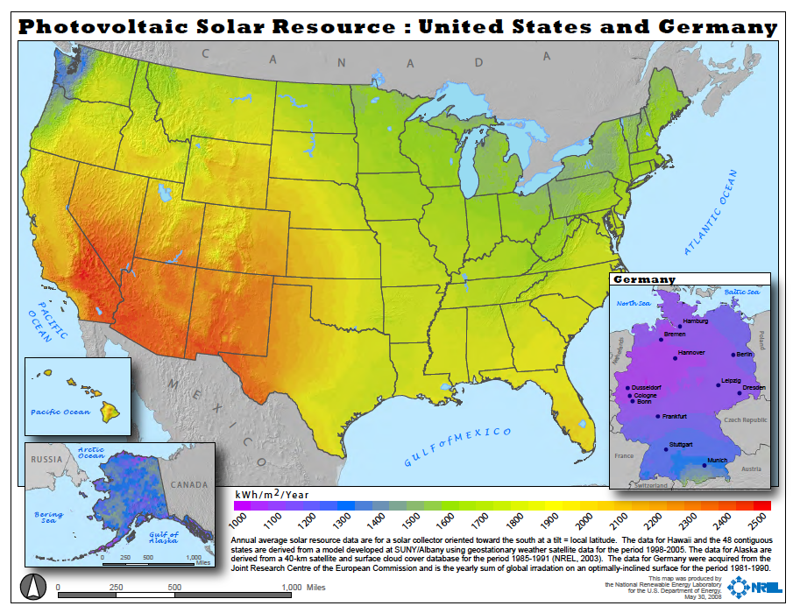

Available from: http://www.energyatlas.org/
Perez, Sweibel and Hoff. Solar Power Generation in the US: too expensive, or a bargain? 2011. Available from: www.asrc.cestm.albany.edu/perez/2011/solval.pdf.
WAC 480-100-238
Docket No. UE-030311, General Order No. R-526, issued 1/9/2006
Id., 480-100-238 Adoption Rule Text.
Docket No. UE-030311, General Order No. R-526, issued 1/9/2006, at 16.
RCW 19.285.030(9)
RCW 19.27A.150(1)(d)
RCW 82.16.110-140
2005 c 300 § 1 (enacted via SB 5101).
PacifiCorp 2011 IRP, ps. 121-24, 243-44, 254.
RCW 19.285.030(9)
RCW 80.60.010(10)
RCW 82.16.110 (2)(a), (3), (7), and (8)
RCW 80.80.010(10). The term “distributed generation” appears only in the definitions section of this statute.
Perez, R., R. Seals, H. Wenger, T. Hoff and C. Herig, (1997): PV as a Long‐Term Solution to Power Outages. Case Study: The Great 1996 WSCC Power Outage. Proc. ASES Annual Conference, Washington, DC.
Perez, Sweibel and Hoff. Solar Power Generation in the US: too expensive, or a bargain? 2011. Available from: www.asrc.cestm.albany.edu/perez/2011/solval.pdf.
Kacia Brockman. Senior Solar Program Manager, Energy Trust of Oregon. Personal Conversation, July 12, 2011.
Based on conversations with solar PV contractors.
http://www.renewablesinternational.net/small-german-solar-roofs-still-cheaper-than-us-utility-pv/150/452/31381/
Mills, Andrew and Wiser, Ryan. 2010. Lawrence Berkeley National Laboratory (LBNL). Implications of Wide-Area Geographic Diversity for Short-Term Variability of Solar Power. LBNL-3884E. September, 2010.
This report is available at: http://rnp.org/node/rnp-report-solar-pv-variability-and-grid-integration
These rates represent a presumed 10% reduction from the rates allocated during the previous open application period on April 1, 2011. These rates will not be certain until the OPUC acts on the decision in August 2011 or later.
RCW 19.285.030(18)
RCW 19.285.030(10)

