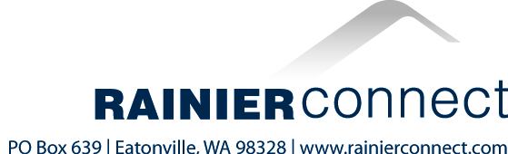

February 9, 2018

BY WUTC WEB PORTAL

Mr. Steven V. King
Executive Director and Secretary
Washington Utilities and Transportation Commission
1300 S Evergreen Park Drive, SW
PO Box 47250
Olympia, WA 98504-72550

Dear Mr. King:

RE: Docket No. UT-180001
Federal Lifeline Certification and Reporting
Pursuant to 47 C.F.R. Section 54.416 (b)

Pursuant to 47 C.F.R. 54.416(b), accompanying this letter for filing with the Washington Utilities and Transportation Commission is a copy of the completed FCC Form 555 (“Annual Lifeline Eligible Telecommunications Carrier Certification Form”), for the reporting year ended December 31, 2017, that has been submitted by Mashell Telecom, Inc. to the Universal Service Administrative Company (USAC) with respect to the Company’s Lifeline service subscribers residing in the State of Washington.

Please let us know if the Commission has any questions regarding the information presented on the form.

Sincerely,

Danielle Clausen
Controller

