**GRADE CROSSING PROTECTIVE FUND**

**2013 – 2015 GRANT APPLICATION QUESTION RESPONSES**

1. **A detailed summary of the hazard being addressed. Include any information about accidents or incidents at the site and photographs, drawings or other materials that support the application.**

The project is designed to reduce the potential for pedestrian/train accidents created by people crossing onto the train tracks along a park site. Currently there is no fence or barrier along the railroad frontage (photos attached).

1. **A detailed summary of the proposed project and how it will eliminate or mitigate the hazard. Include any drawings or construction plans for the proposed project.**

In July 2013, the City acquired 4.97 acres of property for a park through a private property donation. The property had been used as a depository for construction debris and by a transient population. It is located between the Columbia River, the Apple Capital Recreational Loop Trail and the railroad tracks in the southeast Wenatchee.

Working with the community, a conceptual design for the park was created which includes, picnic facilities, skate park, dog off leash area, play equipment and other amenities. Public use of the site is anticipated to increase dramatically after the park is constructed. Construction is anticipated to occur in 2016 with funding from a variety of grants, donations and through fundraising efforts of local citizens.

Our proposed project will fence 1,920 feet of railroad frontage with a 6 foot tall, 9 gauge, black chain link fence. The fencing project would be completed over three years, in three separate phases. The fence would be posted with "no trespassing" signs along its length or with other wording acceptable to the railroad. The fence would include three, locked vehicle gates to provide access for railroad maintenance if needed. We are hoping that this project could be completed prior to the park construction to establish access patterns prior to the site being used more heavily.

Phase one of the project install 628 feet of fence and two gates on the Southern portion of the site. Phase two would install 714 feet of fence in the center portion of the site and the final phase scheduled for 2016, would complete the project by installing 578 feet of fence and one gate. The fence would be signed as segments are installed. The project is phased in this manner to avoid storm water construction work that is anticipated to occur on the northern portion of the site in the fall of 2015.

The project is designed to reduce the potential for pedestrians crossing onto the train tracks and being injured by providing a barrier to access.

Planning is underway for an East-West reconnection of the Columbia River pedestrian bridge over the tracks to Wenatchee Avenue to allow people to safely cross the tracks and address the desire of people to access south Wenatchee from the river and trail. The bridge project was identified also identified as a priority to the community through several recent planning efforts including the City Council "Let's Talk" sessions, South Wenatchee Sustainable Design Assessment Team Project, SR 285 Safety improvement Project and others.

1. **A list of all other companies, organizations, state agencies or local governments that may be involved in implementing this proposal, and the contact name, address and phone number for each (if known).**

The City of Wenatchee will be the agency with primary responsibility for the project. The two individuals working on the project for the City will be:

City of Wenatchee

David Erickson, Parks and Recreation Director & Dan Frazier, Public Works Director

PO Box 519, Wenatchee, WA 98801

daerickson@wenatcheewa.gov

(509) 888-3280 (Parks), (509) 888-3214 (Public Works)

1. **A cost estimate, including:**
   1. **An itemized list of the total costs of the project.**

Fence: 1,920 Lineal feet @ $28 per foot material cost $53,760

Fence installation cost @ $5.34 per foot $10,258

Gates: 3 @ $1,200 each $3,600

Signs: 20 @ $25 $500

Locks: 3 @ $15 $45

Total $68,163

* 1. **Names of parties contributing to the project, including the applicant, and the amount each is contributing.**

**2014 2015 2016**

**TOTAL** **PHASE ONE PHASE TWO PHASE THREE**

Grant Request: $57,360 $19,984 $19,992 $17,384

City of Wenatchee: $10,803 $3,561 $3,965 $3,277

Total $68,163 $23,545 $23,957 $20,661

1. **The name of the party responsible for long-term maintenance, such as repair of fencing.**

City of Wenatchee Public Works- Rob Richards, Park Maintenance Supervisor.

1. **An estimated timeline of the project.**

**PHASE ONE**

July 2014 – Survey boundary

August 1, 2014 – Request for quotes process underway

September 26, 2014 – Purchase materials

October 7, 2014 – Begin construction of fence and install signs

October 30, 2014 – Phase complete, submit reimbursement requests/billing/reports etc.

**PHASE TWO**

June 2, 2015 –Request for quotes process underway

June 22, 2015 – Purchase materials

July 13, 2015 – Begin construction of fence and install signs

September 30, 2015 – Phase complete, submit reimbursement requests/billing/reports etc.

**PHASE THREE**

June 6, 2016 – Request for quotes process underway

June 27, 2016 – Purchase materials

July 11, 2016 – Begin construction of fence and install signs

September 30, 2016 – Project complete, submit reimbursement requests/billing/reports etc.

1. **A description of how the project’s success would be measured.**

Measurement may be completed by monitoring the number of accidents or citations written to people crossing onto the tracks.

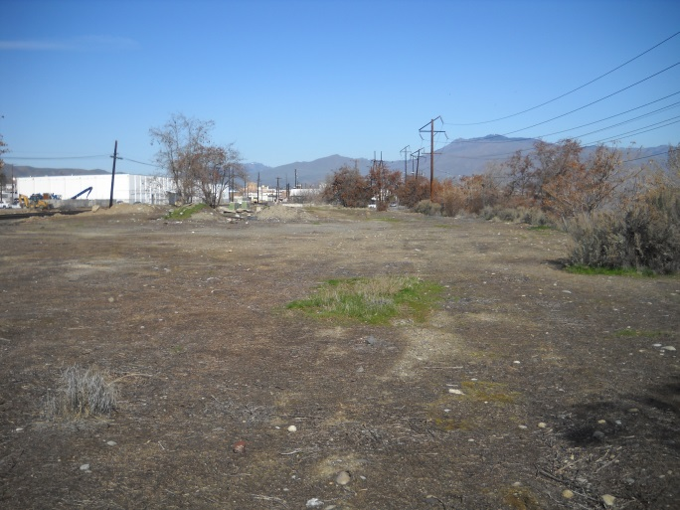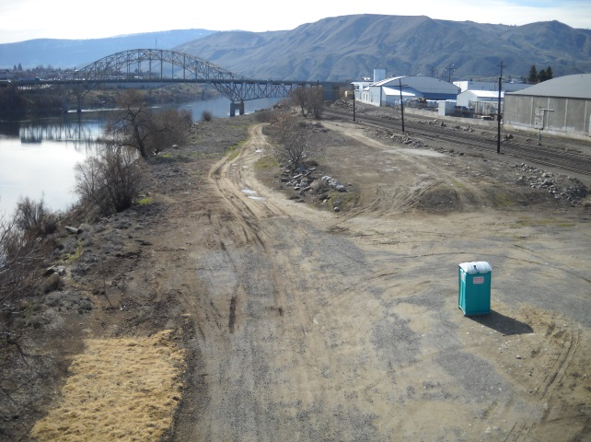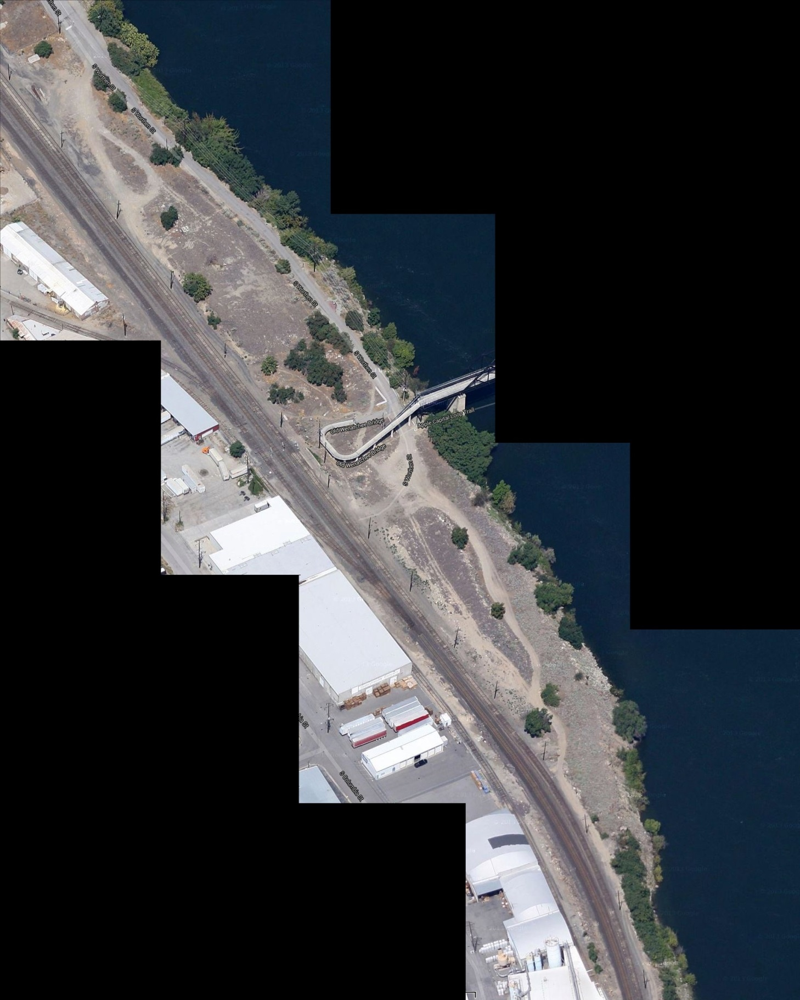

**End of phase, fence will connect**

**Proposed Fence**

**Existing Fence**

**Phase Two - 2015**

**Phase Three - 2016**

**Phase One - 2014**

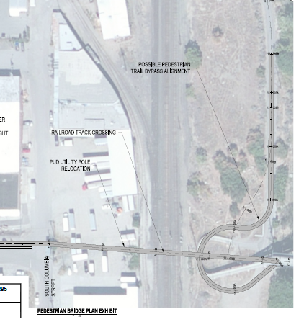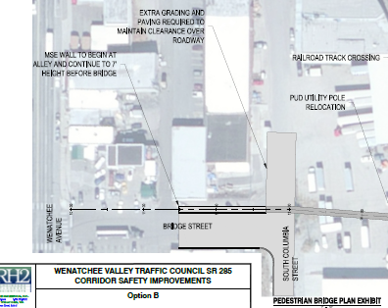

Pedestrian Bridge Extension Concept