

**STATE OF WASHINGTON**

WASHINGTON UTILITIES AND TRANSPORTATION COMMISSION

***1300 S. Evergreen Park Dr. S.W., P.O. Box 47250 ● Olympia, Washington 98504-7250***

***(360) 664-1160 ● TTY (360) 586-8203***

December 18, 2012

David W. Danner, Executive Director and Secretary

Washington Utilities and Transportation Commission

1300 S. Evergreen Park Dr. SW

P. O. Box 47250

Olympia, Washington 98504-7250

RE: *Washington Utilities and Transportation Commission v. A-1 Premium Moving*

Commission Staff’s Response to Application for Mitigation of Penalties

Docket TV-120903

Dear Mr. Danner:

On July 23, 2012, the Washington Utilities and Transportation Commission issued a $2,100 Penalty Assessment in Docket TV-120903 against A-1 Premium Moving for 21 violations of Washington Administrative Code (WAC) 480-15-480, which requires permitted household goods carriers to furnish annual reports to the commission no later than May 1 each year.

On August 6, 2012, A-1 Premium Moving wrote the commission requesting mitigation of penalties (Mitigation Request). [1] In its Mitigation Request, A-1 Premium Moving does not dispute that the violation occurred. The company states, “I missed place [sic] the annual Report and thought I had given it to my accountant to file. I later found out that she had not received it, so I am filing it now.”

It is the company’s responsibility to ensure that the regulatory fee is paid and the annual report is filed by the May 1 deadline. On February 29, 2012, Annual Report forms and Regulatory Fee packets were mailed to all regulated household goods carriers. [2] The cover letter informed the regulated company it must complete the annual report form, pay any regulatory fees, and return the material by May 1, 2012, to avoid enforcement action. On May 15, 2012, the commission mailed a letter to those companies that had not yet filed an annual report notifying them that, to date, they had incurred a penalty of $900. [3] The letter went on to explain that companies who filed their annual reports no later than May 25, 2012, would receive mitigated penalties of $25 per day. An additional penalty of $25 per day would be assessed for each instance in the previous five years that the company received a penalty for filing a late report, up to a maximum of $100 per day.

A-1 Premium Moving did not file its annual report by May 31, 2012, which is 21 business days past the deadline of May 1, 2012. The penalty is $100 per day for a total of $2,100. A-1 Premium Moving became regulated in July 2010 and has never received a penalty for filing a delinquent annual report. The commission received A-1 Premium Moving’s completed annual report on August 6, 2012. Therefore, staff supports mitigating the assessed penalty from $2,100 to $1,050, which represents a 50 percent reduction because this is A-1 Premium Moving’s first late filing.

If you have questions regarding this recommendation, please contact Mathew Perkinson, Compliance Investigator, at (360) 664-1105, or at [mperkinson@utc.wa.gov](mailto:mperkinson@utc.wa.gov).

Sincerely,

Sharon Wallace, Assistant Director

Consumer Protection and Communications

**Attachment A**

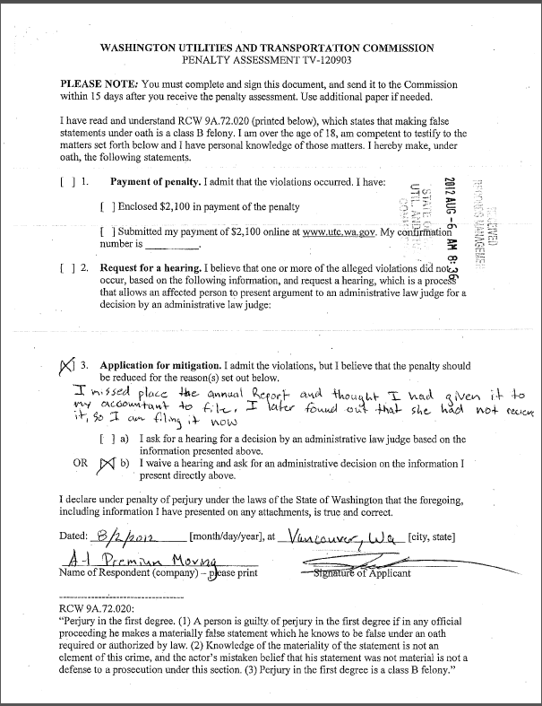**Attachment B**

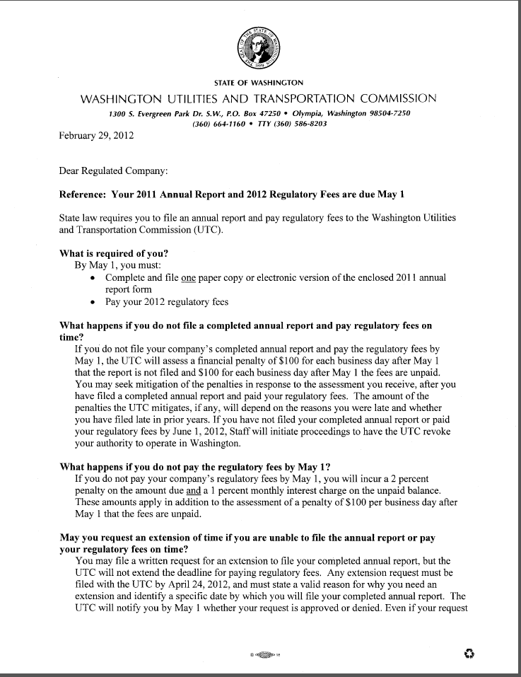

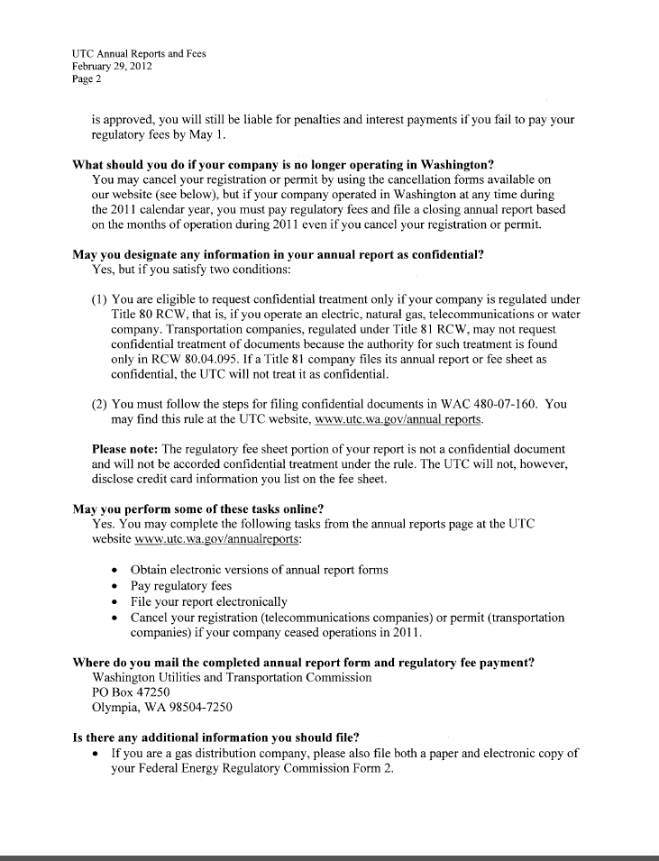

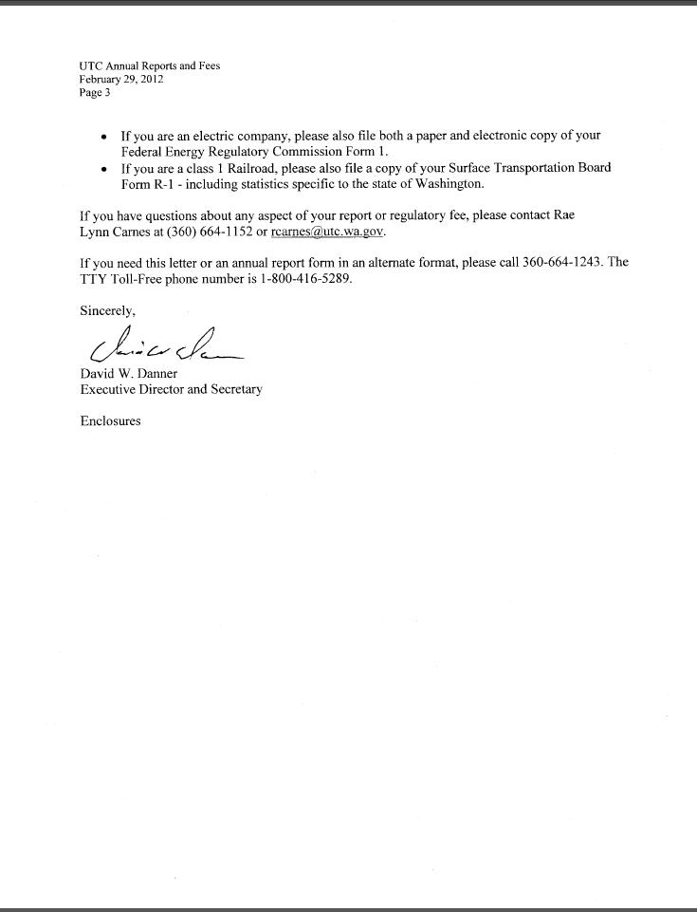**Attachment C**

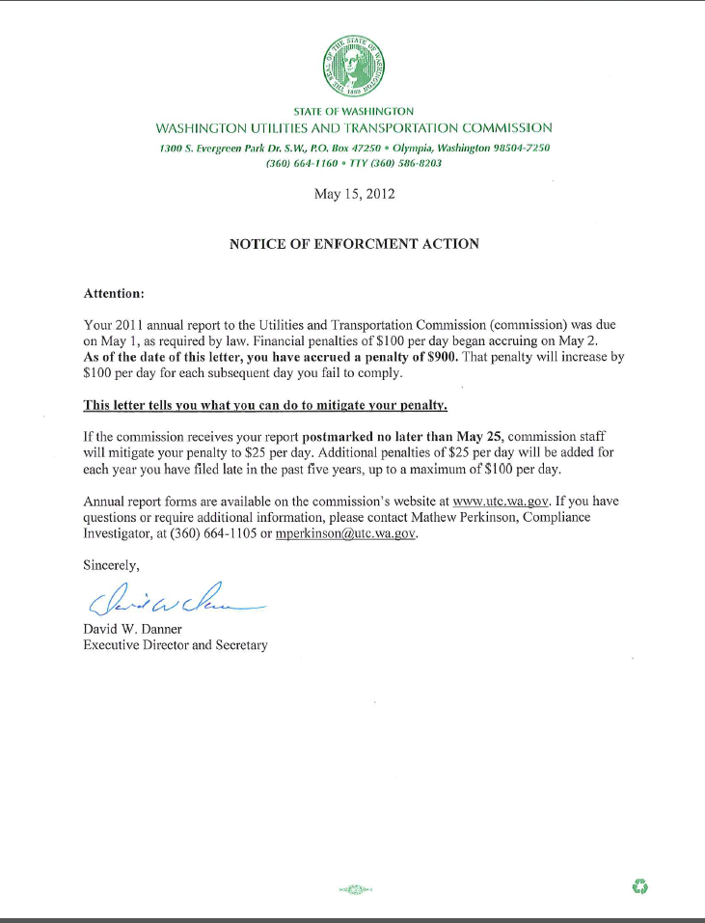

1. See attachment A for a copy of A-1 Premium Moving’s Mitigation Request.
2. See attachment B for a copy of the letter sent to all regulated companies on February 29, 2012.
3. See attachment C for a copy of the enforcement letter sent to the company on May 15, 2012.