**AVISTA CORP.**

### RESPONSE TO REQUEST FOR INFORMATION

# JURISDICTION: WASHINGTON DATE PREPARED: 07/11/2016

# CASE NO.: UE-160228 & UG-160229 WITNESS: Karen Schuh

# REQUESTER: UTC Staff – Huang RESPONDER: David Machado

# TYPE: Data Request DEPT: State & Federal Regulation

# REQUEST NO.: Staff - 132 TELEPHONE: (509) 495-4554

EMAIL: david.machado@avistacorp.com

**REQUEST:**

Please provide the total amounts of the ongoing capital expenditures associated with normal outage activities on Units 3 & 4 at Colstrip from 2005-2015. Please make this Data Request comparable to the information provided in Karen Schuh’s Exhibit No.___ (KKS-5), Section 1, page 20, for the 2016, 2017 and 2018 information.

**RESPONSE:**

Staff_DR_132 Attachment A includes transfers to plant for Colstrip Thermal Capital from 2005-2015.

Colstrip capital expenditures generally coincide with outages that occur every 3rd year for each unit. Some years, such as was the case in 2015, we do not have a scheduled outage on a unit, resulting in a lower level of capital investment for that year (though some investment continues to occur), as illustrated in the graph below until 2016.

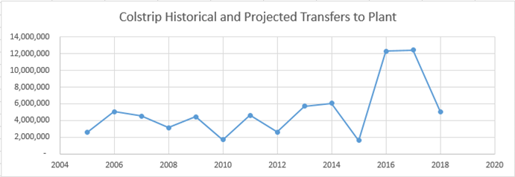

The major jump in capital investment in 2016, 2017, and 2018 is due primarily to new NOx reduction equipment and the new Coal Combustion Residual (CCR) regulations, with which Colstrip must comply. The planned additional capital investment related to these specific projects is provided below:

**2016**

**2017**

**2018**

NOx Equipment

2.05

$

1.33

$

CCR Equipment

3.34

$

2.77

$

2.10

$

Total

5.39

$

4.10

$

2.10

$