BEFORE THE WASHINGTON UTILITIES AND TRANSPORTATION COMMISSION

|  |  |
| --- | --- |
| SHUTTLE EXPRESS, INC.,  Petitioner and Complainant,  v.  SPEEDISHUTTLE WASHINGTON, LLC,  Respondent. | DOCKET NOS. TC-143691 & TC-160516  DECLARATION OF JACK ROEMER IN SUPPORT OF ANSWER OF SPEEDISHUTTLE TO PETITION FOR LIMITED INTERLOCUTORY REVIEW OF ORDERS 12/05/02 |

### Jack Roemer hereby declares as follows:

### I am the Chief Financial Officer of Speedishuttle Washington, LLC (“Speedishuttle”) and in support of Speedishuttle’s Answer in Opposition to Shuttle Express, Inc.’s Petition for Qualified Limited Review of Order 12/05/02 I offer this declaration.

### In its pleadings and current filing with the Commission, Shuttle Express has repeatedly asserted that its decline in passenger counts in 2015 and 2016 was due to competition from Speedishuttle. While Shuttle Express likely has lost some passengers to Speedishuttle, I thoroughly disagree with its conclusions and analysis.

### Trip data for Sea-Tac International Airport derived from records requests to the Port of Seattle demonstrate that ground transportation trips to and from the airport have been increasing annually since at least 2010. During the period of 2010 to 2015, SeaTac Airport trips increased from approximately 1.75 million to approximately 2.8 million trips per year.

### During that same period, Shuttle Express apparently saw a year-over-year increase in passenger count only once, between 2011 and 2012. In fact, between 2012 and 2013, Shuttle Express saw its passenger count decline by more than 70,000, and between 2012 and 2014, Shuttle Express’s annual passenger count declined by approximately 100,000 passenger trips. Those trips also are not separated by door-to-door or routed transportation. There is no way to know whether the reduction is more pronounced in the door-to-door market in which Speedishuttle is authorized.

### I created the following chart, which accurately reflects the trip data obtained from the Port of Seattle and passenger counts, derived from Shuttle Express annual reports to the Commission:

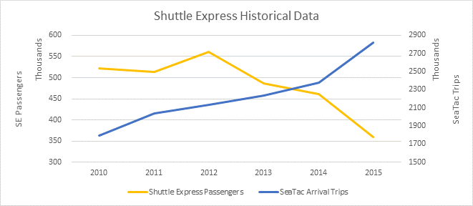

### As is well established on this record, Speedishuttle did not commence operations in Washington State until May 2015.

### Thus, Shuttle Express experienced a significant decline in passenger counts before Speedishuttle’s presence in Seattle, while all throughout the period of that decline the total number of passengers receiving ground transportation to and from the airport increased dramatically.

### I also expect tourist traffic from the airport to downtown Seattle to continue to rise, as cruise ship sizes have increased and reported cruise ship passenger counts are also increasing.

### Shuttle Express’ latest attribution of passenger count declines to Speedishuttle also ignores transportation network companies (“TNCs”) which have significantly grown their presence at SeaTac during the same period of Speedishuttle’s operations, and which obtained authority from the Port of Seattle to pick up shared ride passengers at the airport for the first in the Spring of 2016, likely adding to their trip count from that time onward.  Whether the TNC’s business model will prove to be economically sustainable remains to be seen.

The foregoing statement is made under penalty of perjury under the laws of the State of Washington, is based on personal knowledge, and is true and correct.

SIGNED at Maui, Hawaii this ______ day of January, 2017.

Jack Roemer