

# STATE OF WASHINGTON

## **DEPARTMENT OF ECOLOGY**

***Northwest Regional Office ●3190 160th Ave SE ● Bellevue, Washington 98008-5452 ● (425) 649-7000***

***711 for Washington Relay Service ●Persons with a speech disability can call 877-833-6341***

December 1, 2016

Utilities and Transportation Commission

1300 South Evergreen Park Drive SW

Olympia, WA 98504

**RE*: Skagit County Solid Waste Management Plan, Preliminary Draft November 2016***

Dear Utilities and Transportation Commission (UTC):

The Department of Ecology (Ecology) received Skagit County’s preliminary draft solid waste management plan and formal request for review via e-mail on November 30, 2016. On that same day, I forwarded the e-mail to the UTC Records Center, with a request for the UTC to perform its 45-day review. Today, I am following up with the requested cover letter for our request.

Per RCW 70.95.096, Ecology is to provide the UTC with a copy the preliminary draft local comprehensive solid waste management plan immediately upon receipt. The UTC shall then review the plan’s assessment of solid waste collection cost impacts on rates charged by solid waste collection companies regulated under chapter 81.77 RCW and advise the submitting county and Ecology of the probable effect of the plan’s recommendations on those rates. I look forward to receiving your input, and may be reached at:

Diana Wadley

Waste 2 Resources Program

Ecology NW Regional Office

3190 160th Ave SE

Bellevue, WA 98008

[Diana.wadley@ecy.wa.gov](mailto:Diana.wadley@ecy.wa.gov)

425-649-7056

The Skagit County contact for your review is:

Margo Gillaspy, LHg

Skagit County Public Works

1800 Continental Place

Mount Vernon, WA 98273-5625

[margog@co.skagit.wa.us](mailto:margog@co.skagit.wa.us)

360-416-1441

Thank you for your review, and please feel free to contact me at any time.

Sincerely,

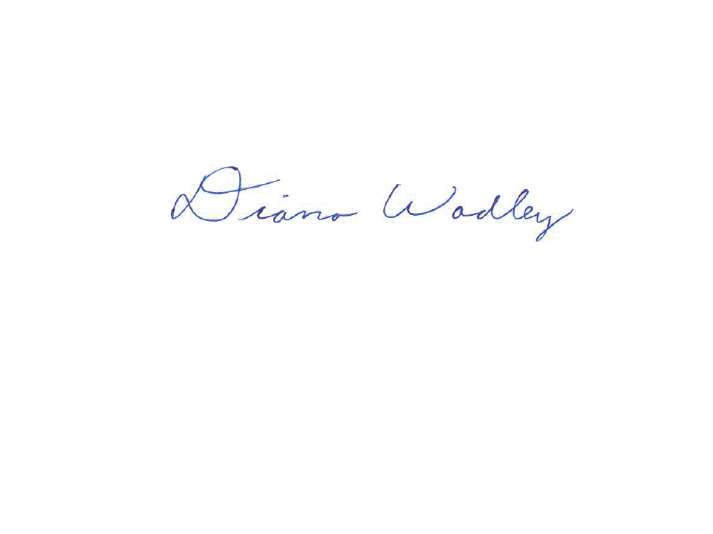

Diana Wadley

Planner and Grant Financial/Project Manager

Waste 2 Resources Program

cc: Margo Gillaspy, Skagit County Solid Waste Division Manager

Peter Christiansen, Waste 2 Resources Section Manager