

**STATE OF WASHINGTON**

WASHINGTON UTILITIES AND TRANSPORTATION COMMISSION

***1300 S. Evergreen Park Dr. S.W., P.O. Box 47250 ● Olympia, Washington 98504-7250***

***(360) 664-1160 ● TTY (360) 586-8203***

March 20, 2013

Steven V. King, Acting Executive Director and Secretary

Washington Utilities and Transportation Commission

1300 S. Evergreen Park Dr. SW

P. O. Box 47250

Olympia, Washington 98504-7250

RE: *Washington Utilities and Transportation Commission v. John Chi International Corp.*

Commission Staff’s Response to Application for Mitigation of Penalties

Docket TE-130204

Dear Mr. King:

On March 5, 2013, the Washington Utilities and Transportation Commission issued a $600 Penalty Assessment in Docket TE-130204 against John Chi International Corp. (John Chi) for six violations of WAC 480-30-071, which requires Charter and Excursion companies to file annual safety reports with the Commission by December 31 each year; and WAC 480-30-076, which requires such companies to pay regulatory fees annually on that date. [1]

On March 12, 2013, John Chi responded to the commission, requesting mitigation of the penalty. In its mitigation request, John Chi does not dispute that the violations occurred. The company indicates that it is operated by only Mr. Chi and that he was in Asia for a business fair and some personal matters during the time the report was required to be filed. Mr. Chi states that he had no intention of breaking the rules. Mr. Chi also states that the annual report process is new to him. He requests reconsideration of the penalty.[2]

It is the company’s responsibility to ensure that the regulatory fee is paid and the annual report is filed by the December 31 deadline. On November 15, 2012, the commission mailed 2012 Annual Safety Report forms and 2013 regulatory Fee packets to Charter and Excursion companies registered in Washington state. A letter from the commission’s Assistant Director for Transportation Safety, David Pratt, instructed these companies to file annual reports and pay regulatory fees by December 31, 2012. The letter stated failure to file the annual report by December 31 would result in a penalty and possible cancellation of the company’s permit to operate in Washington. Those companies wishing to request an extension to file the annual report were asked to do so prior to December 31, providing a reason for the requested extension. No extension was requested.[3]

On January 7, 2013, the commission issued a notice to companies that had not yet filed their annual report and paid regulatory fees, informing these companies that they were subject to enforcement action, including the assessment of penalties beginning to accrue on that date. Companies that filed their annual reports and paid regulatory fees after January 7, 2013, but on or before January 18, 2013, are subject to penalties that the commission uses its discretion to mitigate to $25 per day if the company had not made these filings late in prior years. Companies that were late in prior years are subject to an additional $25 per day for each year in which they were late up to a total of $100 per day. For first time late-filers who filed their report after January 18, the commission will mitigate the penalties to 50 percent of the maximum permissible amount. No further mitigation will be granted unless the company provides new information that is unrelated to these factors. Mitigation will not be granted on the basis that a company was unaware a report must be filed.[4]

John Chi filed its 2012 annual safety report and paid its 2013 regulatory fee on January 23, 2013. That date is 12 business days past the January 7, 2013, notice date when penalties began to accrue, resulting in a potential penalty assessment of $1,200 ($100 per day times 12 days). John Chi has not previously missed the deadline for filing its annual report and paying its regulatory fees. The commission therefore mitigated the penalty by 50 percent to a total assessed penalty of $600.

Staff does not support mitigating the $600 penalty assessment further. The penalty was already administratively mitigated by 50 percent, from $1,200 to $600. In addition, the penalty assessment states mitigation will not be granted on the basis that a company was unaware a report must be filed. Staff recommends denying the mitigation request.

If you have questions regarding this recommendation, please contact Mathew Perkinson, Compliance Investigator, at (360) 664-1105, or at mperkinson@utc.wa.gov.

Sincerely,

Sharon Wallace, Assistant Director

Consumer Protection and Communications

**Attachment A**

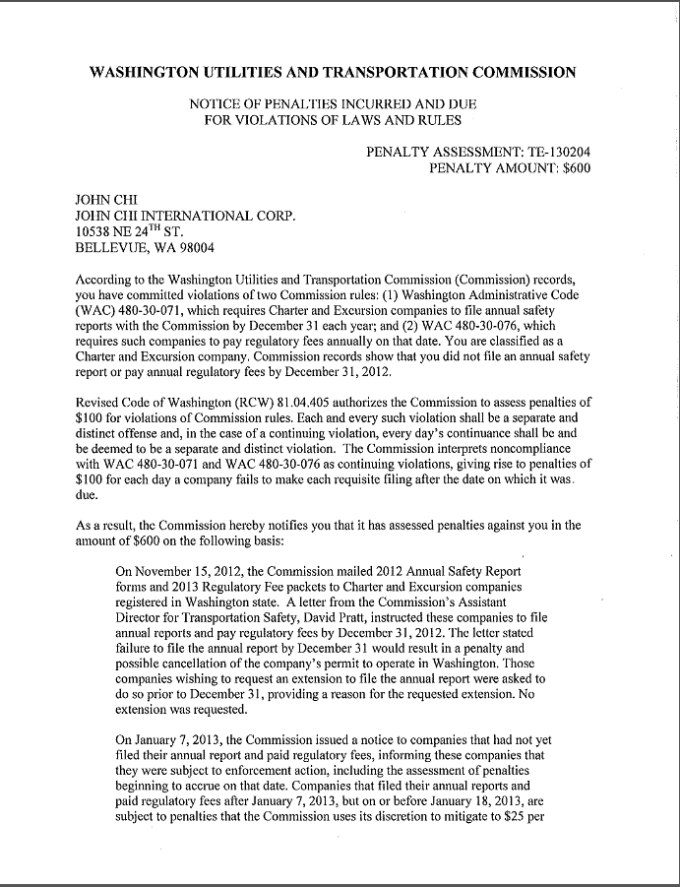

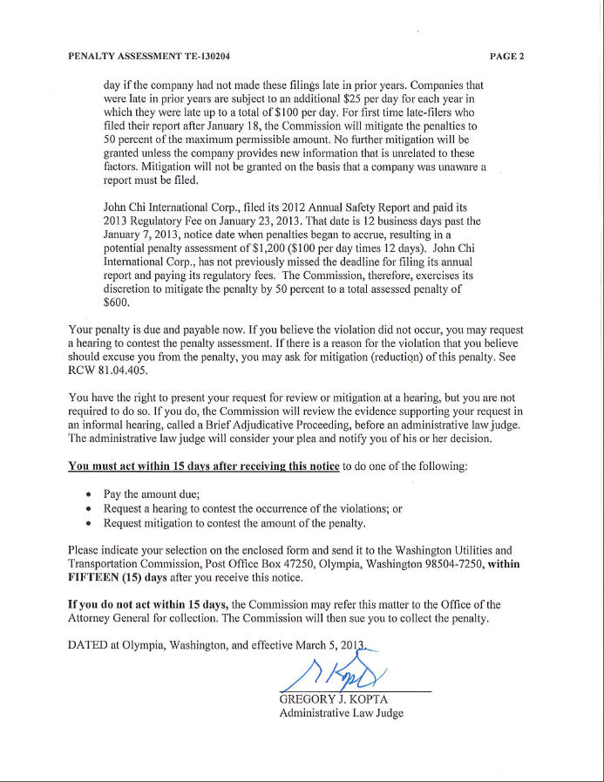

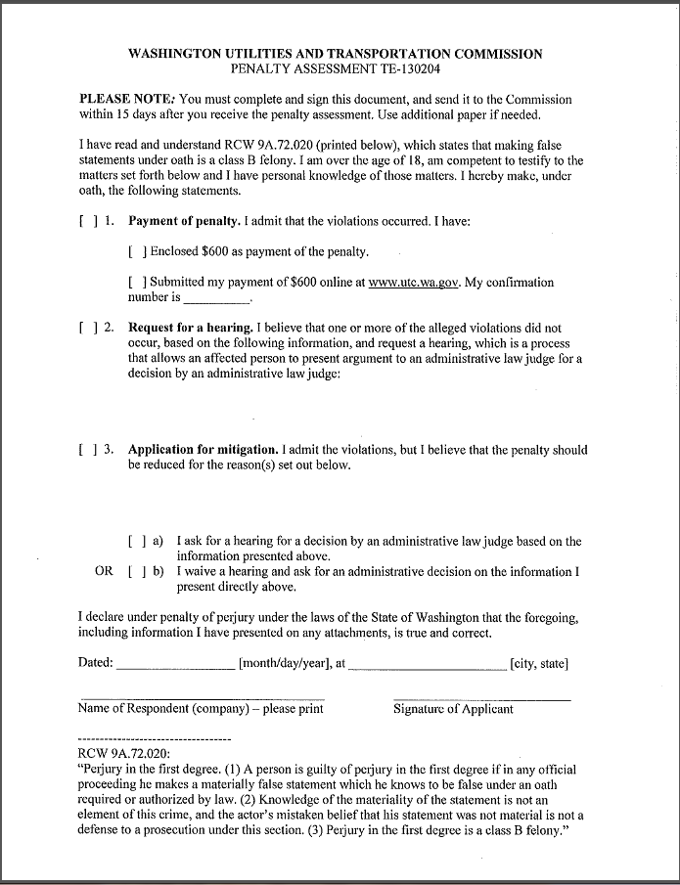

**Attachment B**

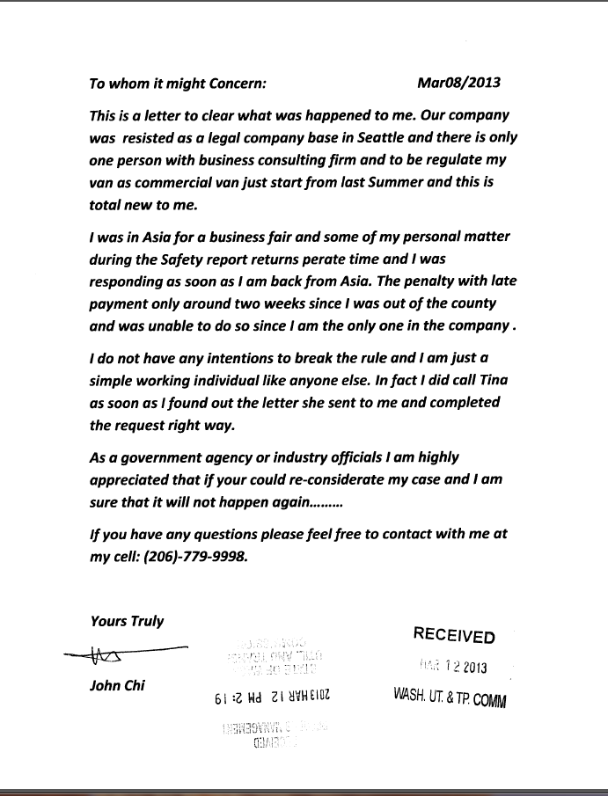

**Attachment C**

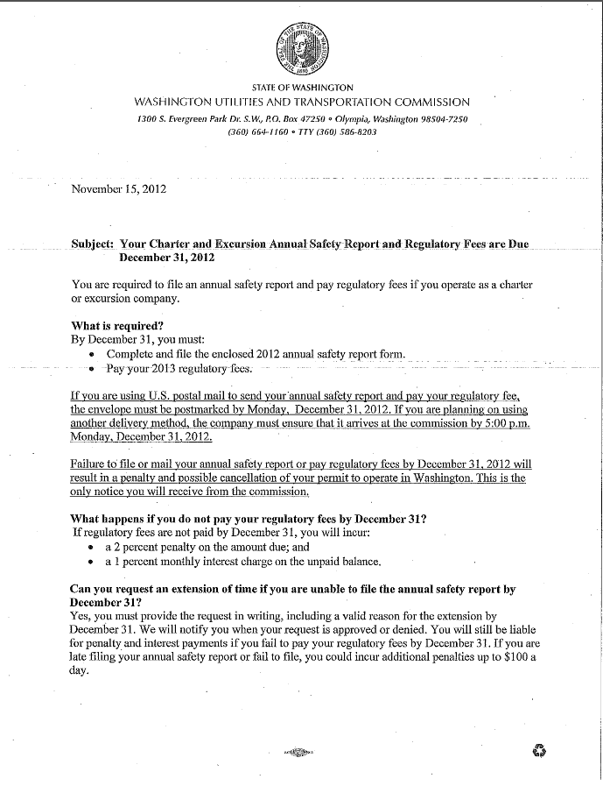

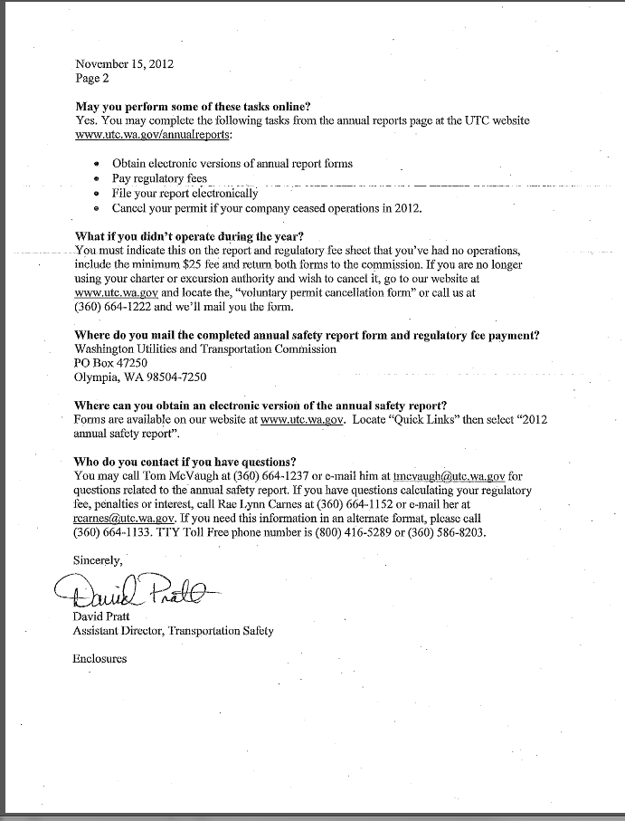

**Attachment D**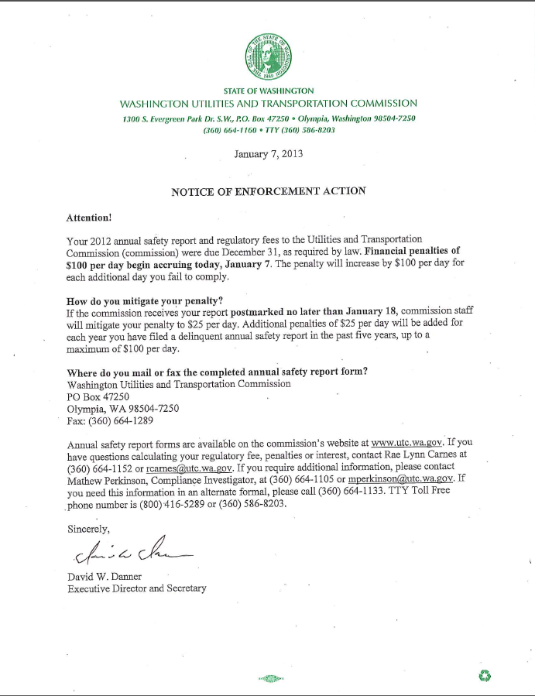

1. See Attachment A for a copy of the penalty assessment sent to John Chi International Corp.
2. See Attachment B for a copy of the letter submitted by the company on March 12, 2013.
3. See Attachment C for a copy of the letter sent to all regulated companies on November 15, 2012.
4. See Attachment D for a copy of the Enforcement letter sent to all delinquent companies on January 7, 2013.