

**2014**

**Qualifying Events Report**

**December 10, 2014 Event**

Filed on March 10, 2015

# **Table of Contents**

Table of Contents 2

Event Description 3

**Event Date and Time** 3

**Event Type** 3

**Service Areas Significantly Affected** 3

**Number of Customers Affected** 3

**Summary of System Impacts** 3

**Mobilization Summary** 3

Active Outage Event Chart 4

Major Event Day – Qualification 5

Qualified Events - 2014 5

**Current Event – Calculation Detail** 5

**YTD Daily SAIDI Detail** 5

Event Restoration – Cost Summary 6

**YTD Storm Restoration Costs Detail** 6

Detail Documents 7

**Restoration Cost Detail – Current Event** 8

**Detailed List of Outages Starting on December 10, 2014, the First TMED-Exceeding Day of the Current Event** 9

**Terms, Codes and Definitions Used on Detail Reports** 13

Media & Communication Coverage 14

# **Event Description**

### **Event Date and Time**

December 10, 2014, 12:00 – December 11, 2014, 02:00

### **Event Type**

Wind

### **Service Areas Significantly Affected**

Thurston County

### **Number of Customers Affected**

System wide, approximately 26,860 customers were without power during the course of this event.

### **Summary of System Impacts**

|  |  |
| --- | --- |
| **Total Number of Outages** | **159** |
| Distribution Circuits Totally Out | 0 |
| Distribution Circuits Partially Out | 159 |

|  |  |
| --- | --- |
| Transmission Circuits Affected | 0 |
| Substations Offline | 0 |

### **Mobilization Summary**

#### Operating Bases Placed In Emergency Status

|  |  |  |  |  |
| --- | --- | --- | --- | --- |
| **Base** | **Date Opened** | **Time Opened** | **Date Closed** | **Time Closed** |
| Whatcom/Skagit/Island | n/a | n/a | n/a | Na/a |
| North King | n/a | n/a | n/a | n/a |
| South King | n/a | n/a | n/a | n/a |
| Pierce | n/a | n/a | n/a | n/a |
| Thurston | 12/10/2014 | 14:00 | 12/11/2014 | 23:30 |
| Kitsap | n/a | n/a | n/a | n/a |
| Vashon | n/a | n/a | n/a | n/a |
| Kittitas | n/a | n/a | n/a | n/a |

#### Emergency Coordination Center (ECC)

|  |  |  |  |  |
| --- | --- | --- | --- | --- |
| **ECC** | **Date Opened** | **Time Opened** | **Date Closed** | **Time Closed** |
|  | n/a | n/a | n/a | n/a |

# **Active Outage Event Chart**

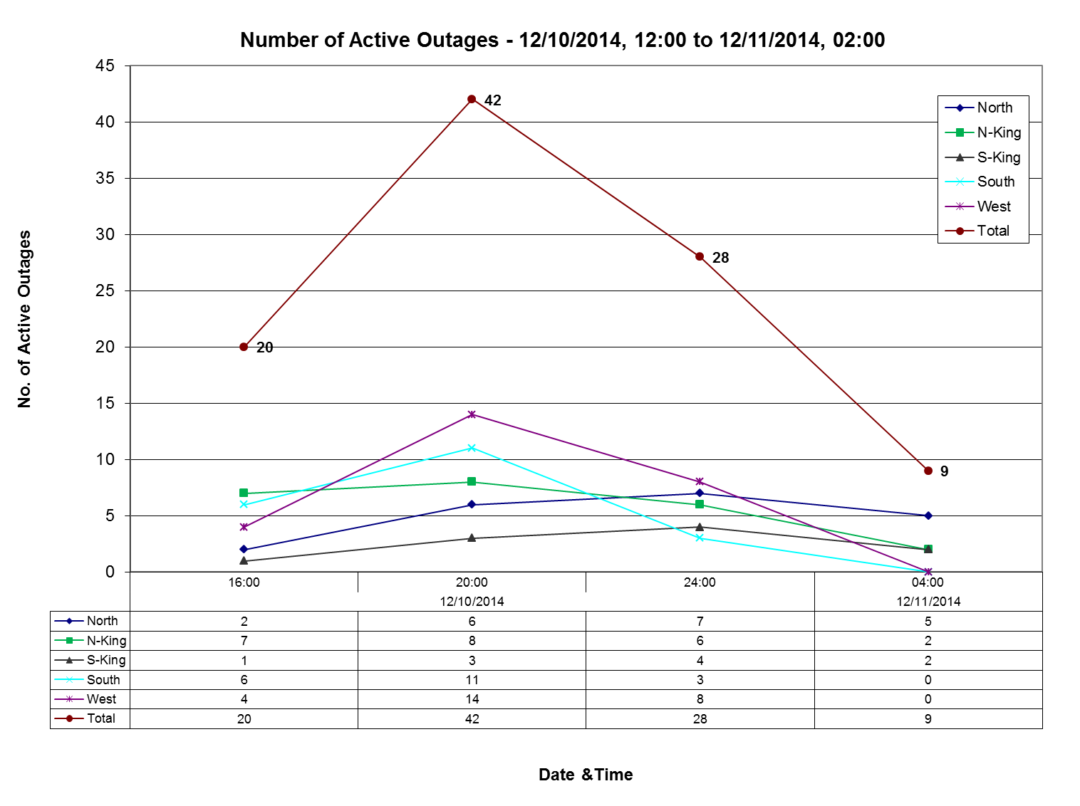

# **Major Event Day – Qualification**

**IEEE[1] Standard 1366**

IEEE Standard 1366 was established to present a set of terms and definitions which can be used to foster uniformity in the development of electric system service reliability indices, to identify factors which affect the indices, and to aid in consistent reporting practices among utilities. Also, it provides guidance for new personnel in the reliability area and tools for internal as well as external comparisons. The Major Event Day definition was created as part of IEEE Standard 1366 to allow for consistent calculation of reliability metrics between utilities and enable more valid comparisons with other utility reliability metrics.

|  |
| --- |
| **IEEE Major Event Day Calculation (2.5 BETA METHOD)**   1. A threshold on daily SAIDI[2] is computed once a year, following year end 2. Assemble the 5 most recent years of historical values of SAIDI/day 3. Discard any days in the data set that has a SAIDI/day of zero 4. Find the natural logarithm of each value in the data set 5. Compute the average (Alpha) and the standard deviation (Beta) of the natural logarithms computed in step 4 6. Compute the threshold TMED where TMED = exp (Alpha + 2.5 * Beta) 7. Any day in the next year with SAIDI > Tmed is a major event day |
| **Puget Sound Energy’s IEEE Major Event Threshold (TMED ) for 2014: 5.6 Minutes** |

# **Qualified Events - 2014**

### **Current Event – Calculation Detail**

|  |  |  |  |
| --- | --- | --- | --- |
| **Event Date, Time Range** | **Total Customer Minutes** | **Average Customer Count** | **Event SAIDI**  (Customer Minutes /Customer Count) |
| 12/10/2014 12:00 – 12/11/2014 02:00 | 3,961,070 | 1,107,403 | 3.58 |

### **YTD Daily SAIDI Detail**

(First day that daily SAIDI exceeded PSE’s TMED of 5.6 Minutes by qualifying event)

|  |  |  |
| --- | --- | --- |
| **Date** | **Daily SAIDI**  **(from midnight to midnight)** | **O&M[3] Costs– Deferrable**  **Accumulation** |
| 1/11/2014 | 41.62 | $ 4,446,568 |
| 2/12/2014 | 9.01 | $ 595,642 |
| 2/23/2014 | 8.4 | $ 1,287,276 |
| 10/25/2014 | 93.38 | $ 1,670,514 |
| 11/11/2014 | 86.48 | $ 0 |
| 11/29/2014 | 13.51 | $ 0 |
| 12/10/2014 | 6.79 | $ 0 |

# **Event Restoration – Cost Summary**

**Restoration Costs Detail by Qualifying Event (updated)**

|  |  |  |  |  |  |  |
| --- | --- | --- | --- | --- | --- | --- |
| Event Date Range | Qualified Events Deferred Account | Capital Costs | O&M Costs Not Deferrable | O&M Costs  Deferrable  Accumulation | Total O&M Costs | Total |
| 1/11/2014 |  | $ 472,000 | $ 358,555 | $ ,447,083(r) | $4,805,639 (r) | $5,277,639 (r) |
| 2/12/2014 |  | $ 65,956 (r) | $ 44,121 | $ 595,642 | $ 639,763 | $ 705,719 (r) |
| 2/23/2014 |  | $ 86,871 | $ 97,208 | $ 1,287,276 | $1,384,484 | $ 1,471,355 |
| 10/25/2014 | $ 2,339,922(r) | $ 324,151 (r) | $ 263,446 (r) | $ 1,669,999 | $1,933,445 (r) | $4,597,518 (r) |
| 11/11/2014 | $ 7,621,972(r) | $ 681,140 (r) | $ 309,076 (r) | $ - | $ 309,076 (r) | $8,612,188 (r) |
| 11/29/2014 | $ 1,205,519(r) | $ 62,760 | $ 76,620 (r) | $ - | $ 76,620 (r) | $ ,344,899 (r) |
| 12/10/2014 | $ 101,668 | $ 10,089 | $ 10,825 | $ - | $ 10,825 | $ 122,583 |

(r) Revised

### **YTD Storm Restoration Costs Detail**

|  |  |  |  |  |  |
| --- | --- | --- | --- | --- | --- |
| Qualifying Events Deferred Account | Capital | O&M - Not Deferrable | O&M - Deferrable Accumulation | Total O&M | Total |
| $11,269,082 | $1,702,966 | $1,159,852 | $8,000,000 | $9,159,852 | $22,131,900 |

# **Detail Documents**

**Restoration Cost Detail – Current Event**

**Detailed List of Distribution Circuits with Outages**

**Terms, Codes and Definitions Used on Detail Reports**

**Newsprint Media Coverage**

### **Restoration Cost Detail – Current Event**



ST: Standard Time

OT: Overtime

OH: Overhead

### **Detailed List of Outages** **Starting on December 10, 2014, the First TMED-Exceeding Day of the Current Event**

| **NUMBER** | **DATE** | **TIME** | **CKT** | **MPG** | **CAZ** | **EQT** | **CUST.OUT** | **CUST.MIN** |
| --- | --- | --- | --- | --- | --- | --- | --- | --- |
| P00139343-1 | 12/10/2014 | 12:06:43 AM | SOU-26 | EBJ | SO | USC | 12 | 1083 |
| P00139404-1 | 12/10/2014 | 2:50:00 AM | MIL-17 | ECE | TV | OCO | 22 | 14132 |
| P00139406-1 | 12/10/2014 | 3:11:02 AM | CPV-15 | EAD | TV | OCO | 51 | 16923 |
| P00139408-1 | 12/10/2014 | 3:39:47 AM | CHI-13 | ECD | EF | OFC | 3 | 351 |
| P00139409-1 | 12/10/2014 | 5:27:34 AM | NLM-16 | EAC | TV | OCO | 6 | 2378 |
| P00139413-1 | 12/10/2014 | 6:22:00 AM | CHA-16 | ECC | EF | UTR | 7 | 646 |
| P00133566-1 | 12/10/2014 | 6:49:11 AM | PAT-15 | ECC | SO | UPT | 2 | 1875 |
| P00139426-1 | 12/10/2014 | 7:00:00 AM | LON-22 | ECC | TV | OCO | 692 | 95646 |
| P00139431-1 | 12/10/2014 | 7:29:57 AM | POU-16 | ECE | UN | OCO | 12 | 1464 |
| P00139436-1 | 12/10/2014 | 7:43:13 AM | KAP-16 | ECA | FI | OPO | 2 | 692 |
| P00139443-1 | 12/10/2014 | 8:56:59 AM | HKX-16 | EAC | EF | OPO | 44 | 9813 |
| P00139463-1 | 12/10/2014 | 9:06:38 AM | BKB-14 | EAC | TV | OFU | 25 | 1659 |
| P00139466-1 | 12/10/2014 | 9:13:59 AM | SEQ-13 | EBJ | TV | OSV | 1 | 223 |
| P00139479-1 | 12/10/2014 | 9:39:34 AM | EGT-11 | EBE | EF | USV | 1 | 200 |
| P00127610-1 | 12/10/2014 | 9:43:51 AM | EPO-13 | ECD | UN | OCO | 8 | 1147 |
| P00139486-1 | 12/10/2014 | 9:44:02 AM | ROC-25 | ECC | TV | OCO | 79 | 7323 |
| P00139488-1 | 12/10/2014 | 9:46:00 AM | NHL-17 | EBD | TV | OTR | 1 | 310 |
| P00139494-1 | 12/10/2014 | 9:52:43 AM | ROC-25 | ECC | EF | OTF | 3 | 1162 |
| P00139495-1 | 12/10/2014 | 9:52:55 AM | WOB-25 | EAA | TV | OTF | 3 | 315 |
| P00139497-1 | 12/10/2014 | 9:53:13 AM | ROC-15 | ECC | TV | OCO | 979 | 71614 |
| P00139521-1 | 12/10/2014 | 9:53:27 AM | ROC-25 | ECC | TV | OJU | 61 | 20220 |
| P00139501-1 | 12/10/2014 | 9:59:14 AM | YEL-23 | ECC | TV | OCO | 1245 | 232851 |
| P00139568-1 | 12/10/2014 | 10:04:10 AM | LTA-18 | ECA | TV | OCO | 899 | 79726 |
| P00139512-1 | 12/10/2014 | 10:04:14 AM | MCA-16 | ECC | TV | OCO | 1861 | 171305 |
| P00139551-1 | 12/10/2014 | 10:05:00 AM | LUH-01 | ECC | TV | OCO | 4884 | 429709 |
| P00139516-1 | 12/10/2014 | 10:06:34 AM | KEN-12 | EAA | TV | OHR | 1433 | 73896 |
| P00139585-1 | 12/10/2014 | 10:10:57 AM | SUN-12 | ECA | EF | OFC | 1 | 102 |
| P00139603-1 | 12/10/2014 | 10:12:00 AM | AIR-22 | ECC | TV | OCO | 75 | 38082 |
| P00139596-1 | 12/10/2014 | 10:12:09 AM | SHD-18 | EBI | TV | OCO | 44 | 5605 |
| P00139606-1 | 12/10/2014 | 10:13:57 AM | SHD-18 | EBI | TV | OFU | 82 | 10389 |
| P00139685-1 | 12/10/2014 | 10:15:11 AM | MAN-13 | ECD | TV | OCO | 144 | 9696 |
| P00139769-1 | 12/10/2014 | 10:19:00 AM | BLU-16 | ECC | TV | OCO | 104 | 63577 |
| P00139657-1 | 12/10/2014 | 10:19:17 AM | LAC-17 | ECC | TV | OCO | 97 | 29173 |
| P00139617-1 | 12/10/2014 | 10:19:45 AM | PLG-17 | ECC | TV | OCO | 1197 | 145974 |
| P00139621-1 | 12/10/2014 | 10:20:05 AM | PAN-12 | EBJ | TV | OCO | 480 | 13160 |
| P00139618-1 | 12/10/2014 | 10:21:42 AM | PEA-17 | EBJ | EF | OPI | 26 | 3155 |
| P00139619-1 | 12/10/2014 | 10:21:51 AM | CUS-13 | EAA | TV | OCO | 22 | 6741 |
| P00139624-1 | 12/10/2014 | 10:22:56 AM | FRG-22 | ECC | TV | OCO | 81 | 42895 |
| **NUMBER** | **DATE** | **TIME** | **CKT** | **MPG** | **CAZ** | **EQT** | **CUST.OUT** | **CUST.MIN** |
| P00139660-1 | 12/10/2014 | 10:26:00 AM | FWD-17 | EBJ | EO | OCO | 1513 | 282012 |
| P00139646-1 | 12/10/2014 | 10:26:36 AM | FWY-15 | EBJ | TV | OCO | 769 | 62058 |
| P00139652-1 | 12/10/2014 | 10:27:26 AM | MAP-13 | EBE | TV | OCO | 2262 | 164260 |
| P00139672-1 | 12/10/2014 | 10:32:32 AM | PCR-24 | EBE | EF | OCO | 278 | 23083 |
| P00139668-1 | 12/10/2014 | 10:32:56 AM | MAP-15 | EBE | TV | OCO | 131 | 8862 |
| P00139670-1 | 12/10/2014 | 10:33:00 AM | MHT-15 | EBJ | TV | OCO | 20 | 6941 |
| P00140027-1 | 12/10/2014 | 10:33:16 AM | MAP-13 | EBE | TV | OCO | 2247 | 411275 |
| P00139842-1 | 12/10/2014 | 10:36:00 AM | TLN-0122 | EBE | TV | OCO | 3498 | 84827 |
| P00139645-1 | 12/10/2014 | 10:37:33 AM | HAN-12 | EAA | SO | OCO | 1 | 44 |
| P00139697-1 | 12/10/2014 | 10:38:00 AM | SWE-23 | EBJ | TV | OCO | 36 | 10092 |
| P00139692-1 | 12/10/2014 | 10:38:51 AM | HOL-13 | ECA | TV | OCO | 87 | 7412 |
| P00139720-1 | 12/10/2014 | 10:39:35 AM | ROC-26 | ECC | TV | OTF | 1 | 263 |
| P00139850-1 | 12/10/2014 | 10:43:11 AM | VAS-13 | EBL | TV | OCO | 52 | 6864 |
| P00139818-1 | 12/10/2014 | 10:45:45 AM | LWS-13 | EBJ | TV | OFU | 6 | 498 |
| P00139848-1 | 12/10/2014 | 10:47:43 AM | ING-15 | EBD | TV | OCO | 2312 | 172861 |
| P00139863-1 | 12/10/2014 | 10:55:15 AM | HAP-16 | EAA | TV | OCO | 419 | 264452 |
| P00139882-1 | 12/10/2014 | 11:00:54 AM | UHL-21 | EBD | TV | OCO | 4937 | 266045 |
| P00139877-1 | 12/10/2014 | 11:01:02 AM | VWY-12 | EAA | EF | OFC | 1 | 83 |
| P00139893-1 | 12/10/2014 | 11:10:00 AM | HWD-25 | EBD | TV | OPO | 28 | 14878 |
| P00139898-1 | 12/10/2014 | 11:14:30 AM | FCR-11 | EBI | TV | OCO | 1749 | 227720 |
| P00139899-1 | 12/10/2014 | 11:16:54 AM | LHL-25 | EBE | EF | OCO | 1 | 110 |
| P00139920-1 | 12/10/2014 | 11:35:22 AM | KAP-15 | ECA | TV | OCO | 20 | 1391 |
| P00139938-1 | 12/10/2014 | 11:49:41 AM | WAB-13 | EBI | TV | OFU | 61 | 6553 |
| P00139970-1 | 12/10/2014 | 12:01:40 PM | BIG-15 | EAC | TV | OCO | 215 | 19754 |
| P00139964-1 | 12/10/2014 | 12:02:00 PM | MAP-13 | EBE | EF | OCO | 15 | 3551 |
| P00139987-1 | 12/10/2014 | 12:15:05 PM | CPV-15 | EAD | EF | OFC | 680 | 10761 |
| P00139975-1 | 12/10/2014 | 12:15:50 PM | LYN-24 | EAA | TV | OSV | 1 | 119 |
| P00139986-1 | 12/10/2014 | 12:20:03 PM | HOL-13 | ECA | TV | OCO | 76 | 7367 |
| P00139993-1 | 12/10/2014 | 12:23:06 PM | BDI-13 | EBI | TV | OTF | 10 | 1875 |
| P00139914-1 | 12/10/2014 | 12:30:34 PM | LTA-17 | ECA | TV | OCO | 88 | 20686 |
| P00139999-1 | 12/10/2014 | 12:31:00 PM | PIP-23 | EBI | TV | OPO | 65 | 21660 |
| P00140022-1 | 12/10/2014 | 12:48:59 PM | PIN-27 | EBD | TV | OCO | 223 | 24091 |
| P00140037-1 | 12/10/2014 | 12:58:18 PM | SME-15 | EBE | TV | OCO | 25 | 3405 |
| P00139607-1 | 12/10/2014 | 1:05:36 PM | RAI-14 | ECC | TV | OCO | 75 | 45974 |
| P00140082-1 | 12/10/2014 | 1:10:21 PM | PLA-21 | EBD | TV | OCO | 1431 | 164493 |
| P00140063-1 | 12/10/2014 | 1:11:36 PM | AVO-17 | EBD | TV | OCO | 267 | 22909 |
| P00140058-1 | 12/10/2014 | 1:11:57 PM | KCR-17 | EBJ | TV | UTC | 4 | 245 |
| P00140085-1 | 12/10/2014 | 1:13:00 PM | DUV-13 | EBD | TV | OCO | 1290 | 19952 |
| P00140068-1 | 12/10/2014 | 1:14:26 PM | AVO-15 | EBD | TV | OTF | 5 | 808 |
| P00140089-1 | 12/10/2014 | 1:24:15 PM | HKX-13 | EAC | EF | OFC | 1 | 155 |
| P00140285-1 | 12/10/2014 | 1:30:00 PM | TLN-0260 | EBD | CP | OCO | 13777 | 1700812 |
| **NUMBER** | **DATE** | **TIME** | **CKT** | **MPG** | **CAZ** | **EQT** | **CUST.OUT** | **CUST.MIN** |
| P00140115-1 | 12/10/2014 | 1:32:00 PM | DUV-13 | EBD | TV | OCO | 79 | 21165 |
| P00140107-1 | 12/10/2014 | 1:40:00 PM | MAP-13 | EBF | EF | UPC | 28 | 13955 |
| P00140112-1 | 12/10/2014 | 1:43:15 PM | VAS-13 | EBL | TV | OCO | 208 | 36001 |
| P00140110-1 | 12/10/2014 | 1:43:24 PM | NOR-24 | EBD | UN | OCO | 10 | 1417 |
| P00140114-1 | 12/10/2014 | 1:48:00 PM | LMC-26 | EBE | EF | OCO | 4 | 1408 |
| P00140121-1 | 12/10/2014 | 1:56:53 PM | EDG-15 | ECA | EF | OTF | 3 | 176 |
| P00140137-1 | 12/10/2014 | 2:17:20 PM | FLD-15 | EAD | TV | OFU | 290 | 27808 |
| P00140146-1 | 12/10/2014 | 2:24:10 PM | VAS-13 | EBL | TV | OTR | 1 | 126 |
| P00140155-1 | 12/10/2014 | 2:32:49 PM | TIL-25 | ECA | TV | OCO | 9 | 982 |
| P00140156-1 | 12/10/2014 | 2:39:26 PM | LAC-17 | ECC | TV | OTF | 8 | 1164 |
| P00140160-1 | 12/10/2014 | 2:41:00 PM | MCW-14 | ECE | EF | UPC | 53 | 17385 |
| P00140161-1 | 12/10/2014 | 2:44:03 PM | FAL-13 | EBF | BA | OTF | 6 | 2021 |
| P00140165-1 | 12/10/2014 | 2:49:16 PM | GRI-16 | ECC | EF | OTF | 2 | 289 |
| P00140176-1 | 12/10/2014 | 2:54:21 PM | SPI-17 | EBD | CP | OPO | 572 | 131331 |
| P00140111-1 | 12/10/2014 | 3:02:02 PM | SHE-16 | ECE | SO | UEL | 1 | 8311 |
| P00140270-1 | 12/10/2014 | 3:04:26 PM | RAI-12 | ECC | TV | OTF | 1 | 340 |
| P00140281-1 | 12/10/2014 | 3:07:17 PM | HKX-12 | EAC | OD | OJU | 35 | 1768 |
| P00140312-1 | 12/10/2014 | 3:38:00 PM | WLS-16 | EAC | CP | OPO | 21 | 6571 |
| P00140318-1 | 12/10/2014 | 4:02:20 PM | LAU-11 | EAA | EF | OFC | 2 | 135 |
| P00140321-1 | 12/10/2014 | 4:09:55 PM | SCH-16 | EAA | TV | OSV | 1 | 187 |
| P00140325-1 | 12/10/2014 | 4:22:35 PM | LYN-14 | EAA | TV | OTF | 1 | 137 |
| P00140330-1 | 12/10/2014 | 4:34:55 PM | SLA-17 | EAA | TV | OTF | 1 | 62 |
| P00140335-1 | 12/10/2014 | 4:47:44 PM | ORT-22 | ECA | TV | OSV | 5 | 1364 |
| P00140339-1 | 12/10/2014 | 5:07:00 PM | FNW-17 | ECD | TV | OCO | 196 | 27347 |
| P00140346-1 | 12/10/2014 | 5:08:33 PM | CHI-12 | ECD | TV | OCO | 74 | 11941 |
| P00140350-1 | 12/10/2014 | 5:12:00 PM | LOL-25 | ECD | TV | OCO | 98 | 15172 |
| 11156623 | 12/10/2014 | 5:15:00 PM | SIN-25 | ECD | TV | OTR | 8 | 1200 |
| P00140355-1 | 12/10/2014 | 5:21:09 PM | POU-15 | ECE | TV | OCO | 1898 | 102178 |
| P00140356-1 | 12/10/2014 | 5:23:01 PM | RAI-11 | ECC | EF | PTF | 1 | 227 |
| P00140361-1 | 12/10/2014 | 5:23:02 PM | FWD-17 | EBJ | TV | OFU | 299 | 50127 |
| P00140358-1 | 12/10/2014 | 5:23:18 PM | TRA-25 | ECE | TV | OCO | 7 | 1922 |
| P00140363-1 | 12/10/2014 | 5:26:10 PM | WIN-13 | ECE | TV | OCO | 15 | 4222 |
| P00140351-1 | 12/10/2014 | 5:29:18 PM | CHI-12 | ECD | TV | OTR | 2 | 403 |
| P00140372-1 | 12/10/2014 | 5:29:43 PM | LAT-14 | EBJ | TV | OHR | 414 | 29505 |
| P00140368-1 | 12/10/2014 | 5:30:01 PM | RAI-14 | ECC | TV | OCO | 1 | 221 |
| P00140377-1 | 12/10/2014 | 5:30:26 PM | OSC-25 | EBI | TV | OFU | 66 | 3955 |
| P00140384-1 | 12/10/2014 | 5:32:10 PM | NHL-13 | EBD | TV | OPO | 2409 | 975982 |
| P00140387-1 | 12/10/2014 | 5:35:00 PM | POU-15 | ECE | UN | USC | 7 | 1148 |
| P00140388-1 | 12/10/2014 | 5:36:20 PM | OVE-13 | EBE | TV | UTC | 11 | 1280 |
| P00140389-1 | 12/10/2014 | 5:36:37 PM | EVA-27 | EBJ | TV | OFU | 163 | 3340 |
| P00140391-1 | 12/10/2014 | 5:38:00 PM | PMA-12 | ECE | TV | OCO | 7 | 3464 |
| **NUMBER** | **DATE** | **TIME** | **CKT** | **MPG** | **CAZ** | **EQT** | **CUST.OUT** | **CUST.MIN** |
| P00140400-1 | 12/10/2014 | 5:44:03 PM | MIL-23 | ECE | TV | OTR | 2 | 868 |
| P00140406-1 | 12/10/2014 | 5:46:53 PM | ROS-21 | EBD | TV | OCO | 96 | 18126 |
| P00140416-1 | 12/10/2014 | 5:56:58 PM | HAZ-15 | EBE | TV | OCO | 22 | 2262 |
| P00140430-1 | 12/10/2014 | 6:02:44 PM | BRE-22 | ECE | EF | OFC | 7 | 2663 |
| P00140440-1 | 12/10/2014 | 6:11:00 PM | FRG-24 | ECC | TV | OCO | 6 | 2287 |
| P00140439-1 | 12/10/2014 | 6:11:00 PM | PMA-13 | ECE | EF | OTR | 1 | 547 |
| P00140441-1 | 12/10/2014 | 6:12:00 PM | LYN-24 | EAA | TV | OPO | 32 | 26345 |
| P00140443-1 | 12/10/2014 | 6:20:52 PM | PMA-12 | ECE | TV | OFC | 4 | 1847 |
| P00140444-1 | 12/10/2014 | 6:21:09 PM | BLA-13 | EAA | TV | OFU | 2 | 181 |
| P00140445-1 | 12/10/2014 | 6:21:27 PM | MER-13 | EBE | TV | OSV | 1 | 245 |
| P00140448-1 | 12/10/2014 | 6:25:05 PM | EGT-27 | EBE | AV | USV | 1 | 95 |
| P00140449-1 | 12/10/2014 | 6:27:00 PM | FWD-16 | EBJ | OD | OFU | 6 | 1044 |
| P00140450-1 | 12/10/2014 | 6:32:00 PM | HOL-13 | ECA | EF | OUP | 11 | 3040 |
| P00140461-1 | 12/10/2014 | 6:48:24 PM | VWY-15 | EAA | EF | OFC | 24 | 77 |
| P00140462-1 | 12/10/2014 | 6:50:45 PM | BIG-15 | EAC | TV | OFU | 177 | 18281 |
| P00140471-1 | 12/10/2014 | 7:04:00 PM | VAS-23 | EBL | TV | OCO | 133 | 65256 |
| P00140476-1 | 12/10/2014 | 7:12:20 PM | HAM-13 | EAC | TV | OFU | 190 | 26679 |
| P00140489-1 | 12/10/2014 | 7:19:44 PM | MKI-17 | ECC | EF | USV | 1 | 126 |
| P00140494-1 | 12/10/2014 | 7:30:08 PM | 13-Dec | ECC | TV | OFU | 1 | 117 |
| P00140496-1 | 12/10/2014 | 7:39:00 PM | BLU-16 | ECC | TV | OCO | 5 | 1776 |
| P00140498-1 | 12/10/2014 | 7:42:41 PM | LUH-14 | ECC | TV | OTF | 1 | 203 |
| P00140499-1 | 12/10/2014 | 7:46:01 PM | SCH-13 | EAA | TV | OSV | 4 | 312 |
| P00140500-1 | 12/10/2014 | 7:46:34 PM | BIG-15 | EAC | TV | OFU | 47 | 2746 |
| P00140502-1 | 12/10/2014 | 8:04:57 PM | VWY-15 | EAA | TV | OFU | 12 | 1199 |
| P00140508-1 | 12/10/2014 | 8:33:02 PM | BTN-36 | EAC | TV | OCO | 11 | 4161 |
| P00140509-1 | 12/10/2014 | 8:39:00 PM | ORC-17 | EBJ | EF | UTR | 15 | 4378 |
| P00140517-1 | 12/10/2014 | 8:54:49 PM | SLA-17 | EAA | TV | OTF | 1 | 196 |
| P00140530-1 | 12/10/2014 | 9:21:00 PM | GWR-13 | EBI | TV | OCO | 86 | 58787 |
| 11161169 | 12/10/2014 | 9:46:00 PM | ROC-26 | ECC | TV | OPO | 10 | 1260 |
| P00140534-1 | 12/10/2014 | 9:55:00 PM | ROE-13 | EAA | EF | UOT | 5 | 1765 |
| P00140535-1 | 12/10/2014 | 10:05:15 PM | HAM-15 | EAC | TV | OCO | 69 | 27825 |
| P00100762-1 | 12/10/2014 | 10:33:33 PM | SME-15 | EBE | SO | UPC | 3 | 128 |
| P00140540-1 | 12/10/2014 | 10:41:27 PM | PIN-26 | EBD | TV | OSV | 5 | 825 |
| P00140542-1 | 12/10/2014 | 10:52:00 PM | BHS-14 | EAA | TV | OCO | 15 | 5300 |
| P00140547-1 | 12/10/2014 | 11:24:38 PM | BHS-14 | EAA | EF | UPC | 6 | 2272 |
| 11161168 | 12/10/2014 | 11:34:00 PM | WOL-25 | ECC | TV | OCO | 40 | 3320 |
| P00140550-1 | 12/10/2014 | 11:41:29 PM | EVA-27 | EBJ | TV | OCO | 164 | 5795 |
| P00140552-1 | 12/10/2014 | 11:43:09 PM | UHL-25 | EBD | TV | OCO | 134 | 18779 |
| P00140551-1 | 12/10/2014 | 11:43:09 PM | UHL-25 | EBD | TV | OCO | 18 | 2805 |

### **Terms, Codes and Definitions Used on Detail Reports**

|  |  |  |
| --- | --- | --- |
| Notification (NUMBER) | A number assigned by SAP, identifying the outage record | |
| **Date (DATE)** | The date of the outage | |
| **Time (TIME)** | The time of the outage | |
| **Circuit (CKT)** | The circuit identifier for the affected circuit | |
| **Area (MPG)** | **Maintenance Planner Group** A code representing the energy, region and service center | |
| EAA – Bellingham | EBJ – South King |
| EAC – Skagit | EBL – Vashon |
| EAD – Whidbey | ECA – Puyallup |
| EBD – Redmond | ECC – Olympia |
| EBE – Factoria | ECD – Port Orchard |
| EBF – Snoqualmie | ECE – Poulsbo |
| EBI – Enumclaw |  |
| **Cause (CAZ)** | **Cause of Outage** | |
| AO – Accident Other | EF – Equipment Failure |
| BA – Bird or Animal | EO – Electrical Overload |
| CP – Car Pole | FI – Faulty Installation |
| CR – Customer Request | TF – Tree Off Right-of-Way |
| DU – Dig-up Underground | TO – Tree On Right-of-Way |
| TV – Trees/Vegetation | SO – Scheduled Outage |
| UN – Unknown |  |
| Equipment (EQT) | | **Affected by, or involved in the outage** | |
| OCN – Connector | OSW – Overhead Switch |
| OCO – Overhead Conductor | OTF – Overhead Transformer Fuse |
| OCR – Crossarm | OTR – Overhead Transformer |
| OFC – Overhead Cut-out | OUP – OH to UG Primary |
| OFS – Overhead Fire Signal | OUS – OH to UG Secondary Service |
| OFU – Fuse Link/OH Line Fuse | SBF – High-side Bank Fuse |
| OGS – Span Guy | SCB – Power Circuit Breaker |
| OHR – Overhead Recloser | UOT – Underground Outdoor Term |
| OIN – Insulator | UPC – Underground Primary Cable |
| OJU- Jump Wire | UPT – Padmount Transformer |
| OPI – Overhead Pin Insulator | USV – Underground Service |
| OPO – Pole | UTC – Underground Terminal Fuse |
| OSV – Overhead Service | UTR – Submersible Transformer |
| ORE – Regulator |  |
| **CUST OUT (CUST.OUT)** | | **Customer Out,** The number of customers without power for any given outage record | |
| **CUST MIN (CUST. MIN)** | | **Customer Minutes,** The total number of minutes customers were without power for any given record | |

# **Media & Communication Coverage**

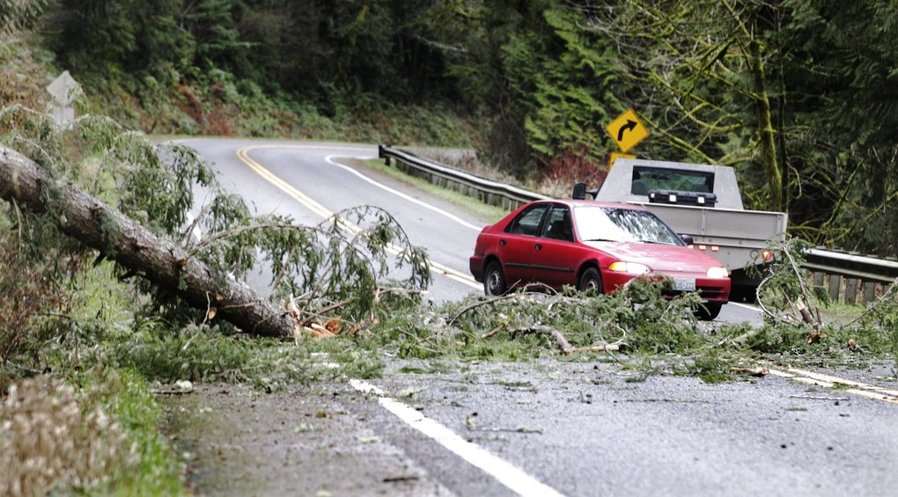****

**High winds bring record temps; big storm coming Thursday**

Originally published December 10, 2014 at 3:43 pm

*Updated December 10, 2014 at 10:28 pm*

By Jack Broom

Paige Cornwell

Warm winds out of the south and southeast cut power to thousands of Western Washington residents Wednesday while driving temperatures to record levels. Utility crews are bracing for an even stronger storm on Thursday.

The reading of 66 degrees at Seattle-Tacoma International Airport made this the warmest December day ever recorded at the airport, which has been the site for official Seattle readings since the 1940s.

The previous record, 64, was hit in 1993.

Wednesday’s storm — the second of three forecast for the week — came with gusts as high as 71 on the Washington Coast.

A storm expected Thursday could bring gusts up to 75 miles and hour on the coast and 40 mph in the Central Puget Sound area.The winds are expected to accompany heavy rain that could cause river flooding and mudslides throughout the region.

Many of Wednesday’s power outages were in Thurston and Pierce counties, said Ray Lane, spokesman for Puget Sound Energy. Severe winds are also expected in the northernmost parts of Washington, near Bellingham.

“It’s all about Mother Nature now,” Lane said. “We have our crews ready to go across our service area.” PSE is the region’s largest utility, with 1.1 million customers in Western Washington.

Depending on its path, the storm — the third to hit the Puget Sound region this week — has the potential to bring sustained winds of 40 to 50 mph and gusts of 65 to 75 mph and could cause widespread power outages, National Weather Service meteorologist Josh Smith said.

1. IEEE: Institute of Electrical and Electronics Engineers
2. SAIDI: System Average Interruption Duration Index
3. O&M: Operations and Maintenance