http://www.bloomberg.com/news/articles/2015-03-16/how-interest-rates-keep-making-people-on-wall-street-look-like-fools
How Interest Rates Keep Making People on Wall Street Look Like Fools

Will this be the year they get it right?

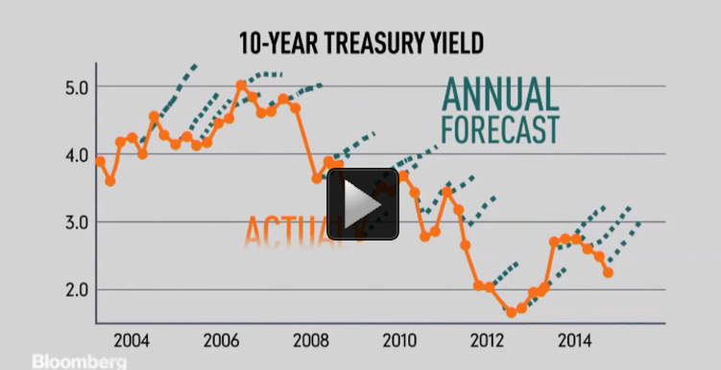

If there’s one call that investors and economists almost always seem to get wrong, it’s the direction of long-term interest rates. For years economists have been predicting that rates would rise, yet rates have been on a downtrend for ages.

Over the years, a variety of reasons have been given for the forecasted rise. Inflation and the amount of government spending have often been cited. You also frequently hear that “rates have nowhere to go but up,” yet it turns out that yes, they can keep getting lower.

The ongoing decline in interest rates isn’t just a U.S. phenomenon, either. In Europe, many government bonds now carry negative interest rates—a decline some wouldn’t have thought possible. In Japan, the term “the widowmaker” has been used to describe the perpetually losing trade of betting on higher government rates.

So why have rates declined so intensely over the years? Inflation has been on a steady downtrend in most places. And as societies get older, the demand for ultra-safe assets, such as government bonds, gets bigger.

And yes, in 2015, analysts are once again predicting higher rates.

