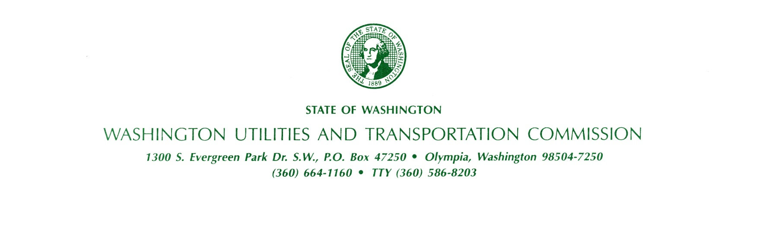April 18, 2013

Steven V. King, Acting Executive Director and Secretary

Washington Utilities and Transportation Commission

1300 S. Evergreen Park Dr. SW

P. O. Box 47250

Olympia, Washington 98504-7250

RE: *Washington Utilities and Transportation Commission v. Onstar Limousine, LLC*

Commission Staff’s Response to Application for Mitigation of Penalties

Docket TE-130475

Dear Mr. King:

On April 8, 2013, the Washington Utilities and Transportation Commission (commission) issued Penalty Assessment TE-130475 against Onstar Limousine, LLC (Onstar Limousine) in the amount of $1,000 for 10 violations of Washington Administrative Code (WAC) 480-30-221, Vehicle and driver safety requirements, which requires passenger transportation companies to comply with Title 49, Code of Federal Regulations (CFR), including Part 395 – Hours of service of drivers, and Part 396 – Inspection, repair and maintenance.

On April 17, 2013, Onstar Limousine filed with the commission its request for mitigation (Mitigation Request). Onstar Limousine admitted the violations but asked that the penalty amount be reduced.

The commission’s rules governing safety requirements for passenger transportation are clear and unambiguous in seeking to ensure the health and safety of the traveling public through specific limitations and requirements.

During compliance reviews, commission staff conducts an in-depth examination of a motor carrier's compliance with regulations that the FMCSA has identified as “acute” or “critical.” Onstar Limousine’s violations of Parts 395.8(a), 396.11(a) and 396.17(a) are considered critical violations.[1] Critical violations are generally indicative of breakdowns in a carrier's management controls. Patterns of non-compliance with critical regulations are quantitatively linked to inadequate safety management controls and usually higher than average accident rates.[2]

As the commission stated in the penalty assessment, ensuring that drivers are in the best physical condition possible, including documenting that drivers have not worked longer than the legal number of hours in a given time period, is key to preventing accidents. Failing to require drivers to make records of duty status as required prevents the company from keeping track of total on-duty hours for those drivers.

Onstar has received ample technical assistance about safety regulations since the commission granted the company charter and excursion carrier authority in 2010. The violations relating to driver vehicle inspection reports are repeat violations from the 2011 compliance review. At that time, when asked to respond with a plan for correcting the violations related to driver vehicle inspection reports, Mr. Tekle wrote, “Before starting out the driver must be satisfied that the motor vehicle is in safe operating condition. If the last driver vehicle inspection report (DVIR) notes any defects, the driver must review and sign to acknowledge that necessary repairs have been completed.”[3] The company knows that these requirements exist.

Staff recommends the Mitigation Request be denied. The commission already mitigated the penalty when it assessed only $1,000 in penalties instead of the $2,800 it could have assessed for the 28 violations found in the compliance review. Commission staff does not object to the commission establishing a payment plan for Onstar Limousine to repay the penalty amount.

If you have any questions, please contact Betty Young, Compliance Investigator, Transportation Safety, at 360-664-1202, or by e-mail at [byoung@utc.wa.gov](mailto:byoung@utc.wa.gov).

Sincerely,

David Pratt

Assistant Director, Transportation Safety

Enclosures

1. ## Code of Federal Regulations, [Appendix B to Part 385—Explanation of safety rating process](http://www.fmcsa.dot.gov/rules-regulations/administration/fmcsr/fmcsrruletext.aspx?contentid=1556), enclosed.

  
2. *Id.*
3. November 2011 letter from Mr. Tekle, enclosed.