June 26, 2014

Steven V. King, Executive Director and Secretary

Utilities and Transportation Commission

1300 S. Evergreen Park Dr. SW

P.O. Box 47250

Olympia, WA 98504-7250

RE: *Washington Utilities and Transportation Commission v. Puget Sound Moving, Inc.*

Commission Staff’s Response to Application for Mitigation of Penalties TV-140985

Dear Mr. King:

On June 6, 2014, the Utilities and Transportation Commission issued a $1,000 Penalty Assessment in Docket TV-140985 against Puget Sound Moving, Inc. for 10 violations of Washington Administrative Code (WAC) 480-15-480, which requires household goods carrier companies to furnish annual reports to the commission no later than May 1 each year.1

On June 12, 2014, Puget Sound Moving, Inc. wrote the commission requesting mitigation of penalties (Mitigation Request).2 In its Mitigation Request, Puget Sound Moving, Inc. does not dispute that the violation occurred. The company submitted a statement to support the mitigation request which provided the reason for late filing due to accounting information not being available until the end of May. The company acknowledges the commission does provide an opportunity for extension requests and will utilize that process in the future.

It is the company’s responsibility to ensure that the regulatory fee is paid and the annual report is filed by the May 1 deadline. On February 28, 2014, Annual Report packets were mailed to all regulated household goods companies. The instructions for annual report completion page of the annual report informed the regulated company that it must complete the annual report form, pay the regulatory fees, and return the materials by May 1, 2014, to avoid enforcement action.

On May 29, 2014, Puget Sound Moving, Inc. filed the 2013 annual report and paid the required regulatory fees and late payment penalty. The company has been active since March 30, 2010. No previous violations of WAC 480-15-180 are on commission record. Staff supports the

UTC Annual Reports

June 26, 2014

Page 2

company’s request for mitigation as this is the company’s first delinquent filing. Staff recommends a reduced penalty assessment of $200.

If you have any questions regarding this recommendation, please contact Amy Andrews, Regulatory Analyst, at (360) 664-1157, or [aandrews@utc.wa.gov](mailto:aandrews@utc.wa.gov).

Sincerely,

Sondra Walsh, Director

Administrative Services

ATTACHMENT A

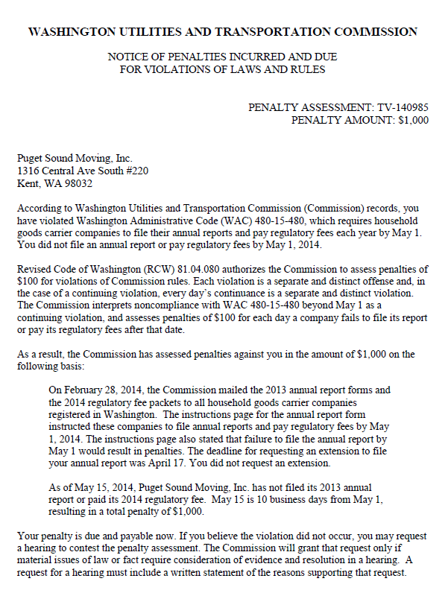

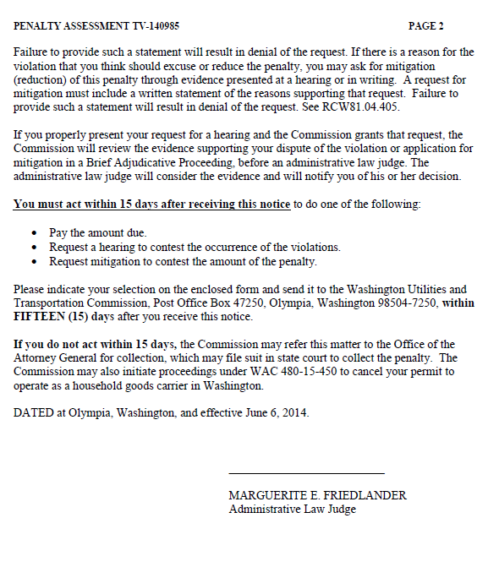

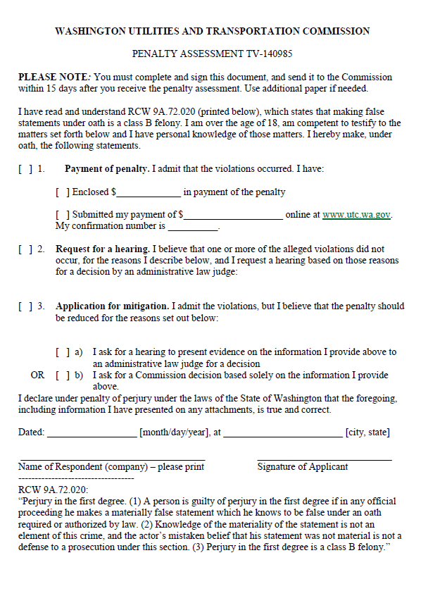

ATTACHMENT B

