BEFORE THE WASHINGTON UTILITIES AND TRANSPORTATION COMMISSION

DOCKET NO. UE-17______

DOCKET NO. UG-17______

DIRECT TESTIMONY OF

KEVIN J. CHRISTIE

REPRESENTING AVISTA CORPORATION

**I. INTRODUCTION**

1. **Please state your name, employer and business address.**
2. My name is Kevin Christie and I am employed as the Vice President of Customer Solutions for Avista Utilities, at 1411 East Mission Avenue, Spokane, Washington.
3. Would you briefly describe your educational background and professional experience?

A. Yes. I graduated from Washington State University with a Bachelor’s Degree in Business Administration with an accounting emphasis. I have also attended the University of Idaho Utility Executive Course and the Finance for Senior Executives program at Harvard Business School.

I joined the Company in 2005 as the Manager of Natural Gas Planning. In 2007, I was appointed the Director of Gas Supply, then in 2012 I was appointed as the Senior Director of Finance. In 2014 I was appointed to Senior Director of Customer Solutions and in 2015 I was appointed to my current position of Vice President of Customer Solutions.

Prior to joining Avista, I was employed by Gas Transmission Northwest (GTN). I was employed by GTN from 2001 to 2005 and was the Director of Pipeline Marketing and Development from 2003 to 2005 and the Director of Pricing and Business Analysis from 2001 to 2003. From 2000 to 2001, I was employed by PG&E Corporation (PG&E) as the Manager of Finance and Assistant to the SVP, Treasurer and CFO. Before joining PG&E, I was employed by Pacific Gas Transmission Company (PGT) from 1994 to 2000. While at PGT, I held several positions including Manager, Pricing and Business Analysis, Senior Business Analyst, Senior Pricing Planner, Director of Regulatory Affairs, Project Manager – Rates and Regulatory Affairs, Senior Regulatory Analyst, Regulatory Analyst, and Revenue Accountant. From 1990 to 1994, I was employed by Chevron USA as a Lease Revenue Accountant.

Q. What is the scope of your testimony?

A. I will provide an overview of the Company’s Customer Solutions organization, our Customer Service & support programs, what we are doing to meet our evolving customer expectations, Avista’s products and services initiatives in Washington, and finally, I will summarize the Company’s natural gas line extension allowance program.

A table of the contents for my testimony is as follows:

Description Page

1. Introduction 1
2. Overview of Avista’s Customer Solutions 2
3. Customer Service & Support Programs 4
4. Meeting Customer Expectations 13
5. Products & Services Initiatives 17
6. Line Extension Allowance Program 20

**Q. Are you sponsoring any exhibits in this proceeding?**

A. No, I am not.

**II. OVERVIEW OF AVISTA’S CUSTOMER SOLUTIONS**

**Q. Please describe Avista Utilities’ Customer Solutions organization.**

A. Avista’s Customer Solutions organization is comprised of customer-facing departments – i.e., those that work directly with our customers. Our organization supports the Company’s 377,285 electric and 340,294 natural gas customers (as of December 31, 2016) of which, 245,916 and 156,777 respectively, were Washington customers. As a department, our team is committed to anticipating, developing, and implementing innovative and engaging solutions that meet our customers’ needs and expectations. In addition, we are continually monitoring trends in the utility industry and non-utility industry in order to be proactive in providing our customers with solutions they may be interested in. Lastly, we have renewed and enhanced our emphasis in creating a feedback loop with our customers. For example, we have been testing our digital concepts with customers in advance, have used a social media panel for testing ideas, as well as, surveying customers on programs they have participated in, like our small business energy efficiency program and natural gas line extension allowance program.

**Q. Please provide an overview of the departments within the Customer Solutions organization that interact with our customers.**

A. The following are the primary departments that interact with our customers:

**Customer Service:** The Customer Service department is the primary interface between the Company and its customers. See Section III for additional details.

**Community Outreach and Energy Assistance:** The Community Outreach and Energy Assistance department is responsible for delivering and administering energy assistance programs that reduce the energy burden for our low income and vulnerable customers. In addition, the department is responsible for offering energy conservation and education to low-income customers. See Section III for additional information about the support offered by this department.

**Energy Efficiency:** The Energy Efficiency department is responsible for delivering the Company’s electric and natural energy efficiency programs. Its primary goal is to meet or exceed the annual kWh and therm savings goals in both the Company’s Washington and Idaho jurisdictions. In addition to delivering programs to reach the Company’s savings goals, the Energy Efficiency department also provides tools and education to help customers control their energy costs and reduce their energy footprint.

**External Communications:** The External Communications department is responsible for customer communications and for the Company’s external facing technologies, which include the Company’s website and mobile applications.

**Products and Services:** The Products and Services department is responsible for delivering new products and services that our customers desire. Through engagement and customer research, the department is focused on delivering solutions that meet our customers’ evolving needs and expectations.

**III. CUSTOMER SERVICE & SUPPORT PROGRAMS**

**Q. Please describe Avista’s Customer Service department.**

A. Avista’s Customer Service department is the primary interface between the Company and its customers and includes Meter Reading, Billing, Credit and Collections, and the Call Center.  In 2016, the Call Center answered 726,644 calls and fielded 66,124 emails and electronic communications from customers across the Company’s three jurisdictions: Washington, Idaho, and Oregon.  The Customer Service department is comprised of approximately 220 employees that work in various roles.

Avista’s Call Center employees are spread across three different service centers located in Spokane, Washington, Coeur d’Alene, Idaho, and Lewiston, Idaho.  The three service centers are networked together to operate as a single Call Center supporting Avista’s customers.  Each employee is trained in their role to work with customer accounts or take phone calls from customers in all three of the Company’s jurisdictions.  All customer phone calls come in through a single number, 1-800-227-9187, and are answered by the next available representative, regardless of the location they reside. Our most recent 2016 year end Voice of the Customer (VOC) results, as further described in Section IV below, show that 93% of our customers that had contact with Avista’s Call Center in our Washington, Idaho, and Oregon operating divisions were satisfied or very satisfied with the service they received.[1]

**Q. What customer support programs does Avista provide for its customers in Washington?**

A. Avista Utilities offers a number of programs for its Washington customers, such as the Low-Income Rate Assistance Program (LIRAP), Project Share for emergency assistance to customers, a Customer Assistance Referral and Evaluation Service (CARES) program, senior programs, level pay plans, and payment arrangements. Through these programs, the Company works to ease the burden of energy costs for customers that have the greatest need.

To assist our customers in their ability to pay, the Company focuses on actions and programs in four primary areas: 1) advocacy for, and support of, assistance programs providing direct financial assistance for payment of customers’ energy bills; 2) low income and senior outreach programs; 3) energy efficiency and energy conservation education; and 4) support of community programs that increase customers’ ability to pay basic costs of living.

**Q. What is the Company’s Low Income Rate Assistance Program, or LIRAP?**

A. The Company’s LIRAP program approved by the Commission in 2001 collects funding through electric and natural gas tariff surcharges on Schedules 92 and 192. These funds are distributed by Community Action Agencies (CAA’s) in a manner similar to the Federal and State-sponsored Low Income Home Energy Assistance Program (LIHEAP)[2]. LIRAP, like LIHEAP, can help a household avoid having its utilities shut off or help reestablish service, and can also help pay ongoing energy costs. Avista is committed to reducing the burden of energy costs for our customers most affected by rising energy prices, including low income individuals and families, seniors, disabled and vulnerable customers.

During the 2015/2016 heating season (October 2015 – September 2016 program year) 30,403 Washington customers received approximately $8.8 million in various forms of energy assistance (Federal LIHEAP program, LIRAP, Project Share, and local community funds). The following funds were distributed by Community Action Agencies (CAA’s) during the 2015/2016 heating season:

|  |  |  |
| --- | --- | --- |
| **Washington** | **# of Grants** | **Amount** |
| LIHEAP | 6,567 | $2,735,954 |
| Project Share | 403 | $99,910 |
| Misc. Grants | 8,622 | $861,445 |
| LIRAP | 14,811 | $5,125,535 |
| **Total** | **30,403** | **$8,822,844** |

**Table No. 1** – **Distribution of Energy Assistance Funding**

**Q. Please describe the recent changes to the LIRAP program.**

A. In the Company’s 2015 general rate case[3], the Commission approved a five-year plan to increase LIRAP funding by seven percent annually or twice the percentage increase in Schedule 1 and Schedule 101 base rates, whichever is greater. This funding plan authorizes multi-year funding increases for Schedules 92 and 192, but does not change any LIRAP programs or the way that LIRAP funds are administered. These annual increases are communicated to the agencies by May, prior to the start of the applicable program year.

In addition, beginning in the October 2015 – September 2016 program year, Avista introduced a two-year rate discount pilot program targeted to reach 800 senior and disabled households with fixed incomes between 126-200 percent of the Federal Poverty Level. The per kilowatt-hour and per therm rate discounts were designed to provide an average benefit of $300 per participant per program year, which is comparable with the grant amount provided through the existing LIRAP Senior Energy Outreach program[4].

The rate discount pilot served 763 individual households by the conclusion of the October 2015 – September 2016 program year. Of this amount, 516 customers received discounts for their electric service and 247 for their natural gas service. The total dollar amount of discounts issued by the program during the first program year totaled $175,468 ($137,348 Electric, $38,120 Natural Gas). On average, customers participating in the Electric discount program received a total annualized benefit of $446.31 or an average monthly discount of $37.19. For Natural Gas customers participating in the pilot, the annualized average discount was $306.86 or an average monthly discount of $25.57. The total annualized benefit for electric customers was higher than the original design due to higher than expected participant usage and from electric only customers, who have higher electric heating costs in the winter compared to customers that have both electric and natural gas.

The rate discount pilot program is scheduled to conclude at the end of the current program year, September 30, 2017. At the conclusion of the two-year pilot program a third-party evaluator will evaluate the success and impact of the program. Because the evaluation report will be delivered after September 30, 2017, the Company along with its Energy Assistance Advisory Group, is planning on proposing a continuation of the pilot program for a third year.

**Q. Please describe the recent results of Project Share.**

A. Project Share is a community-funded program Avista sponsors to provide one-time emergency support to families and/or individuals where Avista provides service. Avista customers and shareholders help support the fund with voluntary contributions that are distributed through local community action agencies to customers in need. Grants are available to those in need, without regard to their heating source, and the customers are not required to be Avista electric or natural gas customers. For the 2015/2016 program year, Avista Utilities’ customers donated $293,009 on a system-wide basis, of which $177,313 was available to Washington Community Action Agencies. In addition, the Company itself contributed $225,000 to Project Share, which included $25,000 for Spokane County due to the devastation of the November 2015 wind storms. Out of the $225,000 contributed by the Company, $154,530 was available for the benefit of Washington recipients. During the 2015/2016 program year, Avista customers received $99,910 from Project Share towards their electric or natural gas bills.

**Q. What other tools does the Company offer to assist customers in managing their bills?**

A. In addition to the bill assistance available through LIHEAP, LIRAP, and Project Share, the Company offers many billing options to make it easier for customers to manager their bills. Choices available to customers include Comfort Level Billing, flexible payment plans or arrangements, and preferred due dates. One of the goals of our Customer Service department is to provide tools and options to customers to help them manage their bills before they face a financial hardship or crisis. By accessing their account online, customers can utilize our Bill Analyzer tool, which helps them compare their usage to prior months or years, as well as understand the key driving factors in any usage increases, such as weather, billing days, rate changes, and increased or decreased usage. Customers can also access our Home Energy Analyzer tool, and complete a survey about their specific usage to help fine tune suggestions for energy savings and management.

**Q. How does the Company assist customers in managing and/or reducing their energy usage?**

A. Based on the Company’s experience, we know that energy efficiency is the best tool available to help customers manage their energy usage and costs. Avista offers over 30 energy efficiency programs, with some 300 individual energy efficiency measures for customers to take advantage of. Energy efficiency messaging, tips, and outreach is utilized to heighten awareness and increase adoption of programs and measures. The Energy Efficiency department is integral in the delivery of this information through the support of community events, energy fairs, and low-income and senior workshops to inform customers about what programs are available to them.

Q. Please summarize Avista’s Customer Assistance Referral and Evaluation Services (CARES) program.

A. In Washington, Avista is currently working with 1,957 special needs customers in the CARES program. Specially-trained representatives provide referrals to area agencies and churches for customers with special needs for help with housing, utilities, medical assistance, etc. One of the benefits we have in utilizing CARES representatives is the ability to evaluate each customer, based on their specific need, and to educate them on what assistance is available within the community. A goal of the program is to enable customers to manage not only their Avista bill, but other bills and needs as well.

Q. Does the Company perform any other outreach to its customers?

A. Yes. The following are examples of outreach programs that are available to customers:

1. **Senior and Low-Income Outreach:** Avista has developed specific outreach efforts to reach our more vulnerable fixed and low-income customers (with special emphasis on seniors and disabled customers) with bill payment assistance and energy efficiency information that emphasizes comfort and safety. Avista accomplishes this outreach mainly through Energy Workshops. During 2016, 22 workshops were conducted reaching nearly 619 seniors and low-income individuals. All workshop participants were given Home Energy Efficiency kits along with tips for low-cost/no-cost ways to manage energy use. Each kit contains energy-saving items such as LED light bulbs, plastic window covering, draft stoppers for exterior light switches and outlets, v-seal for drafty doors and a polar fleece lap blanket. The Company also conducts general outreach in partnership with organizations that are in contact with vulnerable individuals through resource fairs or in-home services. General outreach partnerships reached 5,563 individuals through 37 activities. Through all of these venues, individuals are provided with information to effectively manage their home energy use and the Company’s bill assistance programs.
2. **Senior Publications:** Avista has created a one-page advertisement that has been placed in senior resource directories and targeted senior publications to reach seniors with information about bill and payment options, Avista CARES and energy assistance.
3. **Energy Fairs:** In 2016, Avista hosted three energy fairs in Washington which reached nearly 835 customers. These outreach events provided information and demonstrations on energy assistance, energy efficiency and home weatherization to limited income families and senior citizens as well as provided an environment for customers to learn about billing options and energy assistance, while offering them tips and tools to use to help manage their limited financial resources. The following illustration shows customers receiving a demonstration on how to use energy efficiency items they received at the energy fairs.

**Illustration No. 1** – **Fall 2016 Energy Fair**

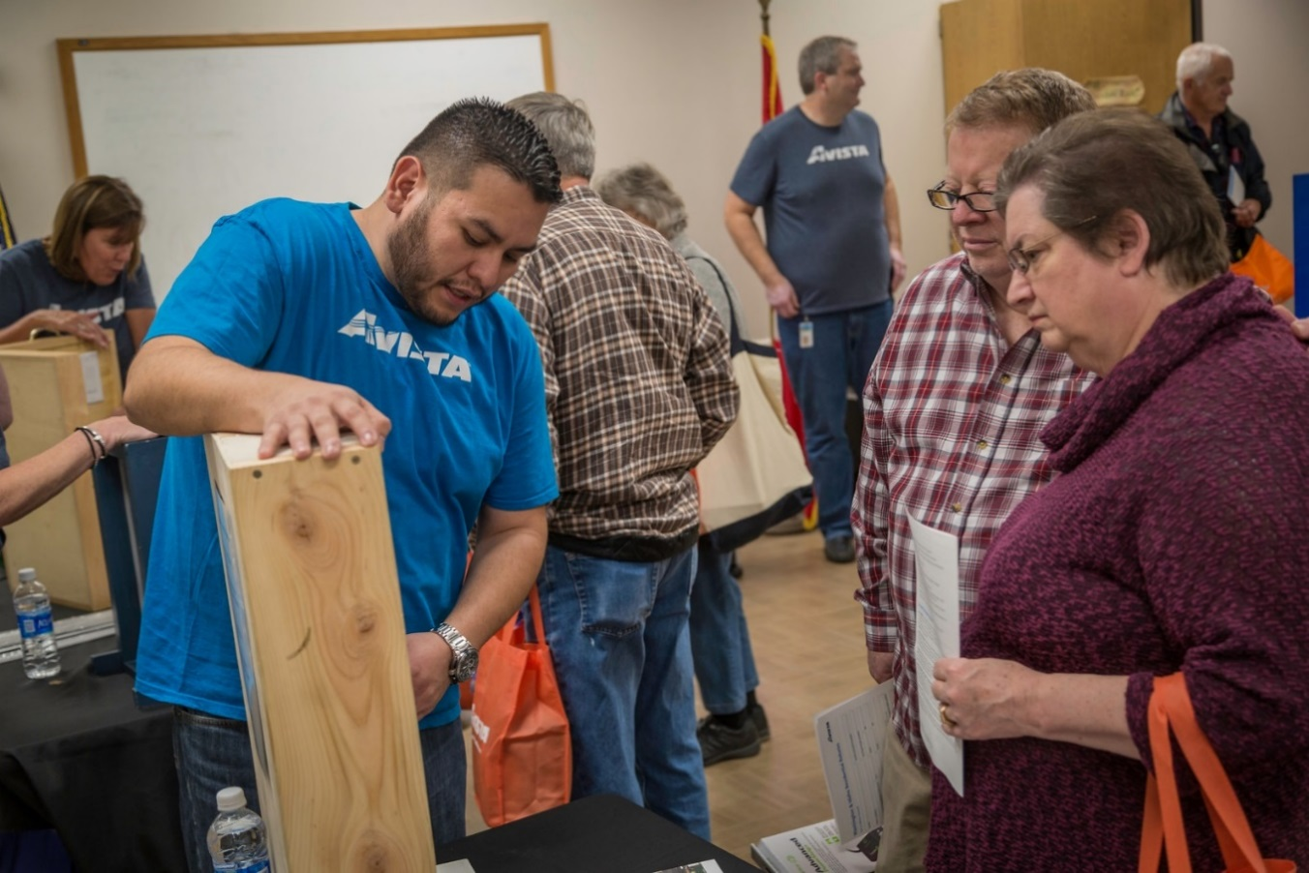

1. **Mobile Outreach Van:** Avista offers many opportunities throughout the year for customers to attend energy fairs or workshops to learn more about energy assistance, energy efficiency and the resources available to them. But some of our more vulnerable customers have a hard time getting to an event to access these resources. So to ensure that we’re reaching as many customers who need our help as we can, Avista created the Energy Resource Team van. The van is fully loaded with energy efficiency items such as rope caulk, V-seals door sweeps and coil cleaners, as well as informational materials about bill and payment options, assistance, safety, and efficiency. In 2016, the van provided outreach efforts to 2,745 individuals through 28 events throughout our Washington service territory, many of which were in conjunction with Second Harvest Food Bank mobile food pantry. The following illustrations show Avista employees working at outreach events with the mobile outreach van.

**Illustration No. 2 and 3** – **Mobile Outreach Van Event**

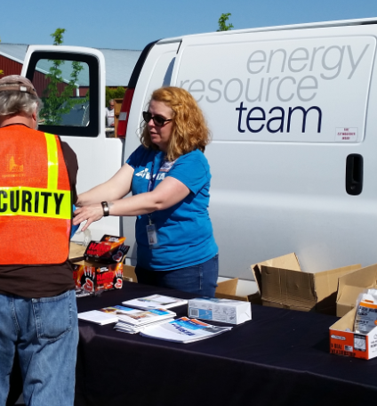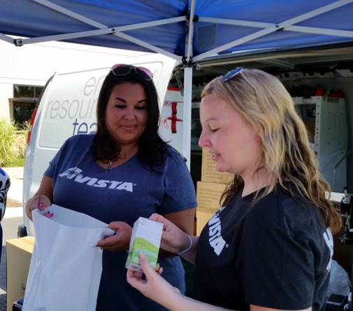

1. **LIRAP Appointment Day:** In November 2016, Avista launched its first ever Energy Assistance Appointment Day. This event was held at the Spokane County Fair and Expo Center and was done in partnership with Spokane Neighborhood Action Partners (SNAP). 320 Avista customers were qualified for energy assistance, in which approximately 70 of those individuals were first time beneficiaries of the program. In addition to energy assistance appointments, customers received energy efficiency items such as V-seal door sweeps and LED light bulbs. Customers could also get a demonstration of how to use the energy efficiency items. Many other community agencies participated and had booths where customers could receive information about various community assistance and services as well. Approximately 100 Avista employees volunteered alongside the approximately 35 SNAP employees who worked the event to make it an overwhelming success.

In total the Company reached 13,134 individuals through 143 low income and senior events in 2016. In 2017, we have increased our goal and have a target of connecting with at least 25,000 customers through the low income and senior programs mentioned above, along with other community engagement activities.

**IV. MEETING CUSTOMER EXPECTATIONS**

Q. Please describe how the Company measures customer satisfaction, and how important it is to Avista.

A. Our customer satisfaction is very important to Avista. We measure satisfaction by conducting a quarterly survey we refer to as “Voice of the Customer” (VOC).[5] The purpose of the VOC Survey is to measure and track customer satisfaction for Avista Utilities’ “contact” customers – i.e., customers who have had contact with Avista through the Call Center and/or work performed through an Avista construction office.

Customers are asked to rate the importance of several key service attributes. They are then asked to rate Avista’s performance with respect to the same attributes (time for connection to a representative, representative being courteous and friendly, representative being knowledgeable, being informed of job status, leaving property in condition found, etc.). Customers are also asked to rate their satisfaction with the overall service received from Avista Utilities. Customer verbatim comments are also captured and recorded.

Our most recent 2016 year end results show that 94% of our customers in our Washington, Idaho, and Oregon operating divisions were satisfied or very satisfied with the service they received. This rating reflects a positive experience for customers who have contacted Avista related to the overall customer service they received.

The VOC results from 2008 through 2016 are shown in Chart No. 1 below. What these historical results represent is Avista’s long history of a culture of service. We understand that good customer service is complex and requires awareness and attention to a host of factors that contribute to the overall service experience of our customers. It is for this reason that we are proud that our annual VOC results have remained consistently high and our expectation is that this trend will continue in the future.

Chart No. 1 – Historical VOC Results

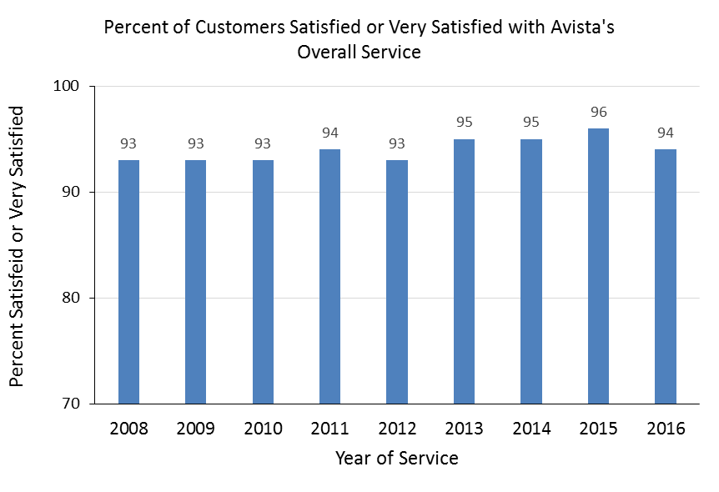

Q. Are customer expectations changing?

A. Yes, customer expectations are constantly changing and the quality and nature of our service must evolve over time to keep up with those expectations. The most rapidly changing expectations are related to advancements in mobile and other personal technology devices and applications, increased proactive communications, and self-service options. As the demographic makeup of our customer base becomes younger, our customers are comparing us to the likes of Amazon or Apple, such that they expect a digitized experience that is personal to their individual preferences. These changing expectations will require us to better understand our customers and their varying needs and expectations.

**Q. What is the Company doing to meet its customers’ changing expectations?**

A. We are continuously engaged in the very granular and evolving work of assessing our customers’ expectations and evaluating our capabilities and performance in meeting them. From a technology perspective, we have been making enhancements to meet the changing customer expectations. In early 2015, the Company launched new customer information and work management systems. These new platforms provide the foundation for future technologies, such as self-service online and mobile applications. In November 2015, we launched our new outage information tools known as our Outage Center, a mere two weeks before a severe wind storm, the most devastating storm the Company has experienced in its history, hit our service territory. The new outage information center allows customers to report outages, and allows Avista to provide real time updates and alerts (via emails or text messages) to customers about outages in their area and can be accessed at [www.avistautilities.com](http://www.avistautilities.com) from a computer or smart phone.

The next phase of the outage information center, released in June 2016, was a mobile application (“App”) that customers are able to download to their smartphone. The Avista Outage App has similar functionality to the storm center, but offers a more personal experience by keeping record of the customer’s account information via user authentication. Through the App customers can quickly report outages, view the outage map, and access important information, including proactive outage alerts. Illustration No. 4 below provides an illustration of Avista’s Outage App.

**Illustration No. 4** – **Avista Outage App**



In February 2017, the Company launched a new payment experience as part of its overall website replacement effort. The new experience provides for easier self-service through the Company’s website from a computer or mobile site from a smart phone. The new payment process is simpler and mobile friendly. In addition, residential customers are now able to pay through any payment channel using any method they choose without a per-transaction fee. The full replacement of the customer website is expected to be completed in phases throughout 2017. Lastly, work is also underway for additional self-service functionality on Avista’s mobile App. Future plans include the ability for a customer to access their account just as they would on the website, view their bill, and make payments. In addition to the mobile App, we will be offering a variety of bill payment alerts and the ability to pay by text.

**V. PRODUCTS AND SERVICES INIATIVES**

**Q. Please provide an overview of Avista Utilities’ products and services initiatives.**

A. As mentioned above, customer expectations are constantly changing and we know that customers have come to expect more from their utility than simply the electricity and natural gas that we deliver. In concert with changing customer expectations, energy related technologies, such as solar and electric vehicles, are increasingly of interest to customers as they improve in functionality and decrease in cost. These trends are creating more choices for customers regarding how they receive, use, and manage their energy and Avista is working to continually develop products and services that enable more choices for our customers. For these reasons we have a team focused on delivering new products and services that our customers are interested in.

A description of the products and service initiatives already launched include the following:

**Community Solar Program:** Avista’s community solar program was built on land the Company owns in Spokane Valley, Washington. Customers who elected to participate in the project were asked to make an upfront contribution equal to their portion of the overall project costs, including both initial costs and ongoing costs, such as operation, maintenance, administrative, etc., that will be incurred throughout the life of the program. This community solar program was open to both residential and non-residential customers in Washington and participation was voluntary. The project consists of a total of 1,512 panels and has a total generating capability of 423 kilowatts, or a little less than one-half megawatt.[6] The project is fully subscribed. Customers are receiving a credit on their monthly bills based on the actual generation from the panels. The project has provided the opportunity for Washington customers to participate directly in solar generation, without having the solar equipment at their premise. Through April 2017, customers have received approximately $603 in credits per panel, which is 10.2% above expectations.

**HVAC Filter Replacement Program:** This program is designed to educate customers on the value of replacing filters, and offer choices to customers to make it more convenient for them to remember to replace their filters. In addition to extending the life of a furnace, replacing the furnace filter helps to maintain the expected operating performance of the furnace. This program was launched in August of 2015, and it is available to all Avista customers in Washington, Idaho and Oregon. Through the filter program, customers have three convenience options: 1) Receiving an e-mail reminder from Avista on a periodic basis to replace their filter, 2) receiving an e-mail reminder with promotional codes from manufacturers and vendors for discounts on filter purchases, and 3) the opportunity to order filters directly from a vendor, for delivery to their home or business on a schedule chosen by the customer. To date, 2,954 customers have signed up for one of the three options in this program.[7]

**Rooftop Solar Estimator:** In mid-2015 Avista launched a rooftop solar estimator on [www.avistautilities.com](http://www.avistautilities.com). The solar estimator tool provides a 20 year financial analysis for customers that allows them to compare their options for rooftop solar and make a more fully informed decision if rooftop solar makes sense for them or not. In order to use the tool a customer enters their address and finds their location on a map, then enters their building type (residential or commercial), and average energy usage. The tool then calculates a personalized solar estimate for the customer, which includes a recommended solar system sized for their roof, their estimated annual savings or cost, and a financial analysis of the costs and benefits of installing rooftop solar. Since being launched approximately 3,400 customers have used the rooftop solar estimator.

**Compressed Natural Gas Tariff:** Avista’s compressed natural gas (CNG) initiative is designed to reduce fuel costs and reduce our carbon footprint by adding more Natural Gas Vehicles throughout our fleet. CNG is a safe, clean and efficient alternative fuel that serves Avista and a growing number of vehicles on the road. In addition, in 2015 Avista proposed, and the Washington Commission approved, a new tariff service offering for CNG fleet operators who may, from time to time, require backup and supplemental CNG services. Several CNG fleet operators in the Spokane area have, or will be installing, natural gas compression facilities at their individual premises to serve their CNG fleet.

**Find an HVAC Contractor Feature on** [**www.avistautilities.com**](http://www.avistautilities.com)**:** In March 2016, the Company launched a new feature on its website for customers to locate an HVAC contractor in their area. Customers frequently ask our field personnel and Customer Service Representatives if they can recommend an HVAC contractor for maintenance, repair, or replacement of their HVAC system. Avista partnered with the Northwest HVAC/R Association to provide referrals for qualified equipment contractors. The tool allows customers to enter their zip code and category of work needed, then they will be provided with up to three equipment contractors that serve their area. Through April 2017, an average of 670 people have accessed the Find an HVAC Contractor Feature webpage per month.

**Electric Vehicle Supply Equipment Pilot:** In April 2016, the Commission approved a pilot program where the Company will install 265 AC Level 2 Electric Vehicle Supply Equipment (EVSE) port connections as a means to better understand Electric Vehicle (EV) charging at home, at work and in public areas, i.e., what is needed, what is effective, and how it may affect the grid in the future. The pilot is helping Avista better understand how to maximize the benefits of EVs for all our customers in the years ahead, as well as supporting a cleaner environment through the increased use of EVs in the Spokane area. By installing a limited number of EVSE in beneficial workplace and public areas, we will also help support greater EV adoption in our service territory and pave the way for effective long-term programs. In addition to the Level 2 EVSE installations, Avista is installing DC Fast Charging EVSE at seven locations as part of the pilot program.

**Q. What product and service initiatives are currently being explored as potential offerings to our customers?**

A. We are continually evaluating new products and services that our customers may be interested in. One example of a program that is currently being evaluated is the Avista Home Energy Marketplace.

**Avista Home Energy Marketplace:** The platform, provided by a third-party company named Enervee, will allow Avista residential customers an upgraded online Marketplace to help them find and purchase energy-saving electronics and appliances by way of comparing a product’s energy efficiency, product popularity and price worthiness, based on industry standards, against all models available on the market.[8] By providing details on each product’s energy usage, (based on Avista’s rate structure) and costs, the marketplace will make it easier for customers to make their purchases, conserve energy and contribute to a clean, sustainable environment. Enervee data shows that customers that shop on the marketplace tend to buy equipment that is approximately 15% more energy efficient than equipment purchased through other methods. Avista customers can create account profiles for saved searches, get price alerts, and access Avista energy efficiency product rebates. Customers will be able to access the Marketplace on their desktop computers or on their mobile devices. The Avista Home Energy Marketplace is expected to be launched mid-2017. An example of what the Marketplace may look like is shown in the following illustration.

**Illustration No. 5** – **Sample Avista Home Energy Marketplace Landing Page**

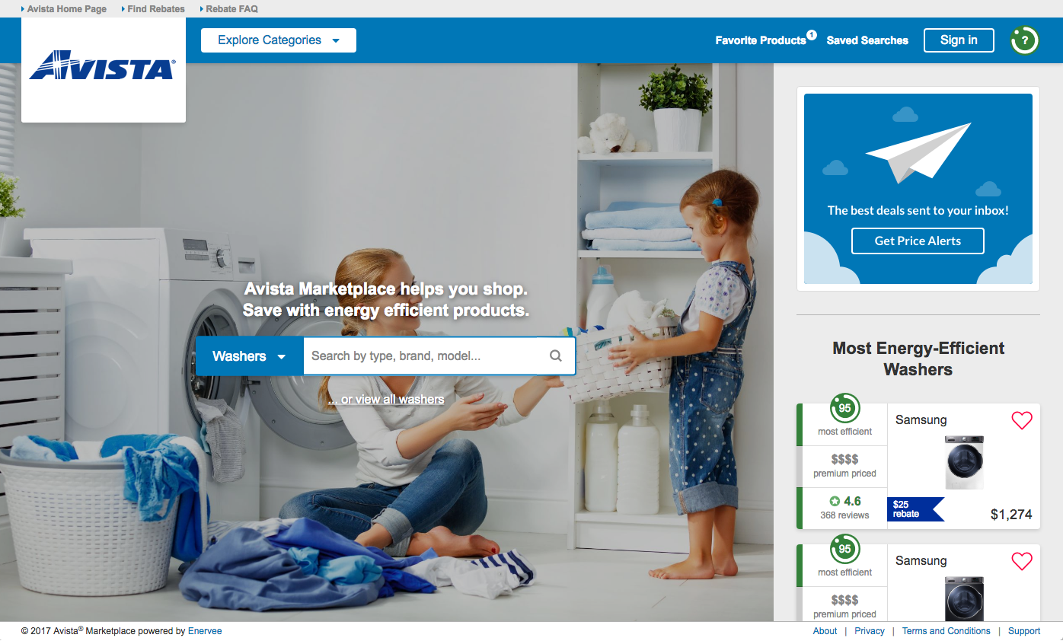

**VI. LINE EXTENSION ALLOWANCE PROGRAM**

**Q. Please describe the changes the Commission approved in Docket No. UG-152394, related to the Company’s natural gas line extension tariff Schedule 151.**

A. On February 25, 2016, the Commission issued Order 01 approving the Company’s Petition for approval of changes to the Company’s natural gas line extension tariff and accounting ratemaking treatment, on a temporary basis, for a three-year period. Specifically, the Order approved the Company’s proposed accounting and ratemaking treatment related to the use of any excess single-family residential line extension allowance as a rebate on customers’ purchase and installation of high efficiency natural gas space and/or hot water heating equipment, if the customer is converting to natural gas from another fuel source.

**Q. Please summarize the accounting treatment approved by Order 01 in the Company’s Petition.**

A. In the Petition the Company proposed to defer, “for later recovery in rates, the excess line extension allowance paid to Washington residential customers upon conversion to natural gas. The deferral of excess line extension allowances paid by Avista would begin on the same date in which the revised tariffs included in this Petition become effective. In the general rate cases filed during the pilot period, the Company would propose to amortize and recover the costs from all customers over a five-year period with a return on the unamortized balance.”[9] The deferral began on March 1, 2016 as approved by Order 01.

**Q. How many customers have converted to natural gas and received an excess allowance credit used towards the purchase of high-efficiency natural space and/or hot water heating equipment?**

A. From the start of the program on March 1, 2016, and through March 31, 2017, the number of customers that converted to natural gas and received an excess allowance credit was 1,039. The total amount deferred is approximately $2.9 million.

**Q. Is the Company seeking to amortize and recover the deferred costs related to the line extension allowance in this filing?**

A. Yes. Company witness Ms. Andrews has included the deferral balanced through March 31, 2017 of $2.9 million in the Company’s request for rate relief, amortizing this balance over a five year period beginning May 1, 2018 to April 30, 2023. Ms. Andrews adjustment 3.13, “Pro Forma LEAP Deferral” shows the annual amortization associated with the five year recovery period of the $2.9 million deferral is $0.58 million. The Company will include additional deferrals associated with the remaining two years of the program in future regulatory proceedings.

1. **Does this conclude your pre-filed direct testimony?**
2. Yes.

1. For the 2016 Voice of the Customer results, 93% of customers that made contact with Avista’s call center reported being very satisfied or satisfied with the service they received, while 94% of customers that had contact with Avista through the Call Center and/or work performed through an Avista construction office reported being very satisfied or satisfied with the service they received.
2. The Low Income Home Energy Assistance Program (LIHEAP) is a federal program established in 1981 and funded annually by Congress. These federal dollars are released directly to states, territories, tribes and the District of Columbia who use the funds to provide energy assistance to low-income households. LIHEAP offers financial assistance to qualifying low-income households to help them pay their home heating or cooling bills. Under federal law, a household must have income below either 150 percent of the federal poverty level or 60 percent of state median income level, whichever is higher. However, states can set lower income thresholds if they choose to.
3. See Dockets UE-150204 and UG-150205, Order No. 05, issued by the Commission on January 6, 2016.
4. The actual benefit amount received by each customer may be more or less than $300 depending on actual usage.
5. The Voice of the Customer survey is conducted by an independent third-party.
6. Avista built the size of the community solar array to the maximum size allowed per WAC 458-20-273 to be eligible for customers to receive the Washington Renewable Generation Incentive.
7. To date, 1,413 customers have requested an email reminder without coupons, 1,390 customers requested email reminders with coupons and 151 customer have signed up to receive filters direct from the vendor.
8. Enervee is the world’s first energy-smart data and commerce platform that connects utilities, retailers, manufacturers and governments through integrated product rankings and recommendations. Through its extensive SaaS platform, Enervee provides the most up-to-date market information to help utilities empower their customers to make energy-smart buying decisions.
9. UG-152394 Avista Petition, ¶ 31