**Docket Number: 100522**

**MEMORANDUM**

**To:** David Danner, Washington Utilities and Transportation Commission

**From:** Josh Bufford, OPOWER  
 Michael Sachse, OPOWER  
 Tim Thompson, Thompson Smitch Consulting Group

**Date:** June 11, 2010

**Subject:** OPOWER Response to Docket Number: 100522

Washington State has a unique opportunity to lead the nation in adopting, deploying, and understanding behavior-based energy savings. In 2008, Puget Sound Energy (”PSE”) became the first investor-owned utility to deploy a large scale behavioral pilot, and PSE remains one of a handful of utilities testing the impact of behavioral messaging and engagement on both electric and gas consumption. In 2009, Seattle City Light (“SCL”) also implemented a comparable behavior-based program. Other states have examined Washington’s results, and those of many other utilities in the nation and have moved ahead in adopting standards to enable their utilities to utilize these savings opportunities. Indeed, just this month, the California Public Utilities Commission ruled that behavior-based savings would count towards efficiency goals. As Commissioner Dian Grueneich put it, “"It is essential that we create a regulatory environment in which potential game-changing efforts such as these innovative behavioral-based strategies can flourish.” Washington can, and should, be a leader in this effort.

As Figure 1 illustrates, the potential impact for cost effective savings from behavior-based programs is enormous and can significantly bolster the conservation and efficiency efforts for Washington.

I write to encourage the Washington Utilities and Transportation Commission to (1) count savings from statistically quantifiable behavior-based programs; (2) expand behavioral programs so that robust results and further understanding can be achieved from different regions across the state; and (3) establish an independent effort to analyze and disseminate the results in order to make future decisions.

**Count savings from behavior-based programs**

Results from the pilot program at PSE (Home Energy Reporting) have been reviewed at length by a number of evaluators and are backed by a transparent measurement and verification methodology that is consistent with both the National Action Plan for Energy Efficiency guidelines and the California Evaluators Manual. The results have been have been independently verified by Ian Ayres of Yale University and the methodology has been reviewed and verified by several other organizations, including Summit Blue (reviewed a program in Sacramento, CA), Power Systems Engineering (reviewed a similar program at Connexus Energy), Hunt Allcott of MIT (published in *Science*), and evaluators within utilities. Moreover, Massachusetts, Minnesota, and California have all found the approach from these pilot programs sufficiently rigorous to count behavior-based savings towards efficiency goals in those states.

In short, there is no reasonable doubt that behavior based programs are effective. Nor is there any real question about how to measure these savings. The only questions are about how to address double-counting issues that, though important, affect a small fraction of the savings achieved through behavior-based programs.

We respectfully suggests that the UTC follow the path established by other states and

1. First commit to counting behavior-based savings, then,
2. Develop a comprehensive methodology for evaluation, measurement and verification.

Not much time is needed to accept this program. Other states already count behavior based savings, and the evaluation techniques are not difficult to determine once the process is begun. We therefore encourage the UTC to move on this first item quickly.

**Expand behavior-based programs across the state**

Currently, all behavior-based programs in Washington are focused in the Seattle area. This will remain true even if PSE and SCL expand their programs, as they have planned to do. Results from other states indicate, however, that behavior-based programming works in all regions – indeed, it is particularly effective in areas where usage levels are highest. Furthermore, the norm against waste is not confined to the most affluent and progressive regions of the state. Rural and conservative areas respond very well to behavioral messaging.

What is missing is a comprehensive, statistically significant deployment of behavior-based programs across a single state as politically, geographically, and demographically diverse as Washington. Once behavior-based efficiency is approved, the UTC should push other utilities in the state such as Avista and Pacific Corp to adopt significant behavior-based programs, as well. Implementations in other regions within the state will put the UTC in a unique position to comprehensively understand and evaluate the efficacy of behavior-based efficiency and any evolution of that impact over a longer term.

**Establish an independent system to analyze and disseminate the results**

We recognize that behavior-based efficiency has to be rigorously measurable to truly count as a resource. Figure 2, below summarizes visually what we believe is a preferred method to ensure a high level of confidence in the measurement. Moreover, we recognize that many useful lessons can be gleaned from the results of existing programs. Not only will larger implementations allow for more meaningful results concerning how different groups within the state react to behavior-based messaging, but it will also assist the UTC in micro-targeting other efficiency efforts. The UTC can gain insight it has not had before into who is accessing utility sponsored rebate programs, what types of actions individual households are likely to take to save energy, and which regions respond best to what program. In short, the UTC could gain, for the first time, a comprehensive audit of key aspects of its efficiency portfolio, through careful use of the statistical analysis that accompanies behavior-based programs.

**Conclusion**

Now is the time for Washington to act to promote behavior-based efficiency. No other state has an equivalent background of results and implementations underway. What is missing is a clear path forward – on EM&V, expansion, and analysis. We respectfully suggest that the UTC embrace this opportunity, and push behavior forward as an efficiency resource.

Figure 1: Impact of behavior-based programs is very large and very cost effective

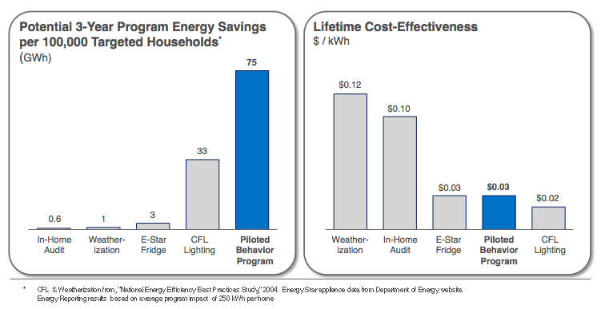

Figure 2: Rigorous M&V Approach for Behavioral Programs

