Attachment 2

**INCREMENTAL COST OF RENEWABLE RESOURCES**

According to RCW 19.285, certain electric utilities in Washington must meet 15 percent of their retail electric load with eligible renewable resources by the calendar year 2020. The annual target for the calendar year 2012 was 3 percent of retail electric load, and for 2016, it is 9 percent. However, if the incremental cost of those renewable resources compared to an equivalent non-renewable is greater than 4 percent of its revenue requirement, then a utility will be considered in compliance with the annual renewable energy target in RCW 19.285. The law states it this way: “The incremental cost of an eligible renewable resource is calculated as the difference between the levelized delivered cost of the eligible renewable resource, regardless of ownership, compared to the levelized delivered cost of an equivalent amount of reasonably available substitute resources that do not qualify as eligible renewable resources.”[1]

**Analytic Framework.** This analysis compares the revenue requirement cost of each renewable resource with the projected market value and capacity value at the time of the renewable acquisition. There may be other approaches to calculating these costs – such as using variable costs from different kinds of thermal plants instead of market. However, PSE’s approach is most reasonable because it most closely reflects how customers will experience costs; i.e., PSE would not dispatch a peaker or CCCT with the ramping up and down of a wind farm without regard to whether the unit is being economically dispatched. For example, a peaker will not be economically dispatched often at all, so capacity from the thermal plant and energy from market is the closest match to actual incremental costs – and that is the point of this provision in the law – a to ensure customers don’t pay too much. This, “contemporaneous” with the decision-making aspect of PSE’s approach, is important. Utilities should be able to assess whether they will exceed the cost cap before an acquisition, without having to worry about ex-post adjustments that could change compliance status. The analytical framework here reflects a close approximation of the portfolio analysis used by PSE in resource planning, as well as in the evaluation of bids received in response to the company’s request for proposals (RFP).

**“Eligible Renewable Resources”**

Figure N-46: Resources that meet RCW 19.285 definition of Eligible Renewable Resource

|  |  |  |  |  |  |
| --- | --- | --- | --- | --- | --- |
|  | Nameplate (MW) | Annual Energy (aMW) | Commercial Online Date | Market Price/ Peaker Assumptions | Capacity Credit Assumption |
|  |  |  |  |  |  |
| Hopkins Ridge | 149.4 | 53.3 | Dec 2005 | 2004 RFP | 20% |
| Wild Horse | 228.6 | 73.4 | Dec 2006 | 2006 RFP | 17.2% |
| Klondike III | 50 | 18.0 | Dec 2007 | 2006 RFP | 15.6% |
| Hopkins Infill | 7.2 | 2.4 | Dec 2007 | 2007 IRP | 20% |
| Wild Horse Expansion | 44 | 10.5 | Dec 2009 | 2007 IRP | 15% |
| Lower Snake River I | 342.7 | 102.5 | Apr 2012 | 2010 Trends | 5% |
| Snoqualmie Upgrades | 6.1 | 3.9 | Mar 2013 | 2009 Trends | 95% |
| Lower Baker Upgrades | 30 | 12.5 | May 2013 | 2011 IRP Base | 95% |
| Generic Wind 2023 | 206 | 71 | Jan 2023 | 2015 IRP Base | 8% |
| Generic Wind 2028 | 131 | 45 | Jan 2028 | 2015 IRP Base | 8% |

**Equivalent Non-renewable.** The incremental cost of a renewable resource is defined as the difference between the levelized cost of the renewable resource compared to an equivalent non-renewable resource. An equivalent non-renewable is an energy resource that does not meet the definition of a renewable resource in RCW 19.285, but is equal to a renewable resource on an energy and capacity basis. For the purpose of this analysis, the cost of an equivalent non-renewable resource has three components:

1. **Capacity Cost:** There are two parts of capacity cost. First is the capacity in MW. This would be nameplate for a firm resource like biomass, or the assumed capacity of a wind plant. Second is the $/kW cost, which we assumed to be equal to the cost of a peaker.
2. **Energy Cost:** This was calculated by taking the hourly generation shape of the resource, multiplied by the market price in each hour. This is the equivalent cost of purchasing the equivalent energy on the market.
3. **Imputed Debt:** The law states the non-renewable must be an “equivalent amount,” which includes a time dimension. If PSE entered into a long-term contract for energy, there would be an element of imputed debt. Therefore, it is included in this analysis as a cost for the non-renewable equivalent.

For example, Hopkins Ridge produces 466,900 MWh annually. The equivalent non renewable is to purchase 466,900 MWh from the Mid-C market and then build a 30 MW (149.4*20 percent = 30) peaker plant for capacity only. With the example, the cost comparison includes the hourly Mid-C price plus the cost of building a peaker, plus the cost of the imputed debt. The total revenue requirement (fixed and variable costs) of the non-renewable is the cost stream – including end effects – discounted back to the first year. That net present value is then levelized over the life of the comparison renewable resource.

**Cost of Renewable Resource.** Levelized cost of the renewable resource is more direct. It is based on the proforma financial analysis performed at the time of the acquisition. The stream of revenue requirement (all fixed and variable costs, including integration costs) are discounted back to the first year – again, including end effects. That net present value is then levelized out over the life of the resource/contract. The levelized cost of the renewable resource is then compared with the levelized cost of the equivalent non-renewable resource to calculate the incremental cost.

The following is a detailed example of how PSE calculated the incremental cost of Wild Horse. It is important to note that PSE’s approach uses information contemporaneous with the decision making process, so this analysis will not reflect updated assumptions for capacity, capital cost, or integration costs, etc.

Eligible Renewable: Wild Horse Wind Facility

Capacity Contribution Assumption: 228.6 * 17.2% = 39 MW

**1. Calculate Wild Horse revenue requirement.**

Figure N-47 is a sample of the annual revenue requirement calculations for the first few years of Wild Horse, along with the NPV of revenue requirement.

Figure N-47: Calculation of Wild Horse Revenue Requirement

|  |  |  |  |  |  |
| --- | --- | --- | --- | --- | --- |
| ($ Millions) | 20-yr NPV | 2007 | 2008 | … | 2025 |
|  | | | | | |
| Gross Plant |  | 384 | 384 | ... | 384 |
| Accumulative depreciation (Avg.) |  | (10) | (29) | … | (355) |
| Accumulative deferred tax (EOP) |  | (20) | (56) | … | (7) |
| Rate base |  | 354 | 299 | … | 22 |
| After tax WACC |  | 7.01% | 7.01% | … | 7.01% |
| After tax return |  | 25 | 21 | … | 2 |
| Grossed up return |  | 38 | 32 | … | 2 |
| PTC grossed up |  | (20) | (20) | … | - |
| Expenses |  | 16 | 16 | … | 22 |
| Book depreciation |  | 19 | 19 | … | 19 |
| Revenue required | 370.9 | 53 | 48 | … | 44 |
| End effects | 4.6 |  |  |  |  |
| Total revenue requirement | 375 |  |  |  |  |

**2. Calculate revenue requirement for equivalent non-renewable: Peaker capacity.**

Capacity = 39 MW

Capital Cost of Capacity: $462/KW

Figure N-48: Calculation of Peaker Revenue Requirement

|  |  |  |  |  |  |
| --- | --- | --- | --- | --- | --- |
| ($ Millions) | 20-yr NPV | 2007 | 2008 | … | 2025 |
|  | | | | | |
| Gross Plant |  | 18 | 18 | … | 18 |
| Accumulative depreciation (Avg.) |  | (0) | (1) | … | (10) |
| Accumulative deferred tax (EOP) |  | (0) | (0) | … | (3) |
| Rate base |  | 18 | 17 | … | 5 |
| After tax WACC |  | 7.01% | 7.01% | … | 7.01% |
| After tax return |  | 1 | 1 | … | 0 |
| Grossed up return |  | 2 | 2 | … | 0 |
| Expenses |  | 1 | 1 | … | 2 |
| Book depreciation |  | 1 | 1 | … | 1 |
| Revenue required | 32 | 4 | 4 | … | 3 |
| End effects | 2 |  |  |  |  |
| Total revenue requirement | 34 |  |  |  |  |

**3. Calculate revenue requirement for equivalent non-renewable: Energy**

Energy: 642,814 MWh

For the market purchase, we used the hourly power prices from the 2006 RFP plus a transmission adder of $1.65/MWh in 2007 and escalated at 2.5 percent.

Figure N-49: Calculation of Energy Revenue Requirement

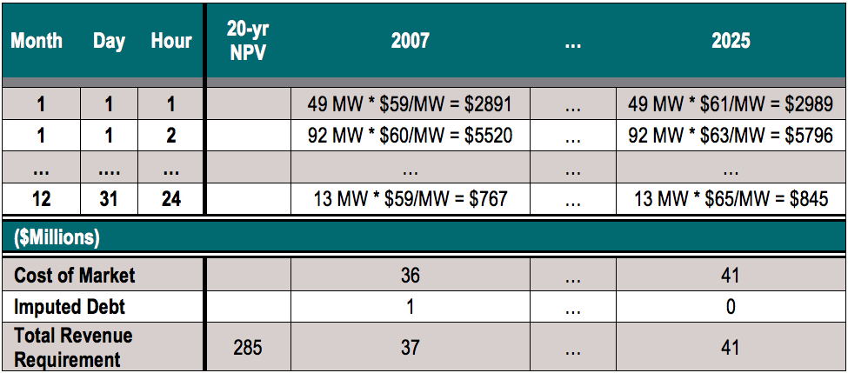

**4. Incremental cost**

The table below is the total cost of Wild Horse less the cost of the peaker and less the cost of the market purchases for the total 20-year incremental cost difference of the renewable to an equivalent non-renewable.

Figure N-50: 20-yr Incremental Cost of Wild Horse

|  |  |
| --- | --- |
| ($ Millions) | 20-yr NPV |
|  |  |
| Wild Horse | 375 |
| Peaker | 34 |
| Market | 285 |
| 20-yr Incremental Cost of Wild Horse | 56 |

We chose to spread the incremental cost over 25 years since that is the depreciable life of a wind project used by PSE. The payment of $56 Million over 25 years comes to $5.2 Million/Year using the 7.01 percent discount rate.

**Summary Results.** Each renewable resource that counts towards meeting the renewable energy target was compared to an equivalent non-renewable resource starting in the same year and levelized over the book life of the plant: 25 years for wind power and 40 years for hydroelectric power. Figure N-51 presents results of this analysis for existing resources and projected resources. This demonstrates PSE expects to meet the physical targets under RCW 19.285 without being constrained by the cost cap. A negative cost difference means that the renewable was lower-cost than the equivalent non-renewable, while a positive cost means that the renewable was a higher cost.

Figure N-51: Equivalent Non-renewable 20-year Levelized Cost Difference   
Compared to 4% of 2011 GRC Revenue Requirement + 2014 PCORC adjustment

**

As the chart reveals, even if the company’s revenue requirement were to stay the same for the next 10 years, PSE would still not hit the 4 percent requirement. The estimated revenue requirement uses a 2.5 percent assumed escalation from the company’s current revenue requirement.

1. / RCW 19.285.050 (1) (a) (b)