**SECTION 8**

**RESOURCE INTEGRATION**

**Overview**

Resource integration is the last step in Cascade’s IRP process. It involves finding the least cost mix of demand and supply side resources given the forecasted load requirements of the core customers. The tool used to accomplish this task is a computer optimization model known as SENDOUT®. This model permits the Company to quickly develop and analyze a variety of resource portfolios to help determine the type, size, and timing of resources best matched to forecast requirements. SENDOUT® is very powerful and complex. It operates by combining a series of existing and potential demand side and supply side resources and optimizes their utilization at the lowest net present cost over the entire planning period for a given demand forecast.

**Scenarios versus Simulations**

Prior to discussing the modeling process, inputs, and ultimately the results of the analyses, a brief discussion of the term scenarios versus simulations is necessary. As stated earlier, SENDOUT® relies on a series of inputs or assumptions and then solves for the least cost solution based on the information provided to the model. Each group of assumptions is considered a scenario. For example, the Company models medium load growth under average weather conditions where the assumed daily weather pattern is input into the SENDOUT® model. The company also runs scenarios utilizing the low and high growth forecasts and historically has run several different price assumption scenarios. The results of each of these scenarios provide an answer or a least cost solution, which the optimization model has solved based on its perfect knowledge. Historically, this has provided the range of expected outcomes. With the use of the Monte-Carlo functionality, the Company runs simulations to determine if the scenario results are reasonable and to provide an expected range of results based on a statistical analysis.

Table 7-1 provides the list of scenarios included in this IRP and their key assumptions. To assess the impacts due to variations in pricing and weather, the company ran Monte-Carlo simulations on the expected case scenario. The Company utilized the expected case scenario as it represents the scenario Cascade considers most likely to be experienced over the planning horizon.

The expected case (Medium Load Growth, Medium Gas Price Forecast, Average weather with Peak Event) includes existing supply contracts, incremental supplies (peaking, annual, seasonal, city gate and satellite LNG from various receipt points (AECO, Rockies, Sumas and Station 2). The expected case includes current upstream pipeline transport capacity as well as incremental NWP and GTN capacity. The Company also included Cascade’s current Jackson Prairie storage accounts and the two Plymouth LNG accounts.

**Planning and Modeling**

SENDOUT®’s broad capabilities allows the Company to develop supply and demand relationships that closely mirror Cascade’s existing operations. Beginning with the 2008 IRP Cascade expanded its modeling from the district level to modeling the system grouped by the various pipeline zones. Figure 8-1 shows the location of these pipeline zones. These pipeline zones reflect Cascade’s customers being served from either Northwest Pipeline LLC (NWP) or Gas Transmission Northwest (GTN) interstate pipeline facilities.

**Figure 8-1: Pipeline Zones Used in this IRP**

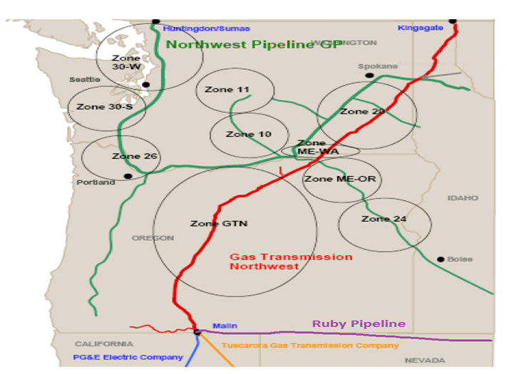

With the introduction of our new in-house load forecast model (LFM) application, the 2016 IRP modeling dives into an even more granular level. This IRP takes a more citygate view, which allows Cascade to take a deeper view of capacity shortfalls and potential constraints. A copy of the network diagram is shown in Figure 8-2. The network diagram is not provided for readability but rather to emphasize the difficulties in configuring the model to best replicate Cascade’s complex system.

**Figure 8-2: SENDOUT Network Diagram of Cascade’s System**

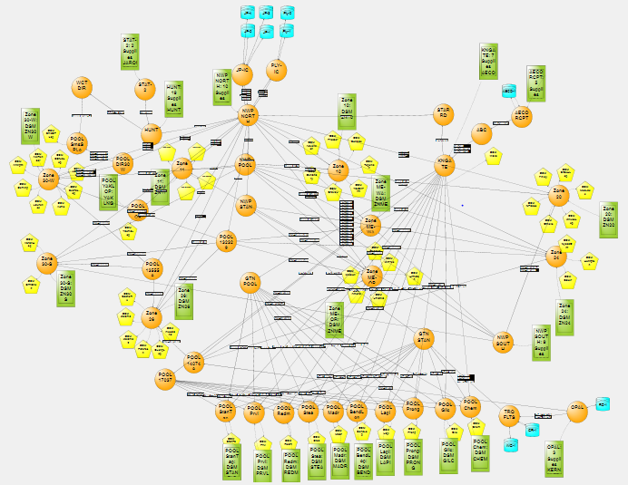

**Tools Used**

Because SENDOUT® utilizes a linear programming approach, its results are considered “deterministic”. For example, the model knows the exact load and price for every day of the planning period based on the analyst’s input and can therefore minimize costs in a way that would not be possible in the real world. Therefore, it is important to acknowledge that linear programming analysis provides helpful but not perfect information to guide decisions.

Since decisions are made in the context of uncertainty about the future, Cascade purchased VectorGasTM. VectorGasTM is an add-in product to the SENDOUT® model that facilitates the ability to model gas price and load uncertainty (driven by weather) into the future. VectorGasTM utilizes a Monte Carlo approach in combination with the linear programming approach in SENDOUT®. The VectorGasTM functionality was integrated in the SENDOUT® software with Version 12.5 (this IRP uses Version 14.3). The addition of the Monte-Carlo modeling capability provides supplemental information to decision makers under conditions of uncertainty. This tool continues to enhance the robustness of the Company’s long-term resource planning and acquisition activities.

**Resource Optimization Output and Analysis Reports**

After the model run is performed and SENDOUT® selects the optimal set of resources from the available portfolio, output reports are generated. SENDOUT® provides the analysts with an assortment of Input and Output reports that it can generate, provided they are selected prior to the optimization run. SENDOUT® offers dozens of separate input reports that summarize various items such as demand inputs, the resulting forecast, temperature patterns as well as supply, storage and transportation resource inputs. These reports allow the analysts to verify that the information supplied to SENDOUT® is being accurately interpreted by the model.

The results of the optimization process are provided in the dozens of output summary reports available to the SENDOUT® analysts. These reports summarize various aspects of the optimal portfolios resource size and selection as well as cost and utilization over the planning period. For purposes of this discussion, certain key output reports will be summarized below.

**Key Output Report - Cost and Flow Summary**

The Cost and Flow Summary Report consolidates a number of very informative aspects of the optimization run. The report provides the analysts with a breakdown of portfolio costs, on a yearly as well as a total planning period basis, in several different formats. For example, an aggregate portfolio cost total is provided for easy comparison between years, as well as between various optimization runs, if the analyst is attempting to quickly compare the influence that one or more resources can have on the portfolio. This total portfolio cost figure is also broken down into supply, storage and transportation cost summaries on both a yearly and planning period basis.

The report also provides unit cost detail of the total portfolio as well as each resource selected and utilized by the model in the optimization process. The analyst is provided with individual resource takes and available maximums to quickly determine how much of a portfolio resource the model actually uses.

Finally, the report also contains the Resource Mix summary. This report summarizes SENDOUT’s decisions regarding the sizing and optimal mix of incremental resources, which enables the analyst to determine whether one or many different types of resources should be considered for inclusion in the total resource portfolio.

**Key Output Report - Month to Month Summary**

While the Cost and Flow summary provides some indication of individual resource utilization, the Month to Month summary allows the analyst to examine more closely how SENDOUT® utilizes each resource. The user can determine if the particular type of resources presented to SENDOUT® are being utilized as envisioned or whether other types of resources would more closely match requirements. For example, the analyst may offer annual supply contracts to SENDOUT® to address load growth over the planning period. The analyst can examine this report to determine if SENDOUT® uses these supplies throughout the year or only occasionally. If SENDOUT® utilizes this resource on a short-term basis during the winter, the analyst can introduce seasonal resources to SENDOUT® to determine whether it would choose them over the annual supplies already available in the portfolio.

SENDOUT® also presents more of this monthly information in other, more specific reports. For example, the supply information provided in this Month to Month report is also available in greater detail in the Supply Summary Report. The same situation is also present with respect to the Transportation Summary Report and the Storage Summary Report. SENDOUT® also offers monthly supply utilization information in a Load Factor Summary Report which some analysts may prefer to use in their approach to analyzing SENDOUT’s results.

**Key Output Report - Supply vs. Requirements**

This report compares a particular forecast’s monthly demand requirement quantity against the optimal portfolio’s various supply quantities. The analyst can observe supply utilization as well as determine whether the supply portfolio quantities are sufficient to meet demand. If an insufficiency exists, the report isolates the shortfall by month as well as the location of the Company’s demand requirement. Armed with this information, the analyst can readily access the Daily Unserved Demand reports to determine if a pattern exists with respect to the shortfall. For example, if the daily report indicates that the shortfall occurs on the peak day the analyst could turn to the Peak Day Reports to determine if the shortfall is supply or transportation related. If the shortfall occurs on a number of days surrounding the peak or at other times during the year, the analyst can turn to the Daily Supply Take and Daily Transport Flow reports to determine whether the portfolio is constrained by supply availability or transport capacity on those particular days.

**Key Output Reports - Custom Report Writer**

Ultimately, the availability and interpretation of information gained by the analyst through SENDOUT’s output reports contribute to developing better resource portfolios. SENDOUT’s output report(s) can overwhelm the user with information, which can complicate the analysis process in some respects. SENDOUT® offers the user a Custom Report Writer (“Report Agent”) module, which can isolate certain information contained in the various output reports, and improve the analysis activity. The report writer provides the user a menu of report information sources from which to choose specific items. The analyst has the option of viewing or downloading the information into a spreadsheets or databases. Provided the information is available, the analyst can readily access specific items, which simplifies the data acquisition process if further analysis is desired. While the report writer is a useful tool in this regard not all of SENDOUT’s output information can be accessed through this module.

**Key Inputs**

Individual transportation segments, storage, supply and demand side resources, both existing and potential, are targeted to demand segments representing the citygates connected to the system and the various classes of core customers behind those gates. This level of precision allows SENDOUT® to consider each resource on an individual basis within the portfolio while also recognizing where physical system limitations exist. Resource characteristics such as a supply contract’s daily delivery capability, minimum take requirements, maximum daily transport capability by individual segment, storage inventory limitations and withdrawal, and injection curve characteristics are part of each resource’s basic model inputs. The ability to model resources in this fashion allows SENDOUT® to tailor the optimization within envisioned constraints and ensures that the model’s optimal solution can work under anticipated operating conditions.

The optimization process compares a portfolio of resources against a specific demand requirement. SENDOUT ® generates a daily demand forecast by combining base load and temperature sensitive usage factor inputs with a specified daily temperature pattern input. For IRP purposes usage factor inputs were specifically developed under high, medium, or low demand profiles culled from our in-house load forecast model. Daily temperature patterns are available as either design or average weather. Due to the complexity of the SENDOUT® application, the model has some combined demand areas compared to load forecast model. Therefore, both usage factor and temperature pattern inputs from the LFM may be slightly adjusted within SENDOUT® on an area specific basis, without creating any material difference in the load demand.

In SENDOUT® each supply contract requires a Maximum Daily Quantity (MDQ) input to establish its specific delivery capabilities. The analyst can establish whether daily, annual, monthly or seasonal minimum utilization of the contract is required or desired. Maximum take quantities can also be established on either an annual, monthly or seasonal basis. The Commodity Rate input can reflect either a known price, in the case of a fixed cost contract, or index prices, if the analyst has established a representative index as a separate input item. There are also several fixed and variable cost rate inputs available to establish separate contract cost items if necessary. Most of the gas supply options discussed above are also available as transportation inputs.

Penalty Rates on an annual, seasonal, monthly or daily basis are needed if either minimum or maximum utilization requirements are required or desired. The penalty rate can be any amount desired or a specific amount if known. The intent of the penalty option is to direct SENDOUT® to adhere to whatever minimum or maximum characteristic is desired.

Resource Mix is one of the more powerful and highly desirable input tools available in the model. By toggling on Resource Mix and providing an MDQ maximum and minimum, the analyst directs SENDOUT® to appraise the supply contract, on a total cost basis, against all other supply resources available within the portfolio. Under Resource Mix SENDOUT® will determine whether the resource is desirable within the portfolio and at what MDQ size, within the MDQ Maximum and Minimum, the resource should be made available within the portfolio. This aspect of SENDOUT® is crucial to the evaluation of potential resources, as the Company conducts its resource planning, appraisal and acquisition activities.

In addition to most of the items discussed above, storage resources have additional input considerations. Instead of Daily MDQ inputs, the analyst establishes inventory maximums and/or minimums. If monthly inventory levels are to change over the years or within a year, SENDOUT® allows the analyst to establish that target. Injection and withdrawal capability, as well as the period within the year that each is available, are also input decisions.

A unique feature of SENDOUT® storage input is the Storage Volume - Dependent Deliverability or SVDD Tables. This input item allows the analyst to tailor injection and withdrawal rates, as either a line or step function, based upon whether the facility has varying operating pressure constraints as the injection or withdrawal activity is conducted. The analyst can also establish whether inventory exists at the beginning of the planning period and whether various prices and specific quantities exist at that time. SENDOUT® provides our analysts with five separate volume and price levels to reflect existing inventories.

**Decision Making Tool**

Analysis of optimization model results and other operational and contractual constraints allows Cascade to make more informed resource decisions. The IRP optimization model output and Monte-Carlo simulation analysis provide the quantifiable output from numerous model inputs. The model does not prescribe the ultimate resource portfolio. It can only determine the least cost set of resources given their specific pricing and quantifiable constraint characteristics. However, there are many other combinations of resources that may be available over the planning horizon. Cascade must still make subjective risk judgments about unquantifiable and intangible issues related to resource selections. These will include future flexibility, supplier deliverability risk, pipeline(s) risk, financial risk to the utility and its ratepayers, operational constraints, regulatory risk, etc. The risk judgments are combined with the quantitative IRP analysis to form the actual resource decisions.

**Resource Integration**

The following sections summarizes the analysis of the preceding section bringing together the demand forecast, existing supply and demand side resources and potential alternative resources to develop the 20 year, most reasonable priced portfolio

**Demand Forecast**

As explained in Section 3, load growth across Cascade’s system through 2036 is expected to fluctuate between 1.16% and 1.31% annually after smoothing the leap year anomaly. Load growth is split between residential, commercial, and industrial customer. Residential and commercial customer classes are expected to grow at a rate above 1% annually while industrial expects a growth rates of around 0.5%. Load across Cascade’s two-state service territory is expected to increase 26% over the planning horizon, with the Oregon portion outpacing Washington at 36% versus 26%.

Within Washington, the western part of the state as well as Walla Walla is expected to see a large increase in growth. Yakima is expected to experience minimal growth. Commercial customers have a higher temperature sensitivity than residential customers. Because of their increasing profile on Cascade’s system over the coming 20 years, weather-sensitive peak demand will increase faster than annual load.

**Long Term Price Forecast**

In Section 4 of the IRP Cascade discussed how the 20 year price forecast is based on a blend of current market pricing along with long term fundamental price forecasts. Since pricing on the market is heavily influenced by Henry Hub prices, the Company closely monitors this market trend. The fundamental forecasts of Wood Mackenzie, the Energy Information Administration (EIA), the Northwest Power and Conservation Council (NPCC), and our trading partners are resources for the development of our blended long-range price forecast. Since the company’s physical supply receiving areas (Sumas, AECO, and Rockies) are at a discount to Henry Hub, the Company utilizes the basis differential from Wood Mackenzie’s most recently available update and compare that to the future markets’ basis trading as reported in the public market.

Natural gas prices have changed fluctuated dramatically over the course of the last ten years. Figure 8-3 shows the history of regional and Henry Hub prices over the past ten years. The Great Recession, the shale boom, environmental concerns around carbon, conservation efforts and improvements in renewable energy.

Figure 8-4 shows the comparison of range of pricing of the planning horizon, including the expected case low, medium and high price.

**Figure 8-3: Historical Regional Pricing for Past Ten Years**

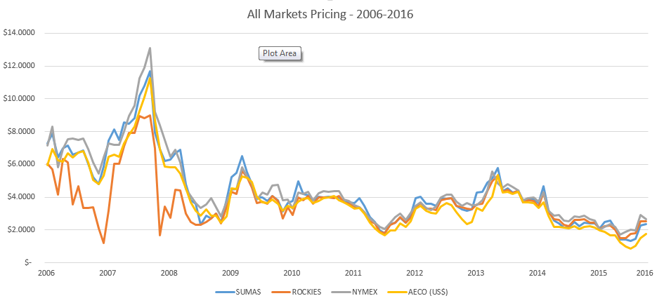

**Figure 8-4: NYMEX Annual Price Comparison**

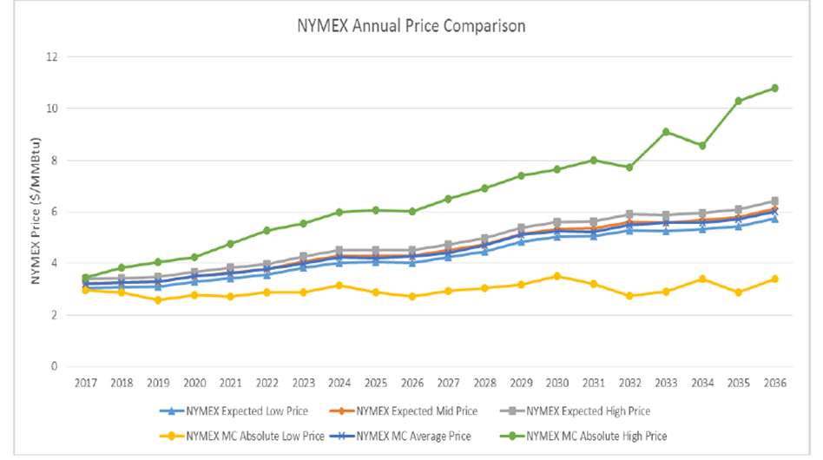

**Carbon Policy**

As discussed in Section 5 (Environmental Considerations), the Company considered policies that aim to cost-effectively achieve state and federal carbon emission reduction policies and regulations. Specifically, these carbon methodologies and assumptions are considered for calculating inputs towards a 20 year avoided cost of natural gas for the 2016 IRP. Of the many approaches examined by virtually all LDCs and electric utilities—as well as the Northwest Power and Conservation Council—have centered on the Carbon Cost Risk approach. Therefore, the Company has included a 10% carbon adder as a placeholder in the 2016 IRP’s expected case 20 year price forecast.

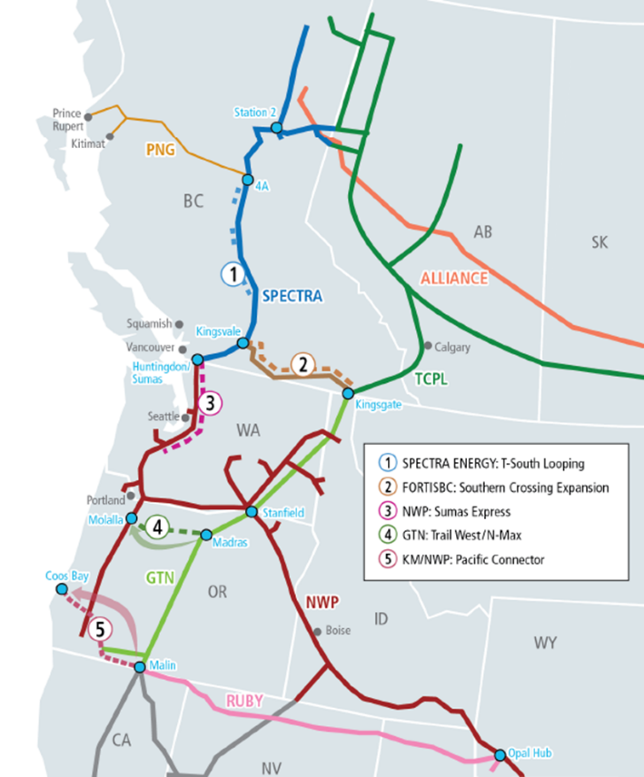

**Transportation/Storage**

In Section 4 of the IRP, the Company discussed the range of current upstream pipeline transportation capacity and storage services under contract to serve core customers. Additionally, the Company identified several proposed transportation resources such as a potential expansion of NWP along the I-5 corridor and acquiring currently unsubscribed GTN capacity that can be used to meet customer growth and address potential capacity shortfalls. The Company also continues to work with NWP to look at re-aligning Cascades’ contracted demand rights (MDDOs) to city gates with potential peak day capacity shortfalls. The Company also works to use segmenting pipeline capacity as a way to maximize the utilization of Cascade’s capacity. These resources plus leasing incremental storage at a number of regional facilities were all considered as a resource mix of possibilities to form the Company’s 20 year integrated resource portfolio.

**Demand Side Management**

Section 7 (Demand Side Management) described the methodology used to identify conservation potential and the interactive process that utilizes avoided cost thresholds for determining the cost effectiveness of conservation measures on an equivalent basis with supply-side resources. For the 2016 IRP, the avoided cost ranges from approximately $5.19 per dekatherm in 2017 to approximately $7.18 per dekatherm in 2037. Through the cost-effective use of conservation programs, the Company is able to reduce the load demand that must be met by more costly supply resources, such as a pipeline capacity expansion.

**RESULTS**

After incorporating all the above into the SENDOUT® model, Cascade analyzed the demand compared to the existing resources as well as the demand against all the available resources. This serves as the foundation for the Company to see what resources are taken to meet system demand with the least cost mix of natural gas supply and conservation. The Company then runs the optimization again removing the resources SENDOUT® did not select from the All-In case. This allows Cascade to confirm that removing these resources does not impact the amount of served demand. Additionally, this step removes fixed costs associated with the resources not taken so Cascade can arrive at a true total system cost. Table 8-1 provides a snapshot of the potential peak day unserved demand across Cascade’s system prior to applying any realignment of delivery rights, transportation contract segmentation or other alternative resources.

**Table 8-1: Load Centers with Potential Peak Day Unserved Demand**



Because Cascade has more delivery rights than receipt rights, the Company must allocate the delivery rights to match up with receipt capability. First, the Company allocates capacity on transportation contracts that have a single receipt point. Next, Cascade allocates capacity on conjunctive contracts that provide corridor and delivery point flexibility (re-allocation of MDDOs). The Company also gives consideration to critical delivery areas, constrained laterals and maximizing our corridor flexibility—longest haul contractual rights.

**Alternative Resources Selected**

The SENDOUT® model selected the following resources for the 20 year portfolio:

**Transport**

* Incremental GTN – Allows Cascade to continue to serve customers as the Company’s core load grows in citygates that are fed by GTN capacity, specifically around Bend, Oregon where the Company expects shortfalls.
* I-5 Expansion – Allows Cascade to continue to serve customers as the Company’s core load grows around the I-5 corridor, specifically in the Sedro-Woolley area.
* Wenatchee Expansion – Allows Cascade to continue to serve customers as the Company’s core load grows in Central Washington in areas such as Wenatchee and Yakima.
* Zone 20 Expansion – Allows Cascade to continue to serve customers as the Company’s core load grows in Eastern Washington in areas such as Kennewick.
* Incremental Starr Road – Allows Cascade the flexibility to move gas off of GTN and onto NWP through Starr Road when needed, displacing the need for potential incremental NWP capacity.
* Eastern Oregon Expansion – Allows Cascade to move gas from NWP to serve Eastern Oregon in areas such as Nyssa-Ontario.

**Supply**

* Yakima Satellite LNG Plant – Allows Cascade the opportunity to serve demand in a cost effective way directly to Yakima, WA without new transport, which in turn helps increase served demand system wide through a displacement of Maximum Daily Delivery Obligations (MDDOs) among existing contracts.

**Alternative Resources Not Selected**

The SENDOUT® model did not select the following resources for the 20 year portfolio:

**Transport**

* Incremental NOVA/Foothills – There is currently no incremental NOVA capacity available. In addition, SENDOUT® did not determine there was a cost effective opportunity presented by moving gas along these contracts to Kingsgate versus buying gas at Kingsgate directly.
* Incremental Ruby / Turquoise Flats – SENDOUT® determined it was more cost effective for the Company to acquire unsubscribed transport from GTN to serve the incremental demand these incremental contracts would otherwise serve.

**Supply**

* Opal Incremental – Since SENDOUT® determined it was best to serve increasing demand through picking up unsubscribed GTN capacity, there was no need to purchase additional gas to move along Ruby.

**Storage**

* Ryckman Creek, Gill Ranch, Wild Goose, AECO Hub – No incremental storage were selected – none of the storage facilities modeled were cost effective, or led to an increase in served demand. The primary reason appear to be that each of storages required long-term incremental transportation, as in the case of AECO Hub, no incremental NOVA capacity is available at this time.

**Portfolio Evaluation**

Table 8-2 summarizes the net present value of the revenue requirement (PVRR) of the portfolios considered. Each portfolio is based on unique assumptions and therefore a simple comparison of PVRR cannot be made.

**Table 8-2: PVRR by Scenario**



**Figure 8-5: Annual Supply Take vs Demand – Expected Case**

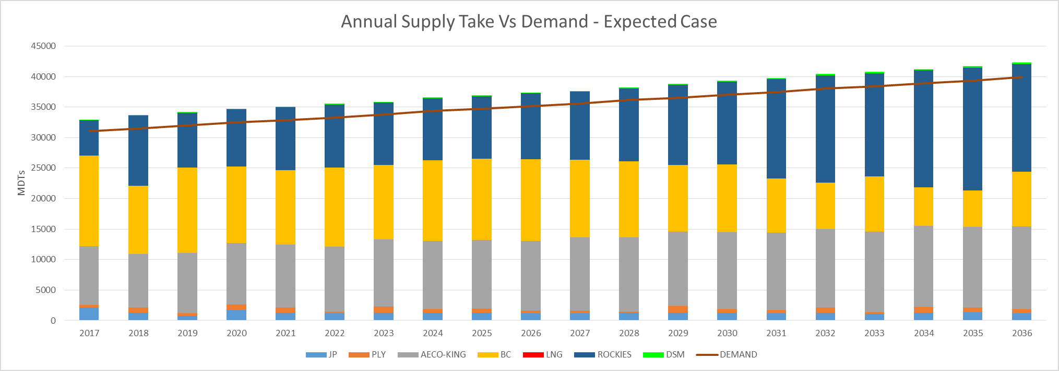

**Figure 8-6: Peak Day Supply Take vs Demand – Expected Case**

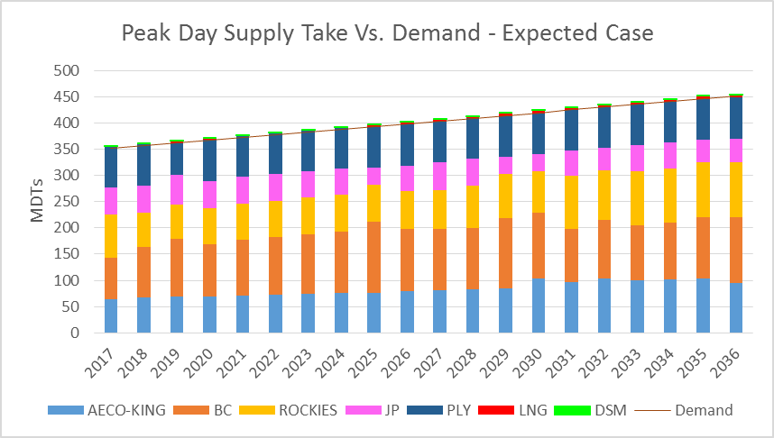

**Figure 8-7 Annual Transport vs Demand – Expected Case**

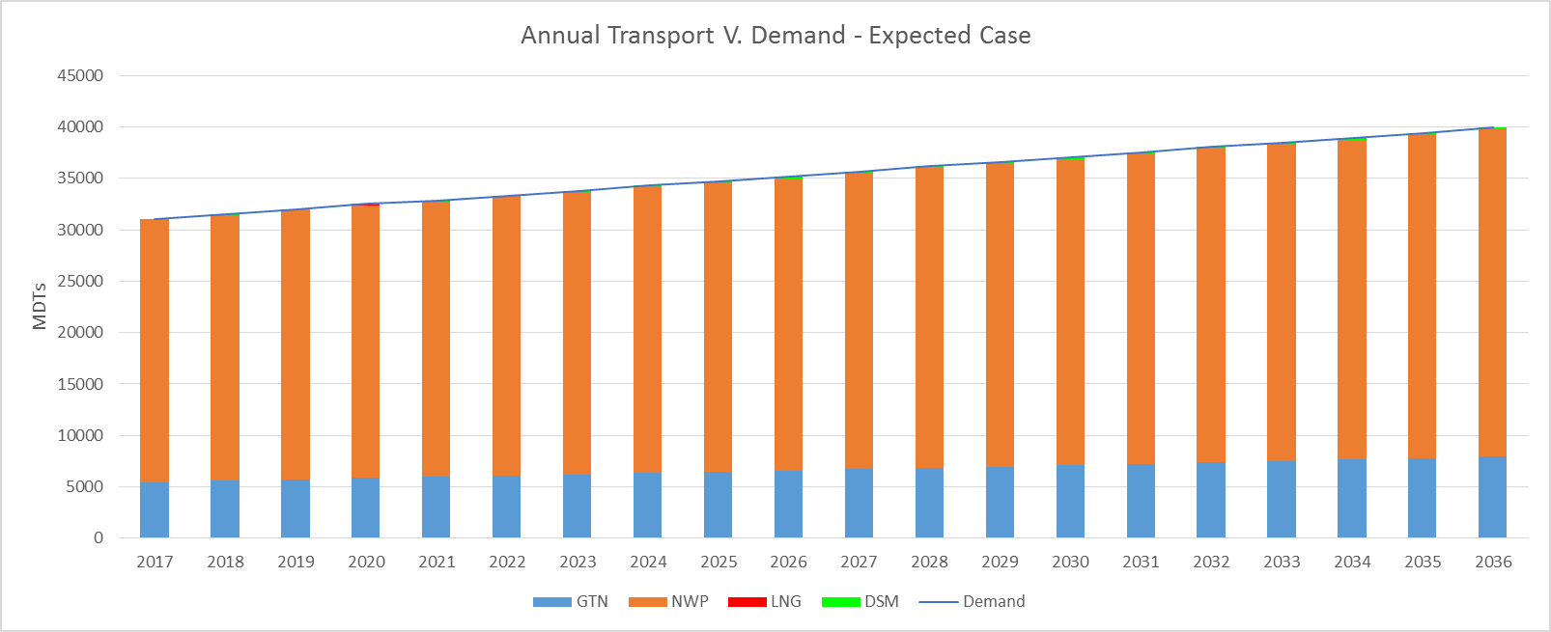

**Figure 8-8: Peak Day Transport vs Demand – Expected Case**

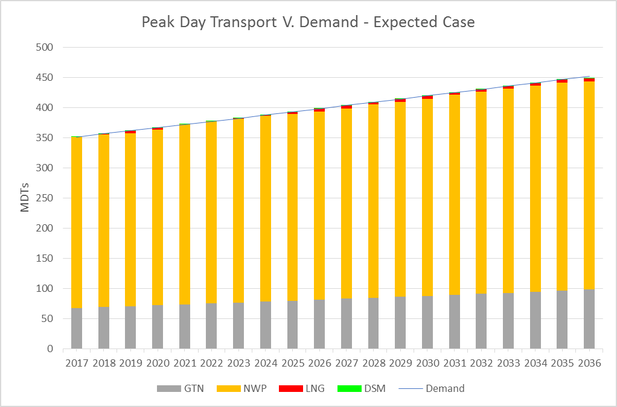

**Portfolio Evaluation – Additional Scenarios**

Table 8-3 summarizes the net present value of the revenue requirement (PVRR) of the additional demand scenarios reviewed. After the expected portfolio is selected, the Company tests it deterministically through a number of extreme situations, which are further explained in Appendix E. One scenario worth discussing further is the “All In – all hi MC” case**.** Here, Cascade selects the highest price per month from the Monte Carlo runs on price, and runs that pricing profile as a deterministic run. Since it is the highest price pulled in 200 draws, the total cost numbers for this run, while high, are not unreasonable. The results of all scenarios evaluated are shown below in Table 8-3, as well as graphically in Figures 8-9 and 8-10

**Table 8-3: Additional PVRR by Demand Scenarios**



**Figure 8-9 Total System Cost Comparison by Scenarios**

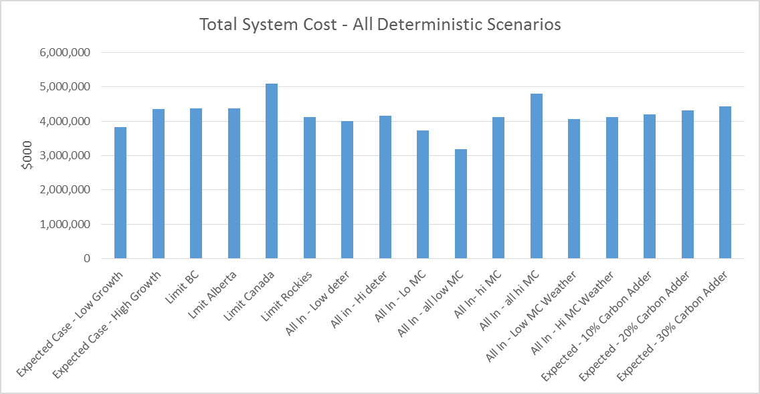

**Figure 8-10: Cost per Therm Served – All Deterministic Scenarios**

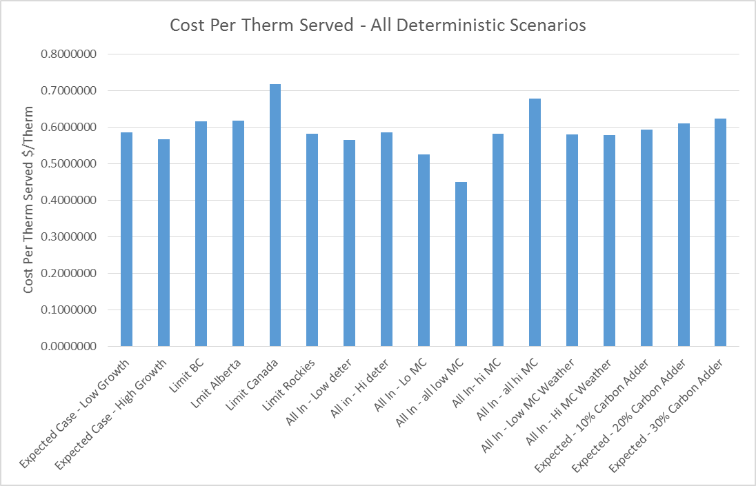

**Stochastic Analyses - Annual Load Requirements and Weather Uncertainty**

The annual load requirements will vary dramatically based on the weather assumptions. Through the use of the SENDOUT® Monte-Carlo functionality, the Company has the ability to analyze the impacts of weather on its load forecast. The chart (Figure 8-13 BELOW) provides the upper parameter, which is based on the assumption that the high load growth forecast occurs with the lower parameter occurring under the low load growth forecast. Capturing the uncertainty around the medium load growth forecast was accomplished through SENDOUT®’s Monte-Carlo functionality. The Monte-Carlo simulation performed 200 draws, with each draw calculating the monthly load based on the weather as randomly determined by the model for each of the weather zones. Figure 8-12 provides a more in depth look at the medium scenario results. The absolute maximum and absolute minimum amounts depict the minimum or maximum system demand from the 200 draws for a particular year. The absolute maximum/minimum does not represent any single results for the 20 year planning horizon.

**Stochastic Results**

The charts below show what happens when our expected portfolio is stress tested in different scenarios. For price, the Company show how the portfolio performs in an expected growth environment over 200 random pricing scenarios to see where our total system costs are. These results are shown in Figure 8-14. Analyzing weather, Cascade examines therm usage in a low growth, expected growth, and high growth environment, analyzing 200 random weather scenarios in each. These results are show in Figures 8-11, 8-12, and 8-13. The growth profiles used are referenced in Section 3, as well as Appendix B. All of these charts show the upper and lower bounds of the draws, as well as how the deterministic numbers compare to the stochastic results. With this analysis, the Company can get an idea of what Cascade’s system would look like in extreme weather and price situations.

**Figure 8-11: Therms Served – Low Growth Monte Carlo Weather Scenarios – Expected Case**

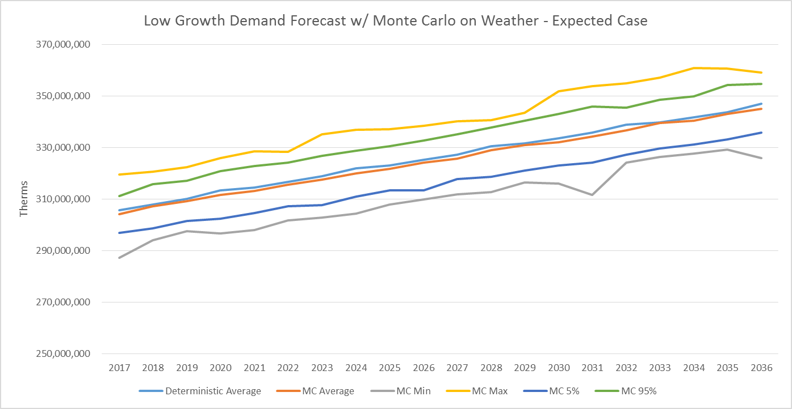

**Figure 8-12: Therms Served – Expected Growth Monte Carlo Weather Scenarios – Expected Case**

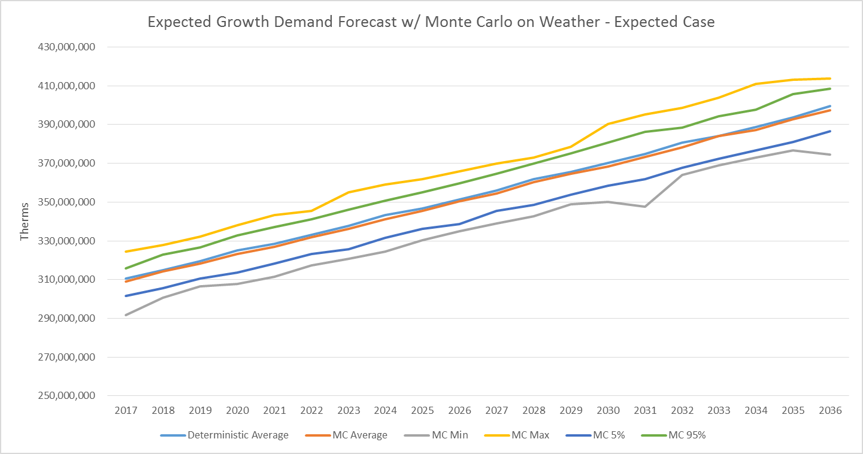

**Figure 8-13: Therms Served – High Growth Monte Carlo Weather Scenarios – Expected Case**

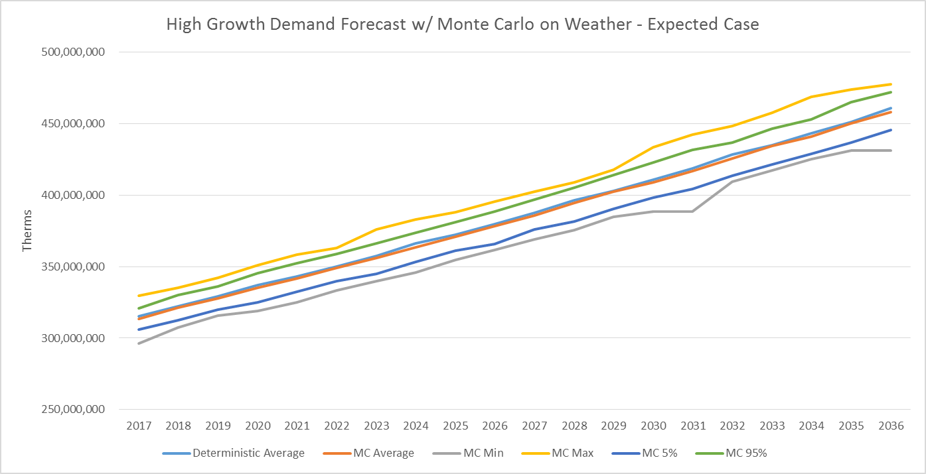

**Figure 8-14: Total System Cost – Monte Carlo by Price Expected Case**

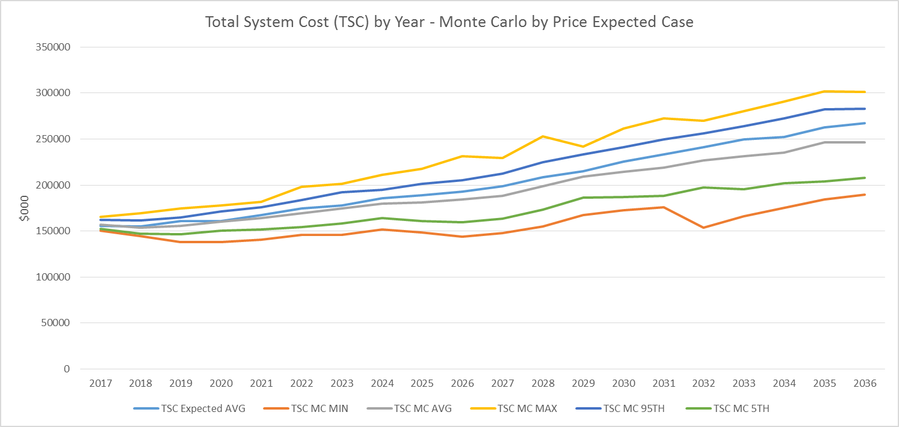

**Alternative Forecasting Methodologies and Consideration of Modeling Modification**

Forecasting is the foundation of integrated resource planning, highly influencing most key items in the two year action plan and twenty year planning horizon. Chief among these is the determination of the avoided cost of natural gas which, in addition to gas supply issues, affects conservation programs.

Qualitative (scenario planning) and quantitative methods (regression modeling of historic data) are combined to arrive at low, medium, and high forecasts. A range of end-results are used to determine sensitivity of specific parameters (e.g., customer growth, use per customer, retail price, carbon policy, etc.). Assumptions and inputs are highly scrutinized by Commission staff and stakeholders. A low forecast would result in lesser planned conservation programs. High forecasts may be overly influenced by uncertainties of future industry issues (e.g., carbon policy), resulting in excess costs.

Commission staffs and stakeholders, across states and fuels (i.e., natural gas and electric), request consideration of “alternative forecasting methods.” This, in practicality, has two meanings. One meaning is technical, focusing on improvements and additions to previous modeling.[1] The second meaning is policy-based (although included in the technical modeling) and lies in sensitivity analysis and scenario planning. Such scenario planning incorporates any adders to the cost-per-ton of carbon emissions (i.e., CO2) and the like.

Throughout each planning cycle, all Washington and Oregon jurisdictional utilities have been requested to improve their technical modeling and include robust sensitivity and scenario analyses to effectuate alternative forecasting methods.

For this IRP the Company is using a linear forecasting methodology. Cascade currently uses SENDOUT®, a model employed by all Washington and Oregon local distribution companies (LDCs). Through linear methodology and with the addition of scenario planning, through Monte Carlo draws, this produces a stochastic (that is, based on random event planning) twenty year forecast.[2]

As previously identified in Chapter 3 (Demand Forecast) the Company believes that our future IRPs would be enhanced by adopting additional technical modifications. Cascade plans a greater inclusion of polynomial algorithms in our future forecast modeling with a continuing focus on developing a wide and deep range of scenarios. Given the improvements in forecasting more analysis of primary variables can be gained by greater use of polynomial equations.[3] Piecewise can be used to incorporate a finite number of the most significant, but separate, components that provides for a more robust forecast.

**Conclusions**

The Expected Case has the lowest cost and risk as expected when considering alternate supply resources. This is primarily due to Cascade’s wide regional spread across the region. The Company’s existing long-term transportation contracts, coupled with robust supply basins provides a base foundation to meet load needs of Cascade’s core customers. However, Cascade’s unique geographical reach creates particular challenges as the system is non-contiguous, often requiring the Company to hold transportation capacity on multiple upstream pipelines to feed the single upstream pipeline that is connected to a particular citygate. The cost of building or acquiring new supply resources would likely increase cost while keeping risk at similar levels.

The High Growth and Low Growth Case demand analyses provide a range for evaluating demand trajectories relative to the Expected Case. Based on this analysis there appears to be sufficient time to plan for forecasted resource needs. Even under an extreme growth scenario, the first forecasted deficiency does not occur until 2021. Many things could happen between now and when the first resource needs occur, so Cascade will continue to monitor and analyze the system demand through reconciling and comparing forecast to actual customer counts and continually update and evaluate all demand-side and supply-side alternatives.

1. For example, modifications could include modules that examine uncertainty and equations that take into account lagged effects of primary variables (e.g., economic conditions).
2. A stochastic approach or randomly determined having a random probability distribution or pattern that may be analyzed statistically but may not be predicted precisely.
3. Polynomial equations are an expression of more than two algebraic terms, especially the sum of several terms that contain different powers of the same variable(s)