|  |  |
| --- | --- |
| Avista Corp.  1411 East Mission P.O. Box 3727  Spokane, Washington 99220-0500  Telephone 509-489-0500  Toll Free 800-727-9170 |  |

August 1, 2017

Steven V. King

Executive Director and Secretary

Washington Utilities & Transportation Commission

1300 S. Evergreen Park Drive S. W.

P.O. Box 47250

Olympia, Washington 98504-7250

Re: Docket No. UE-160082 – Avista Utilities Quarterly Report on Electric Vehicle Supply Equipment Pilot Program

Dear Mr. King,

On April 28, 2016 the Commission issued Order 01 in Docket UE-160882 approving Avista Corporation’s, dba Avista Utilities (Avista or Company) tariff Schedule 77 for its Electric Vehicle Supply Equipment (EVSE) Pilot Program (program). Within the Order the Commission required Avista to submit quarterly reports on the status of the program beginning on August 1, 2016 and ending on August 1, 2018. The quarterly reports must include the following:

1. For DC Fast Charging stations, Avista shall report the locations and utilization of stations, review and revise the DC fast charging rate, and assess the amount of overall fixed and variable costs recovered through user payments and report its findings to the Commission quarterly, beginning August 1, 2016.
2. For all other services offered under the Electric Vehicle Supply Equipment Pilot Program, Avista shall report participation levels, expenditures, and revenues for each service offered for the duration of the program. We expect the Company to collect and report additional data necessary to provide enough information to accurately evaluate the program’s success by August 1, 2018.

As described in Order 01, the effective date of tariff Schedule 77 was May 2, 2016. The term of the program began with the first residential EVSE installation on July 20, 2016. The following are updates on each element of the program.

Overall, the program’s operations, analytics, customer participation and feedback remain positive. As of July 21, 2017, the number of applications and installations for the various EVSE categories are as follows:

**Table No. 1**

|  |  |  |  |  |  |
| --- | --- | --- | --- | --- | --- |
|  | **2-Year Goal of Port Installations** | **Applicants** | | **Installations** | |
| **Applicants** | **Approved\*** | **Scheduled** | **# Ports Installed** |
| **Residential SFH[1]** | 120 | 152 | 129 | 22 | 83 |
| **Workplace\Fleet\MUD[2]** | 100 | 118 | 67 | 7 | 32 |
| **Public** | 45 | 62 | 42 | 12 | 5 |
| **DCFC** | 7 | 5** | 3*** | 2 | 1 |

*21 approved applicants have withdrew from the program due to their costs to participate or other reasons

**Sites identified

***Sites where site agreement has been signed to move ahead with construction.

Other high-level statistics on charging behaviors are shown in Table No. 2 below.

**Table No. 2**

|  |  |
| --- | --- |
| Daily Avg. No. of Charge Sessions | 57 |
| Daily Avg. kWh Consumed | 332 |
| Sessions Charged to Date | 15,946 |
| kWh Consumed to Date | 79,010 |
| Lbs of CO2 Saved to Date | 154,781 |
| Gallons of Gasoline Saved to Date | 7,901 |

**AC Level 2 Charging Stations – Residential**

Progress continues with 83 residential installations completed to date, roughly 70% of the targeted 120 installations. EVSE performance has improved, with fewer difficulties commissioning the units through WiFi communications in residential homes. However, Wi-Fi communications are still lost on occasion, due to a variety of reasons including issues with customer routers and changing network passwords. Communications are most commonly restored by requesting the customer to perform a power reset. Regardless of communication status, the EVSE supplies power and charges the customer’s EV upon plugging in the vehicle, which is the primary customer concern and need that must be met. However, approximately 15% of customers remain offline until a technician can visit the home to troubleshoot and correct more technical issues. Restoring communication to these units improves the volume of data gathered, but requires inconveniencing the customer to some degree in scheduling a technician’s site visit and diverting resources that could otherwise be focused on new installations. Efforts to restore communications will continue in a way that is least disruptive to customers, balanced with the need to prioritize working through the new installation backlog.

New EVSE that competitively meet performance and cost requirements will be considered for acquisition and deployment. At this time, no other units are commercially available that meet these requirements.

The following chart shows the status of residential applications and installations by categories of Battery Electric Vehicle (BEV) Commuter, BEV Non-Commuter, Plug-In Hybrid Electric (PHEV) Vehicle Commuter, and PHEV Non-Commuter.

**Chart No. 1**

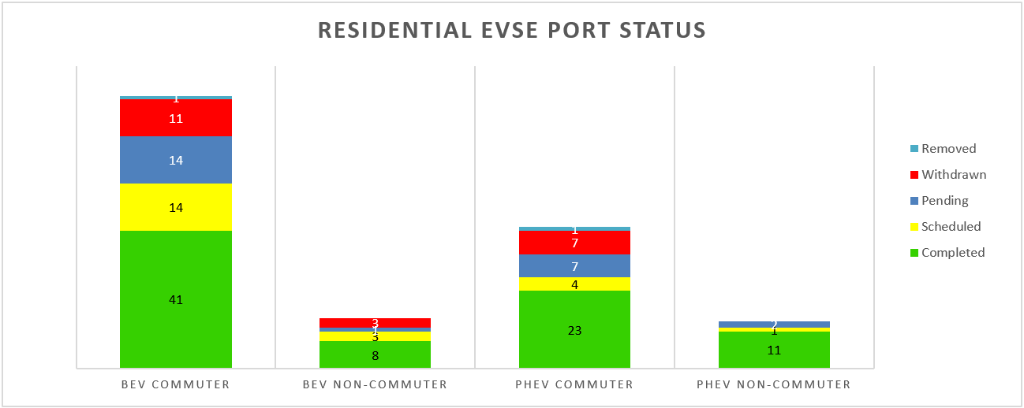

At least 20 installations in each category are desired in order to attain a significant level of statistical sampling. This has been met for the BEV and PHEV commuter categories, and is at roughly 50% of target for the BEV and PHEV non-commuter categories. Continued outreach to area dealerships and other communication channels will be needed to raise awareness of the program and achieve installation targets.

The residential application, approval and installation process is relatively predictable and sustainable. Thus far 152 applications were received, with 129 (85%) approved for installation. The remaining 15% were not approved due to ineligibility, e.g. the customer was out of the service area, already owned an EVSE, or was planning a move. Of the 129 approved applications, 21 customers withdrew, mostly due to the customer’s cost share for premises wiring, upon receiving a site visit and installation quote.

Residential installation cost breakdowns continue to meet expectations and stabilize as shown by the average costs in the table below, with EVSE installed in 83 customer homes thus far.

**Table No. 3**

**Average Costs for Residential Installations:**

|  |  |  |  |  |  |
| --- | --- | --- | --- | --- | --- |
| **Premises Wiring Reimbursement** | **Customer’s Cost** | **Utility Hardware & Installation Cost** | **Total Installation Cost** | **EVSE Cost** | **Total Costs Installation + EVSE** |
| $664 | $287 | $416 | $1,343 | $1,066 | $2,409 |

The chart below shows the residential installation cost components by job, ranging from a total of $452 to $3,721. Low costs correspond to installations where an adequate 240V AC circuit is already installed, with higher costs corresponding to a greater number of wall and floor penetrations, total circuit distance, and/or service upgrades.

**Chart No. 2**

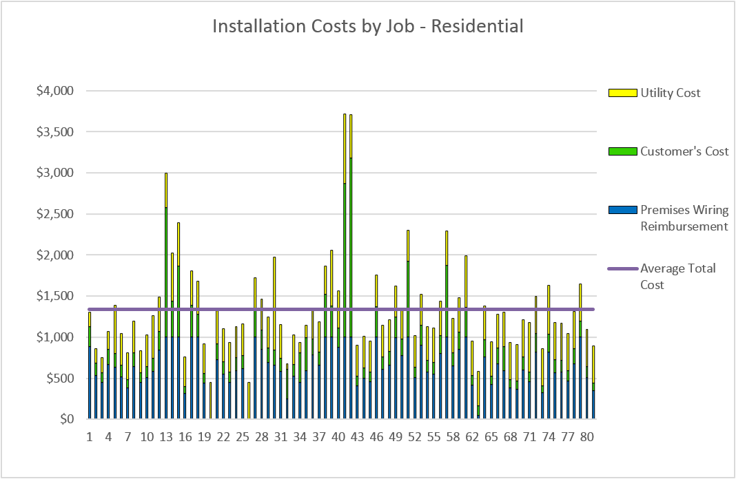

Analysis of costs indicate that service upgrades have the most significant impact. Out of 83 residential installations, 12 required a service upgrade with a new panel installed, but no secondary cable replacement from the utility transformer to the meter. This represents 14%, or 1 in 7 installations requiring a service upgrade in the form of a new service panel. The average total costs for these installations with service upgrades rose $946, an increase of 70% over the average total installation cost of $1,343. Customers requiring a service upgrade paid $881 for premises wiring, more than three times the average customer that paid $290 for their share of premises wiring costs.

The average installation costs for the Company’s residential EVSE installations are comparable to the reported averages from other studies, as shown in the table below:

**Table No. 4**

**Comparison of Average Costs for Residential Installations (not including EVSE) [3],[4],[5]:**

|  |  |  |  |
| --- | --- | --- | --- |
| **Program/Study** | **Timeframe** | **No. of Installations** | **Average Install Cost** |
| Avista EVSE Pilot | 2016 - 2017 | 83 | $1,343 |
| EV Project | 2012 – 2013 | 4,777 | $1,375 |
| EPRI | 2009 - 2013 | 214 | $1,613 |
| North Carolina | 2011 - 2012 | 143 | $1,098 |

Geography is a significant factor of these average costs. For example, the Idaho National Laboratory’s EV Project report on costs by geographic locations placed Los Angeles’ average installation cost at $1,828, Atlanta’s at $775, and Seattle’s at $1,338.

**AC Level 2 Charging Stations – Commercial**

Commercial installations are progressing with a faster rate of installation and stable process for applications, customer site agreements, layout and site design consulting, price quotations, and scheduling. The following chart shows the status of commercial installations by type and category[6]:

**Chart No. 3**

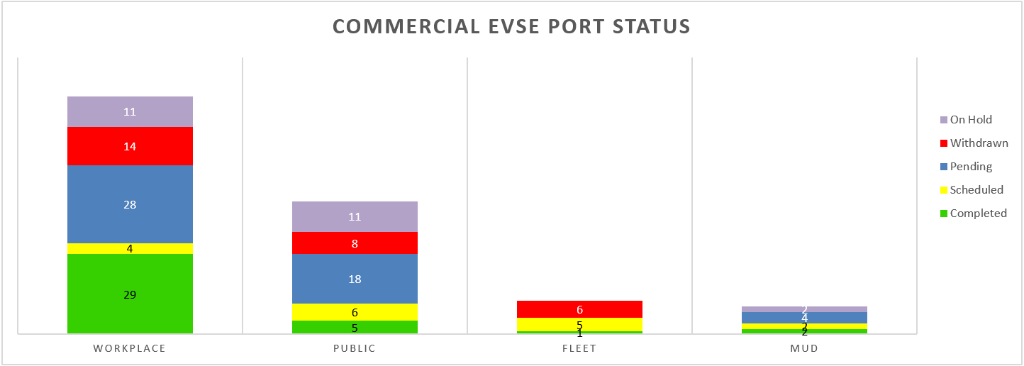

Four public installations and a new fleet installation were completed during the last quarter, as well as 12 workplace installations. Typically, significant outreach and consulting is required to inform and assist the customer to install an AC Level 2 EVSE on their property, particularly for more public locations. Property owners in our service territory are commonly unaware of EVs to a large degree due to lower adoption rates to date, as well as the implications of providing EVSE services on their property. Some of the principal concerns are the projected cost of electricity, liability risks, and potentially adverse impacts on parking areas with limited capacity. Strong efforts will continue to be made in terms of outreach and providing helpful information to customers, in order to make informed decisions that mutually benefit the customer and the program.

A greater number of withdrawals occur for commercial applications, for a variety of reasons. This includes cost share for premises wiring, as well as other common concerns previously mentioned.

Costs for commercial installations are meeting expectations, with an understanding that larger variations in cost are expected depending on site conditions, compared to residential installations. Average cost breakdowns for commercial EVSE sites are listed in the table below, representing connection ports installed at sixteen different facility locations.

**Table No. 5**

|  |  |  |  |  |  |  |  |
| --- | --- | --- | --- | --- | --- | --- | --- |
| **Premises**  **Wiring**  **Reimburse-ment** | **Customer's**  **Cost** | **Utility Hardware & Installation Cost** | **Total**  **Install**  **Cost** | **EVSE**  **Cost** | **Total**  **Cost EVSE + Installation** | **#**  **Ports** | **Total**  **Cost per**  **Port** |
| $3,237 | $1,509 | $2,310 | $7,056 | $4,274 | $11,270 | 2.0 | $5,446 |

The cost components of commercial installations at sixteen different locations are shown below. These EVSE locations are primarily used as workplace charging for employees:

**Chart No. 4**

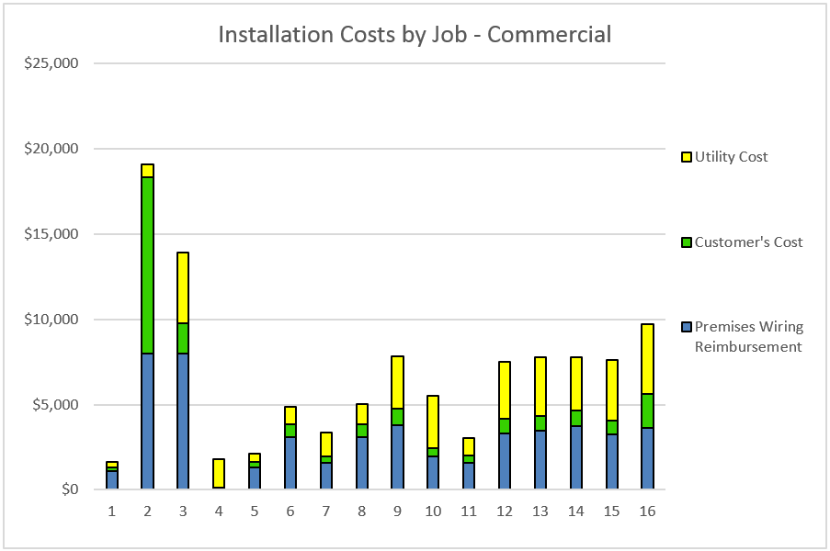

Lower costs correspond to simpler installations avoiding service upgrades and trenchwork, lower cost EVSE, and/or a single port connection. Conversely, higher costs are associated with multiple installed EVSE ports, required upgrades to transformers, supply panels, and/or trench work, especially concrete and asphalt trenching.

The average installation costs for the Company’s non-residential EVSE installations are comparable to the reported averages from other studies, as shown in the table below:

**Table No. 6**

**Comparison of Average Costs for Non-Residential Installations (not including EVSE)**

|  |  |  |  |
| --- | --- | --- | --- |
| **Program/Study** | **Timeframe** | **No. of Installations** | **Average Install Cost Per Port** |
| Avista EVSE Pilot | 2016 - 2017 | 17 | $3,504 |
| EPRI | 2009 - 2013 | 385 | $3,005 |
| North Carolina | 2012 and Prior | 102 | $2,638 |

* Costs per port for the non-residential installations of the EV Project are currently unavailable. The Company will contact the authors of that study to attempt to gain this information.

**DC Fast Charging (DCFC) Stations**

Standardized DCFC site design has an operational 50kW DCFC with both CCS and CHAdeMO connectors, and a dual-port AC Level 2 EVSE as a backup. The installations include adequate property easements and/or site agreements for future expansion, with transformer capacity and conduit installed to allow for low-cost expansion of an additional 150kW DCFC.

The Company has found DCFC installations to pose a number of challenges requiring extra attention, including a much more involved site acquisition process and relatively longer lead times associated with site design and the larger scope and scale of construction work. Site acquisition in particular has required substantial effort and time to negotiate with property owners. Discussions with other experienced industry representatives indicate this is a common issue in other areas and programs around the country.

The first DCFC station in Rosalia, Washington was brought online January 18, 2017, and made available for public use. Remote monitoring shows satisfactory status and availability. More information about the Rosalia DCFC is posted online at [www.plugshare.com](http://www.plugshare.com). As expected, the use of the Rosalia DCFC has been limited thus far. Greenlots’ SKY network indicates twenty-two charging sessions outside of initial testing on January 18, with ten sessions in the last month. Although this DCFC’s use is expected to be limited with lower EV adoption in the area and until the travel corridor is completed with DCFC installations in Pullman and Spokane, the relatively high cost of $0.30 per minute of charging compared to gasoline fuel cost may also be a contributing factor. A fee based on time of charging is desirable as this incents the EV driver to only charge to the level necessary to proceed to the next destination, freeing up the charger for the next driver and creating greater availability. Drivers may spend more time “topping off” at the adjacent AC Level 2 charger, if desired, rather than using the DCFC to top off over a longer period of time which occurs with fees based on kWh consumption. The Company will continue to monitor DCFC use and customer comments. At the present time no change to the DCFC user fee is proposed, however it may be appropriate in the future to change the fee in order to evaluate the correlation of price points with utilization. In order to be competitive in the market and encourage EV adoption, the DCFC user fee should result in an electric fueling cost at or below an equivalent cost to travel using a gasoline vehicle.

DCFC construction is underway for a location at Kendall Yards in Spokane, with installation expected to be completed in September, 2017. Completion of this DCFC site was delayed due to the construction delays for the overall development site. This desirable location is within one mile of Interstate 90, situated among a number of attractive retail and restaurant venues at Kendall Yards, and is within a reasonable walking distance to the downtown core of Spokane and Riverfront Park. The Kendall Yards location will help enable regional transportation on both the North-South and East-West corridors through Spokane, as well as provide quick public charging for inner city travel within Spokane.

Site acquisition and design work is complete for the Pullman location adjacent to the Washington State University Visitor Center, with construction anticipated in September and October. Final stages of legal site agreements and land acquisition are nearing conclusion for the Spokane Transit Authority (STA) Park & Ride in Liberty Lake east of Spokane, and in the new West Plains Transit Center west of Spokane located at exit 272 along I-90. The Park & Ride facilities were identified as excellent locations given their convenient access to Interstate 90 on both the West and East sides of Spokane County, nearby facilities including restaurants and convenience stores, proximity to three-phase power, as well as a partner in the STA that is able to provide the parking space necessary to facilitate the DCFC. The Liberty Lake location may be completed before the end of 2017, or possibly into 2018. Construction for the DCFC installation at the West Plains location is anticipated in the spring of 2018.

Installation of these five identified locations will provide an electrified north-south corridor between Spokane and Pullman, as well as serving east-west traffic along I-90 in the vicinity of Spokane County

This leaves two additional stations to complete the seven DCFC proposed for the pilot program. A suitable location on the outskirts of north Spokane is desirable, which will help to begin to electrify the US-395 corridor and serve customers living in the north Spokane area. Some promising sites have been identified for this general location, but are in the early stages of obtaining site agreements and acquisition. Candidates for the final DCFC location include the Spokane University District, Spokane Valley, Clarkston, Deer Park, Chewelah, and Colville. The Company will continue to consult with the Washington State Department of Transportation on site locations to confirm agreement and alignment with efforts to build out EVSE infrastructure across the state.

**Customer Surveys**

Web based customer surveys are carried out post-installation and quarterly thereafter for both residential and commercial customers. These surveys began on July 21, 2016 and will continue through the course of the pilot program. Completion rates as of July 21, 2017 are as follows:

**Table No. 7:**

|  |  |  |
| --- | --- | --- |
| **Customer** | **Post-installation** | **Quarterly** |
| Residential | 68% (58 of 85) | 46% (46 of 99) |
| Commercial | 35% (7 of 20) | 50% (2 of 4) |

Overall satisfaction with the residential installations remains high with 98% of the 57 respondents reporting satisfied or very satisfied:

**Chart No. 5**

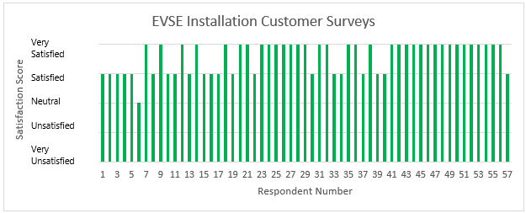

79% of residential customers indicated that they commute to work in their EV, with 26% of those customers indicating that their employer offers an EVSE at work.

Thus far, the average commute was 24.2 miles for those that could use an EVSE at work and slightly lower at 23.7 miles for those that did not have an EVSE available.

**Chart No. 6**

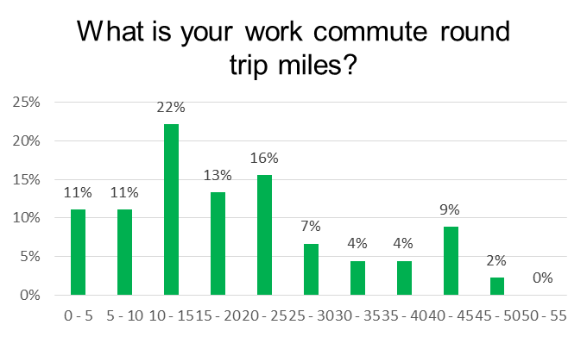

From the quarterly surveys, residential customers indicated a high degree of satisfaction with their EVSE.

**Chart No. 7**

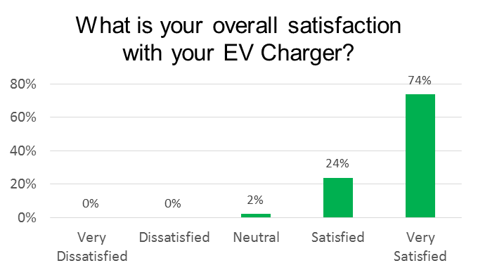

Follow-up phone interviews will be conducted with commercial customers to solicit greater participation in online surveys and to gather more information. Additional insights from the customer surveys will be reported as a greater number of responses are received.

**Data Analysis, Modeling, and Load Management**

Distribution of residential port installations are shown in the chart below, showing the greater concentrations in the Spokane area. In addition to this are a few installations as far north as Colville and south in Pullman and Clarkston.

**Figure No. 1 – Residential Port “Heatmap”**

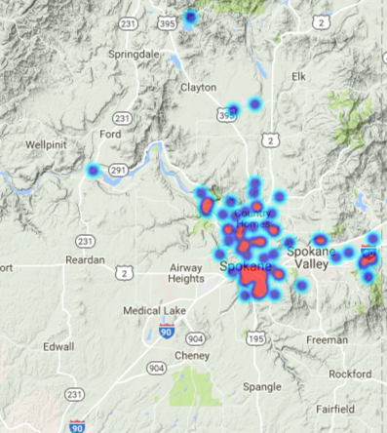

Daily consumption, demand averages, and loading profiles are shown in the charts below. Weekday BEV commuters are highest at 6.3 kWh per day, followed by BEV non-commuters at 5.3, PHEV commuters at 5.2, and PHEV non-commuters at 4.3 kWh per day, respectively. Weekday electricity consumption is consistently higher than on weekends. Also note that there is a roughly 1 kWh difference between commuters and non-commuters in similar vehicle types.

**Chart No. 8**

Weekday demand peaks between 5 - 9 p.m. with a steady decline following, as shown below. Weekends see generally flatter peak demand among the average PEV, as participants tend to consume less energy on average and charging sessions are more widely dispersed throughout the day.

**Chart No. 9**

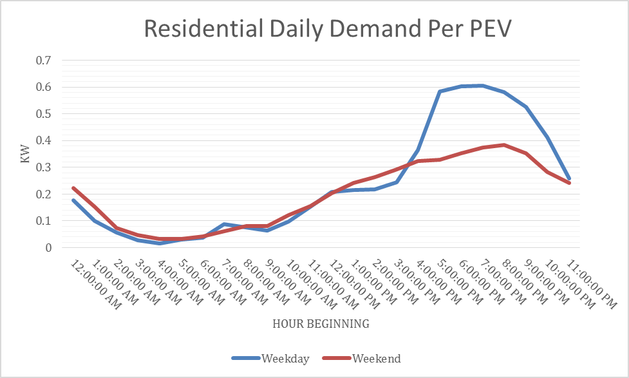

On average, both commuter types of BEV drivers have a slightly higher weekday charge rate than PHEV commuter drivers. This can be attributed to the higher charge rate seen on most BEVs in the program. While PHEV’s like the Chevy Volt generally don’t charge above 3.6 kW, many BEVs in the program are capable of charging at the 6.6 kW maximum rate.

The charts below show the load profiles of the four basic driver and vehicle type categories.

**Chart No. 10**

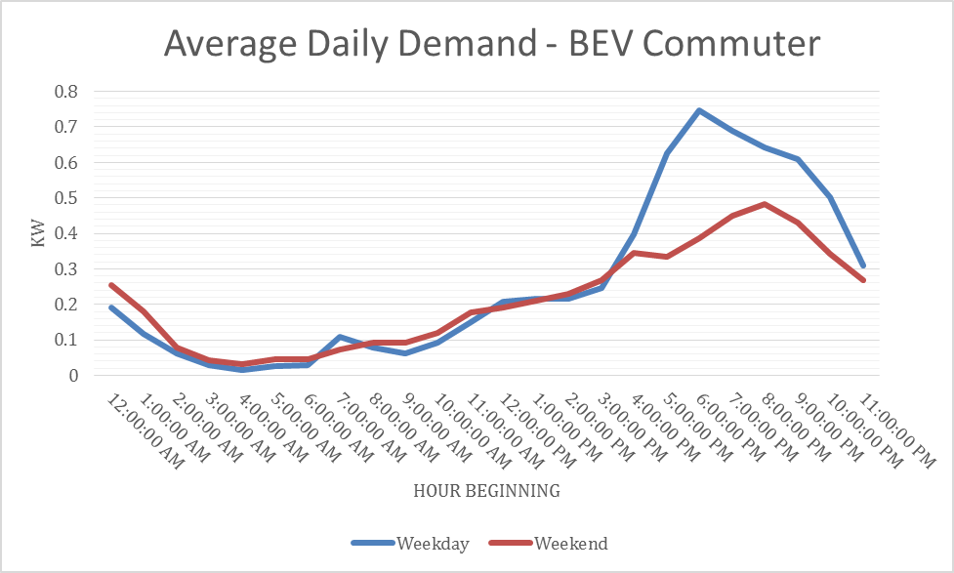

**Chart No. 11**

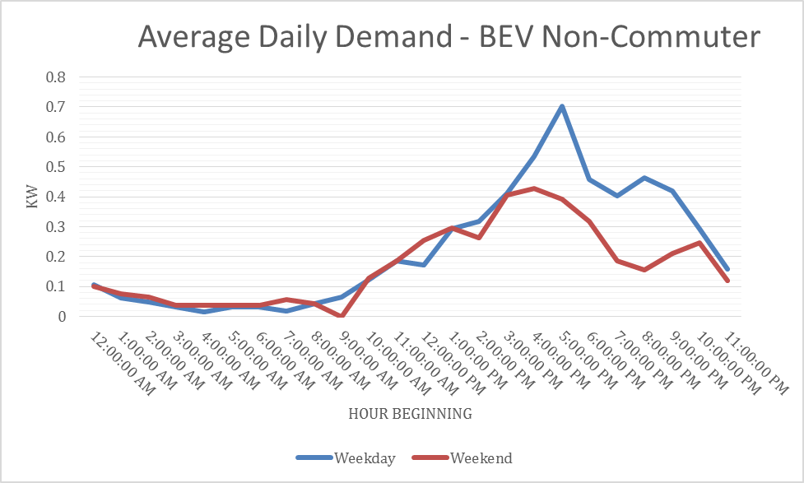

**Chart No. 12**

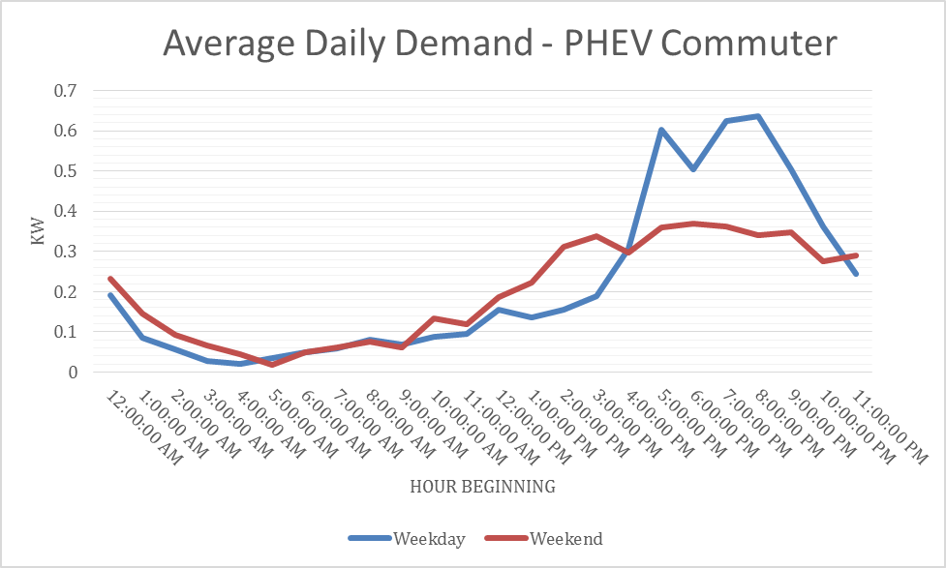

**Chart No. 13**

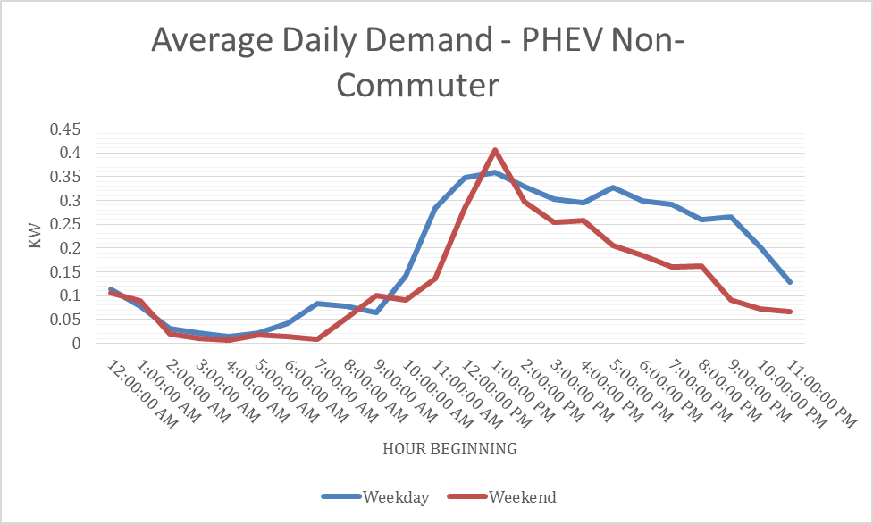

The chart below features a driver with a long-range BEV with no workplace charging, whose average session energy is 29 kWh – much higher than the typical BEV driver that is well below 8 kWh per day. This results in charging sessions with longer times charging at a high rate of power. As more long-range BEVs enter the market, this profile demonstrates the benefit workplace charging could have to reduce peak charging times in the afternoon and evenings during home charging sessions, and allowing for more effective load management programs (where a smaller amount of peak load is shifted to off-peak).

**Chart No. 14**

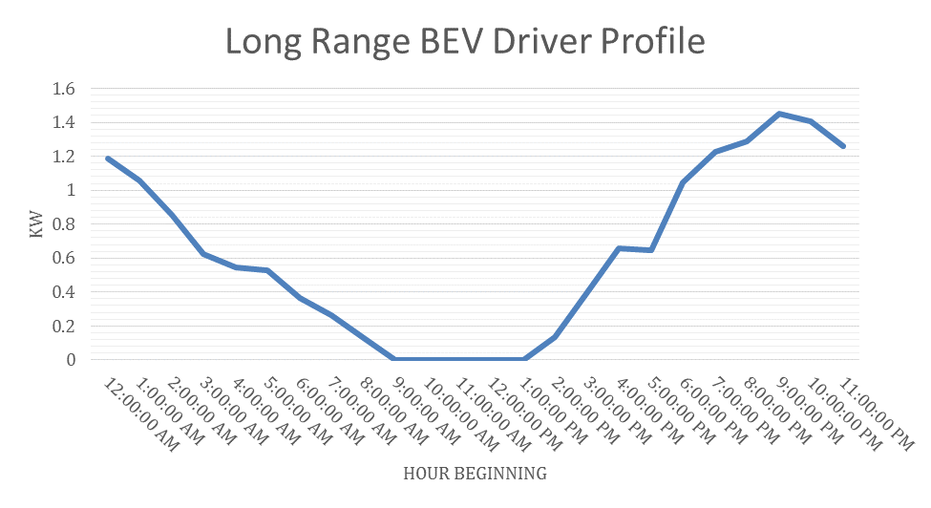

The following chart is an example of a participant with workplace charging. Accessibility to workplace charging for this participant decreases the length of peak charging time at home.

**Chart No. 15**

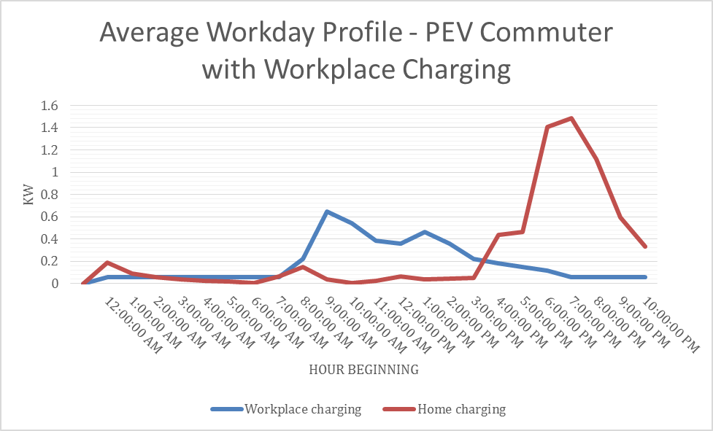

By cross referencing odometer information from customer surveys, an average efficiency of 3.5 miles per kWh was calculated for participants in the program to date.

Distribution of commercial port installations are shown in the chart below, showing the greater concentrations in the Spokane area. In addition to this are two installations south of Spokane, as far as Clarkston. The pilot’s goals include establishing a basic network of approximately 20 public AC Level 2 ports at smaller towns across eastern Washington, in order to provide drivers with some degree of range confidence and begin to support regional EV driving in the area.

**Figure No. 2 – Commercial Port “Heatmap”**

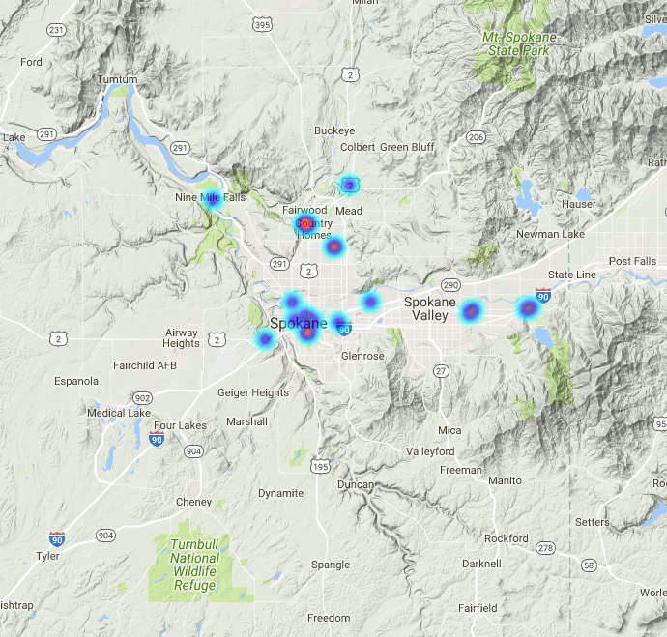

In the chart below the average weekday demand per commercial port shows peak demand at 9 a.m. as the workday begins with a sharp drop until a slight increase at 3 p.m. when the second shift begins.

**Chart No. 16**

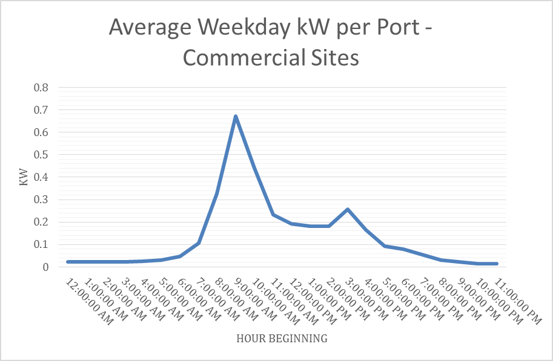

The next chart shows the per port demand of an individual site with four ports, creating a peak system demand of 6.2 kW at 9 a.m. Data on commercial sites are still relatively limited, but increasing as summer installations increase the number of ports in the program.

**Chart No. 17**

**Load Management**

Data collected thus far shows various load profiles representing uninfluenced charging behaviors, and it is now appropriate to begin the early phases of load management experiments. Software development is in progress to allow for robust experimentation with groups of customers, including customer preferences, notifications and opt-outs.

Initial trials with remote load management of the EVSE successfully throttled down the charge rate to 25% of maximum over the designated timeframe. However, anomalies were discovered with power values, and other software refinements and testing are required before expanding tests to a larger group of customers.

The charts below compare a typical charge session with and without a load management event in five-minute increments. In the first chart, no load management occurs and the vehicle begins charging at its maximum rate as soon as it is plugged in until fully charged.

**Chart No. 18**

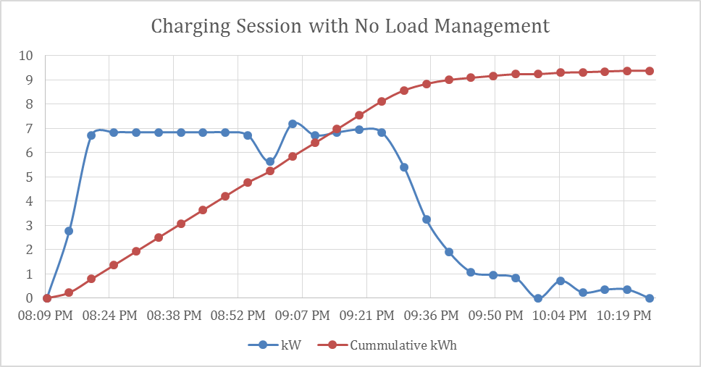

In the next chart, power to the EV is curtailed to 1.4 kW until the load management ends at 9:45 p.m. Upon completion of the load management event, the vehicle charges at full power until it reaches 100% state-of-charge.

**Chart No. 19**

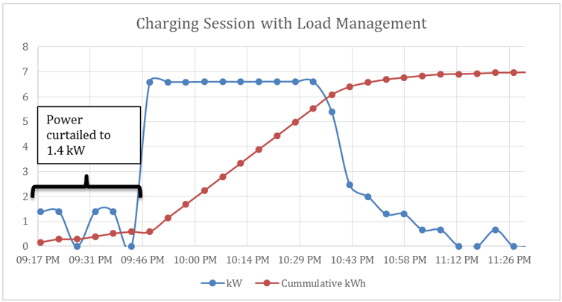

As more sessions with load management are successfully carried out, the Company expects to demonstrate how much peak load may be shifted to off peak hours, while still satisfying the customer’s need to charge the vehicle. This information may be used to model and predict economic costs and benefits to customers over many years and different sets of assumptions.

**Expenditures and Revenues**

Expenditures through July 21, 2017 totaled $1,086,059. A more detailed breakdown is provided in Attachment A.

Revenues to date are as follows, based on data from Greenlots’ SKY network:

**Table No. 8**

|  |  |  |  |  |
| --- | --- | --- | --- | --- |
| **Type** | **No. of Charging Sessions** | **kWh Consumed** | **Rate** | **Revenue** |
| Residential AC Level 2 | 13,579 | 68,279 | $0.09134/kWh | $6,237 |
| Commercial AC Level 2 | 1,122 | 9,121 | $0.1162/kWh | $1,060 |
| DC Fast Charging | 28 | 238 | $0.30/minute | $128 |
| **Total** | 7,637 | 48,770 | - | $7,424 |
|  |  |  |  |  |

Please direct any questions regarding this report to Rendall Farley at 509-495-2823, [rendall.farley@avistacorp.com](mailto:rendall.farley@avistacorp.com), or Shawn Bonfield at 509-495-2782, [shawn.bonfield@avistacorp.com](mailto:shawn.bonfield@avistacorp.com).

Sincerely,

/s/Linda Gervais

Sr. Manager, Regulatory Policy

Avista Utilities

**Attachment A**

**Avista EVSE Pilot Program Expenditures through July 21, 2017**

Expenditures include all costs for both completed EVSE installations and installations in progress, as well as program administrative costs.



1. Single Family Home
2. Multi-Unit Dwelling
3. Brazell, M., Joffe, E., & Schurhoff R. Electric Vehicle Supply Equipment Installed Cost Analysis. Electric Power Research Institute (2013)
4. Idaho National Laboratory. How do Residential Level 2 Charging Installation Cost Vary by Geographic Lecation. The EV Project (2015)
5. North Carolina PEV Taskforce, “Plug-in Electric Vehicle (PEV) Roadmap for North Carolina.” (2013)
6. Completed – EVSE has been installed. Scheduled – EVSE is scheduled to be installed. Pending – customer application is pending full approval. Withdrawn – customer has withdrawn application from program. On Hold – customer application is on hold due to location of requested EVSE.