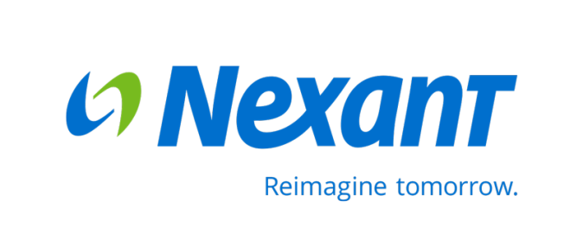

**Supplemental Report: Process Evaluation of 2014-2015 Energy Efficiency Programs

Submitted to Avista Utilities   
August 19, 2016

Contents

1 Introduction and Objectives 1

2 Evaluation Methods 2

2.1 Interviews with DSM Group Staff Members 2

2.2 Document Review 4

2.3 Onsite Verification 6

3 Evaluation Results 9

3.1 Organization of the DSM Group: Effectiveness and Staff Perceptions 9

3.1.1 The DSM Organization Structure Pre July, 2014 9

3.1.2 The DSM Organization Structure Post July, 2014 10

3.1.3 Staff Perceptions of Reorganization 11

3.1.4 Standardized Processes 13

3.2 Quality Assurance Processes 13

4 Summary 15

Appendix A A-1

Appendix B Avista Utilities Demand Side Management Organizational Structure Pre-January 1 to June 30, 2014 B-1

Appendix C Avista Utilities Demand Side Management Organizational Structure July 1, 2014 to Present (dated 12/1/2014) C-1

List of Tables

Table 2‑1: Interviews Conducted as Part of 2014-2015 Evaluation 3

Table 2‑2: Summary of Document Review Sample Sizes – Electric Programs 5

Table 2‑3: Summary of Document Reviews Sample Sizes – Natural Gas Programs 6

Table 2‑4: Summary of Onsite M&V Activities – Electric Programs 7

Table 2‑5: Summary of Onsite M&V Activities – Natural Gas Programs 8

# Introduction and Objectives

At the request of the Washington Utilities and Transportation Commission (WUTC), the evaluation team of Nexant, Inc., and Research Into Action, Inc., submit this supplemental report to augment its reporting on Avista’s 2014-2015 Washington demand-side management (DSM) program portfolio. Specifically, the evaluation team authored the following reports.

* *Process Evaluation of Avista’s 2014-2015 Energy Efficiency Programs,* prepared by Nexant, Inc. and Research Into Action, Inc. and submitted to Avista Utilities May 26, 2016
* *Impact Evaluation of Washington Electric 2014-2015 Energy Efficiency Programs,* prepared by Nexant, Inc.and submitted to Avista Utilities May 26, 2016
* Impact Evaluation of Washington Natural Gas 2014-2015 Energy Efficiency Programs, prepared by Nexant, Inc. and submitted to Avista Utilities May 26, 2016

This supplemental report addresses two topics, both related to statements made in the *Avista 2012-2013 Process Evaluation Report*.[1]

1. Assessment of the extent to which Avista’s organization of the DSM Group during the 2014-2015 biennium effectively addressed the statements in the *2012-2013 Process Evaluation Report*.
2. Assessment of the extent to which the Quality Assurance processes of the Site Specific program effectively addressed the recommendation.

The Appendix provides the statements from the *2012-2013 Process Evaluation Report* in their entirety.

The next section of this report provides an overview of the methods and data used to address the two key topics. Section 3 provides the detailed results of this analysis by topic and Section 4 concludes the report with a brief summary of the results.

# Evaluation Methods

The evaluation team conducted a comprehensive evaluation of Avista’s 2014-2015 DSM portfolio that comprised numerous types of data collection and analysis. These comprehensive methods are fully documented in the authored process and impact evaluation reports. This section describes the three pertinent methods we utilized in the results presented in this supplemental report:

* Interviews with DSM Group Staff Members
* Document Review
* Onsite Verification
  1. **Interviews with DSM Group Staff Members**

The evaluation team conducted interviews with Avista staff at the outset of the evaluation in February 2015 and repeated again in late 2015. We conducted the February 2015 interviews on-site at Avista’s facilities. In late 2015, the evaluation team conducted one-on-one phone interviews with program managers, similar interviews with the DSM Analytical Manager and the Utility Resource Analyst, and a small group interview with key marketing staff. Table 2‑1 provides an overview of the topics covered, the dates, the duration, and a count of the interviews with staff in the given role (such as program manager).

Table ‑: Interviews Conducted as Part of 2014-2015 Evaluation

|  |  |  |  |  |  |  |  |  |  |  |  |  |  |
| --- | --- | --- | --- | --- | --- | --- | --- | --- | --- | --- | --- | --- | --- |
| **Topic** | **Date** | **Duration** | **Roles of Respondents** | | | | | | | | | | **TOTAL (n=22)** |
| **Sr. Manager of EE (1)** | **Mgr. of Energy Solutions (1)** | **Chief Engr. Of EE (1)** | **DSM Manager (1)** | **DSM Analytical Mgr. (2)** | **Engineers (Jr and Sr) (6)** | **Program Manager (6)** | **Dir. Of Policy (1)** | **Marketing (2)** | **Utility Resource Analyst (1)** |
| General Manager Overview | 2/3/15 | 45 m. | 1 | 1 | 1 | 1 |  |  |  | 1 |  |  | 5 |
| Energy Solutions | 2/3/15 | 45 m. |  | 1 |  |  |  |  |  |  |  |  | 1 |
| Residential, Low Income | 2/3/15 | 1 h. 45 m. |  |  |  |  |  |  | 3 |  |  |  | 3 |
| Prior Eval/ Program Planning | 2/3/15 | 30 m. | 1 |  |  | 1 |  |  |  |  |  |  | 2 |
| Site Specific | 2/3/15 | 2 h. | 1 | 1 | 1 |  |  |  | 1 |  |  |  | 4 |
| Cost Effectiveness | 2/3/15 | 1 h. 15 m. |  |  |  |  | 1 |  |  |  |  |  | 1 |
| SalesLogix | 2/4/15 | 1 h. |  |  |  |  |  |  | 2 |  |  | 1 | 3 |
| Engineering | 2/4/15 | 1 h. 15 m. |  |  | 1 |  |  | 6 |  |  |  |  | 7 |
| Commercial Prescriptive | 2/4/15 | 1 h. |  |  |  |  |  |  | 2 |  |  |  | 2 |
| Commercial Lighting | 10/1/15 | 45 m. |  |  |  |  |  |  | 1 |  |  |  | 1 |
| Commercial Nonlighting Prescr. | 10/2/15 | 45 m. |  |  |  |  |  |  | 1 |  |  |  | 1 |
| Site Specific | 10/1/15 | 45 m. |  |  |  |  |  |  | 1 |  |  |  | 1 |
| Residential Prescriptive | 10/5/15 | 1 h. |  |  |  |  |  |  | 1 |  |  |  | 1 |
| Low Income | 10/7/15 | 1 h. |  |  |  |  |  |  | 1 |  |  |  | 1 |
| Opower | 10/8/15 | 1 h. |  |  |  |  |  |  | 1 |  |  |  | 1 |
| Simple Steps | 10/9/15 | 45 m. |  |  |  |  |  |  | 1 |  |  |  | 1 |
| Program Goals and Planning | 10/15/15 | 30 m. |  |  |  |  | 1 |  |  |  |  |  | 1 |
| Marketing | 10/20/15 | 45 m. |  |  |  |  |  |  |  |  | 2 |  | 2 |
| Opower Follow-up | 10/27/15 | 30 m. |  |  |  |  | 1 |  |  |  |  |  | 1 |
| Database Transition | 12/16/15 | 1 h. |  |  |  |  |  |  | 3 |  |  | 1 | 4 |
| TOTAL |  |  | 3 | 3 | 3 | 2 | 3 | 6 | 18 | 1 | 2 | 2 | 43 |

The February 2015 interviews covered the following topics:

* Roles and responsibilities of staff
* Objectives, activities, and expected outcomes for each program,
* Program- and market-related barriers,
* Staff organization and reorganization,
* Perceptions regarding the mid-year 2014 Avista organizational changes,
* Program support such as marketing and outreach,
* Program tracking databases (including changes since the 2012-2013 evaluation),
* Avista’s responses to previous evaluation recommendations,
* Issues of concern relevant to the 2014-2015 evaluation, and
* Additional research issues to address through the current evaluation.

The late 2015 interviews largely covered topics such as the following:

* Program goals
* Program processes
* Participation processes and data tracking
* QA/QC procedures
* Role of contractors and implementers
* Program changes
* Outreach
* Future program opportunities

## Document Review

The evaluation team reviewed the following documents as part of the 2014-2015 evaluation activities:

* Avista’s annual DSM Business Plans from 2010 to 2015
* Prior evaluations and customer studies,
* Program websites,
* Program participation databases and data dictionaries,
* Program tools (such as the Simple Steps retail sales allocation tools),
* Measure offerings,
* Customer-facing materials,
* Descriptions of marketing activities and campaigns,
* Low income invoices the community action agencies submitted to Avista,
* Trade ally lists,

Avista Energy Efficiency Process Guide (version 1.0 2015).

In addition, the evaluation team reviewed application materials, project documentation, invoices and top sheets for all sampled projects. This document review for each sampled project sought to answer the following questions:

* Were the data files of the sampled projects complete, well documented, and adequate for calculating and reporting the savings?
* Were the calculation methods correctly applied, appropriate, and accurate?

Were all the necessary fields properly populated?

Across the electric and natural gas programs and Avista’s Washington and Idaho service territories, the evaluation team conducted 830 document reviews (Table 2‑2 and Table 2‑3). As part of these activities, the evaluation team reviewed all of the Top Sheets submitted for the Site Specific program (92 total Top Sheets encompassing 146 measures).

Table ‑: Summary of Document Review Sample Sizes – Electric Programs

|  |  |
| --- | --- |
| Electric Program | Document Audit |
| Residential Appliance Recycling | 70 |
| Residential HVAC Program | 68 |
| Residential Water Heat Program | 24 |
| Residential ENERGY STAR Homes | 19 |
| Residential Fuel Efficiency | 26 |
| Residential Shell Program | 28 |
| Low Income | 24 |
| Nonresidential Prescriptive Lighting | 68 |
| Nonresidential Prescriptive EnergySmart Grocer | 44 |
| Nonresidential Prescriptive Non-Lighting Other | 24 |
| Nonresidential Site Specific | 101 |
| Small Business | 31 |
| **TOTAL** | **527** |

Table ‑: Summary of Document Reviews Sample Sizes – Natural Gas Programs

|  |  |
| --- | --- |
| Natural Gas Program | Document Audit |
| Residential HVAC Program | 46 |
| Residential Water Heat Program | 12 |
| Residential ENERGY STAR Homes | 11 |
| Residential Fuel Efficiency | 26 |
| Residential Shell Program | 47 |
| Low Income | 24 |
| Nonresidential Water Heaters | 2 |
| Nonresidential Windows & Insulation | 24 |
| Nonresidential Natural Gas HVAC | 24 |
| Nonresidential Food Service Equipment | 11 |
| Nonresidential Site Specific | 45 |
| Small Business | 31 |
| **TOTAL** | **303** |

## Onsite Verification

A sample of projects in the nonresidential sector was selected for onsite measurement and verification activities. Before conducting site inspections, it was important for field engineers to understand the project that they were verifying. This understanding was built from the document review task discussed in Section 2.2. For all onsite inspections, a telephone survey served as an introduction to the evaluation activities and was used to confirm that the customer participated in the program, to confirm the appropriate contact, and to verify basic information such as building type and building size. The evaluation team conducted two levels of rigor associated with the onsite inspections – measurement and verification (M&V) and verification-only (V). Upon review of the project documents, the evaluation team decided which level of rigor was appropriate for each sampled project/measure. In cases where the measure had an approved RTF UES value, the evaluation team’s effort focused on verifying the quality and quantity of installation to apply the RTF UES values to.

An M&V plan was developed for each M&V-designated project. The evaluation team based these plans on a review of the available calculation methods and assumptions used for determining measure-level energy savings. These plans aided in understanding what data to collect during onsite visits and telephone surveys to calculate gross verified savings for each sampled project.

M&V methods were developed with adherence to the IPMVP. [2] The broad categories of the IPMVP are as follows:

* Option A, Retrofit Isolation: Key Parameter Measurement – This method uses engineering calculations, along with partial site measurements, to verify the savings resulting from specific measures.
* Option B, Retrofit Isolation: All Parameter Measurement – This method uses engineering calculations, along with ongoing site measurements, to verify the savings resulting from specific measures.
* Option C, Whole Facility: This method uses whole-facility energy usage information, most often focusing on a utility bill analysis, to evaluate savings.
* Option D, Calibrated Simulation: Computer energy models are employed to calculate savings as a function of the important independent variables. The models must include verified inputs that accurately characterize the project and must be calibrated to match actual energy usage.

In addition, the evaluation team conducted metering tasks on a subset of the onsite inspection sample chosen for the M&V level of rigor. Projects were selected for metering activities based on the measure type, project complexity, and the level of information needed to estimate gross savings for the project.

Across the electric and natural gas programs and Avista’s Washington and Idaho service territories, the evaluation team conducted 241 onsite measurement and verification activities (Table 2‑4 and Table 2‑5). As part of these activities, the evaluation team compared the data provided on the Top Sheets with data verified during the onsite activities.

Table ‑: Summary of Onsite M&V Activities – Electric Programs

|  |  |
| --- | --- |
| Nonresidential Electric Program | Onsite M&V |
| Nonresidential Prescriptive Lighting | 22 |
| Nonresidential Prescriptive EnergySmart Grocer | 20 |
| Nonresidential Prescriptive Non-Lighting Other | 15 |
| Nonresidential Site Specific | 84 |
| Small Business | 31 |
| **TOTAL** | **172** |

Table ‑: Summary of Onsite M&V Activities – Natural Gas Programs

|  |  |
| --- | --- |
| Nonresidential Gas Program | Onsite M&V |
| Nonresidential Water Heaters | 1 |
| Nonresidential Windows & Insulation | 11 |
| Nonresidential Natural Gas HVAC | 0 |
| Nonresidential Food Service Equipment | 0 |
| Nonresidential Site Specific | 26 |
| Small Business | 31 |
| **TOTAL** | **69** |

# Evaluation Results

The following subsections outline the evaluation results related to the assessment of the extent to which Avista’s organization of the DSM Group during the 2014-2015 biennium is effective and the assessment of the extent to which the Quality Assurance processes of the Site Specific program are producing accurate and consistent energy savings.

## Organization of the DSM Group: Effectiveness and Staff Perceptions

During the Avista staff interviews conducted in February 2015, staff were asked their perceptions regarding the mid-year 2014 Avista organizational changes and the related DSM activities. Avista staff described:

* The DSM organization structure at the time of the 2013 evaluation, including a brief history of the factors that led to that organization and challenges of the organization,
* The new organizational structure as of July 1, 2014 – including delineation of roles, assignment of processes and responsibilities, and the structure’s remedy to identified challenges, and small changes to the structure made over the next year.
* Their perceptions of the new organization’s effectiveness.
* Their standardized processes (a component of the 2012-2013 Process Evaluation organizational recommendation).

The following sections present the evaluation results for each of these topics.

### The DSM Organization Structure Pre July, 2014

At the time of the 2013 evaluation, Avista’s DSM-related activities were organized into two teams that had different degrees of separation from the President. (See Appendix B for an organization chart.) The Planning, Policy, and Analysis (PPA) Team was led by a Director of Energy Efficiency (EE) Policy who reported to the Senior Vice President Energy Resources. The program Implementation Team was led by a Director of Energy Solutions who reported to the President.

According to Avista staff recollection, Avista formed the PPA Team during the 2008-2010 period when Washington enacted Initiative 937 (I-937). Staff reported the statute required verification of accomplishments toward goals, but did not require a third-party evaluation. Avista nonetheless recognized the need for an independent assessment of accomplishments and concluded the evaluation function – to be performed by Avista staff – should be independent of the Implementation Team. Consequently, “that was when the two teams divided,” as one manager phrased it, and Avista formed the PPA team to conduct the technical analyses in support of DSM policy and planning, including evaluation as well as conservation potential assessment, measure and program cost-effectiveness assessment, conservation business plan development, and DSM reporting, led by a Director and reported under the VP of Energy Resources.

Within a few years of the PPA Team formation, again according to staff recollection, the Washington Utilities and Transportation Commission (“Commission”) required a biennial conservation achievement report and engagement of an independent third-party evaluator. From that point forward until the re-organization mid-2014, according to the interviewed Avista staff there was redundancy in the evaluation function. Both Avista’s internal evaluator and its third-party evaluator both assessed the performance of the DSM portfolio and its component projects.

Prior to mid-2014, Avista’s organization chart shows that the Implementation Team comprised three groups led by three managers. The ten-person DSM group consisted of program managers, program coordinators, and an executive assistant, and reported to the Manager of DSM. The seven-person Energy Solutions group consisted of account executives reporting to the Manager of Energy Solutions. The six-person EE Engineering group consisted of engineers of various degrees of seniority, reporting to the Chief EE Engineer. This group has principal responsibility for Site Specific projects and additionally supports the DSM group program managers. (The Manager of Oregon DSM was also a member of the Implementation Team, but is not pertinent to this discussion.) The three group managers reported to the Director of Energy Solutions, who reported to the President. This location of the Implementation Team under “Energy Solutions” suggests Avista’s commitment to making energy efficiency a first choice for its customers.

While the logic that initially placed the PPA and Implementation teams under different Directors made sense from multiple vantage points, in practice the structure resulted in unresolvable conflicts, according to both Avista staff and the *2012-2013 Process Evaluation Report*. The activities and work products of the two teams needed to align, and yet as issues arose that required Director-level arbitration, the two Directors at times made decisions consistent with their respective missions of Energy Solutions and EE Policy, yet inconsistent with each other. Avista staff described that the lack of a single chain of authority impeded DSM effectiveness.

### The DSM Organization Structure Post July, 2014

July 1, 2014, Avista re-organized. It separated Energy Solutions (with its staff of account executives) from the Implementation Team umbrella into a new stand-alone group. (See Appendix C for an organization chart.) The groups continue under the same manager and same director, but the director (Director of Energy Solutions) no longer has the DSM groups reporting to the position. As depicted in the organization chart, the DSM groups are under a Senior Manager, Energy Efficiency. Both the Director of Energy Solutions and the Senior Manager, Energy Efficiency report to the Senior Director, Customer Solutions. This structure where all groups come together under “Customer Solutions” again emphasizes Avista’s commitment to energy efficiency that works for its customers, yet this structure has a single chain of responsibility and authority for DSM decisions.

The Senior Manager, Energy Efficiency directs three groups/functions (four including Oregon DSM activities). These are program management (still led by the Manager of DSM, supported by the same team of program managers and coordinators), EE engineering (still led by the Chief EE Engineer, supported the same engineering team), and DSM analysis (formerly the PPA team; now conducting cost-effectiveness analysis, EM&V planning, and related contract management).[3] Under the new organization, the DSM analysis group included three of the staff from the prior organizational structure – the DSM analytical manager, the EM&V engineer, and one of previously three utility resource analysts. The responsibilities of the DSM analytical manager were modified to eliminate program evaluation, with continued responsibility for the analytics associated with program planning and reporting.

During the latter half of 2014, the EM&V engineer took a job in another department and left the DSM group. Avista moved the utility resource analyst to report to the Manager, DSM (the July 2014 organization chart showed that position reporting to the Senior Manager EE. Shortly after our February 2015 staff interviews, Avista severed its relationship with the person who had served as DSM analytical manager and assigned a new staff member to the position.

To summarize, the reorganization aligned DSM-specific functions into a single group under the Senior Manager, Energy Efficiency and placed the account executive team into a single group, under the Manager of Energy Solutions, who reports to the group’s Director. These two groups report to the Senior Director, Customer Solutions. These changes created a single point of authority for DSM (the Senior Manager), and a single point of authority to resolve, as necessary, any issues between DSM and Energy Solutions (account executives).

### Staff Perceptions of Reorganization

The staff most affected by the July 2014 reorganization were the managers (those of the three teams within the DSM group, and that of Energy Solutions) and the senior managers and directors. The staff under these managers experienced what they described as little to no change with the reorganization. With the exception of the analysts formerly in the PPA Team, all of the previous teams (DSM program staff, efficiency engineers, account executives) are intact, comprise the same staff, are led by the same managers, and are responsible for the same activities. The organization structure difference, as stated, is the single line of authority for DSM specifically and for DSM/Customer Solutions interrelated issues.

Because most staff continue to do the same work for the same managers, when asked to share their experiences and perceptions of the organization change, all but two interviewed staff had little to say. Of the two, the DSM Analytical Manager as of February 2015 noted he was no longer involved in evaluation activities as a result of the reorganization, and the Chief of Energy Efficiency Engineering suggested the reorganization allowed his engineering team to be more proactive in identifying facility solutions that would deliver better performance for Avista customers while saving energy. According to the Chief of Energy Efficiency Engineering, the prior organization led to engineering staff spending excess time reporting to the Policy, Planning, and Analysis group and stakeholders, at the expense of garnering savings and effectively working with customers.

Previously, it felt like someone was always looking over our shoulders. There were people talking about what we were doing without ever having done [that type of engineering work] in their lives, [and talking] to outside stakeholders. So we had to answer [to stakeholders] questions about things that, if they [the other Avista staff] had asked us, it would not have been a question [to paraphrase: the question would have been satisfactorily answered.]

If we are doing it wrong, we want to know. We want to be reviewed. We want to fix what we are doing wrong. But to [trails off; apparent reference to previous comments about going first to outside stakeholders]. At that particular time, it was simply not a good working kind of relationship. The reason I say this is not to pound on the fact that we had a bad relationship. The reason I said that was [as a result] we tended to be more retrospective – when we are in that kind of a mode, trying to fix things that are coming in [apparent reference to questions from stakeholders] rather than be prospective and say [ask], “What can I do more than I am right now to satisfy customers, to get more savings, to pull in new types of things?”

We feel right now [February 2015] that we are moving into a more prospective mode where we are saying, “Let’s get out and get some of this stuff and do this.”

The Manager of Energy Solutions, the Chief Energy Efficiency Engineer, and the DSM Manager all explicitly reported that their roles had not changed much with the reorganization. In contrast to their assessment of the DSM organization prior July 2014, they did not describe any communication challenges. Instead of conflicts, staff described close working relationships between the three groups most involved in delivering energy efficiency to customers – the program managers, the energy efficiency engineers, and the account executives.

According to interviewed staff, Site Specific projects require the coordination and collaboration of all three groups (DSM program staff, efficiency engineers, account executives). The engineers take the lead for project development, working with the customer and its contractors to specify a project with sufficient detail to support an incentive upgrade contract between Avista and the customer. The efficiency engineers estimate the project costs and energy savings and assure its functionality (that is, that the proposed energy-efficient solution is the right solution for the specific application). This project development occurs iteratively as a project moves from identified opportunity to scoping to design. Avista staff do not engage in design but rather work with the customers’ contractors to understand the project costs and savings.

The account executives frequently initiate efficiency conversations with their customers and thereby bring opportunities to the engineering group for consideration. Sometimes customers or their contractors contact Avista directly to explore an efficiency opportunity. Regardless of how the project originates, the account executives coordinate with their customers through the typically many iterations necessary to move a project through to completion.

A DSM program manager provides contract administration for Site Specific projects. For all other efficiency projects, the DSM program managers take the lead, with the engineering team providing support. The account executives continue to support their customers to the extent their customers wish to involve them in these projects.

The complex nature of Site Specific projects and the number of people involved in calculating savings and incentives results in a need for good communication across all involved parties. The interviewed staff describe improved communication across these Avista teams since the reorganization.

One group manager that had been an observer of, but had not been party to, the organizational conflict prior to July 2104 emphatically agreed with the change in organizational structure:

I am a firm supporter of the idea that we are an integrated team. To be separated and to not have that flow of information, and to be “independent,” but not really – does not work. Being separated was not taking into account the customer, the [realities of] implementation. This [current] organization does seem to be working well.

### Standardized Processes

In addition to describing clear roles and responsibilities, staff described clear, standardized processes.

The processes for Site Specific projects depends on the total project cost. The structure of the tiered review process is outlined in Section 2.2.1.1 of the *Impact Evaluation of Washington Electric 2014-2015 Energy Efficiency Programs*. The largest projects – which Avista defines as those over $40,000 – have three reviews subsequent to project specification. These projects are reviewed by a PE-credentialed engineer, the Chief EE Engineer, and the Senior Manager, Energy Efficiency. All of these largest projects have a post-installation inspection, which the staff track in Saleslogix. Weekly, staff review Saleslogix data for accuracy. Section 2.2 of the *Impact Evaluation of Washington Electric 2014-2015 Energy Efficiency Programs* describes the processes Avista staff follow for the remaining DSM programs.

## Quality Assurance Processes

As part of the document audit and onsite measurement and verification activities noted in Sections 2.2 and 2.3, the evaluation team reviewed Avista’s Quality Assurance (QA) processes for the Site Specific program and determined that Avista has implemented the recommendations outlined in the *2012-2013* *Process Evaluation Report*.

Avista’s tiered review process for the Site Specific program exceeds the level of scrutiny recommended in the *2012-2013* *Process Evaluation Report*. Avista has designated increasing levels of scrutiny and internal review based on the estimated incentive value. The structure of the tiered review process is outlined in Section 2.2.1.1 of the *Impact Evaluation of Washington Electric 2014-2015 Energy Efficiency Programs* report. The evaluation team found that the review process was effective in improving initial project savings estimates and concluded that the Site Specific program’s QA process was a key contributor towards the program level realization rate of 99% for electricity savings (*Impact Evaluation of Washington Electric 2014-2015 Energy Efficiency Programs,* Section 4.5.4).

The evaluation team’s desk reviews of 146 projects across Avista’s nonresidential electric and natural gas programs included review of the Top Sheet documentation (92 Top Sheets were reviewed that encompassed 146 unique projects). For many projects, the evaluation team reviewed multiple iterations of annotated Top Sheets as the projects worked through the tiered QA process. The evaluation team found that the Top Sheets provided a quality review process, were consistently and accurately completed, and that the recommendations from the prior evaluation were followed, including the inclusion of installation labor costs on the Technical Review Top Sheet.

The evaluation team also found that Avista was conducting post-project installation verification for almost all Site Specific projects during the 2014-2015 biennium. The tracking database indicates that installation verification was completed for 98% of Site Specific projects. The evaluation team’s document audit process also included reviewing documentation of these installation verification visits.

# Summary

The WUTC has requested the evaluation team’s opinion on the appropriateness and effectiveness of Avista’s current organization and on the accuracy of Avista’s Quality Assurance (QA) process as specifically related to the nonresidential Site Specific program.

Our exploration through interviews with Avista staff indicate satisfaction with the current organization, clear understanding of roles and responsibilities, confidence in the quality of work, necessary collaboration, a desire to continually improve processes, and progress in standardizing and improving processes.

The evaluation team concludes that Avista’s current organizational structure aligns with what it has observed as common organizational practice among smaller program administrators such as Avista. In our collective experience, prior to working with Avista, we were unaware of any program administrator that had both an internal evaluator and a third-party evaluator examining the *same* programs, that is, which had redundancy in evaluation efforts.

The programs are operating smoothly and the evaluated program savings exceed Avista’s 2014-2015 biennium savings goals in Washington.

The evaluation team provided an independent third-party review of Avista’s Quality Assurance processes. We carefully examined the accuracy and consistency of the tiered review model and reviewed a random sample of Top Sheets for accuracy and completeness. We found that Avista is adhering to their outlined review model process and that they are correctly completing the Top Sheets. As noted above and in the *Impact Evaluation of Washington Electric 2014-2015 Energy Efficiency Programs* report, the evaluation team found that Avista’s review process was effective in improving initial project savings estimates and concluded that the Site Specific program’s QA process was a key contributor towards the program level realization rate of 99% for electricity savings.



**Recommendations from Avista 2012-13 Process Evaluation Report addressed in this Supplemental Report**

**Organization of the DSM Group**

Avista should continue efforts to improve program processes. Cadmus understands that a reorganization of the DSM group has occurred concurrent to the delivery of this report. This change may be an opportunity for fresh perspectives, clarified responsibilities, and improved coordination within and between teams. We believe unifying the organizational structure under central leadership is a step in the right direction and may help alleviate some previously documented issues with internal communications. In addition to the reorganization, Cadmus recommends that Avista develop standardized processes within the DSM group, including clear delineation of roles and precise description and assignment of all processes and responsibilities for both residential and nonresidential programs. All affected parties should be included in formalizing and standardizing the DSM group’s processes, roles, and responsibilities. Further, all parties must formally agree to clearly delineated responsibilities under the new organizational structure. While these activities need to be prescriptive and precise, we caution that the resulting structure should still allow some flexibility: increased clarity, transparency, and accountability should serve to enhance program delivery and customer satisfaction.

**Quality Assurance Processes**

Continue to monitor the effectiveness of the site-specific project review process and refine as needed. Cadmus recommends implementing the following to ensure continued improvement:

1. All large prescriptive or site-specific projects reporting savings over a threshold of 300,000 kWh or 10,000 therms should undergo a complete QA/QC review prior to incentive payment in addition to the standard Top Sheet review process. Typically, a QA/QC process reviews engineering calculations, verifies inputs, checks payback period and incentive payments for reasonableness, and ensures compliance with program requirements and tariff rules. In order to align with the above recommendation regarding program management and implementation, Cadmus recommends that Avista determine and document the specific requirements and steps in the QA/QC process through a collaborative process that will ensure accountability and balance needs for efficiency and customer satisfaction.
2. Conduct an external third-party review of Top Sheets, including reviewing a random sample of completed Top Sheets for completeness and accuracy. These were not reviewed as part of the current process evaluation, but should be included in the next process evaluation. Review should not only verify the presence of the Top Sheets, but also the quality and accuracy of the information provided.

Avista should continue to perform follow-up measure confirmation and/or site visits on a random sample of projects (at least 10%).

Avista should consider flagging sites for additional scrutiny where the paid invoice does not list installation labor.

1. Avista Utilities Demand Side Management Organizational Structure Pre-January 1 to June 30, 2014

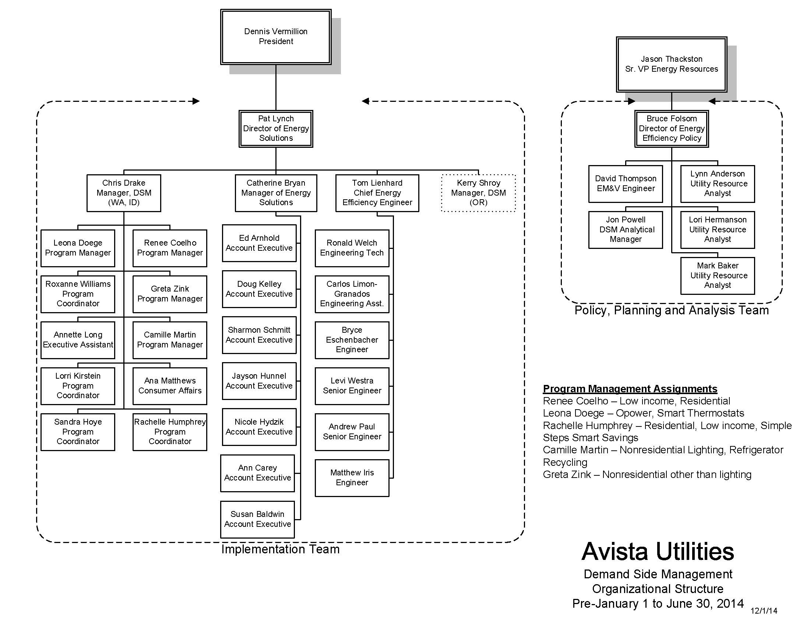

1. 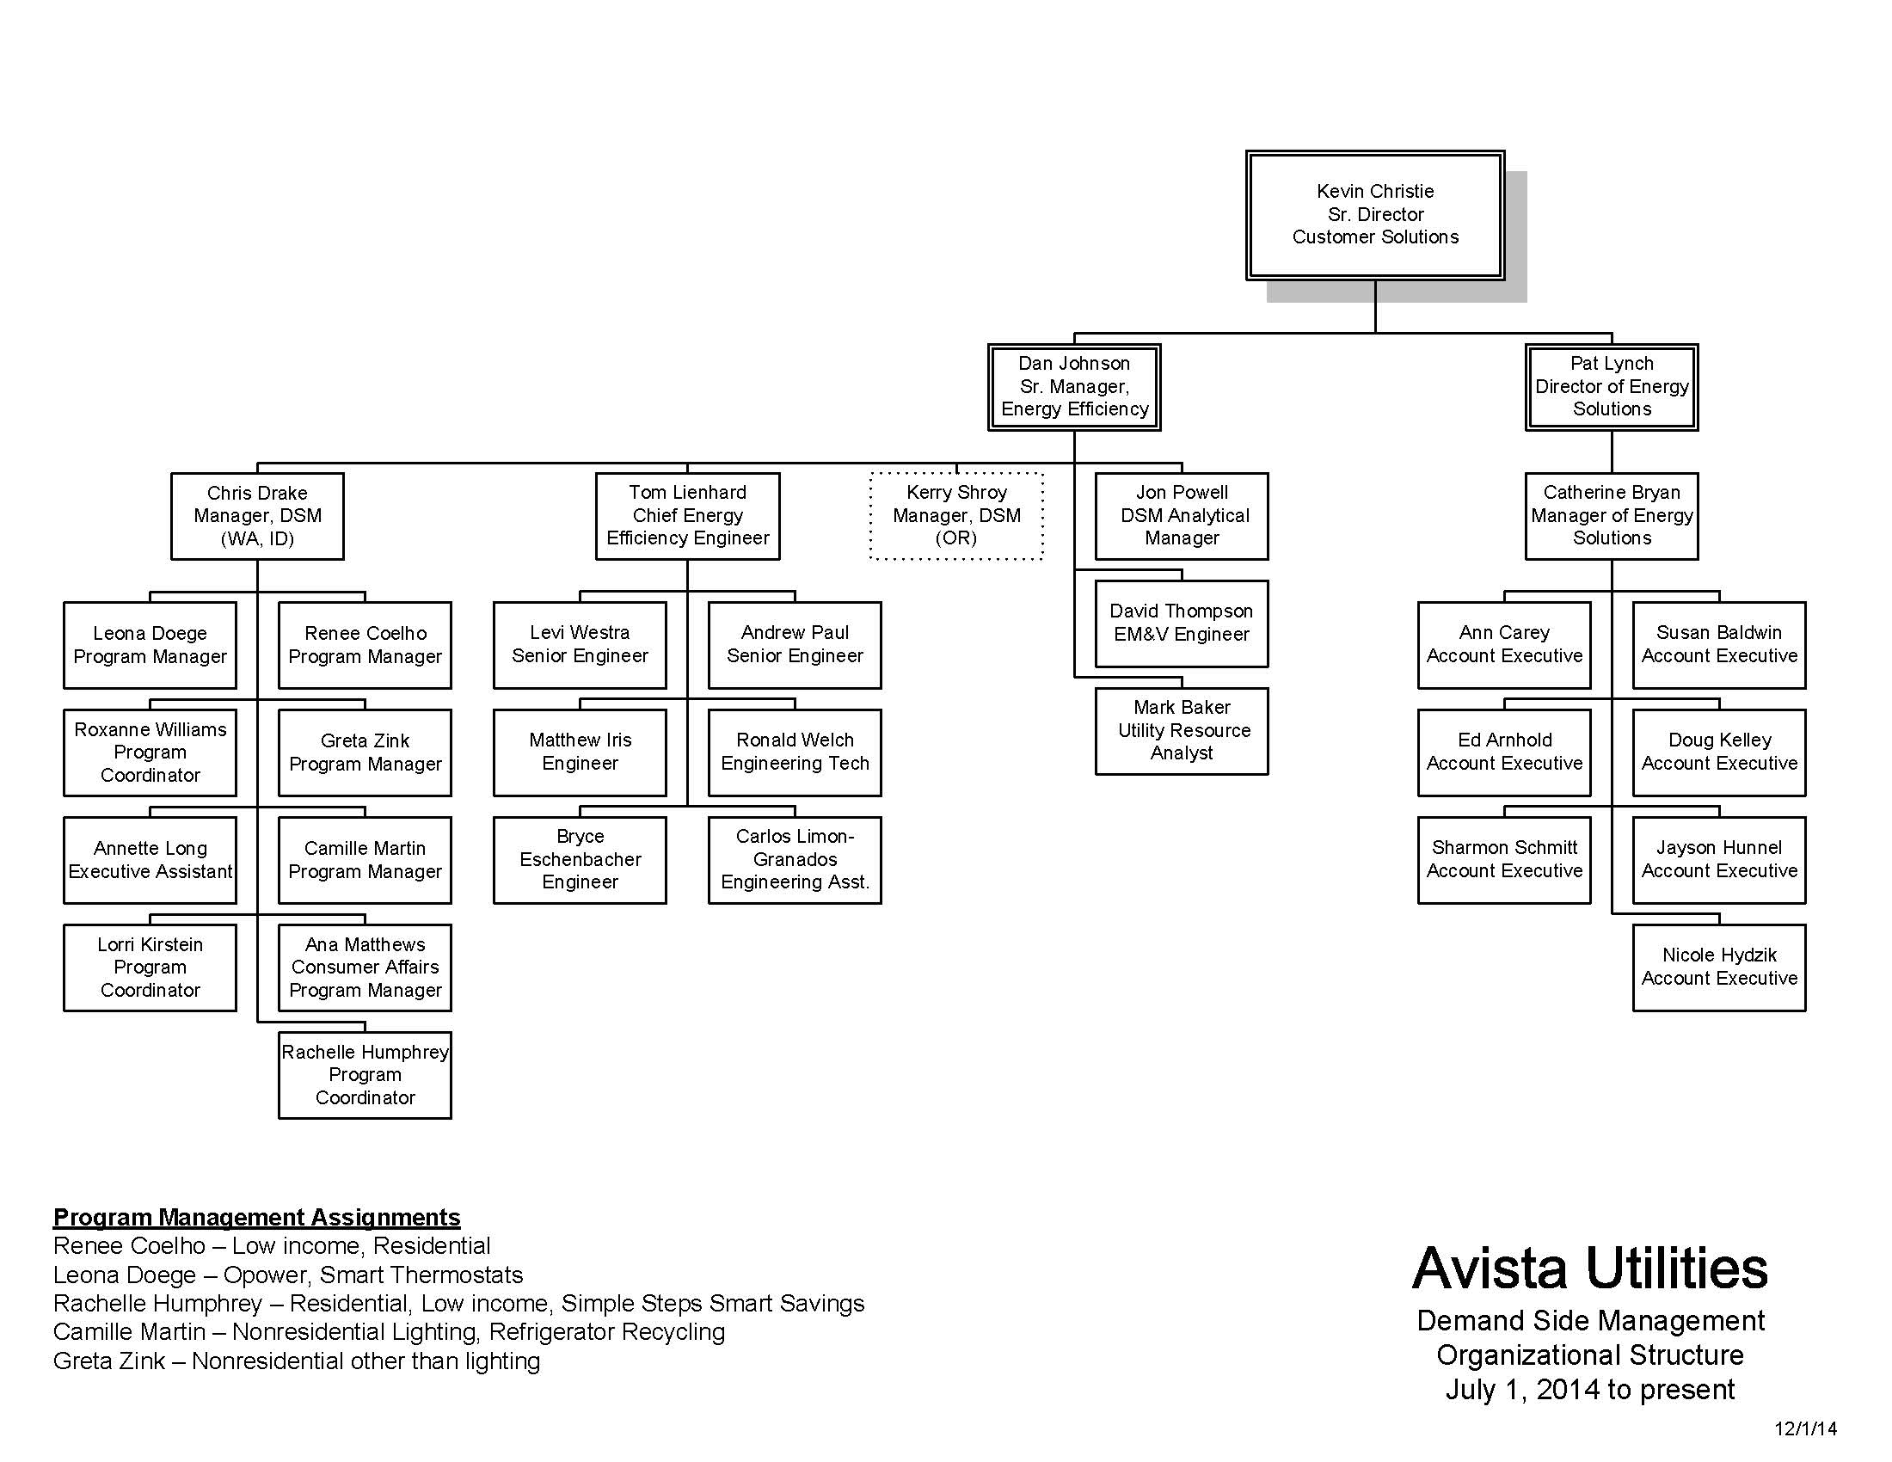Avista Utilities Demand Side Management Organizational Structure July 1, 2014 to Present (dated 12/1/2014)

1. Avista 2012-2013 Process Evaluation Report, May 15, 2014. Prepared by Cadmus.
2. Efficiency Valuation Organization (EVO) “International Performance Measurement and Verification Protocol (IMPVP) Concepts and Options for Determining Energy and Water Savings Volume 1”, April 2007, page 19.
3. This position managed the evaluation team’s contract with Avista. It also manages the conservation potential assessment contract, which Avista conducts through a third party.