

May 24, 2011

Advice No. 3677T

David Danner

Executive Director and Secretary

1300 S. Evergreen Park Dr. S.W.

P.O. Box 47250

Olympia, Washington 98504-7250

Dear Mr. Danner:

Qwest Corporation (Qwest) is forwarding for filing the sheet listed on Attachment A.

This filing introduces the City of Wapato, Washington’s Occupational Tax Rate and Effective Tax Rate for billing of 6.0%

The Legal Effective Date for the tax rates was October 15, 1990. Qwest was not aware of this tax until it was noted on a report this month from one of our tax information vendors. The City’s website states that Wapato does not impose any taxes on businesses in the city so Qwest’s Tax Department contacted the City to confirm the existence of this tax. The City confirmed the existence of the tax and provided the attached ordinances.

Qwest is requesting an effective date of June 24, 2011, for this filing.

f you have questions concerning this filing please contact me.

Yours very truly,

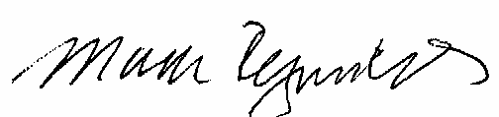

Mark Reynolds

Attachments

Attachment A

Advice No. 3677T

**EXCHANGE AND NETWORK SERVICES**

**WN U-40**

|  |  |  |
| --- | --- | --- |
| **SECTION** | **SHEET** | **REVISION** |
| 2 | 74 | 4 |
|  |  |  |