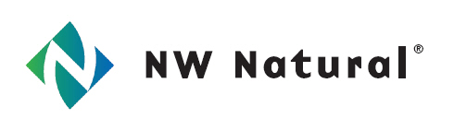

**Modified**

**Pipeline Replacement Plan**

**June 16, 2016**

*In accordance with*

**Policy Statement in Docket: UG-120715**

220 NW Second Avenue

Portland, Oregon 97209

503-226-4211

Table of Contents

Introduction 3

Master Plan and Pipe Replacement History 4

Cast Iron Replacement 4

Bare Steel Replacement 4

Vintage Plastic Replacement 5

Two Year Plan 6

Continual Improvement 6

Film Digitizing 6

GIS (Geographic Information System) 7

Damage Prevention 7

Impact on Rates 7

Public Interest 7

Conclusion 8

# Introduction

NW Natural Gas Company, dba NW Natural (hereafter referred to as NW Natural or Company) submits the following in response to the Washington Utilities and Transportation Commission’s request for the Company’s pipe replacement plan as referenced in docket UG-120715.

NW Natural is committed to pipeline safety and to the implementation of enhanced pipeline safety programs that legitimately improve the company’s already safe pipeline infrastructure.

NW Natural’s distribution system in Washington consists of modern material including cathodically protected coated steel and PE2406 (Medium Density Polyethylene). Since the initial Pipeline Replacement Plan filing NW Natural has replaced all known bare steel mains and services as well as vintage plastic services.

# Master Plan and Pipe Replacement History

NW Natural has a long history of Integrity Management programs focused on safety, risk reduction, and enhanced reliability to customers. Continual improvement is at the heart of providing safe, reliable service, and will remain a focus of Integrity Management at NW Natural. At this time all known at-risk material types in NW Natural’s system have been identified and replaced. Below is a summary of replaced at-risk materials.

## Cast Iron Replacement

In 1985 NW Natural voluntarily began a system-wide cast iron replacement program. The program was completed in 2000. The success of this program is demonstrated in Figure 1.

Figure 1

## Bare Steel Replacement

After completion of Cast Iron replacement in 2000 NW Natural voluntarily initiated a system wide bare main replacement program. This proposed 20-year replacement program was completed in 2015 in the State of Washington with all known bare mains and services replaced in 2015. Figure 2 shows the reduction in bare main mileage throughout the program and the corresponding reduction in leaks attributed to corrosion.

Figure 2

## Vintage Plastic Replacement

ABS was installed from 1961 through the early 70’s to renew ¾” steel services per Figure 3.

ABS was identified as an industry wide threat with failures typically resulting in leaks due to brittleness in the form of stress cracking parallel to the longitudinal axis of the pipe. ABS was designated in NW Natural’s DIMP Plan as an accelerated action because of its susceptibility to failure. Beginning July 1, 2012 NW Natural utilized the GIS to identify potential vintage plastic services in the State of Washington. Based on the results of the query, 393 possible ABS services were identified and subsequently field-verified, resulting in positive identification and replacement of 19 ABS services.

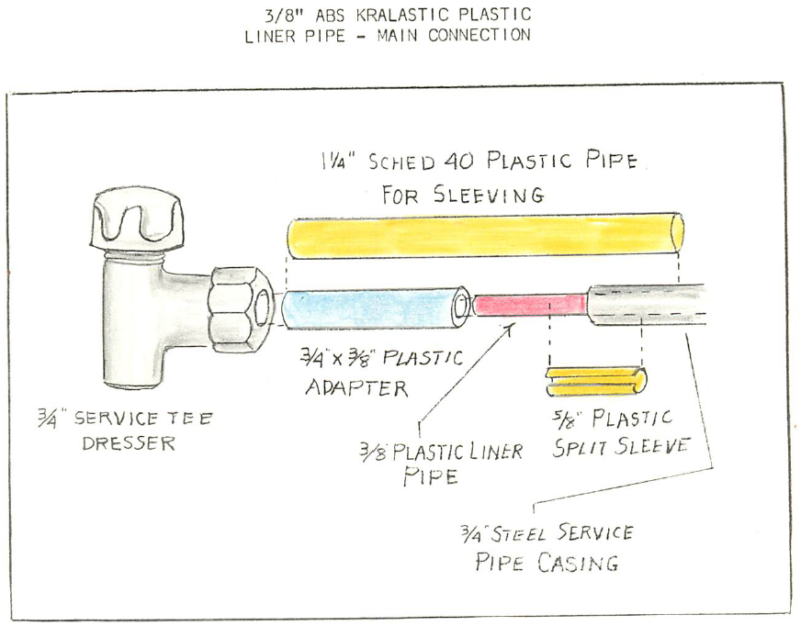

Figure 3

Polyoxymethylene (aka Celcon) caps pose a slightly elevated risk of failure. The Company is replacing polyoxymethylene caps upon discovery.

# Two Year Plan

The pipelines operated and maintained by NW Natural in the State of Washington are comprised of modern material: cathodically protected coated steel and polyethylene. At this time NW Natural does not have a two-year plan to replace existing facilities based on material type. Polyoxymethylene caps are replaced as they are discovered.

**Continual Improvement**

## Film Digitizing

In May of 2013 NW Natural completed phase one of an ongoing project to convert as-built records from micro-film to PDF. This project was necessary because of the lack of parts to replace aging micro-film viewing equipment. The project involved digitizing and entering metadata for more than 100,000 service records which we used to validate bare and vintage plastic in NW Natural’s system.

As of 2016 NW Natural continues to digitize and scan paper records for which metadata is collected and organized in an Engineering Records Viewer (ERV). ERV is a browser based application developed internally to permit the viewing of electronic facility data including as-builts, pressure test records, and work orders.

## GIS (Geographic Information System)

In addition to pipe replacement projects, NW Natural has taken measures to ensure the integrity of pipe and other assets by investing in GIS and mapping. Two notable changes were the migration to the ArcFM data model which allows for improved data management and analysis and a conflation project to align historical facility data with advancements in geo-spatial data including aerial imagery. These investments and continual improvement in the GIS are providing the tools to better integrate GIS with the evolving needs of Integrity Management.

## Damage Prevention

The single largest threat to NW Natural’s facilities is third party damage. NW Natural maintains a robust damage prevention program in the State of Washington to communicate, cooperate, and coordinate with government agencies, municipalities, utilities, contractors, customers, the general public, and other stakeholders to reduce the number to third party damages.

**Impact on Rates**

There is no immediate incremental impact on rates from this plan as the Company is not asking for a cost recovery mechanism nor is the Company filing a rate case at this time. While there is no immediate impact on rates, future impacts could occur as a result of prospective costs due to the identification and replacement of pipelines with an elevated risk of failure.

**Public Interest**

The Company’s actions surrounding pipeline replacement considered factors including:

* Further improving the safety of the distribution system by replacing pipe based on the relative level of risk for each material and location.
* Minimizing the replacement costs and associated rate impacts by maximizing efficiencies and productivity.
* Minimizing the impacts to municipalities and the general public.

**Conclusion**

NW Natural will remain vigilant in the investigation and evaluation of high risk facilities. Under NW Natural’s TIMP and DIMP Programs, there are policies, procedures and practices in place to continually gather and analyze information regarding the performance of the infrastructure.

In addition, NW Natural will continue to participate with peers, industry associations, and regulators in tracking trends and applying learnings to further enhance public safety and system reliability.

NW Natural is firmly committed to continuous improvement and will actively refine and improve current programs associated with system knowledge, threat identification, evaluation of risk, implementation of measures to address risk, and measuring past performance to ensure the safe, reliable delivery of natural gas to customers in the State of Washington and throughout our service territory.