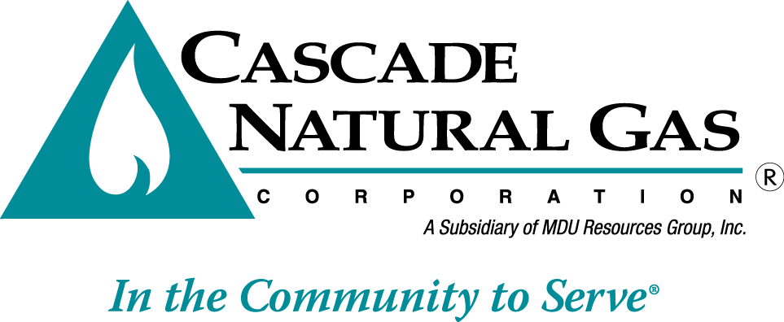 | 8113 W. GRANDRIDGE BLVD., KENNEWICK, WASHINGTON 99336-7166  TELEPHONE 509-734-4500 FACSIMILE 509-737-7166  www.cngc.com

October 20, 2016

Mr. Steven V. King
Executive Director and Secretary
Washington Utilities & Transportation Commission
P.O. Box 47250
Olympia, WA 98504-7250

RE: UG-161110, Supplemental Filing
Advice No. CNG/W16-09-02

Dear Mr. King:

On September 30, 2016, Cascade Natural Gas Corporation (Cascade or Company) submitted Advice No.W16-09-02. The Company now revises this filing with the following sheet which is stated to become effective with service on and after November 1, 2016:

Fiftieth Rev. Sheet No. 577

This replaces one of the sheets in the initial September 30, 2016 filing.

The change made herein corrects an inadvertent error in the numbering of the tariff sheet, as stated in the header.

Any questions regarding this filing may be directed to me at (509) 734-4593.

Sincerely,

Michael Parvinen
Director, Regulatory Affairs

Attachment

