|  |  |
| --- | --- |
| **Avista Corp.**  1411 East Mission P.O. Box 3727  Spokane, Washington 99220-0500  Telephone 509-489-0500  Toll Free 800-727-9170 |  |

February 1, 2017

Steven V. King

Executive Director and Secretary

Washington Utilities & Transportation Commission

1300 S. Evergreen Park Drive S. W.

P.O. Box 47250

Olympia, Washington 98504-7250

Re: Docket No. UE-160082 – Avista Utilities Quarterly Report on Electric Vehicle Supply Equipment Pilot Program

Dear Mr. King,

On April 28, 2016 the Commission issued Order 01 in Docket UE-160882 approving Avista Corporation’s, dba Avista Utilities (Avista or Company) tariff Schedule 77 for its Electric Vehicle Supply Equipment (EVSE) Pilot Program. Within the Order the Commission required Avista to submit quarterly reports on the status of the program beginning on August 1, 2016 and ending on August 1, 2018. The quarterly reports must include the following:

1. For DC Fast Charging stations, Avista shall report the locations and utilization of stations, review and revise the DC fast charging rate, and assess the amount of overall fixed and variable costs recovered through user payments and report its findings to the Commission quarterly, beginning August 1, 2016.
2. For all other services offered under the Electric Vehicle Supply Equipment Pilot Program, Avista shall report participation levels, expenditures, and revenues for each service offered for the duration of the program. We expect the Company to collect and report additional data necessary to provide enough information to evaluate accurately the program’s success by August 1, 2018.

As described in Order 01 the effective date of tariff Schedule 77 was May 2, 2016. The term of the program began with the first residential EVSE installation on July 20, 2016. The following are updates on each element of the program.

**DC Fast Charging (DCFC) Stations**

The first DCFC station in Rosalia, Washington was brought online January 18, 2017. This installation took longer than expected, mainly due to late equipment deliveries and weather conditions. Remote monitoring shows no problems to date and it is available for use by the public, no charge sessions outside of testing have occurred thus far. We expect limited use of this charger until DCFC stations are also installed in Spokane and Pullman in 2017, completing this travel corridor. Key information about the Rosalia DCFC, including real-time availability status, is posted online at [www.plugshare.com](http://www.plugshare.com).

The Company is continuing to consult with Washington State’s Department of Transportation on each DCFC site, ensuring alignment with statewide plans to build out effective EV infrastructure.

DCFC site acquisition for locations in Spokane and Pullman is in its final stages, with targeted construction beginning in Q2 of 2017. The Spokane DCFC will be located in Kendall Yards, which is within walking distance to the downtown core of Spokane and Riverfront Park. While not immediately off of Interstate 90, the location is within one mile of the interstate and meets the location siting specifications of the Washington State Department of Transportation. In addition, the Kendall Yards location will help enable regional transportation on both the North-South and East-West corridors through Spokane, as well as providing quick public charging for inner city travel within Spokane.

The Spokane Transit Authority (STA) has indicated support for a DCFC installation at the existing Liberty Lake Park & Ride, which we expect to install in 2017. In addition, a DCFC at the new STA West Plains Park & Ride located near the Cheney I-90 interchange is anticipated in early 2018. The Park & Ride facilities were identified as opportune locations given their convenient access to Interstate 90 on both the West and East sides of Spokane County, nearby facilities including restaurants and convenience stores, proximity to three-phase service, as well as a partner in the STA that is able to provide the parking space necessary to facilitate the DCFC. Installation of these five identified locations will provide an electrified north-south corridor between Spokane and Pullman, as well as serving east-west traffic along I-90 in the vicinity of Spokane, and between the Spokane and Coeur d’Alene, Idaho travel corridor.

This leaves two additional stations to complete the seven DCFC proposed for the pilot program. A suitable location on the outskirts of north Spokane, possibly as far as Deer Park is desirable to extend northbound electrification of the US-395 corridor. The final DCFC location will be determined as the Company gathers more information and lessons learned.

Total construction and installation costs are currently estimated at $154,322 for the Rosalia site, itemized as follows:

**Table No. 1**

$ 28,111 DC Fast Charger EVSE

$ 4,700 Dual Port AC Level 2 EVSE

$ 7,078 Engineering & Design

$ 5,309 Project Management

$ 72,881 Contractor Labor & Materials

$ 36,243 Avista Labor & Materials

$154,322 Total

The cost of this installation is higher than the expected average of $125,000, but is within reasonable parameters given the specifics of the site location. The total cost includes the requirements for new three-phase service, distribution pole replacement, tree removal, 220 feet of soil trenching and associated concrete work, as well as the cost of the service transformer. The site has an operational 50kW DCFC with both CCS and CHAdeMO connectors, and a dual-port AC Level 2 EVSE rated at 40A per port as a backup. The installation is “future-proofed”, with property easement, transformer capacity and conduit installed to allow for low-cost future expansion of an additional 150kW DCFC and Level 2 EVSE.

With the online date of January 18, 2017, at the time of the due date of this quarterly report, the Company did not have enough experience or data to provide analysis of utilization rates of the Rosalia DCFC and associated rate of $0.30/minute. In its next quarterly report due on May 1st, the Company will report the utilization of stations, assessment of revenues received through user payments, and evaluation of the approved rate of $0.30/minute.

**Level 2 Charging Stations – Residential and Commercial**

Overall, customer participation levels and feedback for Level 2 charging station installations remains positive. As of January 23, 2017, the number of applications and installations for the various EVSE categories are as follows:

**Table No. 2:**

|  |  |  |  |  |  |
| --- | --- | --- | --- | --- | --- |
|  | **2-Year Goal of Port Installations** | **Applicants** | | **Installations** | |
|  | **Applicants** | **Approved** | **Scheduled** | **# Ports Installed** |
| **Residential SFH[1]** | 120 | 104 | 90 | 11 | 56 |
| **Workplace\Fleet\MUD[2]** | 100 | 93 | 48 | 5 | 15 |
| **Public** | 45 | 40 | 21 | 3 | 0 |
| **DCFC** | 7 | 5* | 1** | 1 | 1 |

*Sites identified

**Sites where site agreement has been signed to move ahead with construction.

Since the last report, software updates from the EVSE manufacturer have resulted in much improved reliability of Wi-Fi communications and EVSE stabilization. However, some problems remain and are expected to continue. For example, when customers change Wi-Fi passwords or install a new router it may result in communication issues. When this occurs, the EVSE typically goes offline and the customer must be contacted to coordinate re-establishing communications with the Wi-Fi network and the EVSE.

The following chart shows the status of residential applications and installations by categories of Battery Electric Vehicle (BEV) Commuter, BEV Non-Commuter, Plug-In Hybrid Electric (PHEV) Vehicle Commuter, and PHEV Non-Commuter.

**Chart No. 1:**

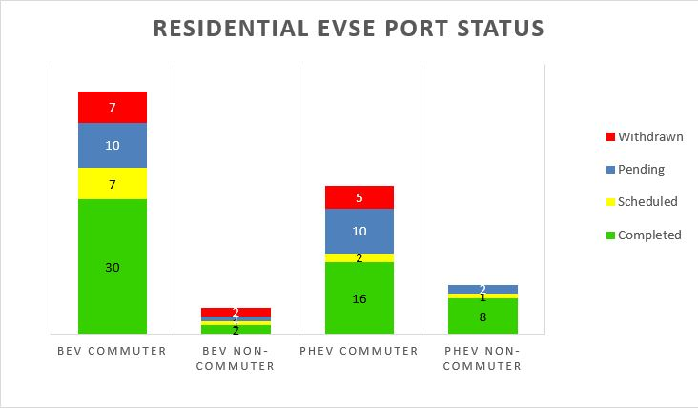

Reaching residential customers to achieve greater program participation is becoming more difficult. Efforts are underway to follow-up with existing customer leads that have not yet applied, as well as renewed attempts to work with auto dealerships to ensure new EV customers are aware of the program and given the opportunity to apply. Ideally, at least 20 customers in each category described above are needed in order to obtain desirable statistical sampling that represents the breadth of large driver populations with minimal errors. We have achieved this in the BEV Commuter category and expect to reach this level in the PHEV Commuter category, but may not achieve the needed participation levels in the PHEV Non-commuter and BEV Non-Commuter categories. This would increase statistical modeling error for the portion of the population that does not use their vehicle to commute to work, but should still allow for attainment of key insights and the Pilot’s major learning objectives.

The chart below shows the various residential installation cost components by job, ranging from a total of $450 to $3,700. Five installations required supply panel upgrades resulting in higher costs that the customer was willing to bear. Not all customers are willing to bear this additional cost, however, as similar high installation costs were the primary reason for four of the 14 residential withdrawals experienced thus far.

**Chart No. 2:**

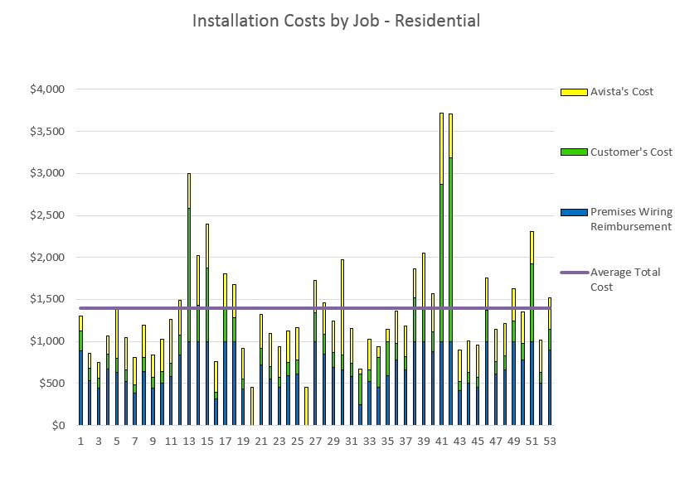

Residential cost breakdowns continue to meet expectations as shown by the average costs in the table below, with EVSE installed in 56 customer homes thus far.

**Table No. 3:**

|  |  |  |  |  |  |
| --- | --- | --- | --- | --- | --- |
| **Premises Wiring Reimbursement** | **Customer’s Cost** | **Avista’s Cost** | **Total Installation Cost** | **EVSE Cost** | **Total Costs Installation + EVSE** |
| $670 | $324 | $397 | $1,392 | $1,066 | $2,458 |

Post-installation surveys have indicated high customer satisfaction, as shown by the chart below.

**Chart No. 3:**

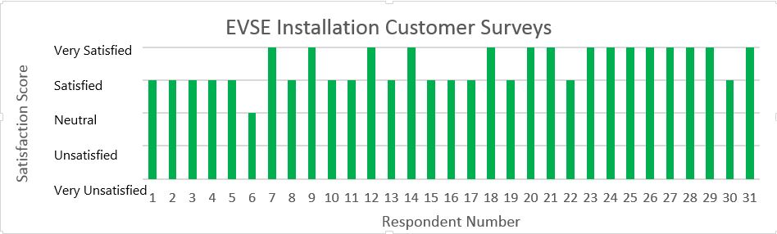

The following chart shows the status of commercial applications and installations by category[3]:

**Chart No. 4:**

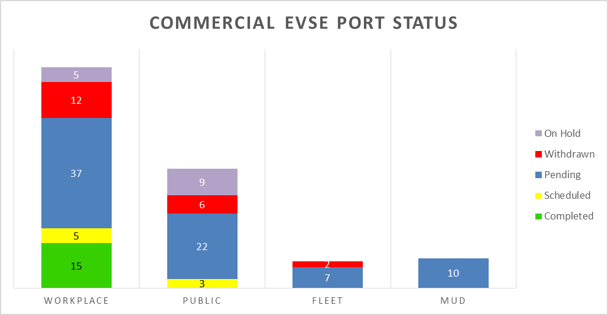

The process of site acquisition continues to be the major cause of delays for commercial installations, primarily involving reaching agreement on legal contracts. We expect through the next few months to line up several pending candidates for installation in the early spring, increasing the rate of commercial AC Level 2 installations. However, it is clear that a strong effort will be required to achieve the targeted levels of workplace and public installations for the program. Most of the commercial leads generated thus far arose through residential participants who engaged their employers to participate in the program, and new residential applications have slowed considerably.

The cost components of commercial installations at seven different locations are shown below, primarily used as workplace charging for employees:

**Chart No. 5:**

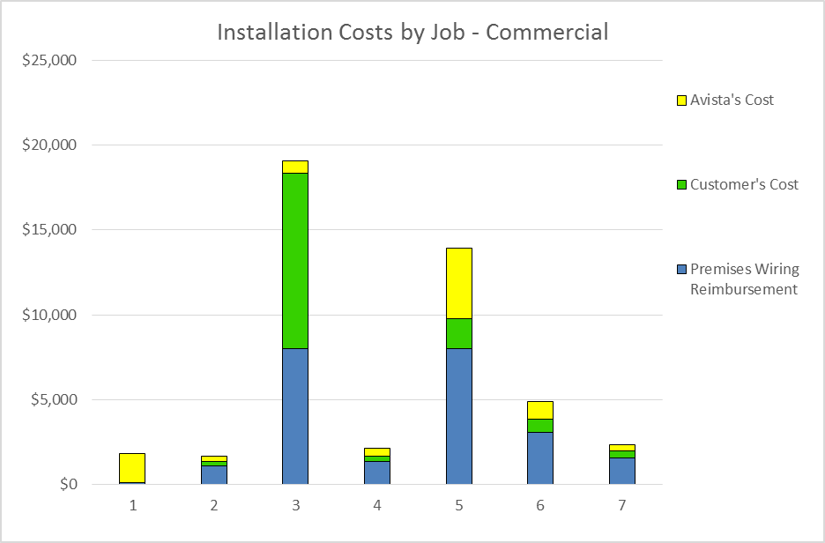

The higher costs for jobs #3 and #5 were due to a combination of multiple installed EVSE ports and required upgrades to transformers, supply panels, and/or trench work. The relatively low cost of jobs #1, #2 and #4 were due to the ability to mount the EVSE on the outer wall of the building adjacent to the parking location, with minimal upgrades to the existing facility’s electrical system. Further cost breakdowns for each location are listed in the table below.

**Table No. 4:**

|  |  |  |  |  |  |  |  |  |
| --- | --- | --- | --- | --- | --- | --- | --- | --- |
| **Job** | **Premises**  **Wiring**  **Reimburse-ment** | **Customer's**  **Cost** | **Avista's**  **Cost** | **Total**  **Install**  **Cost** | **EVSE**  **Cost** | **Total**  **Cost EVSE + Installation** | **#**  **Ports** | **Total**  **Cost per**  **Port** |
| 1 | $100 | $25 | $1,696 | $1,821 | $2,174 | $3,995 | 2 | $1,998 |
| 2 | $1,108 | $227 | $324 | $1,659 | $1,087 | $2,746 | 1 | $2,746 |
| 3 | $8,000 | $10,349 | $728 | $19,077 | $10,985 | $30,062 | 4 | $7,516 |
| 4 | $1,324 | $331 | $488 | $2,143 | $1,087 | $3,230 | 1 | $3,230 |
| 5 | $8,000 | $1,768 | $4,142 | $13,910 | $9,744 | $23,654 | 4 | $5,914 |
| 6 | $3,080 | $770 | $1,046 | $4,896 | $5,970 | $10,866 | 2 | $5,433 |
| 7 | $1,582 | $395 | $380 | $2,357 | $2,087 | $4,444 | 1 | $4,444 |
| **Avg:** | **$3,313** | **$1,981** | **$1,258** | **$6,552** | **$4,733** | **$11,285** | **2.1** | **$4,469** |

**Data Analysis and Modeling**

Data from the Greenlots SKY platform indicates the following high-level statistics for all installations to date:

**Table No. 5:**

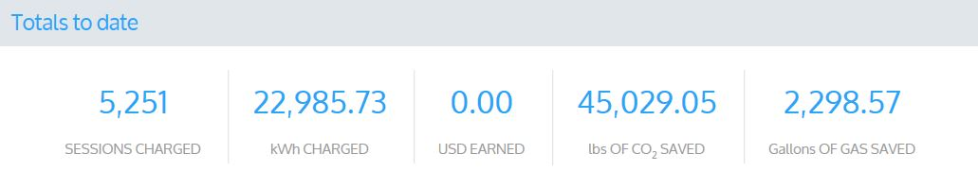

**Chart No. 6:**

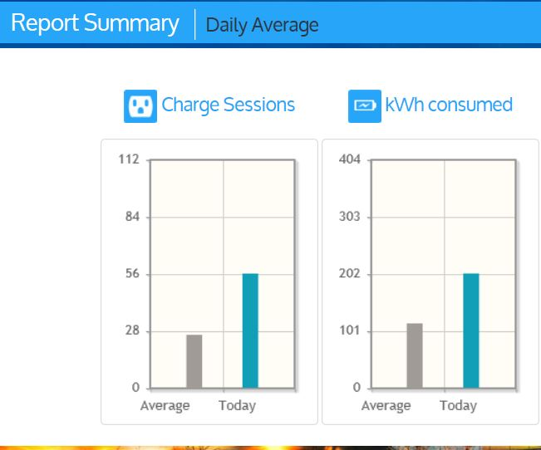

Preliminary analysis of the Greenlots data for 1,403 residential charging sessions shows an average of 10.9 kWh consumed per day, per plug-in electric vehicle (PEV). Assuming 3.3 miles per kWh, this equates to 36 miles driven per day from residential charging, compared to the national average of 29 miles driven per day. Consistent with other studies conducted to date, the load shape of this profile demonstrates a much higher consumption of electricity between the hours of 3 pm and 10 pm, with very little consumption between 1 am and 6 am. Although the quantity of data is still relatively small, this validates that the acquired data is reasonably accurate, without any gross errors. It also confirms the opportunity to shift charging load from evening peak hours to off-peak hours while the EV is parked overnight, while still fully charging the battery by the time the customer uses the vehicle the next day.

**Chart No. 7:**

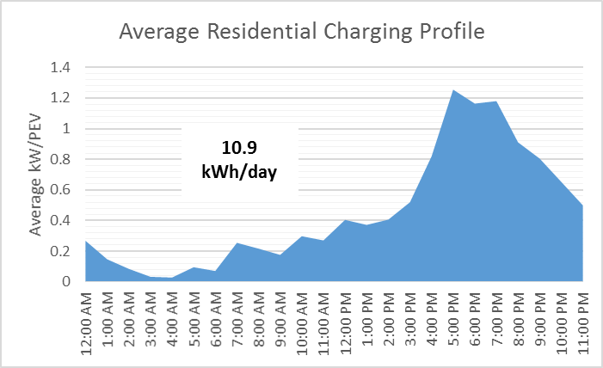

As the pilot proceeds, ongoing data collection in residential and commercial locations will provide for more detailed analysis and reporting.

**Expenditures & Revenues**

Expenditures through January 23, 2017 totaled $616,038. A more detailed breakdown is provided in Attachment A.

The Company does not yet have sufficient information regarding revenues for each service offered. As the pilot progresses, this information will become available and reported.

Please direct any questions regarding this report to Rendall Farley at 509-495-2823, [rendall.farley@avistacorp.com](mailto:rendall.farley@avistacorp.com), or myself at 509-495-2782, [shawn.bonfield@avistacorp.com](mailto:shawn.bonfield@avistacorp.com).

Sincerely,

Shawn Bonfield

Sr. Regulatory Policy Analyst

Avista Utilities

**Attachment A**

**Avista EVSE Pilot Program Expenditures through January 23, 2017**

Expenditures include all costs for both completed EVSE installations and installations in progress, as well as program administrative costs.



1. Single Family Home
2. Multifamily Unit Dwelling
3. Completed – EVSE has been installed. Scheduled – EVSE is scheduled to be installed. Pending – customer application is pending full approval. Withdrawn – customer has withdrawn application from program. On Hold – customer application is on hold due to location of requested EVSE.