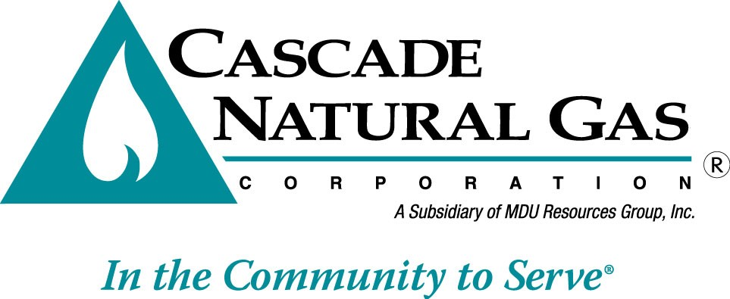



**2017**

**Washington   
Conservation Plan**

**Table of Contents**

Introduction 3

Overview 4

Program Goals & Budgets– at a glance 2017 & 2018 5

Program Cost Effectiveness 6

Docket UG-121207 Policy Statement on the Evaluation of the Cost-Effectiveness of Natural Gas Conservation Programs 7

Measure Updates 8

Emerging Technologies 8

Potential DSM Measures and Their Costs 10

Assessment of Cascade’s Conservation Potential and EM&V Study 11

Administrative costs and TEA-Pot modeling moving forward 13

Total Resource Cost test (TRC) 13

Utility Cost Test (UCT) 14

Market Segmentation Findings 14

Energy Efficiency Portfolio Development 15

DSM Portfolio Updates and Planning 16

Budgeting Parameters 17

Targets 18

Commercial/Industrial Scenarios 18

Most Recent Program Update 19

Residential Program Delivery Changes from 2016 19

Program Offerings as of October 10th 2016 22

Washington Low Income Program 28

Conservation Programs in 2018 31

Improved Granularity by Climate Zone 33

Forward Looking Targets/ TEA-Pot Forecasts 34

CY 2017 & 2018 Targets 38

Long term Conservation Potential 41

Planning and EM&V 43

Housing Stock Assessment Review from NEEA 43

Outreach & Messaging Campaigns 44

Community Participation - A Key to Program Longevity and Support 45

Residential Focus 48

Low Income messaging opportunities 50

Commercial Focus 50

# Introduction

Cascade Natural Gas Corporation has developed this Conservation Plan in consultation with its Conservation Advisory Group (CAG) as a roadmap to the 2017 and 2018 near term conservation strategy for reducing consumption through its Conservation Incentive Programs (CIP).

In this second rendition of the Conservation Plan, the Company has completed transitioning from its traditional planning document housed in the Integrated Resource Plan (IRP) to this standalone plan. Several Conservation Advisory Group (CAG) meetings have been held in the past year to clarify the elements of the Company’s DSM efforts that stakeholders would like to see addressed in the IRP, and those which are more appropriately housed within the Conservation Plan. As a result, the following allocation of planning information can be found between these two documents:

1) An executive summary of the potential forecasting of the Company’s energy-efficiency efforts remains in the Demand Side Management (DSM) chapter of the IRP. 2) General discussion around DSM including environmental externalities, regional energy planning and legislative impacts have also remained a part of the IRP. In contrast, the Conservation Plan places its focus on potential and near-term conservation program planning versus the long term 20 year outlook inherent in the IRP.

The Company’s Conservation Plan, provided below, will discuss the potential savings determined for the Cascade Natural Gas Corporation (CNGC) Washington service territory through the Company’s TEA-Pot (**T**echnical **E**conomic **A**chievable **Pot**ential) modeling tool provided by Nexant Inc. In order to parallel the format of Conservation Plans provided by other utilities in Washington State, this document will demonstrate the Company’s immediate (two year) conservation goals as well as the 10 year forecast of savings.

The Company is approaching the 2017 Calendar Year as an opportunity to further refine a significantly matured program by incorporating improvements that were introduced in 2016 and will continue into early 2017. Updated elements to the CIP include enhancements to program reporting, increased transparency in potential planning, strategic process development and tracking and the implementation of a new software platform to support in-house residential rebate processing activities. As mentioned in the previous Conservation Plan, the Company transitioned from a third party residential program delivery vendor in January 2016 to an internal delivery model for the residential incentive programs. The Company additionally purchased a companion software platform to enable processing of applications. This significant evolution in the Company’s approach to residential program delivery has allowed more direct control of the customer experience throughout the CIP rebate process, while providing greater insight into areas of opportunity for further penetration of the Conservation program throughout our Washington service territory. This move toward internal implementation has enabled the Company to tailor its reporting and tracking to more succinctly align with program strategy. Changes to the Company’s program delivery strategy are further described under the Residential Program Delivery Changes from 2016 heading in this document.

# Overview

Demand Side Management refers to resources acquired through the reduction of natural gas consumption due to increases in efficiency of energy use and/or load management. Unlike supply side resources, which are purchased directly from a supplier, demand side resources are purchased from individual customers in the form of energy that remains unused as the result of energy efficiency. The Washington Utility and Transportation Commission requires gas utilities to consider cost-effective DSM resources in their energy portfolio on an equal and comparable basis with supply side resources. In the gas industry, DSM resources are conservation measures that include, but are not limited to ceiling, wall and floor insulation, higher efficiency gas appliances, insulated doors, ventilation heat recovery systems and weather stripping. By incenting customers to reduce their demand for gas, Cascade can displace the need to purchase additional gas supplies, displace or delay contracting for incremental pipeline capacity, and possibly displace or delay the need for reinforcements on the Company’s distribution system. It’s also important to acknowledge the Company can prompt and encourage customers to reduce their use, but in due course it’s up to the end user to elect to reduce their usage and recognize the values inherent in energy efficiency - ultimately resulting in reduced consumption and load management as encouraged by Company messaging and incentives.

There are two basic types of demand side resources: baseload resources and heat sensitive resources. Baseload resources displace the need for baseload supply-side resources. They will offset gas supply requirements throughout the year, regardless of the weather and outside conditions. Baseload DSM resources include equipment like high efficiency water heaters, higher efficiency cooking equipment and Ozone Injection Laundry systems. Heating load sensitive DSM resources are measures whose therm savings increase during cold weather (meaning the measure is used more often during colder weather). For example, a high efficiency furnace will lower therm usage in the winter months when the furnace is utilized the most and will provide little if any savings in the summer months when the furnace is rarely used. Examples of heating load sensitive DSM measures include ceiling, floor, and wall insulation measures, high efficiency gas furnaces, and improvements to ducts and air sealing. These types of heat sensitive measures offset more of the peaking or seasonal gas supply resources, which are typically more expensive than baseload supplies.

## Program Goals & Budgets– at a glance 2017 & 2018

The Company provides its budgets and therm goals for the next two years in Table 1, for reference.

**Table 1**

**CIP Goals 2017 & 2018**

|  |  |  |  |  |  |
| --- | --- | --- | --- | --- | --- |
| **Program Budgets1** | **CY 2016** | **CY 2017** | **Change from previous year** | **CY 2018** | **Change from previous year** |
| **Incentive Estimates** | | | | | |
| Residential | $1,128,698 | $891,663 | -21% | $912,251 | 2% |
| Commercial/Industrial | $638,494 | $582,149 | -9% | $615,114 | 6% |
| Low Income | $90,000 | $385,000 | 328% | $390,000 | 1% |
| **Total Incentives** | $1,857,192 | **$1,858,812** | 0% | **$1,917,365** | 3% |
|  |  |  |  |  |  |
| **Non-Incentive/Admin Expenses** | | | | | |
| Residential | $507,199 | $550,000 | 8% | $566,500 | 3% |
| Commercial/Industrial | $983,301 | $1,000,000 | 2% | $1,030,000 | 3% |
| Low Income | $15,002 | $8,911 | -41% | $8,911 | 0% |
| **Program Portfolio Admin** | **$1,505,502** | **$1,558,911** | 4% | **$1,605,411** | 3% |
| *Non-Incentive Expenses include:* |  |  |  |  |  |
| *Labor* | *$262,206* | *$345,000* | 32% | *$355,350* | 3% |
| *Trade Ally/ Program Outreach* | *$97,500* | *$174,500* | 79% | *$179,735* | 3% |
| *Third Party Program Management* | *$846,0174* | *$800,000* | -5% | *$824,000* | 3% |
| *Annual Software fees* | *$150,000* | *$150,000* | 0% | *$154,500* | 3% |
| *Other* | *$149,779* | *$89,411* | -40% | *$96,326* | 8% |
| ***Additional Expenses*** |  |  |  |  |  |
| NEEA Market Transformation | $244,996 | $313,174 | 28% | $452,285 | 44% |
| Software Implementation | $100,000 | $35,000 | -65% | $0 | -100% |
| **Total administrative expenses** | **$1,850,498** | **$1,907,085** | 3% | **$2,057,696** | 8% |
| **Combined Expenses Total** | **$3,707,690** | **$3,765,897** | 2% | **$3,975,061** | 6% |
| **Therm Targets2** | | | | | |
| Residential | 409,975 | 323,878 | -21% | 331,357 | 2% |
| Commercial/Industrial | 565,940 | 515,998 | -9% | 545,217 | 6% |
| Low Income3 | 7,000 | 15,000 | 114% | 15,000 | 0% |
| **Total Therms** | **982,915** | **854,876** | -13% | **891,574** | 4% |

1*. Note budgets are estimates and are intended as a guideline for program implementation. Rebate budgets are subject to customer program uptakes.*

*2. Therm targets from this graph have been developed through the TEA-Pot modeling tool inclusive of administrative costs.  These targets are aspirational targets. The Company will actively work toward achievement of these goals, but it is important to recognize program cost-effectiveness is the primary metric of success*

*3Following the submission and approval of a revised LI-WIP tariff to the WUTC, Cascade will refine the anticipated therm savings and budgetary targets for the LI program as appropriate*

*4The 2016 entry includes overlap from previous year’s 3rd party residential program vendor during transition period.*

In addition to the goals and budgets goals, the Company has also provided a comparison of the past three years of achieved overall savings contrasted with the IRP goals below in Table 2. Please note 2016 achievements will be provided as part of the Company’s Annual Conservation Report which is released on June 1 of the following calendar year. It should also be noted 2014 IRP goals were not officially acknowledged by the WUTC. The last set of acknowledged goals was provided as part of the 2012 IRP. The 2012 IRP goals for CY 2015 (843,000 therms) and CY 2016 (927,000 therms) were developed prior to the development of the Company’s TEA-Pot model. Use of the TEA-Pot modeling tool has enabled the Company to significantly refine the forecast inputs to reflect the Company’s distinct customer service territory.

**Table 2**

**Historic Program Achievements compared to Goal**

|  |  |  |  |  |
| --- | --- | --- | --- | --- |
|  | **Year** | **Goal** | **Actual** | **Difference** |
| **2012 IRP** | 2013 | 510,511 | 471,431 | **-8%** |
| 2014 | 566,150 | 641,615 | **13%** |
| **2014 IRP** | 2015 | 584,449 | 831,501 | **42%** |
| 2016 | 620,020 | Not yet available | Not yet available |

# Program Cost Effectiveness

Conservation program offerings are affected by declines and increases in the costs of natural gas in the marketplace which has a direct impact on the avoided cost. A decrease in the cost of gas makes it difficult to maintain robust conservation programs as a utility, whereas gas price increases make conservation efforts more viable from a cost/benefit perspective. Despite these ongoing considerations, the Company continues its commitment to offering meaningful conservation programs to help drive customer decisions toward higher-efficiency appliances and upgrades. In CY 2013/2014 the Company had a fully customized Conservation Potential Assessment performed by Nexant Inc. which specifically included analysis on its potential from both the Total Resource Cost (TRC) test, and Utility Cost Test (UCT). While the Company had previously assessed program cost effectiveness under both tests, this was the first time the Company utilized both the TRC and UCT at the potential modeling phase of program development. This approach reflected guidance from the UG-121207 Conservation Policy Statement from the Washington Utility and Transportation Commission (WUTC), which stated program valuation under the UCT was acceptable in the absence of a fully refined and sophisticated TRC instrument. The Company held multiple discussions with its CAG related to the policy statement, and ultimately move towards the UCT as its primary valuation metric, with TRC as its secondary. This alteration allowed the Company to maintain its Washington programs despite fluctuations in the cost of gas, while recognizing the value of the efforts from a utility provider’s perspective of decreasing demand.

Calendar year 2017 is estimated to have a UCT cost-effectiveness at a portfolio level of 1.597, note Low Income programs are excluded from this calculation. In 2018 cost effectiveness is currently estimated at 1.628 under the UCT, also at a portfolio level (inclusive of the residential, commercial and industrial programs).

## Docket UG-121207 Policy Statement on the Evaluation of the Cost-Effectiveness of Natural Gas Conservation Programs

The Policy statement, released in October 2013, provided the Company with guidance on evaluating the cost effectiveness of its natural gas conservation programs. As per the policy’s guidelines the Company elected to utilize the UCT in consultation with its CAG. The use of the UCT, as opposed to the traditional TRC method, allows the Company to maintain a continued, robust conservation portfolio of measures.

Washington Utilities and Transportation Commission Docket UG-121207 offers guidance regarding the optimal method for the valuation of natural gas conservation efforts in the State of Washington. This document thoroughly addresses best practices for measuring cost-effectiveness as reflected in WUTC’s guidance that: “[W]e are unwilling to allow utilities to end natural gas conservation programs as a result of an unbalanced or incomplete TRC analysis. Any TRC analysis without these values [conservation’s risk reduction value, the downward price pressure from reduced demand, and non-energy benefits] is potentially biased against conservation programs. Accordingly, the UCT is an acceptable option when a properly balanced TRC is not available.”[1]

The Policy statement also addressed the use of discount rates in cost-effectiveness calculations. The Company has worked closely with its CAG to determine the appropriate rate to use when calculating the net present value of its annual costs and benefits from the conservation programs. It was determined Cascade would initially use the long-term discount rate as had previously been used to enable the programs to remain in place at their existing levels and to prevent removal of a significant amount of measures due to a severe discounting scenario, as would have been the case had the Company utilized the Weighted Average Cost of Capital (WACC). As part of the Company’s efforts to maintain consistency throughout its forecasting efforts and IRP documentation, the Company has transitioned to using the average 30 Year Mortgage Rate as the long term discount rate – which will be reevaluated annually as part of the Company’s IRP process. For 2016, the long term discount rate used is 3.52%.

# Measure Updates

As the energy efficiency market continues to develop and cost-effective conservation technologies become increasingly available, the equipment standards and accessibility to such measures will evolve over time. In order to ensure the Company’s DSM offerings stay current, Cascade engages in a regular review of the measure-mix within its conservation portfolio. Measures are added, removed, replaced, or modified when it is determined new technologies of equal or greater cost-effectiveness are available to the market. However, the emergence of a high-performance natural gas conservation technology will only have positive energy-savings impacts if customers are willing to pay the initial higher costs associated with the purchase and installation of cutting edge efficiency measures. Therefore market transformation efforts are essential to increasing accessibility to purchasers while decreasing costs to the consumer. This paves the way for future higher-efficiency choices and actions. By monitoring and updating the measures and incentive levels within Cascade’s Conservation Incentive Program (CIP), and amplifying the education and awareness outreach to customers, the Company can ensure ratepayers have access to an optimal level of behavior-motivating incentives and knowledge needed to encourage the purchase of cutting-edge, cost effective, gas conservation technologies with confidence they will accrue to advantages of increased efficiency. In conjunction with monitoring the viability of more “traditional” natural gas conservation measures, the Company engages in concurrent efforts to research and determine the feasibility of emerging high-efficiency gas technologies. The Company continues to monitor cutting edge measures and has made progress on this front thanks to the reassessment of the Company’s conservation potential in CY 2013/2014 by Nexant. More details regarding both sets of efforts can be found below. Further discussion about the Nexant Conservation Potential study and Cascade’s approach to the UCT will be provided in detail later in this plan.

# Emerging Technologies

The Company evaluates emerging technologies with strong potential for deeper natural gas savings. Such high performance measures include energy-efficient Natural Gas Heat Pumps (GHP) which have been identified as a promising and high-impact conservation measure by Oakridge National Laboratories.

Along with the natural gas heat pumps for use in commercial space heating applications as noted above, the Company continues the process of gathering more information regarding Gas-fired Heat Pump Water Heaters. This technology has been identified by the Northwest Energy Efficiency Alliance (NEEA) as a potentially viable technology with costs in a similar range to electric models currently available on the market.

Utility support for technologies like those noted above is important in the industry to demonstrate to manufacturers there is interest in supporting deployment through rate payer funded efficiency programs. The more interest displayed in emerging technologies, the more likely manufacturers are to increase production and market availability.

As mentioned previously, the Company is deeply invested in market transformation and has elected to partner through NEEA with other gas utilities in the region to participate in the first Regional Gas Market Transformation Collaborative in the nation. The goal is to increase market adoption of energy-efficient natural gas products and practices in the future. As part of the project the Collaborative is working toward creating pilots for five distinct technologies. Their goals is to increase the uptake and availability of these technologies in their members’ collective service territory in the Northwest. They also seek to improve cost effectiveness of these natural gas technologies. This five year effort started in 2015 and should result in increased savings as the technology is adapted and uptake increases in future years for upgrades including residential natural gas ENERGY STAR® dryers and commercial condensing natural gas rooftop units (RTUs).

Already, Cascade’s partnership with NEEA has proven beneficial to identifying opportunities for market transformation, standardization of ratings, and consumer education on available natural gas efficiency technologies. During a focus group discussion around natural gas dryers, it became apparent there is a significant lack of consumer awareness pertaining to natural gas dryers and their potential for energy savings. It was further discovered the residential marketplace does not currently provide a wide variety of high-efficiency natural gas ENERGY STARdryers. NEEA has identified a need to improve the standardized testing processes for achieving an ENERGY STAR rating on residential natural gas dryers while increasing the performance of many of the models to a level commensurate with consumer expectations.

In 2016, NEEA engaged in the first set of pilots pertaining to the rooftop units which included installation of a test unit in Cascade’s territory in Union Gap. Cascade, along with the other funding partners, was instrumental in having the rooftop unit efforts prioritized. Feedback from NEEA and direct observation in the field has suggested that Cascade’s service area could greatly benefit from high-efficiency alternatives to the standard RTUs currently used throughout commercial building stock in Cascade’s service territory. The review and data collection process for these efforts will continue throughout the 2016/2017 winter season. Continued focus on the role of RTU’s and other relevant technologies in Cascade’s service area attests to the direct correlation to, and benefit from, the regional efforts partially funded by Cascade’s rate payers.

Market Transformation efforts are a key element in increasing accessibility of new technologies to the region. The NEEA collaborative meets on a regular basis to discuss results and next steps of its pilot efforts in order to move toward these goals. It is important to recognize, however, that potential savings from market transformation are not realized immediately. Savings are achieved in future years once the market is able to support the higher-efficiency options and increased customer demand resulting in more advanced technological improvements. Cascade is committed to the continued partnership throughout the five year contract and The Company looks forward to 2017 and 2018 reviews of new technology that come as part of the regular discussions. A mid-cycle evaluation of the Collaborative’s efforts will also occur in 2017 which will enable further refinements of next steps.

Cascade continues to participate with the Gas Technology Institute (GTI) Emerging Technology Program to evaluate new technological opportunities as they enter the market. Through these efforts, the Company will continue to stay apprised of proven cutting-edge efficiency options with significant savings potential for customers.

# Potential DSM Measures and Their Costs

In order to understand the impact declining costs can have on the programmatic potential of natural gas conservation programs, it is important to understand how these programs work.  Utility-run energy efficiency programs are designed to encourage the use of high-efficiency natural gas equipment and measures. The Avoided Cost of natural gas is the threshold used to verify if the amount paid by the utility is reasonable.

In short, a utility should not pay more than 100% of the avoided cost of a measure. Likewise, it is considered general industry best practice that a rebate should be no lower than around 1/3 the incremental cost of the measure, nor higher than is necessary to achieve maximum anticipated participation. This helps the utility avoid both the risk of free ridership and the hazards of skewing program cost effectiveness and triggering the law of diminishing returns by paying beyond the level of an appropriate market signal.

As of the latest IRP, Cascade is able to pursue a combined Residential and Commercial/ Industrial conservation portfolio with a total avoided cost range of $5.19 per dekatherm in 2017 to $7.18 in 2037.

Utilizing the UCT, Company program management set the rebate thresholds to achieve an optimal balance between driving program participation and ensuring a broad breadth and depth of measures. The program incentive levels are frequently reviewed with the Conservation Advisory Group, most recently in July 2016, which resulted in current program offerings referenced here as of the time of writing for this Conservation Plan.

The Utility Cost Test is the preferred valuation of these measures since it is a straightforward and clean calculation of the utility’s investment in Demand Side Management and does not penalize customers for making independent determinations regarding the cost-benefit of an energy efficiency upgrade. The UCT instead treats the rebate from utility run natural gas efficiency programs as a leveraged partnership that drives positive market change and the installation of measures with the potential for long-lived and deeper energy savings.

In addition to the use of the Utility Cost Test, in 2014 the Company discussed with its Conservation Advisory Group and Staff the continuation of using its Long-Term Discount Rate of 4.17% to allow longer-lived measures to continue to thrive within its portfolio and prevent reductions and/or slowed momentum as a result of migrating the programs to the WACC. For the 2016 IRP, the Company is using the average 30 Year Mortgage Rate as mentioned earlier as its long term discount rate. For 2016, the long term discount rate is 3.52%. For context, an increased or higher discount rate lowers the therm savings potential while a lower discount rate raises the potential therm savings.

Based on the changes to avoided costs and the continued evolution of building codes and conservation technologies, and in light of the Policy Statement issued through UG 121207, the Company commissioned a study in 2013 to comprehensively reassess its conservation potential and perform evaluation, measurement and verification on previous conservation efforts performed through the Conservation Incentive Program (CIP). This study was noted as a commitment in the Company’s 2012 IRP Action Plan. Cascade recognizes the study may require updating near the completion of the 2018 CY in order to maintain relevance.

# Assessment of Cascade’s Conservation Potential and EM&V Study

As of 2014 the Company discontinued use of its outdated potential assessment study by Stellar/Ecotope and adopted an updated and refined comprehensive reassessment of its potential performed by Nexant Inc. Because of the revised study performed by Nexant, the Company now has a much more nuanced understanding of its conservation potential and is able to further refine and more accurately develop conservation targets and portfolios to optimize energy savings in its Washington service territory. The study provided new insights into the Company’s overall technical, economic, and achievable potential. The vendor noted actual program potential (the on-the-ground portfolio based program offerings) was excluded from this study, but the vendor did provide guidance to Cascade staff as to how this could be manually developed by their program implementation team. In addition, Nexant provided the Company with a thorough planning tool for use by Cascade in drilling down to more precise conservation targets for IRP and program planning based on the actual measures included in the conservation portfolio.

The primary goal of the Nexant assessment was to develop a comprehensive analysis of technical, economic and achievable potential for natural gas energy efficiency for customers on Washington Rate Schedules 503, 504, 505, 511, 570 & 577 (residential, commercial and non-transport sales industrial customers). This third-party analysis illustrated the remaining savings potential by climate zone, market, segment and end use as a means to inform future program design. The study also integrated a detailed evaluation and measure savings review of Cascade’s conservation portfolio. Key objectives of this study included:

* Provided a credible and transparent estimation of the technical and achievable energy efficiency potential by year over the next 21 (2014-2034) years within Cascade’s Washington service territory;
* Assessed and validated therm savings associated with key measures that qualified for, and received, a conservation incentive in the 2012 program year, and applied findings to determine realistic therm savings potential in Cascade’s Washington Service area;
* Provided a user friendly, executable dynamic model that would support the potential assessment and allow for testing of sensitivity of all model inputs and assumptions;
* Developed a final report including summary data tables and graphs reporting incremental and cumulative potential by year from 2014 through 2034.

The Nexant study estimated energy efficiency savings in the form of technical potential, economic potential, and achievable potential. Market penetration rates were estimated and included in this assessment. Nexant analyzed this potential via a customized Microsoft Excel-based modeling tool, TEA-Pot (**T**echnical/**E**conomic/**A**chievable **Pot**ential) for the Cascade Conservation Potential Assessment.[2] This modeling tool was built on a platform that provides the ability to run multiple scenarios and re-calculate potential savings based on variable inputs such as volume, customer and load profile forecasts, natural gas prices, discount rates, transmission loss rates, inflation rates, multiple adoption curves and avoided costs. This model provides Cascade with the utmost transparency into the assumptions and calculations for estimating market potential.

While technical and economic potential are theoretical limits to efficiency savings, achievable potential embodies a set of assumptions about the decisions consumers make regarding the efficiency of the equipment they purchase. Relevant factors to Cascade’s conservation program were included in the Achievable Potential to simulate a realistic estimate of real-life conditions. Again, as stated earlier, program potential (i.e. the subset of achievable potential attainable given constraints on program budget and implemented measures) was not presented in Nexant’s report. In 2016, the Company had Nexant enable the ability to include administrative costs in the model, better aligning the achievable level of potential inclusive of costs to realistically implement programs as described below.

## Administrative costs and TEA-Pot modeling moving forward

As per Stakeholder and Commission request, the Company moved away from developing a subset of Programmatic Potential below the Achievable level and instead included administrative costs associated with program implementation under the Achievable screen. The TEA-Pot tool developed by Nexant has the capability of factoring the administrative costs into the modeling, but as this was not the initial intent when the model was activated for Cascade, it was not initially enabled. The Company requested Nexant activate this feature in 2015 in order to include administrative costs as an input in the model. The model now provides forecasts inclusive of the administrative costs and will be used in estimates of potential for the full forecast horizon in this Plan.

Please note, the Company maintains the Achievable potential (with administrative costs included) will still be an *aspirational* goal (especially as it relates to the residential program) and believes it does not provide the same level of refinement to goal setting as can be performed at a program implementer level. Having said that, this method does allow the Company to set future goals commensurate with the Achievable level through the modeling tool, while increasing transparency.

The following section elaborates on the methods used by the TEA-Pot model to develop the three levels of Potential for the programs and subsequent creation of the Company’s 2-year plan.

Industry standard cost effectiveness tests as identified in the California Standard Practices Manual, are performed to gauge the economic merits of the portfolio. Each test compares the benefits of the energy efficiency metric to their costs defined in terms of net present value of future cash flows.

Total Resource Cost test (TRC)***.***

This test weighs avoided energy costs and avoided capacity costs for the lifetime of the measure (and non-energy benefits) against the total installed costs and administrative costs incurred by the utility for an energy conservation measure or portfolio to determine if it is in the interests of the customer. It is assumed that a customer’s decision to participate in an energy conservation effort is solely economic, and that it is the responsibility of the program administrator to screen-out measures that are expensive as compared to lower efficiency technologies. While the Company did not run the TEA-Pot model under the TRC, annual reporting for the program will include the calculation of cost effectiveness under a TRC for reference as per UG-121207.

Utility Cost Test (UCT)***.***

The benefits in this test are the avoided energy costs and avoided capacity costs for the lifetime of the measure, the same as the TRC benefits. The costs in this test are the program administrator’s incentive costs and administrative costs. Under this test, the customer is considered a rational actor who may assign multiple forms of value to an energy conservation purchase. The cost of the measure is not taken into consideration, thus allowing for higher-cost measures with deep, long-term energy savings potential to achieve deeper market transformation.

Cost effectiveness was measured under a base-case scenario of Cascade’s current avoided costs used in the most recent iteration of the 2016 IRP which is in review status now, along with an incentive rate near 30% for most measures and 50% for a screened select set of measures. The Company will further discuss opportunities for altering incentive rates later in this plan. Inputs can be altered within the TEA-Pot model and updated by the Company on an ongoing basis as appropriate.

Market Segmentation Findings**:** An important first step in calculating Cascade’s energy efficiency potential estimates is to establish baseline energy usage characteristics and disaggregate the market by sector, segment, and end use. In its final report to the Company, Nexant offered the Company control totals to which all energy usage was calibrated in the base year of the study and then forecasted while using the same three climate zones the Company has used in the past for calculating its potential. This resulted in a calculation of total natural gas consumption by eligible residential, commercial and industrial customers in Cascade’s Washington service territory.

**Table 3**

|  |  |  |
| --- | --- | --- |
| **Washington Conservation Climate Zones by District** | | |
| **Zone 1** | **Zone 2** | **Zone 3** |
| * Bellingham | * Aberdeen | * Sunnyside |
| * Mount Vernon | * Bremerton | * Tri-Cities |
|  | * Longview | * Walla Walla |
|  |  | * Wenatchee |
|  |  | * Yakima |

## **Energy Efficiency Portfolio Development**

Cascade’s energy efficiency potential model was developed by Nexant in 2013. Based on measures screened through the initial run of the TEA-Pot model for the study, Cascade’s forecast was rerun under the following main assumptions for the 2016 IRP and Conservation Plan:

* Measure cost effectiveness screen: Utility Cost Test (UCT)
* Incentive percent of incremental cost (for achievable scenarios): 30% and 50%
* Avoided Costs: Current avoided costs, provided in Appendix H of Cascade’s 2016 draft Integrated Resource Plan
* Long Term Discount Rate: The average 30 Year Mortgage Rate, which will be reevaluated annually as part of the Company’s IRP process. For 2016, the long term discount rate used is 3.52%.

The high level screens performed under Nexant’s baseline conditions yield total Achievable Potential for the Residential, Commercial and Industrial sectors. The summary pages of the study provide a high-level view into what would be *theoretically* possible without concerns from program budgets, administrative costs or regulatory parameters. But in reality, not all measures identified by Nexant remain cost effective under real-world conditions and within the cost-screen thresholds identified in Appendix H of the Company’s IRP. When Nexant developed the TEA-Pot model for the Company, they did not enable the model to include administrative costs associated with program implementation (as mentioned previously) – as the intention was to include them at the programmatic potential development level.

Refinement of the model in 2016 allowed climate zone specific Avoided Costs to be utilized in developing the most granular conservation forecast to date for the company.

Cascade evaluated all of Nexant’s original energy saving measures’ cost effectiveness by climate zone, market segment, and vintage with 2016 IRP conditions in order to discern which could afford incentive amount increases. The results yielded three groups of measures: Those that were not cost effective at the 30% minimum, those that were cost effective at 30% but could not tolerate an increase, and those that remained cost effective after an incentive increase to 50% of incremental costs. The Company is planning to file a tariff change by the end of the first quarter of 2017 in order to update its offerings to reflect the most cost-effective mix after a thorough review of actual incremental costs. By doing so, Cascade will be able to send better price signals to customers about energy efficiency options.

A summary of the program planning and TEA-Pot modeling scenarios used by the Company for its Conservation Incentive Program portfolio in the 2016 IRP is included here. Following is a visual representation of the process of narrowing down potential from the Technical to the Achievable level employed by the Company.

**Figure 1**

**Technical, Economic and Achievable Potential**

|  |  |
| --- | --- |
| **Technical Potential** | |
| Technical Potential represents a substitution by the end user of all *technically* feasible measures at the end use level | |
| |  | | --- | |  | |  |
|  |  |
| **Economic Potential** | |
| Economic considers the most efficient measures that pass *economic* screening tests and is a subset of Technical Potential | |
| |  | | --- | |  | |  |
|  |  |
| **Achievable Potential** | |
| Achievable embodies a set of assumptions about the decisions consumers make regarding the efficiency of the equipment they purchase to simulate a realistic estimate of real-life conditions | |

# DSM Portfolio Updates and Planning

TEA-Pot provides the Company with a much more nuanced and manageable method to developing its portfolio than was used in the past.

The Company’s objectives in developing its rebate offerings center on the desire to:

1. Maximize the inclusiveness of viable, industry-acknowledged conservation measures
2. Maintain incentive levels that send meaningful price signals to consumers to upgrade to high-efficiency natural gas equipment and energy saving measures
3. Remain cost effective at the Company’s draft 2016 IRP avoided costs

Below is a brief snapshot of a few of the elements that go into the process by which the Company narrows down its portfolio, in collaboration with its CAG.

## Budgeting Parameters

The Company sets an administrative budget in order to plan and operate programs. This budget must ensure an acceptable ratio of costs balanced with therm savings achievements. Since therm savings offset the costs of administrative investment, the greater the achievement, the more cost-effective the Company’s programs. If the budget or therm savings upon which the portfolio is built are unrealistic, there is a risk of developing a scale-dependent portfolio unable to maintain cost effectiveness.

The Company recognizes the need to increase program performance commensurate with higher savings goals. Traditionally it has geared toward a conservative approach when establishing administrative budgets and estimating costs. In fact, the Company repeatedly looked to decrease administrative costs in past program years to offset lower avoided costs and maintain as robust a program portfolio as feasible. In the new realm of increased program achievable goals and expectations the Company took a close look at areas where it could invest more heavily to meet those goals and encourage uptake.

In order to maintain a conservative budget to protect the CIP’s cost-effectiveness on the portfolio level, past benefit cost ratios were reviewed in order to determine how much could be available to invest toward increasing program uptake. It was determined under a worst-case-scenario, where therm savings achieved yielded the lowest cost-effectiveness over the past five years (2013), a sufficient buffer existed to both increase the rebate amounts for measures with high enough benefit-cost ratios to 50 percent of incremental costs, as well as bring the Residential delivery in-house in order to improve customer service satisfaction, provide an up-to-date online application processing experience, and allow for faster and more accurate data acquisition.

For example, using the three year average of therm savings achieved (648,000) with the Company’s three year average benefit/cost ratio (1.606), under the current Avoided Costs available at the time, as well as an increased 2017 administrative budget, the cushion (which could be used on admin, program marketing and/or a combination of rebate increases under “costs” in the Utility Cost Test) was approximately $1.45 million.

In addition, the numbers were explored for the worst case scenario mentioned above. Looking at the lowest performing year (as measured by benefit/cost ratios) 2013 measured 1.306 at a portfolio level, when administrative costs were higher than in 2015 and deemed therm savings achieved were the lowest in six years (471,000). Under this scenario a significant buffer would still exist for increasing administrative efforts by approximately half of the best case cushion noted above.

Utilizing these two scenarios for best and worst cases helped set budget guidelines to determine which investments could yield the greatest potential increases in therm savings for the program. The Company discussed the necessary increase in administrative budgetary costs throughout its CAG meetings in 2015 leading up to implementation of the residential internal program delivery model. The Company continues to monitor the effects of ever changing avoided cost impacts to the CIP’s budgetary options.

Incentive Level

The Company is planning to increase some incentive levels to encourage additional uptake from the base 30% level to 50% of incremental costs, where cost-effectiveness permits. It has modeled this scenario in TEA-Pot for 2017 onward under the (administrative cost inclusive) Achievable potential later in this plan for reference. Incentive levels had been previously set to around 30 percent of incremental costs as determined by Nexant and programmatic data.

## Targets

TEA-Pot generated targets will be acknowledged in the conservation plan as *aspirational* targets and those which the Company will aggressively strive towards throughout the year. However, the programs will be built in a way that ensures cost-effectiveness can be maintained even if final numbers fall short of that target. See Section CY 2017-2018 Targets for additional details.

## Commercial/Industrial Scenarios

It is important to note that the screen conducted with the TEA-Pot tool and internal valuation mechanism for the Commercial/Industrial sector was performed to assess both viable prescriptive and custom measures’ potential, thus reflecting inclusion of all available measures from Nexant’s Potential Study. For reference, program experience has demonstrated the prescriptive portion of savings from the program is fairly consistent, with an average of around two-thirds of therm savings coming from custom projects. The full program forecast for planning purposes also included the same review of measures by market segment and vintage to allow for a portion of the measures’ incentive levels to be increased from 30% to 50%, with the aim of increasing program participation.

## Most Recent Program Update

The Company frequently re-evaluates its program offerings in the changing context of avoided costs, building codes and ENERGY STAR updates. This approach is consistent with how technology on the market gradually increases in efficiency (i.e. market transformation). As per UG-152286[3] the Company is committed to updating the tariffs for the Conservation program at least once per year. On July 13, 2016 the Company met with its CAG to discuss alterations to the program including removal of a furnace upgrade to the ENERGY STAR whole home bundle, inclusion of the Demand Control Ventilation commercial rebate (as noted in the Company’s 2016 Conservation Plan) and revisions to the residential air sealing rebate criteria. The Company submitted these proposed program updates after consultation with its CAG to the WUTC and they were approved with an effective date of October 10th, 2016. See section: *Program Offerings as of October 10th 2016* for further detail around the current measures offered through Cascade’s programs.

The Company will continue to monitor the state of natural gas conservation technologies within its service territory and make adjustments commensurate with evolving ENERGY STAR standards and code requirements. Cascade will also monitor new and promising technologies available to optimize the use of natural gas in customers’ homes. Such measures may include a natural gas heat pump as they become more widespread throughout the market place, or potentially Boiler Pipe Insulation. The Company is also continuing to monitor the residential natural gas furnace standards as well as water heater criteria and will alter the program offerings as standards and building codes change in the next few years.

# Residential Program Delivery Changes from 2016

Calendar Year 2016 was a transition year for the Conservation Department as the Company set the stage for expansion of program savings into the next 10 years.

For the past two years, the residential programs had been delivered through a mix of third party implementation and internal program oversight which impaired transparency and data quality and required a high level of Cascade intervention and oversight. In order to pursue a strategic affordable and simplified delivery model the Company began to explore internal conservation program delivery options for its residential program in the summer of 2015, in light of the expiration of the existing vendor contract at the end of the year. Internal delivery allows the Company to manage the customer rebate experience for more efficient rebate processing from start to finish, effective data quality and data management resulting in a best in class customer experience as noted in the most recent JD Edwards survey of midsized gas companies.

The Company also recognized administrative funding and budgets for program implementation needed to increase to accommodate the higher savings targets (see*Budgeting Parameters*for further details*)*. Historically, the Company has taken a conservative approach and attempted to reduce administrative budgets as much as possible to accommodate lower gas costs and maintain cost effectiveness of the programs. However, during discussions with the prior residential program delivery vendor the Company came to understand expenses for delivery of the residential programs would increase for 2016 as initial estimates of administrative costs for delivery of the Cascade residential rebate programs by the vendor were not adequate to cover the vendor’s costs.

Transitioning to an internal delivery model was not a lower upfront cost option as the decision necessitated adding two internal staff to support residential rebate processing and Trade Ally management. In the long term it will provide customer experience continuity and data management security in future years when taken hand-in-hand with the Nexant software solution.

The Company submitted a request for proposals for an Energy Efficiency incentive software platform which allows customer submission via an online rebate portal. In the summer of 2015 Cascade vetted various software implementation companies to better understand the potential benefits of cloud based software offerings for internal residential program delivery.

In late summer the Company engaged in conversations with its CAG about proposed program delivery changes and advised it would send out an RFP for software support. All RFPs received a response and the current software platform vendor, Nexant Inc., was chosen in November 2015. Work started immediately to customize the Nexant Inc. iDSM Central and iTrade Ally product to Cascade’s needs. The program’s residential delivery vendor (EGIA) agreed to continue processing residential rebates and work with the Company through the first few months of CY 2016 as their program delivery ramped down and the new software and commensurate internal delivery processes ramped up.

Over the past ten months of internal residential program delivery, it has become apparent internal implementation of the programs has allowed for greater insight into areas to improve the experience for the customer. The more streamlined and frictionless the process to apply, the more likely he or she is to recall the programs positively when making future home and business energy choices, and consequently the more likely to choose higher-efficiency upgrades. The Company has thoroughly reviewed and revised its residential applications and program requirements to remove barriers while increasing ease of submission and maintaining program integrity. Improvements to the process include removal of the “Paid in full” requirement (which allows and encourages equipment financing when appropriate for the customer) as well as increased messaging to contractors to include all relevant install data on the invoice, negating the need for repeat data entry by the customer.

One additional item to note is recognition of the improvements to the program in reviewing and processing of rebate applications with missing data – thereby reducing the amount of “Disqualified” applicants. The Company estimates a reduction in DNQ’d projects by 66%, which could reflect the reality that two-thirds of the projects previously disqualified between May 2013 and January 2016 could have been approved if some additional follow-up had been performed. Previously, the vendor administering the residential programs did not allocate adequate resources toward project follow up, resulting in a significant portion of the residential rebates sitting in limbo awaiting additional data from either contractors or customers to allow the program to either approve or disqualify the submissions. While it is important to acknowledge the onus is ultimately on the customer to provide all required data, it’s also important to contribute to their success and help with what can be a confusing application process (when feasible within administrative budgetary constraints). The in house program provides the technical resources to advise the customer during the pre-purchase decision-making step, facilitating a more informed choice by the customer and less follow up during rebate processing.

Upon transition of the existing files to the Company it was determined a significant portion of the pending applications could be processed and approved if additional administrative time was allocated to the process. While this effort did require a significant amount of time and effort from the internal team to resolve the missing data projects, and unfortunately caused a backlog of newer projects in the process, it has allowed the program to more accurately portray savings associated with equipment and weatherization measures that had already been installed and should be counted toward the program achievements.

During the residential program transition planning phase the Company also began to alter a few key elements of the program administration to increase the timeliness of reporting related to program accomplishments. Supporting the capacity to create a timelier snapshot of current program accomplishments would allow the Company to more nimbly pivot efforts as the need arose and better enable the Company to react to market trends in building construction and efficiency. One of the elements explored was altering the reporting methodology from tracking per Paid Date versus Install Date as discussed in the 2016 Conservation Plan.

Historically, the Company tracked rebate submissions by the date the measure or upgrade was installed at the premise. CAG members requested the Company pursue tracking via the date a rebate was paid rather than the previous install date method to help reduce lag-time in reporting savings. The Company agreed to transition the program reporting model to track savings based on the date the rebate was paid, which makes annual reporting more straightforward and allows the Company to accommodate the earlier submission deadline of June 1st to the Commission each year.

The Company also altered the requirement for submission of rebates to require they be sent to the utility within 90 days of install (as opposed to previous guidelines to submit by March 1 of the following year after install). The combination of these two changes should help the programs avoid the standard influx of rebate applications in the following year, thereby enabling greater transparency into program accomplishments throughout the year.

All program updates and changes have an effect on the savings the Company is able to achieve. These noted changes allow Cascade staff to focus more time on implementing the program and looking toward future outreach opportunities to bring in additional savings.

Outside of the significant updates to the residential program in the past year aimed at achieving increased savings goals, Cascade also increased its administrative support for the Commercial and Industrial Conservation Incentive Program. While the internal staff have been increasing efforts and support, Lockheed Martin, the Commercial program delivery vendor, has significantly increased its support of the program as well by performing additional outreach to commercial and industrial Trade Ally Contractors, and implementing a marketing and outreach campaign to notify customers of available offers while highlighting success stories in the local communities to encourage additional uptake. This is an ongoing effort and will be discussed further under the Outreach section in this plan. It’s also relevant to note the increased internal staffing support on the residential side of the program, as well as the investment in the internal software package, positions the Company to grow the commercial program into the future in a variety of ways whether through the existing vendor or through a combination of more robust internal support paired with the expertise of the external vendor’s experience and known achievements.

## Program Offerings as of October 10th 2016

As suggested above, all items offered at the time of this writing are based on the draft 2016 Integrated Resources Plan, based on the Company’s best understanding of avoided costs as outlined in Appendix H and savings assumptions and targets were built from the Nexant Study, TEA-Pot modeling tool and on-the-ground knowledge of Cascade’s Washington service area. The Company’s conservation portfolios and programs are subject to modification following the acknowledgement of this more recent IRP, and/or following any and all changes to the underlying data or circumstances surrounding the assessment and measurement of program cost-effectiveness. Customer participation levels will be commensurate with a cost-effective natural gas conservation measure mix that Cascade maintains in its portfolio.

Current program offerings for the residential and prescriptive commercial/industrial program can be found on the following pages.

For the following tables please note – levelized costs displayed include administrative costs. As mentioned, the Company includes the administrative costs at the achievable level, which are used for planning and are in turn represented within the annual report. Also note, levelized costs differ for some measures depending on the customer’s geographic location since Cascade tracks therm savings dependent on which of Washington’s three climate zones the measure is installed within. The range below is based on the 2015 Cascade Natural Gas Conservation Incentive Program Annual Report. Blank entries indicate zero installs in CY 2015 in the specified Climate Zone.

**Table 4**

**Residential Program Offerings from Tariff 300 as of the 2015 Annual Report**

| **MEASURE** | **ZONE** | **ANNUAL THERM SAVINGS** | **PROGRAM REBATE** | **UC w/Delivery & Admin** |
| --- | --- | --- | --- | --- |
| **New and Existing Home Measures** | | | | |
| 90% AFUE New Gas Furnace(New construction) **(Discontinued 09/02/2014**) | 1 | 65 | $150.00 | $0.356 |
| 90% AFUE New Gas Furnace(New construction) **(Discontinued 09/02/2014**) | 2 | 61 | $150.00 |  |
| 90% AFUE New Gas Furnace(New construction) **(Discontinued 09/02/2014**) | 3 | 81 | $150.00 |  |
| 90% AFUE New Gas Furnace(Existing) **(Discontinued 09/02/2014)** | 1 | 81 | $150.00 | $0.319 |
| 90% AFUE New Gas Furnace(Existing) **(Discontinued 09/02/2014)** | 2 | 75 | $150.00 |  |
| 90% AFUE New Gas Furnace(Existing) **(Discontinued 09/02/2014)** | 3 | 99 | $150.00 |  |
| 95% AFUE New Gas Furnace(New & Existing) | 1 | 111 | $250.00 | $0.352 |
| 95% AFUE New Gas Furnace(New & Existing) | 2 | 110 | $250.00 | $0.353 |
| 95% AFUE New Gas Furnace(New & Existing) | 3 | 111 | $250.00 | $0.352 |
| 80% AFUE Hearth *(Incentive decreased effective 09/02/2014)* | 1 | 75 | $250.00 | $0.409 |
| 80% AFUE Hearth *(Incentive decreased effective 09/02/2014)* | 2 | 75 | $250.00 | $0.409 |
| 80% AFUE Hearth *(Incentive decreased effective 09/02/2014*) | 3 | 75 | $250.00 | $0.409 |
| 70% FE Hearth **OLD** | 1 | 56 | $200.00 | $0.426 |
| 70% FE Hearth **OLD** | 2 | 56 | $200.00 | $0.426 |
| 70% FE Hearth **OLD** | 3 | 56 | $200.00 | $0.426 |
| 70% FE Hearth *(Incentive decreased effective 09/02/2014)* | 1 | 56 | $150.00 | $0.360 |
| 70% FE Hearth *(Incentive decreased effective 09/02/2014)* | 2 | 56 | $150.00 | $0.360 |
| 70% FE Hearth *(Incentive decreased effective 09/02/2014)* | 3 | 56 | $150.00 | $0.360 |
| High Efficiency Entryway Door | 1 | 13 | $50.00 | $0.390 |
| High Efficiency Entryway Door | 2 | 13 | $50.00 |  |
| High Efficiency Entryway Door | 3 | 13 | $50.00 | $0.390 |
| High Efficiency Combination Radiant Heat **OLD** | 1 | 475 | $1,000.00 | $0.307 |
| High Efficiency Combination Radiant Heat **OLD** | 2 | 468 | $1,000.00 |  |
| High Efficiency Combination Radiant Heat **OLD** | 3 | 476 | $1,000.00 |  |
| **MEASURE** | **ZONE** | **ANNUAL THERM SAVINGS** | **PROGRAM REBATE** | **UC w/Delivery & Admin** |
| High Efficiency Combination Radiant Heat *(Incentive decreased effective 09/02/2014*) | 1 | 475 | $825.00 | $0.280 |
| High Efficiency Combination Radiant Heat *(Incentive decreased effective 09/02/2014)* | 2 | 468 | $825.00 | $0.282 |
| High Efficiency Combination Radiant Heat *(Incentive decreased effective 09/02/2014)* | 3 | 476 | $825.00 |  |
| .64 Water Heater **(Discontinued 09/02/2014)** | 1 | 33 | $40.00 | $0.360 |
| .64 Water Heater **(Discontinued 09/02/2014)** | 2 | 33 | $40.00 | $0.360 |
| .64 Water Heater **(Discontinued 09/02/2014)** | 3 | 33 | $40.00 | $0.360 |
| .67 Water Heater | 1 | 33 | $45.00 | $0.304 |
| .67 Water Heater | 2 | 33 | $45.00 | $0.304 |
| .67 Water Heater | 3 | 33 | $45.00 | $0.304 |
| .91 Tankless Hot Water Heater | 1 | 54 | $150.00 | $0.394 |
| .91 Tankless Hot Water Heater | 2 | 54 | $150.00 | $0.394 |
| .91 Tankless Hot Water Heater | 3 | 54 | $150.00 | $0.394 |
| Energy Saver Kit (Kit 1) | 1 | 17 | $10.00 | $0.339 |
| Energy Saver Kit (Kit 1) | 2 | 17 | $10.00 | $0.339 |
| Energy Saver Kit (Kit 1) | 3 | 17 | $10.00 | $0.339 |
| Energy Saver Kit (Kit 2) | 1 | 31 | $16.00 | $0.330 |
| Energy Saver Kit (Kit 2) | 2 | 31 | $16.00 | $0.330 |
| Energy Saver Kit (Kit 2) | 3 | 31 | $16.00 | $0.330 |
| **Existing Homes Measures** | | | | |
| Ceiling Insulation | 1 | 0.062 | $0.30 | $0.346 |
| Ceiling Insulation | 2 | 0.057 | $0.30 | $0.367 |
| Ceiling Insulation | 3 | 0.067 | $0.30 | $0.328 |
| Floor Insulation **OLD** | 1 | 0.056 | $0.45 | $0.504 |
| Floor Insulation **OLD** | 2 | 0.054 | $0.45 | $0.519 |
| Floor Insulation **OLD** | 3 | 0.059 | $0.45 | $0.484 |
| Floor Insulation *(Incentive decreased effective 09/02/2014*) | 1 | 0.056 | $0.30 | $0.372 |
| Floor Insulation *(Incentive decreased effective 09/02/2014*) | 2 | 0.054 | $0.30 | $0.381 |
| Floor Insulation *(Incentive decreased effective 09/02/2014)* | 3 | 0.059 | $0.30 | $0.358 |
| Wall Insulation **OLD** | 1 | 0.071 | $0.40 | $0.385 |
| Wall Insulation **OLD** | 2 | 0.065 | $0.40 |  |
| Wall Insulation **OLD** | 3 | 0.076 | $0.40 | $0.367 |
| Wall Insulation *(Incentive decreased effective 09/02/2014)* | 1 | 0.071 | $0.35 | $0.350 |
| Wall Insulation *(Incentive decreased effective 09/02/2014)* | 2 | 0.065 | $0.35 | $0.373 |
| Wall Insulation *(Incentive decreased effective 09/02/2014)* | 3 | 0.076 | $0.35 | $0.334 |
| **MEASURE** | **ZONE** | **ANNUAL THERM SAVINGS** | **PROGRAM REBATE** | **UC w/Delivery & Admin** |
| **Efficient New Home Package Measures** | | | | |
| Energy * Certified Home (BOP 1)  *(Incentive Increase effective 09/02/2014)* | 2 | 200 | $600.00 |  |
| Energy * Certified Home (BOP 1) *(Incentive Increase effective 09/02/2014)* | 3 | 207 | $600.00 | $0.297 |
| Energy * Plus Certified Home **(Discontinued 09/02/2014)** | 1 | 235 | $550.00 |  |
| Energy * Plus Certified Home **(Discontinued 09/02/2014)** | 2 | 221 | $550.00 |  |
| Energy * Plus Certified Home **(Discontinued 09/02/2014)** | 3 | 296 | $550.00 | $0.236 |
| Built Green Certified Home | 1 | 209 | $600.00 | $0.296 |
| Built Green Certified Home | 2 | 203 | $600.00 |  |
| Built Green Certified Home | 3 | 210 | $600.00 |  |
| 95% AFUE Gas Furnace Upgrade E* **OLD** | 1 | 111 | $200.00 |  |
| 95% AFUE Gas Furnace Upgrade E* **OLD** | 2 | 110 | $200.00 |  |
| 95% AFUE Gas Furnace Upgrade E* **OLD** | 3 | 111 | $200.00 | $0.315 |
| 95% AFUE Gas Furnace Upgrade E* *(Incentive Increase effective 09/02/2014)* | 1 | 111 | $250.00 | $0.352 |
| 95% AFUE Gas Furnace Upgrade E* *(Incentive Increase effective 09/02/2014)* | 2 | 110 | $250.00 |  |
| 95% AFUE Gas Furnace Upgrade E* *(Incentive Increase effective 09/02/2014)* | 3 | 111 | $250.00 | $0.352 |
| **TOTAL PROGRAM** |  |  |  | **$0.349** |

**Table 5**

**Commercial/Industrial Program Offerings from Tariff 302 as of the 2015 Annual Report**

|  | **ANNUAL THERM** |  | **PROGRAM** | **UC w/Delivery & Admin** |
| --- | --- | --- | --- | --- |
| **MEASURES** | **SAVINGS/UNIT** | **UNITS** | **REBATE** |
| ***Prescriptive Measures*** |  |  |  |  |
| **HVAC Unit Heater** | **0.61** | **kBtu/hr** | **$ 1.50** |  |
| **HVAC Unit Heater** | **1.10** | **kBtu/hr** | **$ 3.00** | **$ 0.421** |
| **Warm Air Furnace** | **1.10** | **kBtu/hr** | **$ 3.00** | **$ 0.421** |
| **Radiant Heating** | **4.33** | **kBtu/hr** | **$ 6.50** |  |
| **Insulation-Attic** | **0.40** | **sq. ft.** | **$ 0.50** |  |
| **Insulation-Attic** | **0.22** | **sq. ft.** | **$ 0.50** |  |
| **Insulation-Attic** | **0.41** | **sq. ft.** | **$ 0.65** |  |
| **Insulation-Attic** | **0.23** | **sq. ft.** | **$ 0.65** |  |
| **Insulation-Roof** | **0.45** | **sq. ft.** | **$ 0.60** |  |
| **Insulation-Roof** | **0.25** | **sq. ft.** | **$ 0.60** |  |
| **Insulation-Roof** | **0.46** | **sq. ft.** | **$ 0.80** |  |
| **Insulation-Roof** | **0.25** | **sq. ft.** | **$ 0.80** |  |
| **Insulation-Wall** | **0.22** | **sq. ft.** | **$ 0.30** |  |
| **Insulation-Wall** | **0.12** | **sq. ft.** | **$ 0.30** |  |
| **Insulation-Wall** | **0.24** | **sq. ft.** | **$ 0.40** |  |
| **Insulation-Wall** | **0.14** | **sq. ft.** | **$ 0.40** |  |
| **Domestic Hot Water Tanks** | **0.79** | **kBtu/hr** | **$ 2.50** | **$ 0.518** |
| **Boiler Vent Damper** | **270.00** | **kBtu/hr** | **$ 1,000.00** |  |
| **Gas Fryer** | **548.00** | **each** | **$ 600.00** | **$ 0.542** |
| **Clothes Washer** | **90.00** | **each** | **$ 180.00** | **$ 0.563** |
| **Steam Trap (New Tariff)** | **136.90** | **kBtu/hr** | **$ 125.00** | **$ 0.577** |
| **Boiler** | **1.50** | **kBtu/hr** | **$ 4.00** | **$ 0.388** |
| **DHW Tankless Water Heater** | **35.00** | **gpm** | **$ 60.00** | **$ 0.340** |
| **Gas Convection Oven** | **261.00** | **each** | **$ 400.00** |  |
| **Conn 6 Pan Gas Steamer** | **912.00** | **each** | **$ 1,200.00** |  |
| **Conn 6 Pan Gas Steamer** | **448.00** | **each** | **$ 600.00** |  |
| **Double Rack Oven** | **1,806.00** | **each** | **$ 2,000.00** |  |
| **Gas Griddle** | **158.00** | **each** | **$ 200.00** |  |
| **Gas Fryer (New Tariff)** | **272.00** | **each** | **$ 600.00** | **$ 0.510** |
| **Attic Insulation Tier 1 (New Tariff)** | **0.31** | **sq. ft.** | **$ 0.50** | **$ 0.245** |
| **Wall Insulation Tier 2 (New Tariff)** | **0.19** | **sq. ft.** | **$ 0.56** | **$ 0.323** |
| **Motion Control Faucet** | **136.00** | **each** | **$ 105.00** | **$ 0.745** |
| **Gas Convection Oven** | **213.00** | **each** | **$ 450.00** | **$ 0.500** |
| **Radiant Heating (New Tariff)** | **4.330** | **kBtu/hr** | **$ 6.95** | **$ 0.331** |
| **ESK A** | **109.000** | **each** | **$ 119.00** | **$ 0.818** |
| **ESK B** | **14.000** | **each** | **$ 44.00** | **$ 0.705** |
| ***Custom Measures*** |  |  |  |  |
| **Restaurant A Standard and Custom** | **1,892** | **/unit** | **$ 1,789.00** | **$ 0.188** |
| **Junior High School Standard & Custom** | **1,933** | **/unit** | **$ 2,588.00** | **$ 0.160** |
| **State Office A Standard and Custom** | **15,706** | **/unit** | **$ 13,982.00** | **$ 0.210** |
| **Elementary School Custom and Standard DHW Tank** | **1,442** | **/unit** | **$ 1,818.00** | **$ 0.187** |
| **High School Control Upgrade, Boilers** | **7,504** | **/unit** | **$ 9,459.00** | **$ 0.187** |
| **Event Center DCV Control** | **4,219** | **/unit** | **$ 2,250.00** | **$ 0.165** |
| **Warehouse Silverdale Custom Controls** | **1,045** | **/unit** | **$ 1,317.00** | **$ 0.187** |
| **Commercial Building Custom Insulation** | **119** | **/unit** | **$ 241.00** | **$ 0.167** |
| **Industrial Manufacturing Custom 2014+** | **229,000** | **/unit** | **$ 145,750.00** | **$ 0.130** |
| **Restaurant B Combi Oven** | **712** | **/unit** | **$ 739.00** | **$ 0.197** |
| **State Offices B Standard and Custom** | **6,613** | **/unit** | **$ 3,059.00** | **$ 0.284** |
| **Industrial Custom** | **174,600** | **/unit** | **$ 146,500.00** | **$ 0.149** |
| **Restaurant C. Custom Dishwashers** | **244** | **/unit** | **$ 217.00** | **$ 0.210** |
| **Restaurant D. Custom Dishwashers** | **422** | **/unit** | **$ 438.00** | **$ 0.197** |
| **Commercial Building Custom** | **280** | **/unit** | **$ 353.00** | **$ 0.187** |
| **High School Retro-commissioning** | **28,046** | **/unit** | **$ 12,971.00** | **$ 0.284** |
| **State Offices Standard and Custom** | **11,359** | **/unit** | **$ 17,765.00** | **$ 0.176** |
| **TOTAL PROGRAM** |  |  |  | **$ 0.216** |

## Washington Low Income Program

The Low Income Weatherization Incentive Program (LI-WIP) offers rebates to weatherization agencies performing work to increase energy efficiency in low-income households within Cascade’s service territory. Rebates are provided for the installation of certain energy efficiency measures following the completion of a home energy evaluation performed by a qualifying Community Action Agency or Low Income Agency.

The following measures qualify for a rebate through the current LI-WIP tariff. Calculations for rebates are based on projected annual therm savings of the measure(s) x 100% of the Avoided Cost per therm.

**Table 6**

Current Low Income Weatherization rebate offerings from Tariff 301

|  |  |
| --- | --- |
| **Measure** | **Avoided Cost per Therm** |
| **Ceiling Insulation** | $8.09 |
| **Wall Insulation** | $8.09 |
| **Floor Insulation** | $8.09 |
| **Duct Sealing & Insulation** | $6.15 |
| **Infiltration Reduction** | $6.15 |

Cascade has partnered with low income weatherization providers since 2008, offering rebates to the agencies delivering essential home energy improvements to CNGC customers in the State of Washington. Achievements for each year have been provided in the table below.

**Table 7**

|  |  |  |
| --- | --- | --- |
| **Weatherization Incentive Program Participation Levels and Savings by Year** | | |
| **Year** | **Number of Homes Served** | **Therm Savings** |
| 2008 | 46 | 13,985 |
| 2009 | 54 | 14,733 |
| 2010 | 112 | 30,809 |
| 2011 | 84 | 24,130 |
| 2012 | 64 | 21,824 |
| 2013 | 38 | 14,960 |
| 2014 | 21 | 7,338 |
| 2015 | 19 | 11,724 |

As demonstrated, participation by agencies in Cascade’s LI-WIP rose steadily from 2008 through 2010, peaking at 112 homes served in a single year. This success was reflective of the abundance of funds available through the American Recovery and Reinvestment Act of 2009 (ARRA). It also reflected a time when natural gas costs were higher, thus resulting in higher avoided cost payments associated with the work performed. The higher energy burden of natural gas households at that time also resulted in greater prioritization of natural gas weatherization work.

Since 2011, the number of CNGC natural gas homes served by the low income weatherization program has steadily declined. Several agencies that had only minimally participated in LI-WIP since the advent of Cascade’s program (even during the height of ARRA) have all but discontinued providing low income weatherization services to Cascade customers. More troubling is anecdotal feedback that formerly active weatherization agencies have begun to inform customers that no weatherization services are available to natural gas customers, despite the ongoing availability of Rate Schedule 301 LI-WIP offered by Cascade.

Fortunately, the low income weatherization agencies, with the support of The Energy Project, and the Company’s CAG have been extremely responsive to Cascade’s request for feedback and support in restructuring its LI-WIP program to better accommodate the needs of the agencies with which the Company partners. The Company has further committed to coordinating with the CAG and Energy Project to present a proposal for overcoming barriers to the implementation of the LI-WIP program to the Commission by December 31, 2016.

On Wednesday, October 5, 2016 the Company presented the CAG with a discussion paper centered on potential revisions to Cascade’s LI-WIP. Points of discussion included:

1. Identifying barriers to success, such as program design constraints; natural gas weatherization costs; and Federal guidelines. This included exploring the current design of the LI-WIP, Federal prioritization methods inhibiting deeper penetration of the program, and areas of potential improvement;
2. Identifying potential solutions to increase program viability by addressing the limitations associated with the current funding mechanism; and potentially reconfiguring the current program design to meet the needs of the agencies delivering the program.

The Company found this meeting to be extremely productive. Following this discussion, Cascade staff integrated feedback from the CAG and Opportunity Council to map out a preliminary re-design to its LI-WIP, which will be modeled in part from the success of the ongoing Conservation Achievement Tariff (CAT) pilot operated by the Company in the State of Oregon. CAT bridges the gap between avoided energy costs payable under the traditional Oregon Low Income Energy Conservation (OLIEC) program, and the total installed cost of a qualified weatherization measure.

In the State of Washington, it has generally been acknowledged that low-income weatherization is different from standard-income conservation efforts in that it also helps customers mitigate their energy burden, reduces arrearages, and addresses the long term energy needs of a low income customer’s household in contrast to other programs such as bill assistance that address the immediate crisis. Supportive feedback from the Energy Project and the CAG on LI-WIP has led to consideration of the following proposed program modifications to Rate Schedule 301.

It is essential to note that these modifications will be further refined with the feedback of the Energy Project and the CAG in preparation for the Company filing to the Washington Utilities and Transportation Commission (WUTC) by December 31, 2016.

Proposed changes to the Company’s LI-WIP include:

* Expansion of qualified Energy Efficiency Measures to align more closely with the Washington State Department of Commerce’s Weatherization Priority List. This includes potential inclusion of measures such as water heater insulation, showerheads, aerators and furnaces and other measures that are eligible under the appropriate priority list for the Weatherization Agency’s region and the home type being weatherized, or that qualify with a savings-to-investment ratio of 1.0 or higher under the TREAT audit performed by a qualifying agency.
* Project rebate payments to be expanded to include the total installed cost of approved measures as demonstrated through contractor invoices and/or an itemized list of work performed. Project payments to be capped at $10k to manage costs and ensure as many homes as possible receive weatherization services.
* Inclusion of an audit and inspection fee to agencies for work performed, similar to the one offered via Cascade’s CAT pilot in Oregon.

Additional program terms and conditions will be reflected in the tariff and will also take the form of a memorandum of understanding (MOU) with each participating agency. The MOU will include individualized, realistic targets for each Agency to ensure as many low income natural gas homes as possible are served in Cascade’s service territory.

Following the submission and approval of a revised LI-WIP tariff to the WUTC, Cascade will refine the anticipated therm savings and budgetary targets as appropriate.

# Conservation Programs in 2018

The Company expects in the next year to engage the CAG in discussions around viable rebate levels and potential portfolios for the 2018 program year. As mentioned in the previous iteration of the Plan, the Advisory Group showed interest in the Company moving away from its traditional method of maintaining the most robust cost-effective portfolio as feasible with rebates set near 30% of the incremental cost of the measure. The Company will explore varying levels of incentive per viable measure near the end of Q1 2017, leaving additional opportunities to review throughout 2017 and into 2018, with the idea being to increase the incentive levels to make them more enticing to consumers, without adversely affecting the programs or inadvertently promoting free-ridership.

As the Company becomes more familiar with the strengths and capabilities of the iDSM Central software, and continues to build the historical database through everyday use, there is an opportunity to more fully capture actual installed equipment costs based on real data collected from the Company’s service territory. One of the elements noted by Nexant Inc. in the potential study and evaluation from 2014 was a need for the Company to track the actual installed cost of measures on a regular basis. Installers often do not provide a detailed invoice broken down to the level of equipment cost vs. labor, but when available it provides a key metric the Company can use in future program planning and evaluation. The Company is using the 2017 year as a time to educate and condition its Trade Allies to provide all relevant data on invoices, including installed costs as available.

There is also a possibility in 2018 the Company will be able to start tailoring targeted conservation efforts and offers in climate zones and towns where the potential in that zone is not being met. Cascade’s new method of forecasting savings potential based on climate zone will allow close tracking of achievements throughout 2017, and position the Company to act on this tracking in 2018 to pivot efforts as needs arise.

Calendar year 2018 also provides further opportunity to explore more robust messaging opportunities online for the program. All of these efforts will be geared toward increasing program uptake throughout the territory to meet the program goals as indicated by the TEA-Pot model.

## Improved Granularity by Climate Zone

**Figure 2**

**Cascade Natural Gas Washington Climate Zone Map**

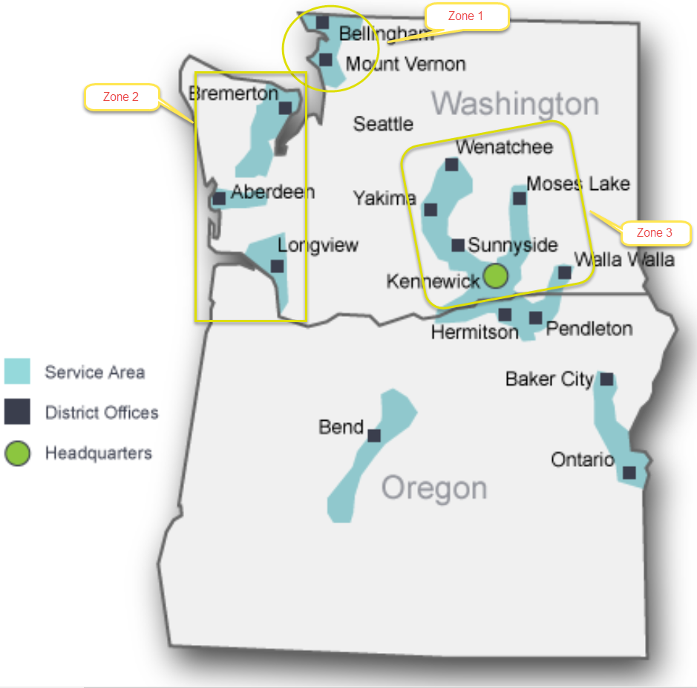

As noted for the first time, the Conservation Forecast was run at the climate zone level of granularity instead of at a state wide level, see Figure 2. By tailoring the inputs, each of the three climate zones was able to reflect its technical, economic and achievable potential individually. This allows program administrators to tailor outreach to specific, potentially underperforming areas, and mimic other areas’ successful marketing campaigns if they surpass their calculated potential.

Unique inputs include customer count and volume growth rate forecasts by customer class, (Residential, Commercial, and Industrial) as well as by avoided costs. All other factors were held constant across each climate zone’s scenario, such as the inflation rate, long term discount rate, load profile, transmission loss rate, cost effectiveness threshold, which measures were left at the 30% of incremental costs incentive levels or bumped to 50%, and the administrative levelized costs per therm by end use. All factors of the model, as well as other changes introduced for the first time in this year’s IRP, are discussed further in depth in the following Forward Looking Targets/TEA-Pot Forecasts section below.

The results of both the Residential and Commercial/Industrial Incentive Programs’ climate zone level potential are summarized in the following graphs.

Note, Climate Zone 3 contains the Industrial customer class’s highest potential. Large Industrial customers’ projects are not available every year, but when they are, they have a large impact on the Commercial & Industrial program’s annual achievements and full program portfolio’s cost effectiveness.

The Total CIP Forecasted Potential by Zone graph demonstrates Climate Zone 2’s lower potential compared to Climate Zones 1 and 3. The difference in potential can be tied to its significantly lower customer counts and volume inputs, which are partially offset by the lowest avoided costs in both the near and long term time horizons.

## Forward Looking Targets/ TEA-Pot Forecasts

As mentioned previously the method Cascade uses to calculate potential is the TEA-Pot modeling tool (developed in 2013/2014 by Nexant Inc.) The study’s analysis at the time was based on calendar year 2012 and tailored to Cascade’s distinct service territory.

The following section provides Cascade’s achievable forecast by climate zone and customer class as per TEA-Pot calculations from October 2016 for the 10 year horizon in Figures 3 through Figure 6.

**Figure 3**

**Zone 1 Achievable Conservation Forecast Potential by Customer Class**

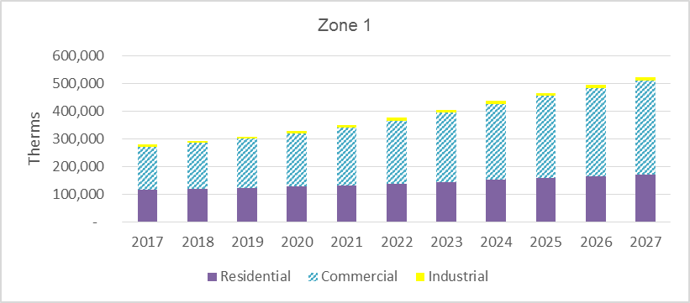

**Figure 4**

**Zone 2 Achievable Conservation Forecast Potential by Customer Class**

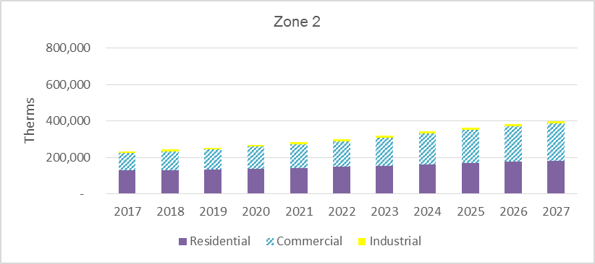

**Figure 5**

**Zone 3 Achievable Conservation Forecast Potential by Customer Class**

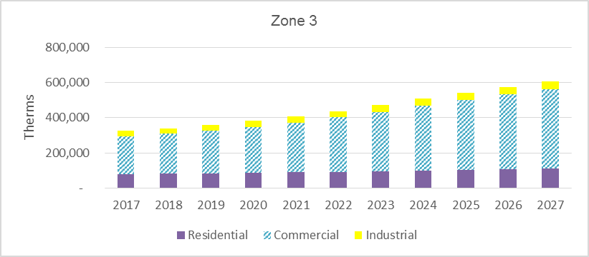

**Figure 6**

**Total CIP Forecasted Potential by Zone**

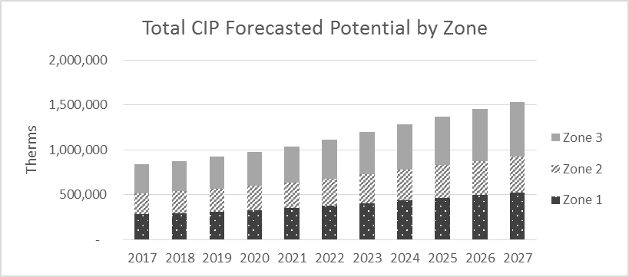

Cascade’s methodology has changed in two key ways along with the inclusion of the administrative costs in the model, and climate zone granularity. First, on both the Residential and the Commercial/Industrial programs, all measures from the study are used for all years of the time horizon. This methodology was implemented instead of past Commercial/Industrial forecast modeling where solely the prescriptive measures offered under the current tariff in place at the time of writing were included in the forecast. This new methodology accounts for capturing the savings inherent to the custom project sector more accurately, in addition to the prescriptive measure offerings, without applying a subjective percentage of custom project therm savings (based on historic performance) on top of the prescriptive savings estimate. On the Residential side, this allows for a full review of the cost-effectiveness measures available in the Nexant Study’s library to be considered for future changes to the menu of efficiency offerings.

Second, for both the Residential and Commercial/Industrial programs, measures deemed cost effective at the 50% level of incremental costs were run through the model at the higher incentive level. A higher incentive level yields a higher adoption curve because installation of the measure becomes more cost effective and thus more appealing to participants. In return, a higher level of potential therm savings becomes possible. A full list of included measures’ cost effectiveness and incentive levels by customer class at the original base 30% incentive level are available in *Appendix A*.

Below is a summary of the other model inputs, updated from the 2016 Conservation Plan:

* Inflation rate decreased from 2.00% to 1.00% and is in line with the remainder of the IRP. It was also applied to the Administrative Costs per levelized therm by end use, based on 2015 Annual Report achievements. Thus, the decrease in inflation rate helped decrease the long term Administrative Costs’ forecast, and brought down the overall costs needed to acquire therm savings, thereby increasing the Benefit-Cost ratios for measures to pass cost-effectiveness.
* Transmission Loss rate decreased from 0.1959% to 0.1348%
* Long Term Discount rate decreased from 4.17% to 3.52%, aligned with the rest of the IRP’s’ models. Note, the lower the long term discount rate, the higher the therm savings potential because future years’ therm savings’ avoided cost values are discounted less, and thus more of the avoided costs can be included, thereby allowing the Benefit-Cost ratios for measures to pass the 0.90 cost-effectiveness threshold for inclusion in the modeling run. This approach recognizes the value of long-lived conservation measures and the generational benefits of deep energy savings.
* Administrative Costs increasedto bring the Residential program administration in house, thereby increasing accuracy of reporting and improving control of the customers’ rebate processing experiences. It also allowed expansion of Commercial and Industrial CIP outreach. The 2017 budget was set at $550,000 for the Residential program and $1 million for the Commercial/Industrial to accommodate the additional outreach efforts. Note while this may appear to have a negative impact on the Benefit-Cost ratios for each measure, and raises the costs needed to acquire therm savings, it is necessary to accommodate higher therm savings goals.
* Avoided Costs were updated per Appendix H and divided by Climate Zone. It is important to note the higher the Avoided Costs, the higher the therm savings potential because Avoided Costs under the Utility Cost Test increase the Benefit-Cost ratio to allow more measures to be considered cost-effective. Conversely, the lower the avoided costs, the lower the therm savings potential forecasted.
* Load Profile system wide and Customers and Volume Forecasts, divided by Climate Zone, were updated per the Demand Forecast chapter.

Nexant’s model provides three levels of potential: Technical, Economic, and Achievable which are further defined below

* *Technical Potential*: An estimate of all energy savings that could theoretically be accomplished if every customer that could potentially install a conservation measure did so without consideration of market barriers such as cost and customer awareness.
* *Economic Potential*: The most efficient measures that pass economic screening tests and is a subset of Technical Potential. Because measures’ cost effectiveness differs by Climate Zone, market segmentation, and vintage, Cascade implements a 0.90 cost-effectiveness threshold in order to be able to include the largest breadth of measures feasible.
* *Achievable Potential:* Embodies a set of assumptions about the decisions consumers make regarding the efficiency of the equipment they purchase to simulate a realistic estimate of real-life conditions.

As mentioned in the previous section, the model was run individually by climate zone in order to provide increased granularity. The outcomes shown in that section are by climate zone, whereas the summary of the model’s output below combines Technical, Economic, and Achievable therm savings potentials, in addition to the past three years of program performance for perspective. Note, 2016 figures are not available at time of writing as the program year has not ended, January 1, 2016 through December 31, 2016. Further analysis and representations of these forecasts can be found in *Appendix A*.

**Figure 7**

**Technical, Economic, Achievable 20 year potential snapshot**

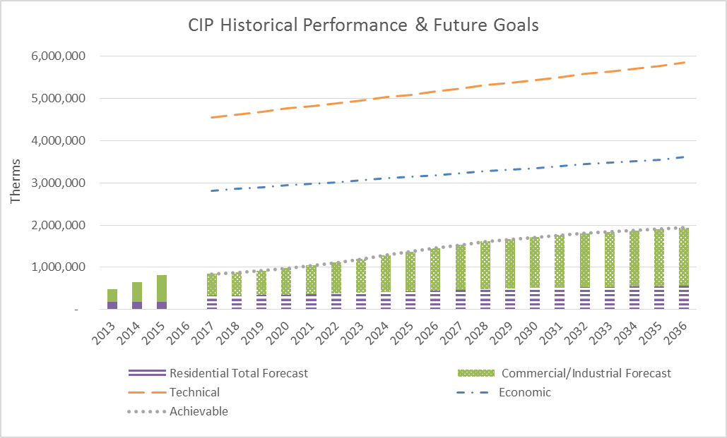

The Figure 7 line graph provides two separate lines denoting the savings potentials for Technical and Economic levels, followed by the Achievable Residential and Commercial /Industrial targets.

## CY 2017 & 2018 Targets

Cascade is providing targets the Company has reported for its conservation potential from the 2016 IRP in the following section (in review status at the time of writing of this Conservation Plan). The Company has included the most up to date Achievable goals as per the TEA-Pot model *inclusive* of administrative costs as aspirational goals for 2017 and 2018. These goals have been developed keeping in mind the alterations the Cascade program is currently implementing.

As mentioned, historically the Company tracked rebate submissions to the date the measure or upgrade was installed at the premise. CAG members requested the Company track via the date a rebate was paid rather than the install date method to reduce lag-time in reporting savings. The Company agreed to transition its program reporting which should make annual reporting more straightforward for the 2016 program’s Conservation Achievements Annual Report.

In the next two years the Company will continue to explore the cost-effectiveness of some of those measures included in the full Nexant review and not currently offered in its portfolio based on availability to the marketplace, administrative costs in implementing and a variety of other elements.

Note in the 2016 IRP, the Company included the full breadth of measures from Nexant’s model for CY 2017 & CY 2018. For 2017, based on the most recent TEA-Pot model and current program offerings, the on-the-ground realistic goal would be closer to 156,459 therms for Residential, with a total of 687,457 including Commercial. However if the Residential program offerings in 2017 were altered significantly to include all possible measures in the Residential portfolio (the Commercial program is slightly different as all measures are encompassed under the custom option category) the goal would be that which is included as the “official” goals noted in this Plan.

The Company is aware it is important to demonstrate the level of savings that could be achieved should the full breadth of offerings be included in the program portfolio throughout the 10 year plan horizon. It is also important to recognize the portfolio will likely change throughout the next two years to accommodate building codes and technology updates.

The following graph shows the next ten years’ worth of savings potential in Cascade’s territory based on customer type under all three potential levels.

**Figure 8**

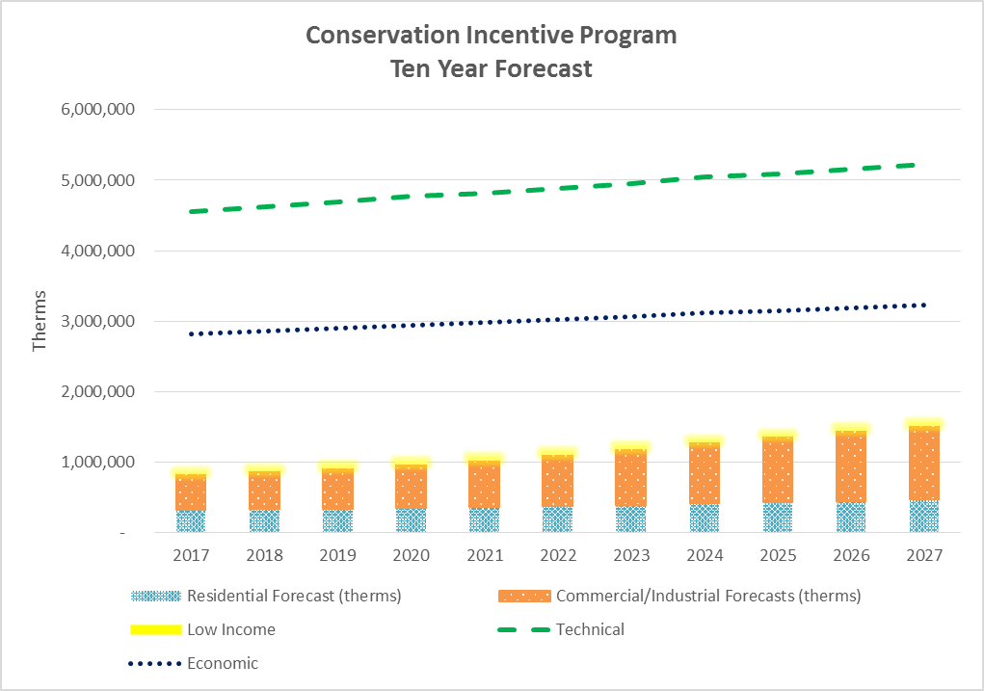

**Figure 9**

These projected achievements are based on the Company’s current best estimates of its Achievable potential, which are based on projected gas costs and the Nexant Potential study of viable natural gas measures. Projections are subject to modification dependent upon updated forecasts; knowledge of evolving efficiency technologies; customer interest and program participation levels; and updates based on external influences. Budgets for FY 2017 and 2018 are based commensurately with these targets and adjusted to ensure maintenance of cost-effectiveness and appropriate levelized costs. The Company anticipates the budget on a portfolio level for 2017 to be in the range of **$1.55 million** in administrative costs to support the increased goals for the residential program. FY 2018 is estimated to have a budget up to $**1.6 million**. The 2017 budget is in line with that which was released in the 2016 Conservation Plan. Administrative costs for FY 2017 are higher than those in previous years due to the transition of the Residential program processing to internal delivery, as well as the initial implementation fee for the new software platform (costs for this one-time software implementation will be accounted for separately in the annual report outside of the standard cost benefit analysis).

Note some of the set-up and development costs for the software package will be paid in 2017 as opposed to 2016 due to a lag in invoicing from delays in meeting delivery timelines. The Company also includes expected participation level costs for the five year NEEA pilot (total **$1,705,130**) as agreed upon in January, 2015. The Company lists these costs in the Annual Conservation Report and will represent the program’s cost-effectiveness primarily without the associated NEEA pilot efforts, but also with the costs included in the analysis to demonstrate its effect on cost-effectiveness on the program as a whole.

**Table 8**

**Cascade Natural Gas NEEA Natural Gas Market Transformation Pilot Participation**

|  |  |
| --- | --- |
| Year | Cascade’s Washington Commitment at 9.3% of total budget for 5 year pilot |
| 2015 | $145,872 |
| 2016 | $244,996 |
| 2017 | $313,174 |
| 2018 | $452,285 |
| 2019 | $548,803 |
| Total | $1,705,130 |

# Long term Conservation Potential

The Company provided a table of total CIP Forecasted therms for Residential, Commercial and Industrial efficiency gains from 2017-2036 in the 2016 IRP. Cascade is providing a clearer iteration of the incremental annual potential savings for this Conservation Plan for years 2017-2027 below.

**Table 9**

|  |  |  |  |  |  |  |  |
| --- | --- | --- | --- | --- | --- | --- | --- |
| **Total CIP Forecast 2017-2027** | | | | | | | |
| **Incremental Annual Energy Savings** | | | | | | | |
| **Year** | **Technical** | **Economic** | **Residential Achievable** | **Commercial/Industrial Achievable\*** | **Total Achievable** | **Low Income** | **Conservation Plan** |
| 2017 | 4,552,099 | 2,815,454 | 323,878 | 515,998 | 839,876 | 15,000 | 854,876 |
| 2018 | 4,622,799 | 2,858,324 | 331,357 | 545,217 | 876,574 | 15,000 | 891,574 |
| 2019 | 4,686,406 | 2,896,840 | 340,468 | 580,973 | 921,441 | 25,000 | 946,441 |
| 2020 | 4,769,664 | 2,948,056 | 352,843 | 626,755 | 979,599 | 25,000 | 1,004,599 |
| 2021 | 4,817,844 | 2,977,179 | 363,984 | 675,894 | 1,039,878 | 25,000 | 1,064,878 |
| 2022 | 4,886,307 | 3,018,791 | 378,657 | 735,221 | 1,113,877 | 25,000 | 1,138,877 |
| 2023 | 4,954,176 | 3,060,537 | 395,111 | 800,558 | 1,195,669 | 25,000 | 1,220,669 |
| 2024 | 5,044,322 | 3,115,644 | 414,680 | 872,792 | 1,287,472 | 25,000 | 1,312,472 |
| 2025 | 5,093,061 | 3,145,133 | 431,139 | 938,231 | 1,369,370 | 25,000 | 1,394,370 |
| 2026 | 5,163,110 | 3,187,846 | 449,272 | 1,004,324 | 1,453,596 | 25,000 | 1,478,596 |
| 2027 | 5,231,124 | 3,229,479 | 466,452 | 1,064,697 | 1,531,149 | 25,000 | 1,556,149 |

Note, short-term goals are more realistic when viewed in two-year increments since they allow flexibility in addressing current legislative, building code and budgeting criteria.

Many specific details are required to implement successful programs. As discussed above, the program potential, that which is based from actual implementation design, delivery, and market conditions, reflects some variance in savings, costs, and overall achievements. Customer participation in a program is heavily influenced by the level of incentive paid by the utility versus the cost to the customer.

External infrastructure considerations must also be addressed, such as product availability to utility customers and an adequate network of contractors, retailers, and trade allies to support a program. As new measures or expanded programs are developed and added to the current program mix, internal and external resources and capabilities need to grow accordingly and progress through a “learning curve.” Additionally, revised projections regarding the cost of natural gas and other external factors will always lead to needed revisions to the Company’s existing programs, and will result in additional impacts on the company’s projected participation levels.

# Planning and EM&V

The Company and its software vendor Nexant Inc. is continuing the process of customizing and building the iDSM Central platform for the Cascade residential programs including Low Income and iTrade Ally support. As part of the transition to internal program delivery, the Company researched ways to cost-effectively increase Evaluation, Measurement and Verification opportunities within the program reporting software platform. Nexant is committed as a partner in further developing the opportunities inherent in its software into Calendar year 2017. The following year will also provide the Company with the means to use the software to provide the tracking and groundwork for future EM&V efforts, potentially in conjunction with additional outside evaluations in future years when deemed necessary and not cost-prohibitive.

## Housing Stock Assessment Review from NEEA

One of the areas CAG stakeholders requested Cascade explore and incorporate into future efforts involves engaging further with NEEA in relation to their housing assessment reports. These reports encompass a snapshot of a specific building stock (Residential and Commercial) and have information relevant to natural gas service percentages throughout each of the years of the study. This will enable a view into trends amongst gas usage and gas equipment types. Although the reports do not have gas meter data they have been a key element of the NEEA efforts to understand the market potential in the region. The desire is for Cascade to work with NEEA staff to develop recommendations for exploring what else can be extrapolated specific to Cascade as a gas utility from the data to help in updates to the Company’s programs.

Cascade currently depends on its Nexant potential study from 2013-2014 to establish program potential (as that study was specifically intended to address Cascade’s territory), but sees an opportunity to further refine its approach to future program planning by including elements of the NEEA housing assessments from a regional perspective and in other areas where it might not have previously seen opportunities or needs.

The Company will engage in conversations with NEEA in 2017 to explore additional opportunities for leveraging this resource into its program planning methods.

# Outreach & Messaging Campaigns

The Company frequently reaches out to the public to notify rate payers of available incentives in order to drive uptake of the Conservation Incentive Programs – thereby reducing overall consumption of natural gas. The Company approaches its customer-facing energy efficiency messaging through an integrated marketing strategy - meaning multiple marketing methods or avenues are used to deliver a single (unified) message.

This method utilizes a consistent message that is reinforced frequently to increase brand awareness of the Cascade CIP to natural gas customers. In addition to the integrated marketing approach, the Company is also employing a cross channel marketing practice whereby the customer not only receives messaging via various mediums, but can also use the medium which they are most comfortable with to, in turn, interact with Cascade’s programs. The Company does not employ all possible channels by which it could reach customers since marketing can be a costly endeavor, but rather is strategic in its approach to focus on marketing channels that take advantage of synergies in the avenues traditionally employed. The Company leverages existing partnerships and communication channels and adds new opportunities as they arise to keep its energy efficiency message useful, low-profile (yet impactful) and natural in its placement.

The marketing world is rapidly changing with additional technology and social media opportunities. The Company’s CIP has traditionally centered on known messaging opportunities but is poised in the next year or two to move further into the digital and social media realm to reach rate payers through additional media channels – always keeping the integrated message in mind.

Current examples of avenues customers can use to gain information or interact with the program include using the internet as a resource for information about the programs through the [www.cngc.com/conservation](http://www.cngc.com/conservation) website, applying to receive a residential rebate through a customer portal <https://cngc.dsmcentral.com/traksmart4/public/registration.do>, sending in a hard copy application through the mail, contacting the program via phone or email and direct one-on-one interactions during an event at which program staff present.

In turn, the Company has multiple avenues in place to deliver program messaging including bill inserts to existing customers, radio advertising, event participation, community engagement and program material inclusion in external publications as well as targeting specific audiences for that message. With the increased goals comes a need to increase outreach and messaging to those key audiences.

A messaging campaign includes elements of consistency for brand awareness with a key focus on the Conservation Incentive Programs offered through Cascade as a standard go-to for high-efficiency options to assist with offsetting the cost of higher-performance upgrades.

Cascade’s messages and print material are tailored to the intended audience. Examples of potential audiences include residential, commercial, construction industry, real-estate and the financial or loan industry.

## Community Participation - A Key to Program Longevity and Support

One area Cascade has repeatedly found essential to increased program participation and awareness is involvement with local community energy efforts and programs. The Company has long followed the motto *‘”In the Community to Serve”* which is strongly reinforced through the offerings provided through the Energy-Efficiency and Community Outreach Department. Energy program efforts outside of the utility programs are often a valuable resource for the utility to leverage in order to reach a new audience while reinforcing the same efficiency message to audiences the Company has targeted in the past.

The following discussion highlights some of the community groups and areas the Company will continue to partner with and message through:

On an annual basis Cascade partners with community energy programs including Sustainable Connections and the Community Energy Challenge in Whatcom and Skagit County and the Sustainable Living Center in Walla Walla. The Company provides funds to assist with delivery of its program information and pave the way for additional customers to apply for (and qualify for) rebates while working through the local auditors and the Community Energy Efficiency Programs (CEEP) where available. The CEEP were created by the Washington State Legislature in 2009 and administered by the Washington State University Extension Energy Program. The funds were used to help deliver energy efficiency upgrades to targeted customers throughout Washington State – both homeowners and small businesses alike. Funding for the program participants originated with the U.S. Department of Energy’s State Energy Program and the American Recovery and Reinvestment Act. Once the pilot efforts had wrapped up additional funding was provided to the organizations to leverage already existing community investment. See *Appendix B* for copies of the sponsorship letter agreements between the Company and Sustainable Connections, Community Energy Challenge and the Sustainable Living Center which list out the benefits of partnering with the agencies for their energy use reduction collaborative efforts.

These CEEP funded organizations have been creative in the methods used to help customers reduce usage – ranging from performing energy audits, suggesting energy-saving efforts, leveraging utility rebates, creating and maintaining Trade Ally networks of qualified contractors and providing additional rebates on top of the existing utility sponsored rebates. In each of these situations, the CEEP group has been an integral partner with the utility in providing personal interactions with community members to help them apply, and more importantly, qualify for the rebate program. In many situations the community organization has helped make the final push to encourage the customer to go with the higher-efficiency options by providing an in-depth understanding of how the different elements of the home affect their comfort, health and overall energy use. Having the ability to partner with local organizations whose efforts include reaching out and performing these services has proved immensely beneficial to all parties in the equation. If a customer can look at their energy use on a whole home basis as opposed to a one-off upgrade approach the overall reduction and potential for repeat efforts increases dramatically.

The Company has spent the past several years working with four towns within its service territory, three of which are in Washington, in their community wide effort to reduce energy use in the residential and municipal realm. Walla Walla, Bellingham and Anacortes engaged in the Georgetown University Energy Prize (GUEP) Competition an effort to encourage local governments and utilities to work with their communities to develop and implement plans for replicable, innovative, scalable and consistent reductions in natural gas and electric consumption. Three areas of import for the prize include:

* Spurring innovative approaches for communities to decrease their per-capita energy usage;
* Highlighting best practices for communities working with utilities, businesses, and their local governments to create and implement inventive plans for sustained energy efficiency;
* Educate the public and engage students in energy efficiency issues including methods, benefits and the environmental costs of the full fuel cycle.

Support from the Company has taken the form of assisting the GUEP with developing best practices in data tracking from a utility perspective, providing quality aggregate data downloads to track reductions in the participating towns and providing miscellaneous assistance as requested to the cities in the variety of activities and events they have engaged in within the communities to promote the efforts. The competition timeframe concludes at the end of 2016, however final evaluation and data management will continue into 2017. As part of the support the Company has provided to communities participating in these efforts, a joint bill insert was released to the four towns in Cascade’s territory in 2015 and 2016 (see *Appendix B* for reference.) The Company has also provided a copy of a coloring book cover that was tailored to efficiency messaging for local students interested in energy-efficiency which can be viewed in the *Appendix B.* Note the remainder of the coloring book includes low-cost/no-cost tips for children to reduce their energy use.

Cascade has also found great value in coordinating with the Western Washington University Institute for Energy Studies. This partnership has grown for the past two years and has been an excellent opportunity for Cascade to provide support to the Sustainability efforts on the Campus with information about its Energy-Efficiency programs, tabling at events as they arise and providing guest lectures about demand side management and associated efficiency programs for multiple classes at the university including a Business of Energy and an Energy Policy class in support of the Energy Policy and Management major as well as the Energy Policy minor.

Company representatives are also involved in a Women in Energy Mentoring Network (WIEMN) which meets on a monthly basis and provides students an opportunity to talk to professionals throughout the industry about various energy topics including efficiency and renewable resources. Its goal is to develop leadership skills in students while maintaining diversity in energy studies and the energy industry through the support and feedback of professionals.

In 2015 Cascade partnered with other utilities in the Tri-Cities area to provide an Energy Experience to local junior high students. The event’s goal was to target middle school students and educate them about energy generation, production, safety, efficiency and conservation. Participation by Cascade helped increase awareness of natural gas as a source of energy in the home and how it is used, and in turn how it could be conserved. It also provided an opportunity to talk about the Cascade rebate program in terms of rebates, home energy consumption, and the importance of understanding how a home performs and can be audited, see *Appendix B* for a copy of the flyer developed for the outreach event to students. The event is slated to occur again in 2017 with the Company planning to continue participation.

In accordance with the Company’s integrated marketing efforts Cascade has also branched out to its customers through an alternative messaging venue from standard energy efficiency focused events in the community. During the spring and summer season for the past two years the energy efficiency department has worked closely with the safety department on a joint message. The groups will continue outreach of this nature in future years, although the final format will be determined based on discussions with the advertisers and team. A messaging campaign was provided during the Walla Walla Sweets baseball team and Yakima Pippins baseball team seasons for the Company to provide information about natural gas safety going hand-in-hand with efficient use of natural gas. See *Appendix B* for a copy of a handout provided to all attendees at the games as well an image of one of the signs at the fields. Overall program impressions at one of the fields was up to 1,300 fans viewing the messaging each night throughout the season, and at the other field 41,255 fans attended games this season. The campaign included the following elements:

* Either a 3’x4’ poster at the stadium entrance or a 12’x8’ outfield sign
* In-game promotion of safe digging (811 promotion) - (*please note costs for this element of the messaging were not covered through deferred funds*)
* 30 second video board commercial during Yakima game
* 30 second radio commercial per game
* 3 tabling nights at each field with distribution of up to 600 efficiency flyers per game
* Web-button linking to CNGC and the efficiency programs from the team’s website

Energy efficiency messaging is also provided when requested for support of District Office community engagement efforts including the items from Longview’s outreach during sporting events in *Appendix B* from 2016.

In the coming year, Cascade also plans to create Spanish language messaging and forms to ensure the Company is engaging more fully with the Latino community in energy efficiency education and awareness.

## Residential Focus

The Company takes advantage of the opportunity to message to its customers on the energy efficiency programs whenever possible and cost effective. One such example includes the monthly energy efficiency bill insert sent to all core customers which is sent to customers receiving utility bills in both an electronic and hard copy form. This venue continues to be a viable and consistent format for providing efficiency messaging and updates to customers on program offerings. See *Appendix B* for samples of inserts sent during CY 2016. The bill inserts are generally residential customer focused as it’s important for the decision makers in the home to receive the messaging. Having said that, the Company has also referenced its commercial program offerings in bill inserts on occasion and has received follow-up from customers based on the information in the piece.

Local Home Builders Associations provide another strong partnership opportunity for energy efficiency messaging. These organizations play an integral part with local contractors and the new home industry to promote higher-efficiency equipment use and efficient building practices, including Built Green® certification. The Company attends Built Green meetings and events as available to further encourage uptake of program offerings and higher-efficiency natural gas investment from builders at the time when decisions are being made. HBAs commonly message to new home buyers and those interested in renovating their existing homes – which in turn, provides the Company with a premier opportunity for outreach during an association’s Home and Garden Shows and Home Tours. During these events, the Company often places advertisements in event directories and at the homes themselves (see *Appendix B*). The Company will also attend such events in person to speak with customers and support local Trade Ally Contractors by providing program materials and rebate information for distribution to attendees. These efforts will continue into 2017 and 2018 with the Tri-Cities HBA, Central Washington HBA, Skagit/Island County HBA, Home Builders Association of Whatcom County and others as deemed appropriate. Note – in Longview the Company has also provided ad placements in the Lower Columbia Contractor’s Association Directory which meets many of the same messaging opportunities as coordinating with the HBAs (See Appendix B for ad placements from 2016).

The real-estate industry also poses a unique opportunity for Company representatives to provide information about energy-efficiency offerings to an audience that is poised to help home buyers make wise decisions on future energy consumption in their homes. Informing real-estate agents of available rebates and the impact energy choices can make to a home’s energy costs during the lifespan of the measure is important to start the purchaser on an energy efficient path as early as possible. The Company has attended Association of Realtor meetings in the past and will seek additional opportunities to increase outreach to this group throughout 2017 and into 2018.

As the home owner/buyer is most frequently the decision maker in efficiency upgrade situations it’s also an opportunity for the Company to provide information to the industry helping home buyers with their purchase – i.e. the financial or loan industry. The Company recognizes that one of the main barriers to installing higher-efficiency equipment in existing homes and businesses is the initial higher costs. If the Company is able to get information about rebates into the hands of those making the purchasing decisions it helps them be more informed about their options and possibly accommodate the additional higher costs at the time funding is being discussed and made available. Cascade will research opportunities for outreach to this industry in 2017 and increase its efforts accordingly into 2018.

The Company relies heavily on coordination with local area contractors to encourage uptake of its conservation programs. Contractors are on site with the customer, in their home, helping them make the decision to install either standard or high-efficiency appliances. Since contractors play such an integral role in the customer experience and decision making process the Company therefore maintains a robust Trade Ally (TA) network and encourages these contractors to promote higher-efficiency natural gas equipment. The TA network also enables the Company to confirm the majority of installations performed as part of the CIP conforms to industry best practices meaning the install meets expectations and results in anticipated energy savings.

As part of the residential transition to internal program implementation, Trade Ally management is now being handled directly by Cascade staff. This gives the Company the ability to interface directly with the contractors should questions or concerns arise. The Company also sends periodic newsletters and emails to the contractors addressing pertinent aspects of the program including updates, quality control issues, highlighting best practices and case studies, etc. The Company also provides a range of Trade Ally benefits to encourage active sales of higher-efficiency natural gas equipment and measures. See *Appendix B* for an example of a trade ally bonus coupon, which provides an additional incentive to customers working directly through a qualified TA. These coupons must be submitted by a customer in conjunction with a qualifying rebate application whereupon funds are distributed directly to the customer. The TA program also provides limited cooperative marketing funding for Trade Allies along with reimbursement monies for trainings relevant to working with homes served by natural gas.

## Low Income messaging opportunities

With the revision of the LI-WIP programs there will be opportunities for additional messaging to customers and the Agencies. The Company will continue to work hand-in-hand with the Agencies to encourage uptake of the programs and may also use bill inserts to generate greater program awareness in select areas, or other strategies at the request of the Company’s weatherization partners including public facing advertising as deemed appropriate and cost-effective.

## Commercial Focus

In addition to the Company’s residential outreach efforts, Cascade also tailors messaging to Commercial and Industrial customers. Outreach efforts for these customers in the past were tailored to one-on-one customer engagement and have since blossomed to a more robust effort in accordance with the cross-channel marketing mentioned earlier. For the past several years, Cascade has been a sponsor at the Northwest Food Processors Association Energy Summit. This sponsorship gives program representatives a unique opportunity to discuss conservation options in person and provide information directly to industrial customers who can otherwise be difficult to reach.

The Company also sponsored the 2016 Washington Energy Future Conference where we displayed messaging about the program in the directory. This event plays a key role in promoting energy efficiency throughout the state to industry decision makers and the general public. See *Appendix B* for a sample of the ad.

Additionally, the Company has posted a standee at the Columbia Center Mall tailored to both residential and small commercial business owners, encouraging these customers to consider efficiency in the business and purchasing decisions they make. See *Appendix B*.

The Company regularly attends and tables at Chamber of Commerce events including annual meetings, business expos and monthly meetings to distribute commercial/industrial messaging, and will continue to do so in the following years as opportunities arise.

In 2016, Lockheed Martin, the Company’s Commercial program implementation vendor increased its outreach efforts on behalf of the Cascade CIP and is positioned to continue to further increase these efforts into 2017. The Lockheed team attends and tables at events as needed to provide information about Commercial and Industrial program offerings and requirements. They have also reached out to local Chambers and directories to display advertisements to further increase interest in rebates. Lockheed has identified multiple opportunities to highlight customer achievements by providing case studies and public check presentations to increase awareness and excitement about commercial natural gas upgrades. See *Appendix B* for sample

The program will continue to move forward with its outreach strategy into 2017. The Cascade team will also work with Lockheed to develop a more robust second tier of commercially focused trade allies who can serve the same role as the residential program in helping customers move toward higher-efficiency options.

1. Washington Utilities and Transportation Docket UG-121207 – Policy Statement on the Evaluation of the Cost-Effectiveness of Natural Gas Conservation Programs pg. 14-15
2. To review the full study referenced in this section see:

   Nexant, Inc. (February 25.2014). Cascade Natural Gas Corporation, Assessment of Achievable Potential & Program Evaluation Volume 1: Executive Summary, Volume 2: Assessment of Achievable Potential & Program Evaluation, Volume 3: Appendices
3. Washington Utilities and Transportation Commission Docket UG-152286 Order 4, Final Order Approving Settlement Agreement. Page 3-4