|  |  |
| --- | --- |
| natural gas Utility Hedging practices and Regulatory oversight  An Inquiry into Local Natural Gas Distribution Companies' Hedging Practices and Transaction Reporting  July 2015  Docket UG-132019 | Prepared for  The Washington Utilities and Transportation Commission  By Michael Gettings  Senior Partner  RiskCentrix, LLC |
|  |  |

**Author**

Michael Gettings, Senior Partner

RiskCentrix, LLC

**Collaborative Partners**

Danny Kermode, CPA, Senior Energy Policy Advisor

Washington Utilities and Transportation Commission

Lisa W. Gafken, Assistant Attorney General

Mary M. Kimball, MPP, Senior Regulatory Analyst

Washington State Office of the Attorney General, Public Counsel Unit

Table of Contents

Executive Summary 2

Introduction 5

Background 6

Quantitative Finance, Overview and Origins 8

Overview of Energy Hedging Approaches 9

Essential Questions 10

Why Hedge? 10

What Objectives? 11

Economic Effectiveness 15

Regulatory Framework 15

Contrasting Approaches 16

Fixed Ratio 16

Risk‑Responsive Hedging 16

Clear Understanding of the Nature of Risk and Risk Assessment 17

Strategy Development 19

Illustrative Strategy Comparisons 23

Simulation Clarifications 26

Simulation Results 26

Regulatory Choices 29

Supportive Regulatory Environment 29

Prudence Standards and Reporting Needs 30

Standards for Review 33

Schedule of Adoption 35

Closing Comments 35

# **Appendix**

Appendix A: Commission Staff Report - Attachment B (March 1, 2013).

Appendix B: Notice of Opportunity to File Written Comments (December 18, 2013).

Appendix C: Comments of Michael A. Gettings, RiskCentrix (January 13, 2014).

# **Executive Summary**

In January 2014, the Washington Utilities and Transportation Commission (commission) held a workshop to discuss with stakeholders the hedging practices of natural gas local distribution companies (LDCs) and the regulation of those hedging practices. While there seems to be consensus in this docket about whether utilities should hedge, further discussion is necessary regarding regulatory policies and effective frameworks for robust hedge practices. This white paper provides an exploration of key issues geared toward stimulating that discussion.

There are three issues that will likely determine the course of hedging programs and regulatory treatment in the future, and this paper offers approaches to each. A brief synopsis of each issue is presented below.

**Hedge-strategy objectives**

Any risk management program’s objective is, by definition, to manage risk. When managing commodity price risk, efforts to constrain only cost outcomes typically increase the risk of hedge losses.[1] In other words, risk is polar, presenting both the risk of upside cost movement and the risk of a downside hedging loss. Since risk is polar, objectives should balance the mitigation of potential costs against hedge‑loss potential by identifying a company’s upside cost tolerance as well as its hedge-loss tolerance. Further, because risk conditions vary radically and continuously, objectives must be monitored routinely to ensure high confidence in tolerable cost and loss outcomes. Historically, investor-owned utilities have chosen to implement “lock-and-leave” hedging programs that identify the percentage of purchases to be hedged, but do not identify cost or loss tolerances. The management of dual, competing tolerances discussed in this paper constitutes a major change from simple volatility‑reduction objectives that are prevalent today, and therefore, hedging methodologies must change accordingly.

**Effective frameworks**

To move toward a more robust approach, it is important to measure risk. By measuring risk, a utility will know when its cost-tolerance and loss-tolerance are in danger of being breached and may react accordingly. The principles of quantitative finance offer the ability to quantify and monitor risk on a daily or weekly basis. Value at Risk (VaR) is an effective tool that companies may deploy to measure the risk of breaching cost boundaries or hedge-loss boundaries. A framework for the deployment of VaR metrics, and the development of risk-responsive hedge strategies will be described in some detail in this paper, including the use of a simulation to demonstrate how the strategies would work under certain market scenarios.

**Regulatory Policies and hedging strategies**

Prudence-risk – the risk incurred by regulated utilities that costs may be found imprudent and not allowed for recovery from ratepayers – is a necessary component of economic regulation. Prudence-risk is reasonable and necessary to protect ratepayers because regulated utilities operate in monopoly markets that do not provide competitive checks and balances. However, prudence-risk may be the principal reason that investor-owned utilities have been slow to adopt quantitative finance methodologies. Specifically, these utilities protect their shareholders from undue prudence-risk by using programmatic lock-and-leave hedging techniques.

The development of regulatory policy, which defines a framework and assessment criteria for utility hedge strategies, would provide greater clarity as to fair and predictable prudence standards. Further, establishing a process by which each utility would articulate its risk management strategies to the regulator, and establishing reporting requirements to facilitate regulatory review of the execution of those strategies, would foster better outcomes for both utilities and ratepayers.

Hedging practices are complex, therefore, a common understanding of terms is essential. This paper includes a detailed discussion of risk metrics, hedge decision-types, and the elements of strategy formation that should assist in defining the necessary language.

This paper also includes a discussion of strategy assessment criteria and explores the differences between two illustrative approaches. The discussion will assist in defining the strategy assessment criteria, which will be explored further by stakeholders during upcoming proceedings conducted under Docket UG-132019.

Defining prudence standards and reporting requirements will allow utilities to further develop their current hedging programs while facilitating regulatory review. Prudence standards should look at strategy formation and execution. The resulting data would be used to file annual reports summarizing the risk metrics and hedge responses. This paper includes an outline of what such a report might look like.

Hedge outcomes should fall within tolerances, except when market conditions are more extreme than design standards, or when the hedge ratios have reached the maximum under the utility’s policies. Outcomes that fall within tolerances should carry an assumption of prudence barring material irregularities. For outcomes that fall outside of tolerances, utilities will need to demonstrate extreme market conditions or constraints of the maximum hedge accumulation to show prudence.

# **Introduction**

In January 2014, the Washington Utilities and Transportation Commission held a workshop to discuss regulatory oversight of natural gas company hedging practices. All four of Washington’s LDCs participated in the discussion, along with the commissioners and staff, the Public Counsel Unit of the Washington Attorney General’s Office (Public Counsel), and other stakeholders. The workshop highlighted prospects for meaningful improvements in hedging practices. This paper has been written and published to initiate a comprehensive follow-up discussion of how local natural gas utilities might implement more robust hedging strategies, and to explore the regulatory policies that could facilitate beneficial changes.

The commission and Public Counsel retained the author to prepare this paper and to participate in Docket UG-132019, the commission’s investigation into the regulation of natural gas company hedging practices. This paper is not a policy statement by the commission, but rather serves to stimulate discussions with Washington’s LDCs and other stakeholders. It may also inform the commission’s policy decision-making.[2]

In this paper, the phrase “more robust” describes strategies that work effectively across a broad range of market conditions. The goal is to attain results consistent with clearly articulated risk tolerances in the face of sometimes dramatic price peaks and troughs, like those experienced around 2005 and 2008, when gas prices rose dramatically and then fell precipitously.

The paper explores the following areas:

* Is hedging a beneficial activity?
* What are appropriate hedge-strategy objectives?
* What is the status quo with regard to utility hedging programs?
* Is there an effective framework for a more robust approach?
* How do regulatory policies influence hedging strategies?
* What are typical utility concerns in adopting hedge‑strategy changes?
* What kind of change in regulatory approach could be beneficial?

The purpose of this paper is to stimulate a discussion among stakeholders aimed at facilitating a favorable environment to promote excellence in hedging. There are no definitive conclusions with respect to implementing a prescribed approach. On the other hand, the concepts discussed, while complex, are well accepted, so the paper is written in a manner that minimizes ambiguities. Readers should recognize that while the language is often definitive, it is intended to be a seed for discussion rather than conclusive.

# Background

The price of natural gas experienced unprecedented extreme peaks and troughs in recent decades. Natural gas prices are typically viewed in two parts: the supply component (e.g., NYMEX prices referenced at Henry Hub in Louisiana); and the “basis” component which captures the cost differentials attributable to transportation and congestion. Basis differentials are local and unique for each region, so to facilitate a common perspective, the discussion here will focus solely on the supply component (“NYMEX”) because it is universally applicable. Hedge programs typically manage the risk of both components, as they should, and the principles described here can be applied to both components provided market liquidity is sufficient.

Focusing only on the NYMEX component, monthly closing prices have ranged from under $2 per MMBtu[3] to more than $15 per MMBtu. Peak prices are about 800 percent of trough prices. Daily prices are even more volatile and basis values are more volatile still. Figure 1 shows a chart of NYMEX monthly closing prices over the last 25 years.

**Figure 1: Monthly NYMEX Prices Since 1990**

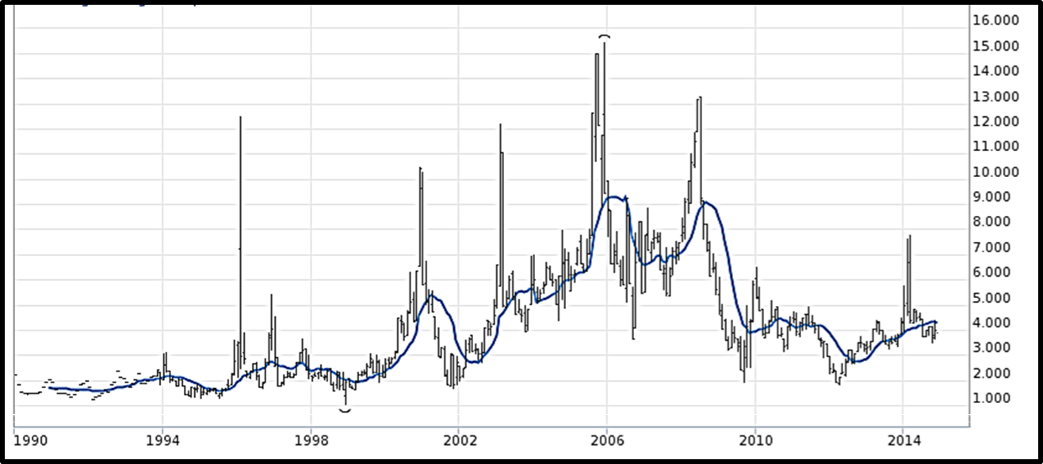

The smoothed blue line in Figure 1 indicates the 12-month rolling average which is probably more reflective of utility pass‑through costs if smoothing mechanisms are deployed.

A few other observations are informative:

1. Price volatility is not a recent phenomenon. Price spikes occurred in every decade since the advent of the NYMEX contract in 1991.
2. Extreme increases and decreases often occur over relatively short time periods. During the decade beginning in 2000, there were four separate price spikes, each followed by a dramatic collapse in prices.
3. Even with a twelve-month smoothing, prices ranged from more than $9 to less than $3 per MMBtu.
4. Price peaks tend to last three to six months, while price troughs tend to last a few years.
5. Since 2000, the average price has been about $5.20 per MMBtu. A utility that bought gas at prevailing market prices over that period would have passed through dramatic price swings. On the other hand, a utility that contracted for $5.20 gas would have “saved” about $4 in some year-long periods and experienced “losses” from non-competitive cost differentials in excess of $2 in other periods of greater duration.

The implications of these price properties will be discussed in some detail later, but are simply provided as background for now.

Historically, price variations have produced material consequences for utility customers. In a March 2013 report, commission staff commented on individual company results, stating:

The net losses on a system basis from financial hedges during the survey period range from a low of $680,000 to a high of $157 million. The net losses over a 10 year period range from a low of $18 million to a high of $695 million. One hundred percent of Washington’s share of these net losses has been passed on to ratepayers in prior PGA filings.[4]

The report indicates aggregate hedge losses from November 2002 through October 2012 were approximately $1.15 billion, on a system basis, for the four LDCs serving Washington consumers.[5]

It should be noted that the report’s examination period ending date of October 2012 coincides closely with a historical low point for market prices which followed the extreme price peaks of 2005 and 2008, as shown in Figure 1. Had the same analysis been performed in 2005 or 2008, it probably would have shown substantial “savings” had fixed-ratio hedging strategies been deployed for the periods leading to those price peaks.

As a follow up to the staff report, the commission published a *Notice of Opportunity to File Written Comments* under Docket UG-132019 on December 18, 2013.[6] In addition, it provided a *Notice of Workshop* to be held on January 23, 2014. This notice posed several questions to stakeholders, which are summarized below:

|  |  |
| --- | --- |
| * What is the purpose of hedging? * Who should benefit? * What is appropriate as to time horizon and hedge ratio? * What factors affect the amount of hedges? * If it chooses to, by what means should the Commission act? | * Should the Commission consider an incentive mechanism? * Is a benchmarking model feasible? * How might PGA mechanisms be affected? * Should a uniform reporting standard be considered? |

Comments were filed by various parties including utilities, Public Counsel, and various energy users. Without specific attribution, comments generally supported hedging as a means of gaining some degree of price stability, price certainty, and even some predictability for budgeting purposes. There was general agreement that the beneficiaries were gas users and that costs should be borne accordingly. There was little appetite for a prescribed strategy, incentive mechanism, or a one-size-fits-all benchmark. Comments cited the need to recognize the individual characteristics of each utility.

The workshop in Olympia, Washington, on January 23, 2014, elicited broad participation, and facilitated a deeper discussion of the questions posed by the commission. Participants included the commissioners, commission staff, Public Counsel, utility management, energy users, Ken Costello of the National Regulatory Research Institute, and Michael Gettings of RiskCentrix. Danny Kermode, a senior energy policy advisor for the commission, facilitated the meeting. The discussions focused substantially on a framework for viewing hedge strategy formulation and hedge results, as well as the goals and consequences of regulatory policies, and how they might be formulated in the future. The concepts discussed at the Olympia workshop serve as the basis for this white paper and the next workshop to follow.

# Quantitative Finance, Overview and Origins

As this paper develops, the term “quantitative finance” will be used extensively, so a bit of background might be helpful prior to a deeper discussion. In 1989, JP Morgan developed risk metrics and quantitative methods to manage its own financial risk. In the early 1990s it published the methodology and various enhancements for use by the marketplace via RiskMetrics.[7] Key concepts from those works have become risk-industry standards for management of financial risk in volatile markets. Natural gas markets are a natural fit for use of quantitative finance tools to manage risk because the volatility of natural gas prices is very high and the dollars at risk are substantial. These quantitative finance methodologies are taught in most top university financial programs and deployed in most companies facing volatile price or cost factors in their core businesses.

These methods were adopted by energy traders in the mid 1990s, after the advent of the New York Mercantile Exchange (NYMEX) natural gas futures contract in 1991, to deal with the newly deregulated markets and newfound price volatility.[8]

In the risk management field, quantitative finance involves the quantification of statistical parameters, particularly price volatility, to measure risk and design effective hedging strategies. These parameters are then used to monitor risk and make hedging decisions in accordance with the selected strategy.

# Overview of Energy Hedging Approaches

Adoption of a risk management approach tends to be determined by the market environment, core expertise, and the regulatory environment of different industry segments. This paper addresses risk management programs that deal with energy‑price risk and contrasts the following industry segments:

1. Banks and other large counterparties;
2. Merchant energy companies; and
3. Utilities in three subcategories:
   1. Investor-owned regulated utilities;
   2. Investor-owned utilities’ non-regulated merchant subsidiaries; and
   3. Public (quasi-governmental) utilities.

With regard to the respective market environments, all segments deal with natural gas, electricity, or both. The prices of these commodities are extremely volatile and comprise a material portion of these firms’ risk profile. In some cases, energy risk influences financial results directly, but for regulated utilities, the impact is often indirect, impacting customer satisfaction, company reputation, regulatory treatment, and financial results. For these reasons, one might expect energy‑price risk management to be a core or near‑core competency for all of these industry segments.

Clearly, banks and other counterparty firms view risk management as a core competency. In fact, quantitative finance methods and the reporting of risk metrics are typically mandated by financial regulators. Similarly, most energy companies operating in a merchant capacity deploy quantitative finance methods to manage exposures unless somehow they have been able to fix contractually the elements of both cost and income.

Yet, investor‑owned regulated utilities generally have been slow to adopt these methods. The reasons may be due essentially to the regulatory implications of adopting complex methods with potentially large financial implications. There is substantial inferential evidence of this reasoning when contrasting the three utility subcategories.

Regulated utilities deal with the same highly volatile energy markets, but typically choose not to develop a core expertise in managing those risks. It is not unusual for regulated investor-owned utilities (IOUs) to simply choose to hedge some fixed percentage of requirements, and never perform quantitative measurements of the exposures which their decisions entail. The situation is quite different for energy merchant operations and for public/quasi-governmental utilities.

For example, companies with large unregulated merchant power generation, or trading arms, typically deploy a reasonably sophisticated basket of quantitative finance tools even when their operations fall under a utility parent or within a common holding company. Like other merchants, this would not be true if they fix contractually the elements of both cost and income; for example, a marketing subsidiary might mandate that all sales be simultaneously backed with a matching supply contract.

Regulated IOUs are unlike their public sector neighbors which, like the energy merchants, often deploy very sophisticated quantitative finance methods in managing energy price risk. Although each type of energy provider is similar in many ways, the regulatory structure is plainly different. Public entities are typically regulated by their own governmental board – an elected or appointed board of directors or city council, for example. Such a structure may make it easier to reach a compact with regulators over risks, methods, and potential consequences. Merchants have no economic regulators; rather they have shareholders who demand sophisticated risk management. Without it, they or their investors will simply invest in a company that does.

It appears that regulatory prudence risk is the dominant differentiating factor for those companies that do not adopt the more sophisticated risk management methods. Indeed, the regulatory environment may be a material impediment to the deployment of the more effective risk mitigation methods. The current rulemaking proceeding provides an excellent opportunity to identify improved methods, and propose a regulatory environment that encourages them.

# Essential Questions

## Why Hedge?

To examine hedging properly, one must ask: (1) should utilities be hedging? If yes, then two further questions arise: (2) what are appropriate objectives; and (3) what methodology would produce superior economic outcomes?

We should first address the question of whether utilities should be hedging. Does hedging constitute the right thing to do? In their comments to this rulemaking, most respondents indicated that hedging was a beneficial endeavor because price (or cost) stability was of value to customers. Michael Gettings, on behalf of the Attorney General’s Office, stated:

“The reason for hedging is to reduce customer pain in severe upside markets and thereby create marginal utility for customers. Customers derive greater value from upside cost mitigation than they forego from hedge losses because upside cost outcomes tend to require them to make painful adjustments relative to prior expectations, but hedge losses, while still painful, occur in declining markets when the net costs are more favorable than prior expectations, thus moderating the pain. This statement is not meant to understate the real value foregone by high cost hedges; it is meant to put a proper perspective on the relative pain associated with whatever unfavorable outcomes are realized. Unless hedges are always made at market troughs, there will always be some degree of unfavorable outcomes relative to retrospective opportunities. Similarly, customers’ pain response is not linear. Radical cost increases are disproportionately painful when compared to modest year-to-year changes.”[9]

Figure 1 above showed historical price variations and observed that 12-month rolling price extremes deviated from the average by about $4 to the upside, but only about $2 to the downside. Price peaks tend to last three to six months, while price troughs tend to last longer. In other words, low price environments are more usual but more moderate, while high price environments tend to be more temporary but more radical. The combination of this asymmetrical price behavior with the customers’ asymmetrical and non-linear sensitivity to cost variations creates a powerful case for hedging programs.

## What Objectives?

Before discussing objectives, another illustration of price risk would be helpful, this time from a forward-looking perspective. Rather than looking at historical outcomes, we assume the perspective of a hedge manager assessing the prospects for possible price outcomes one year from now. The graph in Figure 1-A shows a typical risk distribution for gas prices that might prevail one year from now if today’s NYMEX price were $4/MMBtu and volatility were measured at 50 percent.

**Figure 1-A: Typical Price Risk Distribution**



The potential price outcomes stretch farther to the upside than the downside in this distribution, while the probabilities are weighted more heavily to the downside. This is a pattern that has been well established and thoroughly analyzed for decades. The actual shape of this graph would depend on the prevailing volatility, but this will serve as an illustration. It assumes prevailing volatility equal to 50 percent which is well within the range of volatility experienced for natural gas prices. In this example, if a utility were to leave all gas requirements unhedged, customers would be exposed to $10.66/MMBtu costs at the 2-sigma upside.[10] If the utility were to hedge all of its requirements, its customers would have the potential to avoid a $6.66 cost increase at 2-sigma, and also barring a prudence review would be exposed to a potential loss of $2.50/MMBtu.

Returning to the question of objectives, consider what hedge-strategy objectives are appropriate. If the aim is to mitigate risk, appropriate objectives would be to protect against some upside cost tolerance and also against some hedge‑loss tolerance. These dual objectives are necessary because, as stated before, commodity price risk is polar; there is “Cost Risk” and there is “Loss Risk” so tolerances should always be stated in pairs. Yet as discussed earlier, most investor‑owned utilities simply choose an annual fixed hedge ratio (50 percent for example), the “lock-and-leave” hedging approach, without articulating any quantitatively explicit tolerances at all.

The often stated objective of “lock-and-leave” programs is to mitigate volatility; or as stated for the illustrative 50 percent hedge ratio, to constrain costs to 50 percent of unmitigated upside exposures. The implicit flipside is a willingness to accept hedge losses equal to 50 percent of potential downside market movements. In effect, the 50 percent hedge decision implies a willingness to accept the consequences of one-half of any market movements in either direction, regardless of how severe volatility might be in the year to come. By setting a fixed hedge ratio and accepting whatever outcomes might result regardless of market and risk conditions, tolerances become an unidentified by-product of the hedge strategy rather than the driver of it.

While the example above in Figure 1-A deals with explicit assumptions of NYMEX futures prices ($4/MMBtu) and volatility (50 percent), the hedge manager can make a similar risk assessment for any prevailing futures price and any volatility as observed from time to time. This perspective is a critical element in formulating appropriate hedge objectives because when properly established, hedge objectives should be articulated as cost tolerances and loss tolerances, and the market conditions dictate reasonable pairings.

Figure 2 illustrates the point. The same 50 percent hedge strategy, established for two successive years under different market conditions, produces radically different implicitly “acceptable” outcomes. In the first year with prices at $3/MMBtu and volatility at 24 percent, a 50 percent hedge ratio would tolerate a $3.90/MMBtu cost and a $0.56/MMBtu hedge loss potential. This pairing could be viewed as acceptable.

In the second year, with futures prices starting at $3.50 and observed volatility at 55 percent, costs could rise to $6.75/MMBtu and losses could reach $1.14/MMBtu. Of course, the point is that when the prevailing price and volatility are high, the second set of “acceptable” outcomes could really be unacceptable.[11]

**Figure 2: How a Fixed-Hedge Ratio Strategy Undermines Unspecified Tolerances (Illustrative)**

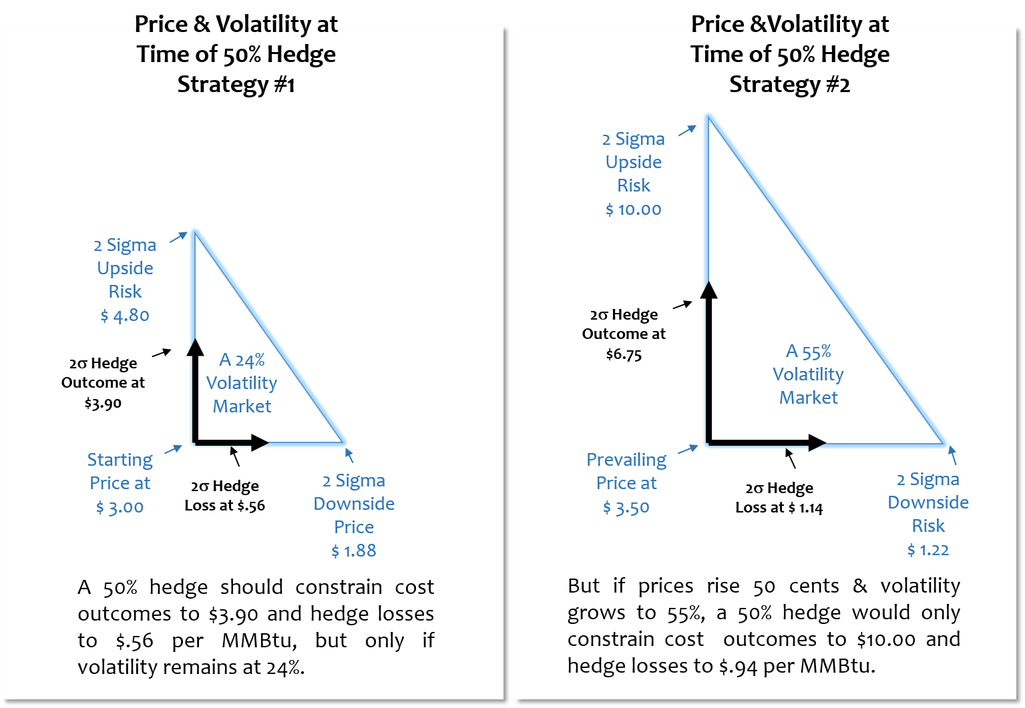

**The Difficulty with the Fixed Hedge Ratio (‘Lock and Leave’) Approach**

In simply setting a preemptive hedge ratio, no explicit upside tolerance or hedge‑loss tolerance is specified; the strategy attempts to manage risk without ever measuring it. As prices rise and volatility expands, someone should decide if increasingly unfavorable potential outcomes are still tolerable and that could only be done if risk measurements are performed.

The problem is particularly severe in extreme markets like the rise and fall of prevailing natural gas prices surrounding 2005 or 2008. For example, if one had run the risk numbers when the forward curve for natural gas was $8 and volatility was 80 percent, there would have been a loss potential in excess of $3/MMBtu within a one-year horizon. Would that be a tolerable outcome for a prospective strategy? Would that strategy persist, without change, for multiple years if measures were established to monitor potential loss accumulation?

Setting a preemptive hedge ratio, and accepting implicitly variable and unidentified tolerances as market conditions evolve, is a classic case of putting the proverbial cart before the horse. Tolerances should drive strategy, not the reverse.

## Economic Effectiveness

Another key aspect of a robust hedge program is economic effectiveness. An economically effective hedge program both mitigates high-cost exposures and constrains exposure to potential hedge losses. When considering risk‑mitigation strategies, the strategy that produces a cost-mitigation tolerance with the smallest hedge-loss exposure is the strategy that is economically superior. To illustrate, if a company estimated next year’s 2-sigma upside and downside market prices for a given natural gas portfolio, various strategies could be evaluated to determine the extent the portfolio’s costs are constrained in the upside extreme, and to what extent hedge losses would be incurred in an extreme downside market. If, at those market extremes, strategy A constrains costs to $200 million while constraining potential hedge losses to $30 million, it would be demonstrably superior to strategy B which constrains costs to the same $200 million, but is exposed to $50 million hedge‑loss potential.

In addition to economic effectiveness, implementation costs and management effort must also be considered in the selection of a strategy. That is, avoidance of losses must be weighed against the costs of implementing a program. The implementation cost of an effective strategy is typically a few million dollars; therefore, most large utilities would acknowledge that avoiding orders‑of‑magnitude‑larger hedge losses provides good value. On the other hand, small utilities might conclude otherwise.

Later, it will be shown that a quantitative finance-based and risk-responsive set of hedging protocols is superior to any lock‑and‑leave hedging approach under a broad range of price environments.

## Regulatory Framework

The basic question “Are we doing the right things?” is not just relevant for utilities in this context, but extends to regulators and stakeholders as well. Consider a utility that decides to measure risk and establish its tolerances for cost exposure and hedge losses. This utility has analyzed risk‑responsive hedge strategies and concluded that under high‑but‑reasonable volatility assumptions, it can constrain next year’s cost outcomes to a $1/MMBtu increase and hedge losses to $0.60/MMBtu. The strategy required to do so would consist of deploying quantitative finance methods to measure and monitor risk and then place hedges in response to specified risk conditions should they arise.

What now? Does this utility expose itself to regulatory and stakeholder criticism by raising the risk specter of a $1/MMBtu increase in natural gas costs and millions of dollars in *potential* hedge losses before anything ever actually happens? Does it undertake a quantitative finance program, make 10 incremental hedge decisions over the course of next year and hope to explain them later? Or, does it attempt to reach a compact with regulators beforehand by explaining all of the complexities and hoping for that elusive understanding as to reasonable hold-harmless expectations? In the absence of a mutual regulatory understanding, the utility might not take any of these steps; instead, the company would likely go back to a 50 percent hedge ratio and change nothing.

On the other hand, regulators do not and cannot manage utility companies, and they should not preemptively impose methods or make hold‑harmless judgments. Utilities have a duty to prudently operate and provide safe and reliable service to consumers. Neither utilities nor regulators can be expected to unilaterally implement or impose quantitative finance methods for risk mitigation. A mutual recognition of the merits and regulatory implications must be attained before an improved regulatory framework can be established.

The benefits of (1) setting meaningful tolerances, (2) measuring and monitoring risk, and (3) hedging – but only as much as necessary – will be shown to carry material benefits. It will take the consensus building efforts of regulators, utilities, and stakeholders to create a constructive compact where the regulatory risks do not outweigh those benefits.

# Contrasting Approaches

## Fixed Ratio

If a utility concludes the right approach consists of picking a fixed hedge ratio each year and locking and leaving it for the year, there is little to discuss regarding how to do it right. It would be wiser instead to understand the risk at the time of making that decision, so that potential cost outliers and hedge loss outliers can be estimated. However, as Figure 2 reflects, risk assessments exhibit fleeting accuracy unless monitored routinely. It would be better to accumulate the hedges in a non-precipitous fashion, diversifying hedge prices over some advance period. It would also be wise to pick an appropriate hedge ratio that includes some understanding of ratepayer preferences for avoiding cost increases versus avoiding uncompetitive prices in a down market. A high hedge ratio would be biased toward cost mitigation, while a lower ratio would be biased toward smaller hedge losses.

If we accept the arguments regarding consumers’ marginal utility made earlier, high costs are more painful than less competitive prices in falling markets, so a hedge ratio greater than 50 percent might be appropriate to protect against high prices. Of course, a higher hedge ratio will carry greater prudence risk should losses grow.

## Risk‑Responsive Hedging

Typically, utilities manage their financial and structural systems expertly and effectively with most striving to constantly improve. With respect to natural gas cost risk mitigation, “the right thing to do” is to manage competing tolerances of natural gas costs and potential hedge losses using the tools found in quantitative finance. That is, developing a conceptual framework for risk mitigation driven by quantitative metrics. For many utilities, especially those without merchant affiliates, this could be a new discipline. Even those managing merchant risk would need to transition from managing profitability-risk to managing cost-risk, probably using different employees on the regulated side. Doing things well could require a learning curve to attain expertise, management systems, and controls commensurate with the standards required. It would not take decades to do this, but rather only a year or two.

As discussed above regarding Figure 2, the fixed-ratio approach sets a strategy without specifying risk tolerances, and then allows results to migrate to whatever costs or hedge losses arise from changing volatility and the gas prices that result. What would be required to put the horse in front of the cart, i.e., to set tolerances for upside cost outcomes and the size of outlier hedge losses in severe market downturns, and then design and execute a strategy to constrain results accordingly? This key question is discussed below.

## Clear Understanding of the Nature of Risk and Risk Assessment

Since natural gas LDCs are by design “short” on natural gas, that is, they always need to purchase gas, gas-price risk takes two forms. When completely unhedged there is only the risk of increasing costs, and when fully hedged there is only risk of hedge losses.[12] Any hedge ratio between those extremes will produce a middle ground. Since risk is polar; there is “Cost Risk” and there is “Loss Risk.” Truth be told, hedging doesn’t reduce risk, it simply exchanges cost risk for loss risk. Any program designed to address one without addressing the other is bound for trouble.

Also, it is fundamental that price movements are not symmetrical in the two risk directions. Upside prices tend to be more dramatic, but less probable. Downside prices tend to be more probable, but less dramatic. This phenomenon can be observed in the actual history of Figure 1, but it also has implications for risk estimation. Figure 3 shows how an analyst, working with a $4 current futures price, would estimate one-year‑later price probabilities using a lognormal distribution to capture this asymmetry.

**Figure 3: A Typical Risk Estimate for One‑Year‑Forward Outcomes**



Risk can be measured statistically for a specified confidence level. Volatility can be measured by observing the standard deviation of the daily ups and downs of price movements,[13] and daily exposures can be extrapolated to weekly, monthly, or annually by multiplying by the square root of time. For example, if the risk of price changes is $0.10 for a single business day, it would be $0.30 over the next nine business days and $1.59 over the next 252 business days (one year). Typically, these might be estimated at 2-sigma confidence, meaning they would encompass all but about 1‑in‑40 outcomes.

Measuring risk is only the first step. The value at risk (VaR) must also be managed to effectively address risk. VaR is indicative of how much a company might see in cost increases, or how big hedge losses might become. For ease of reference, we can refer to these as VaR-C and VaR-L respectively. If one were to do the risk assessment described above for each forward contract month, VaR-C would be the potential upward price migration for each month multiplied by the respective unhedged volumes; VaR-L would be the potential downward price migration for each forward contract month multiplied by the respective hedged volumes. The 1-in-40 cost outcome would then be the current cost estimate plus VaR-C, and the 1-in-40 hedge loss outcome would be the current forward mark to market plus VaR-L.

This brief discussion represents the heart of risk assessment from a quantitative finance perspective. It is nonetheless worth emphasizing a few points, particularly because some could influence regulatory views:

1. Risk estimates are only useful if they are actionable. If it will take two weeks to execute responsive hedges, the risk estimates should reflect no less than a two-week forward potential price migration. The time interval described here is typically referred to as a “Holding Period.” Note that Figure 3 above shows the risk for a full year. If hedge responses could be executed in two weeks (ten business days), the risk would be about one-fifth as great as that shown in figure 3.[14] It is easier and more effective to manage risk in smaller increments, so a quicker response time is advantageous.
2. There can never be absolute confidence. Estimating 1-in-40 probabilities, by definition, means that one time in forty, results could fall outside of the risk estimate. If that confidence level is inadequate, a higher confidence can be used.
3. When 1-in-40 risk estimates are used, results will occasionally exceed tolerances. This is a normal condition related to statistical estimation and does not require a “black swan” event. The term “black swan” has become famous but is often misunderstood. It was coined by Nassim Taleb in a book by the same name. [15] Black swans are, by definition, unpredictable and dramatic; they do not reflect routine statistical estimates. Prudence assessments must consider that “outlier” outcomes could be black swan related, or they could reflect routine outcomes that fall outside of the 1-in-40 risk estimates, but both are extraneous factors. A finding of imprudence should probably be associated with an inadequate strategy, lack of diligence in conducting risk measurements, or faulty execution of an approved strategy.

# Strategy Development

It would be ideal if firms could only hedge when necessary to minimize the risk of increasing costs, and avoid unnecessary hedges to constrain loss potential. The obvious question, then, is how one could know when hedges are necessary and when they are not. The risk assessment methods described above provide a solution. This section will describe a strategy development logic, but it will be necessary to define a few concepts and terms first.

Below are four typical types of hedge decisions listed in the order they would typically be executed, from the earliest hedges to later hedges approaching the delivery month.

1. **Programmatic:** Positions accumulated systematically in accordance with a simple calendar schedule, lock and leave approach.
2. **Defensive:** In response to risk measurements indicating a threat to an interim “action boundary” or final cost tolerance.
3. **Contingent:** In response to risk measurements indicating a threat to an interim or final “hedge‑loss tolerance.”
4. **Discretionary:** In response to a market opportunity; however, it could be argued that these are unnecessary.

They are discussed below in order of design logic:

**Type B, Defensive Hedges:** To be clear, as used here, market-responsive strategies do not rely on prediction of market movements. Instead, they rely on measuring and monitoring prevailing risk conditions. Hedge programs should manage risk; opportunity management is a different issue. Hedges should be executed based on a “risk-view,” not a “market-view.” A hedge program works most reliably when risk is measured daily or weekly and prospective hedge decision responses are pre-planned for risk conditions that might emerge.

The distinction between “risk-view” and “market-view” is important. Hedges are placed at futures market prices which reflect all participants’ money-backed consensus as to the future price of natural gas. For the purpose of making hedge decisions, it is meaningless to hold a view that the spot price of natural gas is likely to rise or fall due to fundamental factors simply because one cannot hedge next year’s natural gas at today’s spot price in any case. A hedge manager who buys on a “market view” is effectively acting on something far more speculative. If stated properly, the manager’s point of view could be summarized as, “While all market participants have equal access to data regarding consumption, production, storage, and other factors, and they have reached a consensus on next year’s futures price, I know better.”

A “risk-view” is very different. It holds that we do not know the direction or magnitude of futures price changes, but we do know the current futures price (market consensus) and we can observe the uncertainty of that consensus as reflected in daily futures price fluctuations. If we decide on our tolerances for upside costs and downside hedge losses, we can compare the observed risk to our tolerances and take hedge actions accordingly.

If no hedges are ever executed, no losses will be incurred, so if practical, the preference would be to hedge only when necessary, i.e., use defensive hedges. Also hedging in small increments avoids the “all-in” risk of waiting until prices are nearly intolerable to hedge, only to see them collapse afterward.

Recall that VaR-C, discussed above, can be used to estimate the 1-in-40 cost outlier over a two-week holding period.[16] Ultimately, the cost outlier can be compared to the cost tolerance, and a hedge can be made when the tolerance is in jeopardy. However, natural gas volatility can be very high, and defensive hedges might be precipitously large unless the utility uses tiers of responses. By using two interim “action boundaries,”[17] hedge responses are smoothed over three graduated tiers – boundary 1, boundary 2, and boundary 3, which is the ultimate risk tolerance.

Any time risk metrics indicate that an action boundary could be breached over the two-week holding period, hedges would be placed in proportion to the VaR that must be eliminated. In the design process, simulation of random price-walks facilitates exploration of the size and frequency of the hedges that would be required. The following is an illustration of how tiered action boundaries could be designed, and as such, the percentages used are for illustrative purposes only.

First, hedge as necessary in defense of boundary 1 up to a 45 percent hedge ratio; then shift to defending boundary 2; and hedge as necessary up to a 55 percent hedge ratio, etc. The hedge manager is not waiting for the potential breach of an ultimate tolerance boundary to hedge all needs in a precipitous manner.

In the example above, the utility could add an additional 10 percent to the hedge ratio from boundary 1 to boundary 2. The additional 10 percent will not be executed in one large tranche, but rather hedges are placed in proportion to the value at risk that must be eliminated. Stated more precisely, if unhedged positions represent 60 percent[18] of the portfolio, VaR‑C is entirely attributable to those positions. So, when managing next year’s gas portfolio, if we need to eliminate $.05 per MMBtu of excess VaR out of a total VaR-C of $1 per MMBtu, we would only add a hedge increment of three percent ($.05/$1 times the 60 percent open positions). The effect is, as desired, to hedge only as necessary and in small increments.

The illustration in Figure 4 below shows a progression of defensive hedges under illustrative market conditions when prices rise by about 15 percent over 13 weeks. It could be informative for those inclined to follow the calculations.

**Figure 4: Defensive Hedging Illustration**

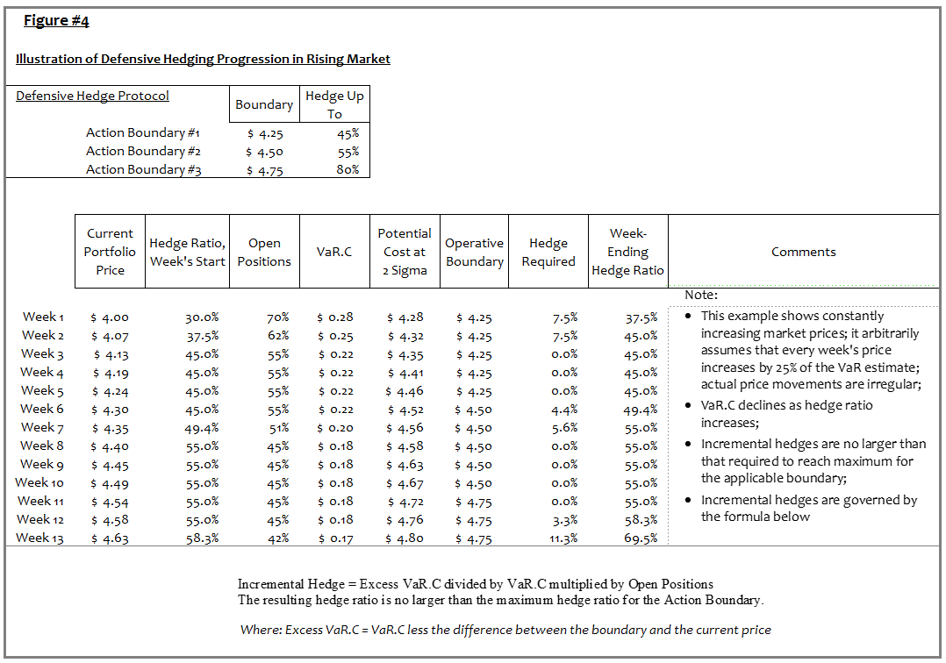

**Type A, Programmatic Hedges:** If concerns persist that defensive hedges will be required in large tranches, programmatic hedges can be accumulated up to a low to moderate level, e.g., 10 percent or 30 percent hedge ratio. The programmatic hedges will preempt the need for large defensive hedges later. Volatility tends to grow as each contract-month grows closer, so early programmatic hedges provide a constant-volume averaging technique before the emergence of severe contract-month volatility. The main objective of programmatic hedges, when necessary, is to make the defensive hedging tranches manageable in highly volatile markets.

If programmatic hedges are deployed, the first defensive boundary’s maximum hedge ratio would typically be raised to something greater than the programmatic level; i.e., in the example above, the defense of boundary 1 was illustrated as up to a 45 percent hedge ratio; this might be consistent with a 30 percent programmatic hedge ratio.

**Type C, Contingent Responses:** Contingent responses aim to constrain losses in price collapses. If defensive and programmatic hedges are designed correctly and tolerances are compatible with market realities, contingent hedges are almost never necessary. For most programs, the collapsing prices following the 2008 financial crisis presented the only such environment in the last decade. Contingent responses are placed in response to a potential breach of a hedge-loss tolerance. Notably, the potential for a breach will be recognized long before the actual losses are reflected in market prices. The only time contingent responses might be triggered is when prices run up very rapidly (driving defensive hedges) and then down very rapidly; in other words, volatility is very high and price trends reverse dramatically. When volatility is very high, so is the VaR, so for a company monitoring VaR-L, the potential for outlier-sized losses would be identified before they actually develop. Contingent hedge decisions might consist of overlaying options (premiums, while high, could be a bargain in the rare crisis environment) or simply reversing prior hedges via counter positions.

It is worth noting how the defensive protocols work in conjunction with the contingent responses. Since the defensive hedges are added as graduated responses to tiered boundaries, each new defensive hedge is added to prior hedges that look very favorable to the then-current market price; in other words, as more defensive hedges are added, the mark to market is increasingly favorable. The contingent hedges, as just explained, are only triggered when prices run up very rapidly and then down very rapidly. At the price apex where the reversal occurs, the portfolio will exhibit a very favorable mark to market, so even under extreme volatility, there is time to execute the contingent responses. Having said that, given the general aversion to hedge losses and the collateral implications of unfavorable mark to market, it is often advisable to use a longer holding period when measuring the contingent VaR-L risk in order to provide a more advance warning of potential losses.

The illustration in Figure 5 shows a steadily decreasing market, and how contingent responses could be used to constrain hedge loss potential.

**Figure 5: Contingent Response Illustration**

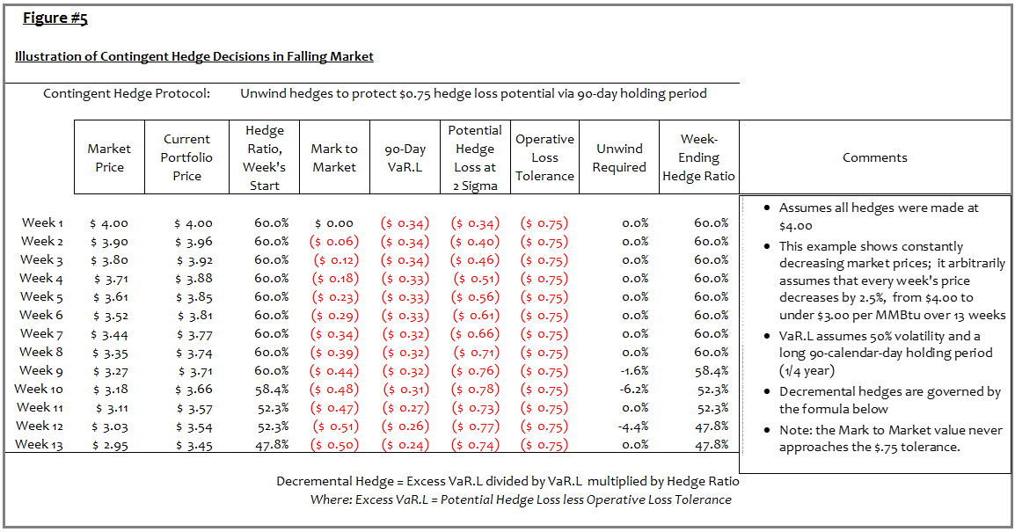

**Type D, Discretionary “Hedges”** are opportunity‑focused rather than risk‑focused, and they are very susceptible to prudence issues if executed early, so they are best left to managing near-term gas needs. In the short term, LDC managers often have specialized knowledge of system and pipeline factors that can influence price and reliability, so discretionary hedges become more an extension of operating discretion.

**Conflict Resolution:** When volatility reaches outlier proportions, a rare conflict might arise where both VaR-C and VaR-L indicate potential breaches of boundaries. In other words, the risk of cost increases exceeds tolerance, and the risk of hedge losses also exceeds tolerance. This rare situation requires management to decide if they are more risk averse with respect to cost increases or hedge losses. It is typically better to make such decisions at the time of strategy development, rather than waiting until the realities of crisis management. The history would indicate that, in terms of economic results, allowing contingent protocols to dominate and suspending new hedges produces superior results because typically, such a conflict would only arise at or near extreme market peaks, and recall from Figure 1 that such peaks tend to be transient. Having said that, the company’s risk aversion preference should guide this decision.

# Illustrative Strategy Comparisons

The conceptual discussions above may be more easily understood by way of examples. Simulations were run for contrasting strategies using the actual historical prices and daily forward curves from 2000 to 2014. For each day of the 15‑year history, the simulation used the prevailing forward curve to calculate portfolio values, VaR-C, and VaR‑L for a forward horizon of two calendar years. It then made decisions to hedge or not to hedge based on decision rules postulated for each strategy.

Two hedge strategies are compared and summarized in Table 1 below. The first strategy reflects a programmatic‑only accumulation up to a 65 percent hedge ratio. This is a typical investor-owned utility practice, but is not intended to reflect any specific company’s history or be representative of Washington state’s average. The second strategy dramatically reduces programmatic hedges to a limited 24 percent maximum, but when appropriate, uses defensive hedges to reach a maximum 80 percent hedge ratio. It also deploys contingent protocols to protect against large hedge losses.

Note that these two strategies illustrate a simple contrast of fixed-ratio swaps versus responsive swap decisions. The strategies have not been customized in any way, further benefits could be gained by adjusting the parameters of the responsive strategy. Boundaries could be tighter or looser, options could be used in contingent protocols, and so on. The strategy design summaries are shown in Table 1.

**Table 1: Summary of Simulated Hedge Decision Rules**



## Simulation Clarifications

A few clarifications regarding the simulation's risk‑responsive hedge strategy might be helpful. First, the simulation’s 80 percent maximum hedge ratio, this ratio would typically be set at whatever level reflects a high‑confidence supply requirement. In many respects, a higher number is better. The risk‑responsive hedge strategy can typically constrain losses despite using a higher maximum ratio, and any supply requirements in excess of the imposed maximum will be exposed to full market price changes. However, actual volumetric needs will depend on weather and other factors, and it is preferable to avoid hedging volumes that might not be needed. The 80 percent maximum has been used here as an estimate of how the desire for full mitigation might be reconciled with the uncertainty of volumetric requirements.

Secondly, in practice, action boundaries would be set by management, but for the purposes of computer simulation, “management” intervention is impractical. So for the simulations, the price to defend for each action boundary was calculated as a specified percentage increment over the portfolio values on the first of December prior to each year’s hedging activities.

Similarly, the maximum hedge ratio for each boundary has been set at a consistent 40 percent, 60 percent, and 80 percent respectively. These could be changed each year depending on the hedge ratio already established as the year starts. As an example, because the defensive hedges look forward two years, some years will begin with a higher hedge ratio than 40 percent, rendering the first boundary moot. In such cases, management could set smaller increments for the coming year’s maximum hedge ratios, effectively resulting in smaller defensive hedge increments.

Finally, the contingent rules specify that in the event of a breach, hedging will be suspended for one month. This provision is aimed at resolving potential conflicts in the simulations – again without management intervention - avoiding a series of weekly decisions calling for unwinding then re-hedging then unwinding. It effectively makes the contingent protocol superior to any defensive protocols for one month.

The clarifications mentioned here simply facilitate the computer simulations, and offer opportunities for improvements when management judgment is deployed on each annual review.

## Simulation Results

The results of the simulations confirm expectations. Using a flat 120 Bcf per year portfolio as a benchmark, the average annual cost at market prices over the study period would have been $624 million annually. The fixed hedge ratio produced a $662 million average annual cost, and the risk‑responsive strategy produced a $614 million average annual cost. Superficially, the costs look to be advantageous with the risk‑responsive strategy, but cost reduction is not the goal and those results could be accidental.

The more important question from a risk perspective is how the respective strategies perform in stressful markets, and that contrast is dramatic. With respect to mitigation, the best mitigation for the fixed hedge ratio occurred in the twelve months ending February 2006 following hurricane Katrina, and it totaled $268 million, while the worst mark to market occurred in the twelve months ending December 2009 and was $377 million. The risk‑responsive strategy was far better. The best mitigation was $361 million, again following Katrina, while the worst mark to market occurred in the twelve months ending September 2009 and totaled $190 million.

So to summarize, at market extremes between 2000 and 2014, the risk‑responsive strategy provided 35 percent more cost mitigation while constraining worst‑case hedging losses to 50 percent of the fixed-ratio strategy.

Figure 6 below shows a graphic representation of the costs resulting from each strategy. Note that for periods where the fixed ratio produces lower expense than market costs, the savings show as green; where the fixed ratio produces higher expense, hedge losses show as red. The risk-responsive strategy is shown as the blue line, and it produces comparable results to the fixed ratio in price peaks, but far superior results in declining markets.

**Figure 6: Cost of Gas Comparison**

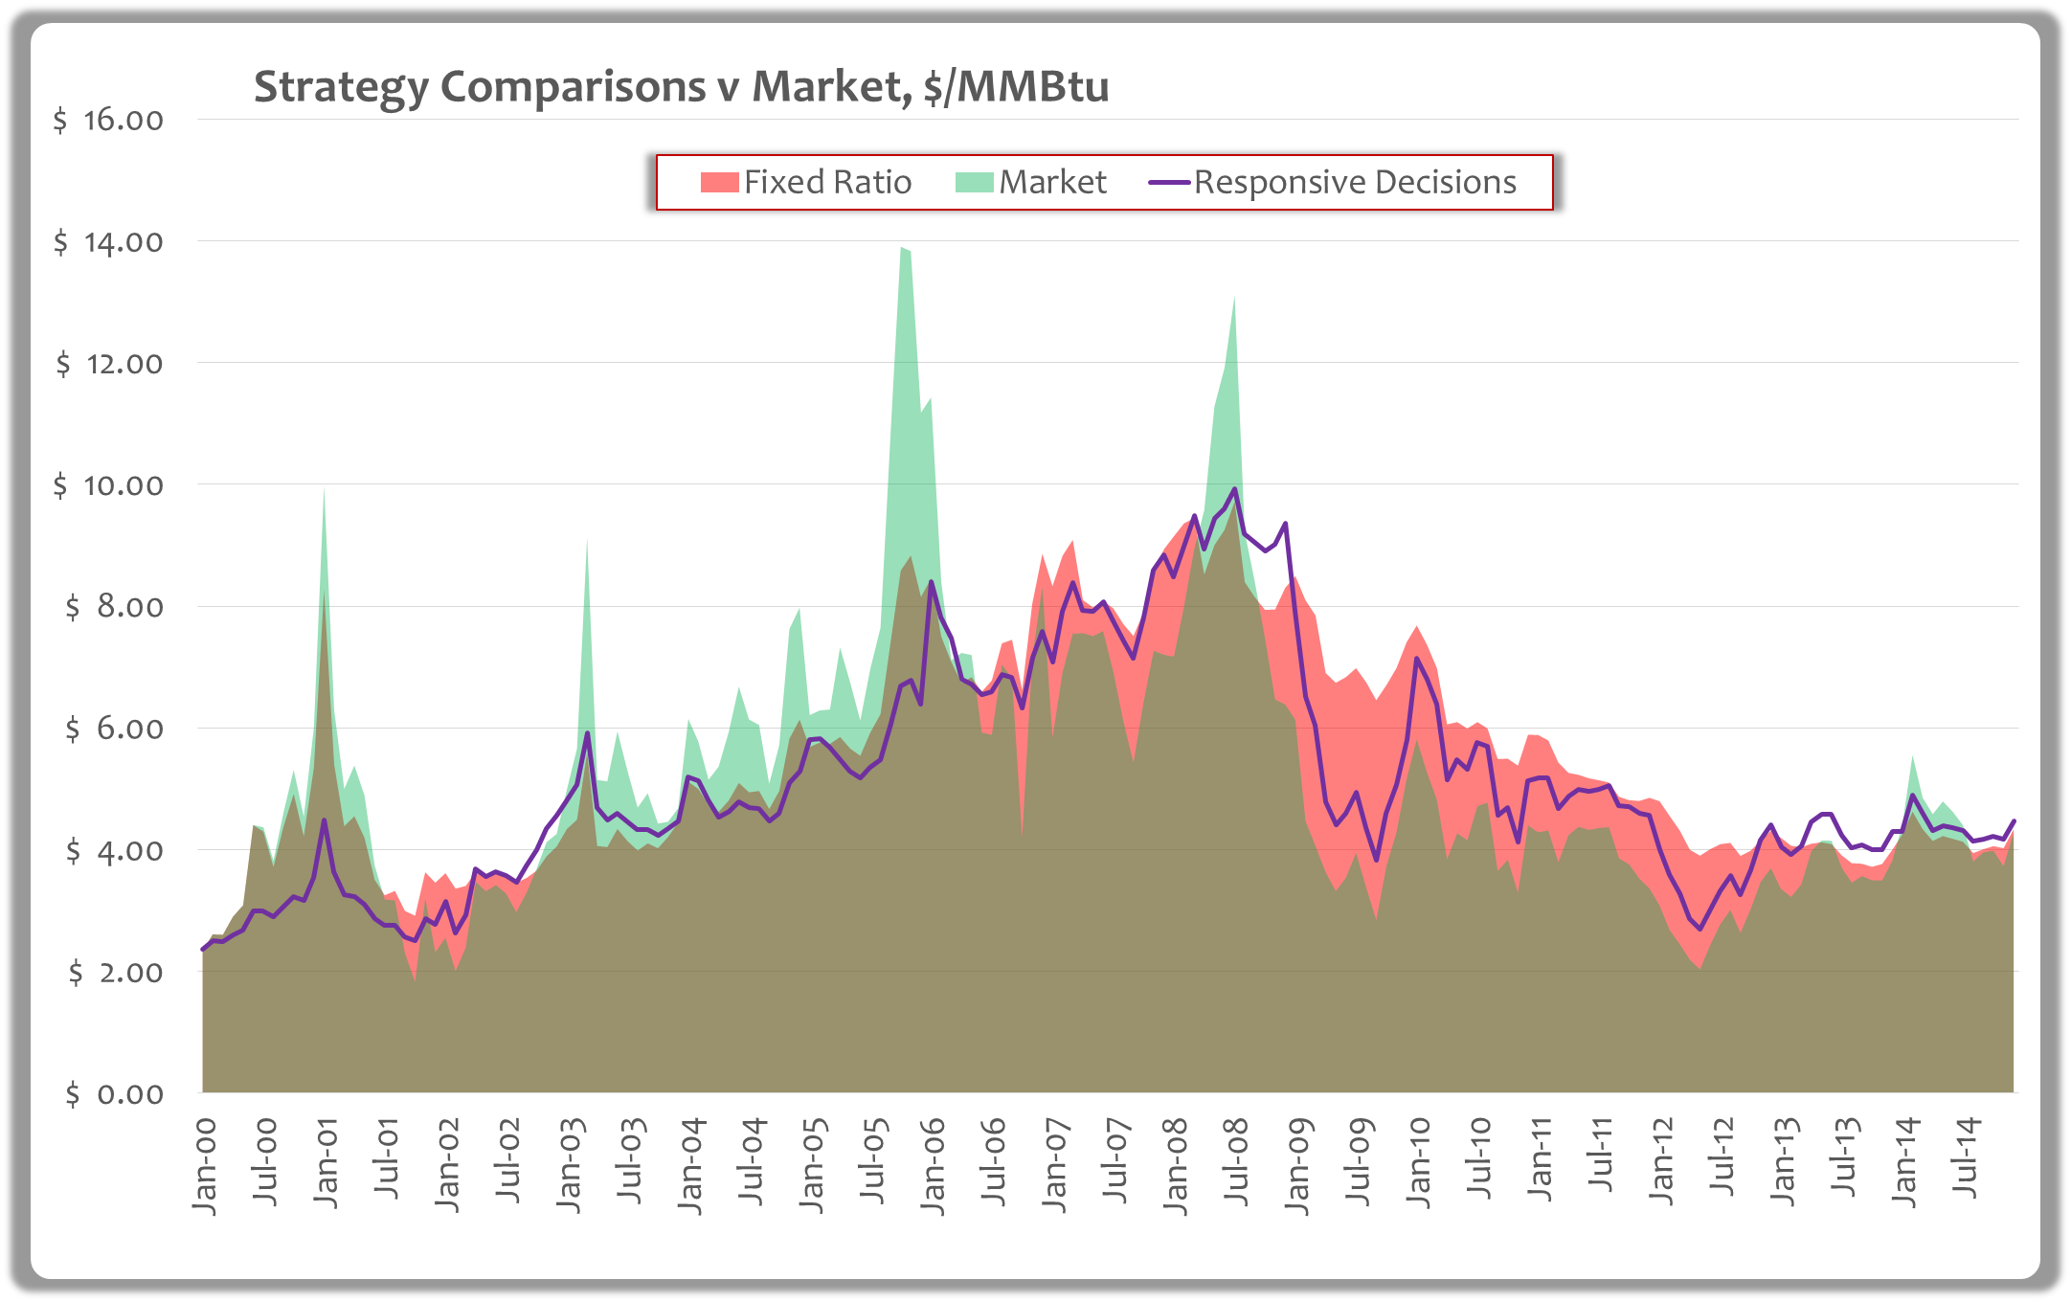

Figure 7 below reflects the same results as shown in Figure 6, but focuses on the mark to market outcomes; it also shows the superiority of the risk‑responsive strategy. In Figure 7, green columns represent favorable outcomes versus market for the fixed hedge ratio and light red columns represent the hedge losses of that strategy. For the risk‑responsive strategy, hedge gains and losses are shown in yellow and dark red respectively. The risk‑responsive strategy is superior for the vast majority of the decade-plus study period. There are only small periods where the responsive strategy produces worse mark to market results, and they show as purple columns.

**Figure 7: Mark to Market Comparison**

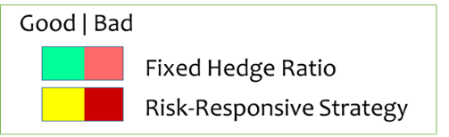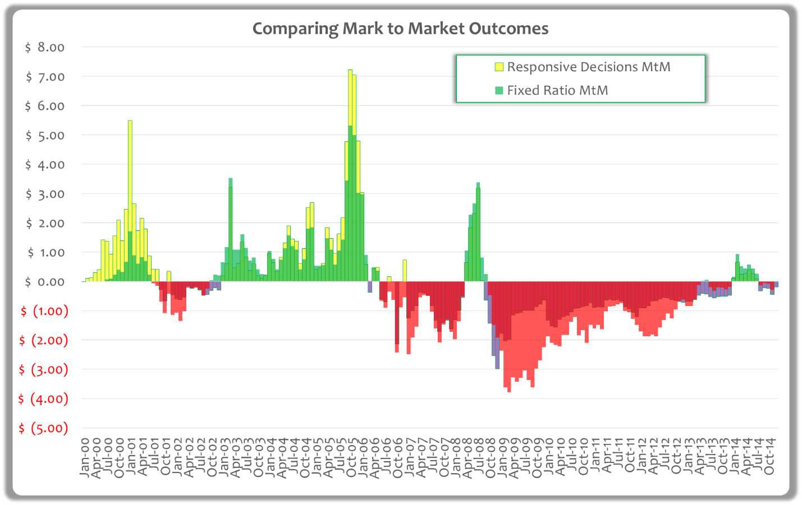

It is worth repeating that these strategies were not customized or optimized in any way. Different companies have different risk appetites, and some might prefer tighter or looser defensive boundaries, higher or lower hedge ratios, or more stringent confidence levels and holding periods. Also, options can often be deployed to pay a modest premium thereby gaining cost mitigation while further constraining hedge loss potential. The strategies used in the simulations were chosen simply to illustrate the points discussed earlier.

# Regulatory Choices

If superior hedge results can be attained by monitoring risk and responding to evolving conditions, there are implications for regulatory policy regarding hedges. In this section, the following questions are addressed; they are offered to stimulate discussion and not to present a finalized approach.

1. How can the regulatory environment be modified to support more robust risk management practices?
2. What sort of prudence standards are appropriate?
3. What reporting requirements would be appropriate?
4. What would be a reasonable schedule of adoption with respect to hedge methodology and regulatory standards?

## Supportive Regulatory Environment

Prudence risk is a necessary component of economic regulation. This risk, borne by regulated utilities, is reasonable and necessary in order to protect consumers given the market power utilities possess. Because a utility must protect its shareholders from undue prudence risk, prudence risk naturally affects a utility’s behavior and its willingness to change. Traditionally with respect to hedging, most utilities have protected shareholders by focusing on keeping things simple and then executing its strategies well. Simple methodologies are easier to execute well. They also allow utilities to avoid the difficulties of explaining complex methodologies, and then defending complex decisions on regulatory review.

To be effective, regulatory policy must promote “doing the right things” as well as “doing things well.” Unfortunately, utilities have generally responded to prudence risk by defaulting to fixed-rate, lock-and-leave hedge programs in their attempt to “do things right.” As discussed earlier, this results in an unspecified loss tolerance, which is never articulated but rather a random consequence of the chosen hedge ratio. Given the radical price movements over the last decade, large losses have resulted when natural gas market prices have fallen precipitously.

Regulators should not be unduly prescriptive with respect to what constitutes best hedging practices, but should focus on establishing appropriate oversight while supporting robust risk management. If utility management is to be accountable for the effectiveness of its decisions, those decisions must be owned by management. Also, best practices today could be supplanted by new methodologies in the future, and institutionalizing an approach could result in stagnation.

Some changes seem appropriate, and material effort and some cost would be necessary to improve hedging capabilities. The results detailed in the staff report (Appendix A) and the economics shown by the contrasted simulation results clearly justify material effort and cost. The balance between cost and expected results should be determined by management and subject to regulatory review using clear standards.

So, what would constitute a constructive regulatory framework without being unduly prescriptive? The answer seems to lie in defining language, defining assessment criteria for strategies, and then establishing processes through which the utility would articulate its risk management strategy to the regulator. In addition, reporting requirements to facilitate the regulator’s review should be established. The definition of language would address the problem of explaining complex methodologies, while the clear assessment criteria and reporting requirements would address the problem of defending complex decisions on review.

As to language, the preceding discussion should materially assist in defining risk metrics, hedge decision types, and the elements of strategy formulation. Similarly, strategy‑assessment criteria are articulated in the “Strategy Development” section above. These concepts will be further explored in this inquiry.

# Prudence Standards and Reporting Needs

Again, prudence standards might apply to two elements: strategy formulation and then execution, whereas regulatory review could be incorporated into annual natural gas cost recovery filings, or if needed, in a separate process. Importantly, such standards cannot include arbitrary judgments of retrospective results since cost increases or hedge losses are probable outcomes of any hedging program. Instead, prudence standards should be developed for both strategy formulation and execution from which company actions and decisions can be assessed

**Prudence of Strategy Formulation:** Prudence with respect to strategy formulation would be assessed by assuming that the coming risk environment could exhibit historically high volatility.[19] Then, the prospective cost outcomes and hedge losses that the strategy would produce in statistically high upward-price markets and respective downward-price markets could be assessed against a fixed-hedge-ratio benchmark.

To illustrate, Figure 8 shows how the simulated strategy discussed earlier would look against a 65 percent fixed hedge ratio benchmark as a reference.

**Figure 8, Illustrative Strategy Assessment**

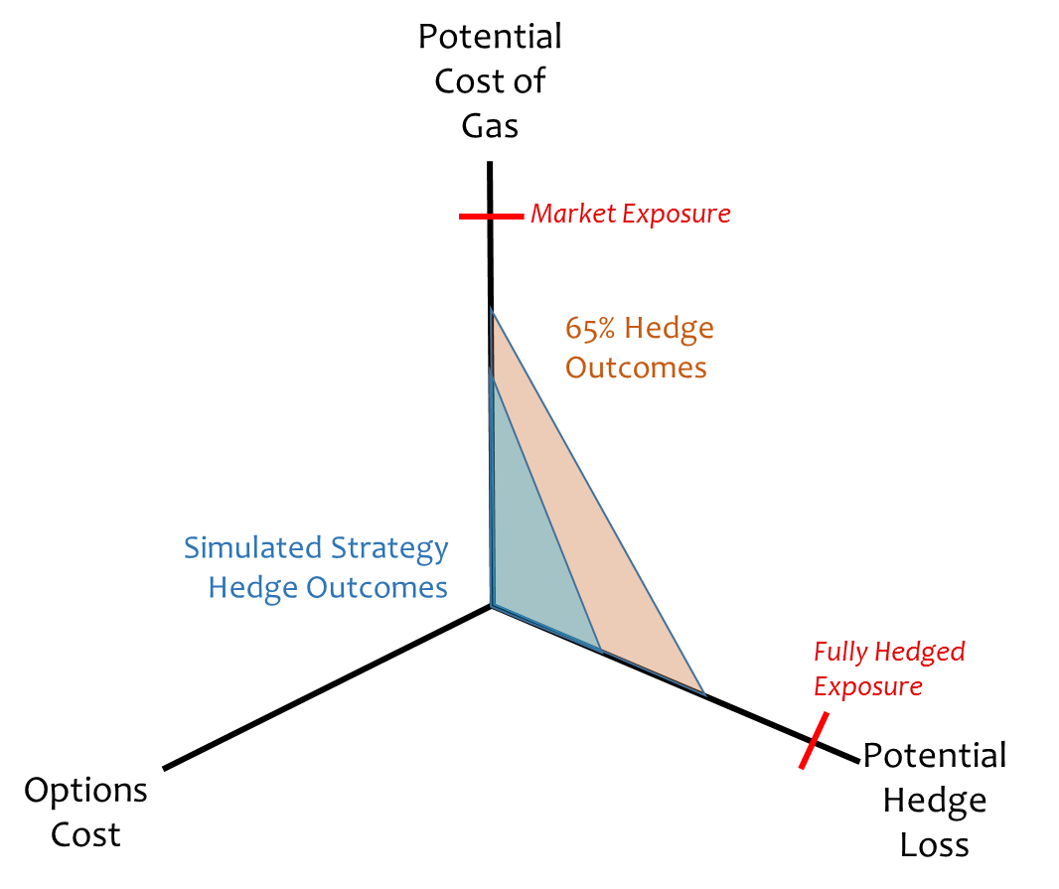

The points on each triangle in Figure 8 are drawn from the most extreme environments of the last decade. Recall that at market extremes, following Katrina and the price collapse of 2008, the risk-responsive strategy provided 35 percent more cost mitigation while constraining worst-case losses to 50 percent of the fixed-ratio strategy. The triangular graphic highlights that distinction.

It quickly becomes apparent that simply mandating a representation of strategy outcomes should cause most companies to abandon a lock‑and‑leave, fixed-ratio approach. Consider Figure 8A below which contrasts two hypothetical company submittals. Company #1 submits a plan calling for a 65 percent programmatic-only hedge strategy, while Company #2 submits the simulated strategy enhanced by some options expenditures. To create some improvement from the reference, the programmatic strategy also has been enhanced with modest options expenditures. The regulatory view of Company #2’s strategy would likely be meritorious, while Company #1 may face challenges. Even if Company #1’s plan were accepted in the first year because of some constraining issues, as practices evolve state-wide, all firms should move toward more effective strategies. In this regard, companies are expected to utilize lessons learned in prior periods when formulating their strategies for the next period.

**Figure 8A, Illustrative Strategy Assessment**

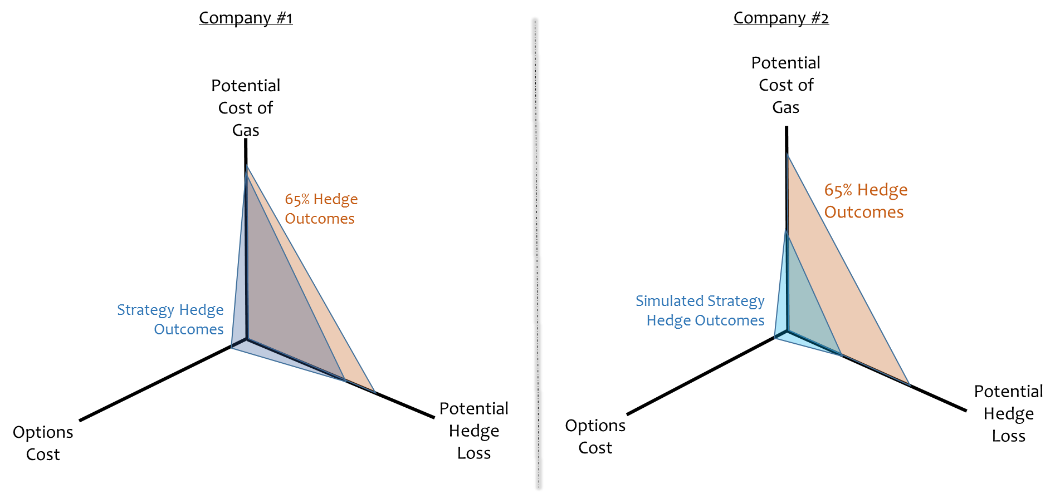

**Execution Prudence:** Because the strategy specification would include the timing of programmatic hedges, the risk conditions driving defensive responses, and the contingent response triggers, the only element needed to test strategy compliance would be hedge accumulation data and weekly risk metrics. Companies could be required to file an annual summary of risk metrics and hedge responses. Of course, records that are more detailed would be maintained in support of these summaries, and should be made available to the regulator, and upon review, certain stakeholders,[20] upon request.

Under this construct, the report would list 52 weeks[21] for each natural gas year within the program horizon. An illustration of such a “Hedge Program Summary Report” is presented in Table 2 below. Notice that the report provides a column for “Notes” on the assumption that management will occasionally exercise judgment rather than following the originally filed strategy by rote. It would be expected that contemporaneous documentation would be kept for such occasions to explain the reasoning and timeliness of any strategy deviations. No plan is perfect for all eventualities, so overriding judgment is sometimes necessary. If the strategy is well conceived, such judgments should be fairly rare. Regulators should assess the judgments in the context of information known at the time, rather than doing so with the benefit of perfect hindsight.

## Standards for Review

To support the adoption of more complex methods, the prudence review should be governed by certain guidelines.

1. A utility’s accepted strategy development and diligently applied execution process, does not relieve the utility of its duty to demonstrate the prudence of its actions, but may create a presumption that it acted appropriately when a party recommends a disallowance; and
2. Hedge outcomes should fall within tolerances except when market conditions are more extreme than design standards, or when hedge ratios max out per policy. Outcomes that fall within tolerances carry an assumption of prudence barring material irregularities, and outcomes outside of tolerances carry a burden that the company demonstrate extreme market conditions or the constraints of the maximum hedge accumulation in accordance with the accepted strategy.

There is also an issue of confidentiality. It should be recognized that both the strategy and the Hedge Program Summary Report constitute proprietary commercial “trading” information, and broad dissemination of this material could jeopardize a utility’s ability to access fair price quotes for prospective hedges. Regulators should provide whatever protections are available in the submittal and review process.

**Table2, Illustrative Summary Report Template**



## Schedule of Adoption

Should this construct be favored and adopted, it cannot happen all at once. Utilities will need to build expertise and management systems. The following schedule is offered to start discussion of a reasonable adoption process. It assumes that the regulatory review of companies’ hedge programs happens within the existing PGA structure. However, that review may take place in a separate proceeding. It also assumes that each company will adopt a more robust strategy of its own design and at its own pace over two years, modestly at first, beginning with the 2017 calendar year. Then by 2018, all parties will have accumulated substantial expertise and experience, so that strategies and review processes can be fully functional.

|  |  |  |
| --- | --- | --- |
| Task | Schedule | Comments |
| Complete workshop and follow ups | Q-4, 2015 | In progress |
| Interim draft strategy design | Feb. 2016 | Modest step: Reduce programmatic ratio; initiate modest defensive protocols, maybe contingent protocols |
| File draft plan | Feb. 2016 | Including draft strategy and draft implementation plan |
| Staff and parties review | May 2016 | Comments on draft |
| Design and file formal strategy with PGA | File PGA:  Sept. 1, 2016 | First intended strategy: Reduce programmatic ratio; initiate defensive protocols and contingent protocols |
| PGA review, ex hedge plan | Oct. 21, 2016 | Tariffs effective Nov. 1 |
| PGA hedge plan review complete | Dec. 10, 2016 | Prudence criteria framework to be specified |
| Implement first new strategy | Jan. 1, 2017 |  |
| Full strategy implementation | Jan. 1, 2018 | Follow similar schedule for 2017 PGA; implement full strategies by Jan. 1, 2018 |

# Closing Comments

This paper is intended to be a catalyst for discussion that helps guide all parties toward a consensus about improvements that are consistent with the needs of all stakeholders. The goal is to establish a clear regulatory compact that enables more robust natural gas hedging practices by Washington’s investor-owned utilities while providing benefits to consumers and common understanding for regulatory oversight.

We look forward to the workshop and discussions to follow.

# **Appendix A**: Commission Staff Report Attachment B (March 1, 2013)

# **Appendix B**: December 18, 2013 Notice of Opportunity to File Written Comments

# **Appendix C:** January 13, 2014, Comments of Michael A. Gettings, RiskCentrix,

1. Hedge losses occur when the contract price is greater than the actual market price at the time of final transaction.
2. Although Public Counsel has assisted in the development of this paper, Public Counsel will not be involved with any deliberations conducted by the Commissioners that may result in policy decision-making.
3. MMBtu – million British thermal units
4. Washington Utilities and Transportation Commission, *Report of Commission Staff Regarding the Natural Gas Hedging Policies and Practices of Avista Corporation, Docket UG-121501, Puget Sound Energy Inc., Docket UG-121569, Cascade Natural Gas, Dockets UG-121592 & UG-121623, and Northwest Natural Gas Company, Docket UG-121434*, (March 1, 2013), page 4.
5. *Id.*, Attachment B of staff’s report, showing losses from financial hedges, is attached hereto as Appendix A.
6. Appendix B.
7. J.P. Morgan & Co, and Morgan Guaranty Trust Company of New York. 1996. *RiskMetrics technical document. Fourth edition,* New York: JP Morgan.
8. In 1985, FERC issued Order No. 436, which provided open access to transportation services by natural gas pipelines and allowed negotiation of prices directly with producers.
9. See Appendix C.
10. A standard deviation (σ or sigma) is a measure used to quantify the amount of variation or dispersion of a set of data values – two standard deviations (2 sigma) accounts for all but about 2.5 percent of potential outcomes.
11. The left side of Figure 2 illustrates risk measurements that could have been made at the time of implementing the 50 percent hedge ratio for the first year. At that time, with volatility at 24 percent, market price outliers one year later (2 sigma or 1in 40 outcomes) could be $4.80 so the implicit tolerance for upside portfolio exposures would be $3.90/MMBtu (i.e., 50 percent of the $1.80 price movement plus the $3.00 starting price). A similar downside extreme price outcome would be $1.88/MMBtu, so losses of $.56/MMBtu would be the expected 2-sigma bound (50 percent of the $1.12 downward price movement).
12. Due to the vagaries of volume requirements and intra-month activities, this is never really attainable.
13. The standard deviation is actually performed using logs of the price ratios (PriceDay#2/PriceDay#1, P3/P2, P4/P3, etc.)
14. Recall that risk is proportionate to the square root of time and there are about 250 business days per year, thus SQRT(10/250) = 1/5
15. *The Black Swan: The Impact of the Highly Improbable,* by Nassim Taleb, Random House, April 17, 2007
16. The 2-week holding period is representative of a typical response time, but the actual holding period would depend on the company’s response time. Similarly, the 1-in-40 cost outlier is representative, but different circumstances could call for a different confidence level.
17. The term “action boundary” describes an interim cost level which when threatened will prompt hedge defenses. Using this term allows us to reserve “cost tolerance” for the ultimate cost level to be defended.
18. The 60 percent unhedged position (40 percent hedged) is consistent with where we might be in defending the first action boundary (up to a 45 percent hedge ratio).
19. For example, a 90 percent confidence high volatility could be quantified for the last decade, and that volatility could constitute a strategy-design environment.
20. Wide dissemination of commercially sensitive information is not intended or anticipated. However, records containing commercial information may be provided with certain protections to both the Washington Utilities and Transportation Commission and to the Office of the Attorney General under RCW 80.04.095.
21. Fewer weeks would be reflected for years that are in progress.