Report to the Washington Utilities and Transportation Commission

## Electric Service Reliability - Major Event Report

# Date: July 18, 2010

Date Submitted: April 14, 2011

Primary Operating Area(s) Affected: Yakima

Exclude from Reporting Status: Yes

Report Prepared by: Heide Caswell

Report Approved by: Brett Allsup

**Event Description:**

At approximately 9:03 PM on July 18, 2010, a wildfire which ultimately involved more than 10,000 acres erupted in the Cowiche Mills[1] area, which is located within the Company’s Yakima system, notably generally around its Tieton substation. As a result of the fire, smoke caused the Company’s Wide Hollow 115 kV transmission line to open at Tieton (breaker 2Y260), Union Gap (breaker 2Y92) and Pomona (breakers 2Y102 and 2Y103), clearing the faulted condition. The breakers reclosed, re-energizing the transmission line however the fire’s smoke was still sufficient to result in a second fault. The second fault was also cleared and no further recloses were attempted. The location was identified as 16.77 miles out of Union Gap, on the section between Union Gap and Tieton. It resulted in a sustained outage on the transmission line that caused loss of supply to five substations. They were Wiley, Tieton, Naches, Wenas and Selah, and impacted 22,892 customers.

In general faults on the looped transmission system are of a temporary nature and would not normally result in sustained outages; generally only momentary outages would occur. However, two factors are significant in this event. First, the pervasive smoke resulted in successive faults that prevented successful re-energization by automatic reclosing to take place (because of the apparent location and spread of the smoke from the fire). Second, during the fire season (generally from Memorial Day through Labor Day) the Company invokes a “no test” policy which requires that prior to manually re-energizing faulted lines local operations are required to either patrol or establish with high certainty that downed lines do not exist. Re-energizing without taking certain precautions could result in a variety of hazards, including ignition of highly flammable local brush if a line was no longer properly secured. Thus, because this outage event was due to faulting from smoke and occurred during high fire season and required greater investigation, the customer interruptions were sustained interruptions (greater than five minutes in duration).

Substation operations staff and local troublemen were required to promptly restore power. No additional outside support was required.

Twenty circuits experienced sustained interruptions. At the substation transformers energy was flowing within about twelve minutes (at Selah, Wenas, Naches Plant and Wiley substations) to about sixty three minutes at Tieton (which was in closer proximity to the fire).

Overall, 99% percent of customers were restored within three hours; the longest customer interruption affected 4 customers on 5Y164 for 17.76 hours due to burnt poles that required replacement.

Facilities replacements included 6 distribution poles.



Customers Out Sustained: 23,114

Total Customer Minutes Lost: 578,381

Momentary Interruptions: 6

Sustained Interruptions: 36

PacifiCorp is requesting this event and the consequences thereof to be classified a “Major Event”. While the event did not result in a daily SAIDI in excess of the Company’s Washington major event day threshold, the safety-related nature of the event and the fact that it was determined to be a FEMA declared emergency underscores the unique nature of this event, and warrants exclusion from underlying performance statistics. Further it clearly meets criteria outlined in Washington Administrative Code 480-100-388 which defines a major event as an event, such as a storm, that causes serious reliability problems, and that meets criteria established by the utility for such an event.

Below are charts which demonstrate the magnitude of the event locally, but also show the promptness with which service was restored once appropriate safety precautions were undertaken.

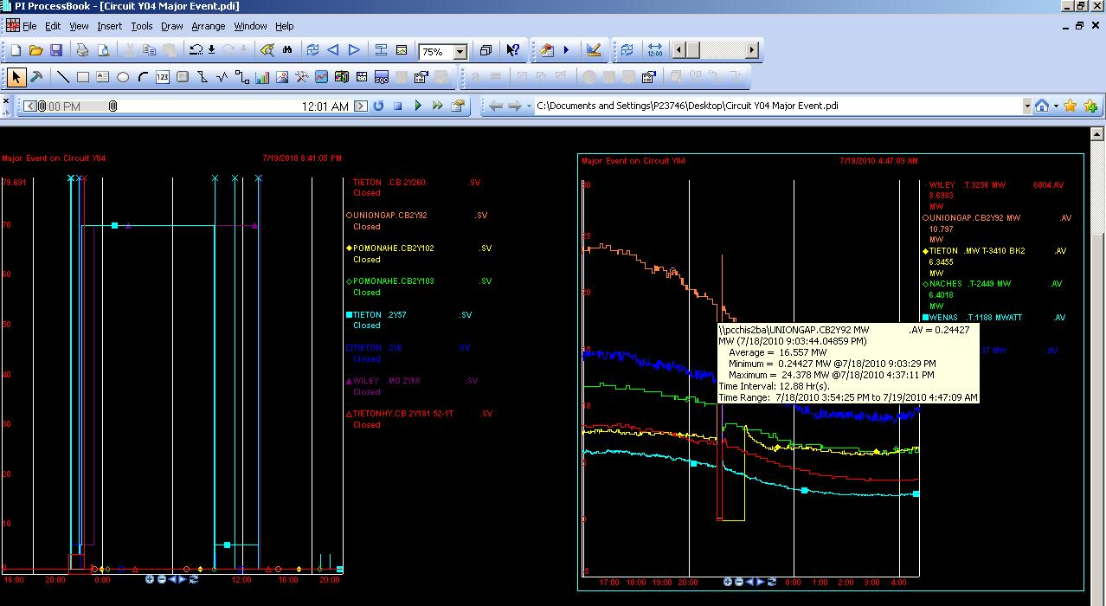

**Estimated Major Event Cost:**

Capital: $30,000 Expense: $0 TOTAL: $30,000

**SAIDI, SAIFI, MAIFI Report:** Attached

1. On July 19, 2010 Federal Emergency Management Association (FEMA) authorized the Cowiche Mills Fire for federal funding under Release number R-10-10-024. The news release by FEMA states that “Federal fire management assistance is provided through the President’s Disaster Relief Fund and made available to by FEMA to assist in fighting fires that threaten to cause a major disaster.” The Cowiche Mills Fire was determined by FEMA to meet relevant criteria.