

January 12, 2011

Advice No. 3673T

David Danner

Executive Director and Secretary

1300 S. Evergreen Park Dr. S.W.

P.O. Box 47250

Olympia, Washington 98504-7250

Dear Mr. Danner:

Qwest Corporation (Qwest) is forwarding for filing the sheet listed on Attachment A.

This filing increases the City of Medina, Washington’s Occupational Tax Rate and the Effective Tax Rate for billing from 0% to 3.0%.

The Effective Date requested by City of Medina, WA was January 8, 2011. Since this date has past, we are enclosing a Less Than Statutory Notice (LSN) requesting an effective date of January 27, 2011.

If you have questions concerning this filing please contact me.

Yours very truly,

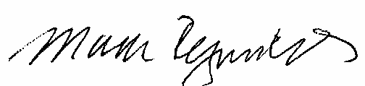

Mark Reynolds

Attachments

Attachment A

Advice No. 3673T

**EXCHANGE AND NETWORK SERVICES**

**WN U-40**

|  |  |  |
| --- | --- | --- |
| **SECTION** | **SHEET** | **REVISION** |
| 2 | 70.1 | 3 |
|  |  |  |