

January 26, 2009

David Danner, Executive Director and Secretary

Washington Utilities and

Transportation Commission

P.O. Box 47250

Olympia, Washington 98504-7250

* **Do Not Re-docket**

RE: Docket UT-081973 (Advice No. 3653T, Replacement No. 6)

ATTENTION: Sharyn Bate

Dear Mr. Danner:

Qwest is making this replacement filing in the above referenced docket to extend the effective date from February 1, 2009 to, March 1, 2009 and to define the way the jurisdiction of a call is determined. Replacement sheets are attached.

If you have any questions concerning this filing, please contact Sue Henson at 206-345-4341.

Sincerely,

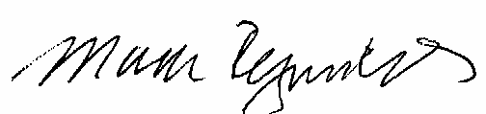

Mark Reynolds

Attachment A

Advice No. 3653T

Replacement No. 6

**ACCESS SERVICE**

**WN U-44**

|  |  |  |
| --- | --- | --- |
| **SECTION** | **SHEET** | **REVISION** |
| 2 | 12 | 3 |
| 2 | 12.1 | Original |
| 2 | 15 | 2 |