

February 19, 2010

Advice No. 3664T

David Danner

Executive Director and Secretary

1300 S. Evergreen Park Dr. S.W.

P.O. Box 47250

Olympia, Washington 98504-7250

Dear Mr. Danner:

Qwest Corporation is forwarding for filing the sheets listed on Attachment A. Also included is Attachment B which contains the confidential cost study. Qwest requests that Attachment B be treated as confidential under WAC 480-07-160.

This filing initiates charges for the use of New Number Referral Service and introduces Basic Intercept Service, at no charge, in Section 5.8.4, Intercept Services, of Qwest’s Washington Exchange and Network Services Tariff, WN-U40.

Qwest is requesting an effective date of March 22,, 2010.

If you have questions concerning this filing, please contact Judy Lee on (303) 383‑6587.

Sincerely,

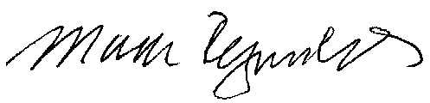

Mark Reynolds

Attachments

Attachment A

Advice No. 3664T

Page 1

**EXCHANGE AND NETWORK SERVICES**

**WN U-40**

|  |  |  |
| --- | --- | --- |
| **SECTION** | **SHEET** | **REVISION** |

5 135.1 1

5 137 1