**ATTACHMENT “B”**

**To**

**PSE’s February 6, 2015, Comments in Docket No U-140621**

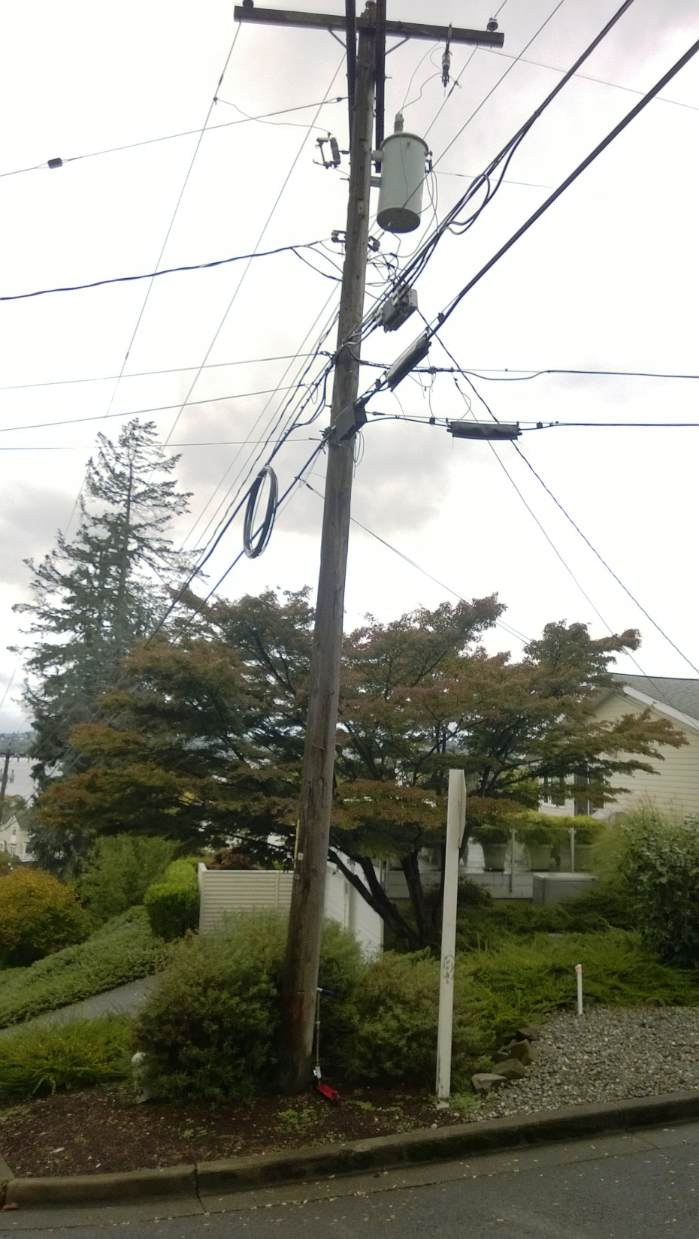

Both communications are too close to power. Lowest power is the bottom of the drip loop. Overlashing had occurred one week prior to this picture being taken.

Both communications are too close to power. Lowest power is the bottom of the drip loop. Overlashing had occurred one week prior to this picture being taken.

**Too close to power.**

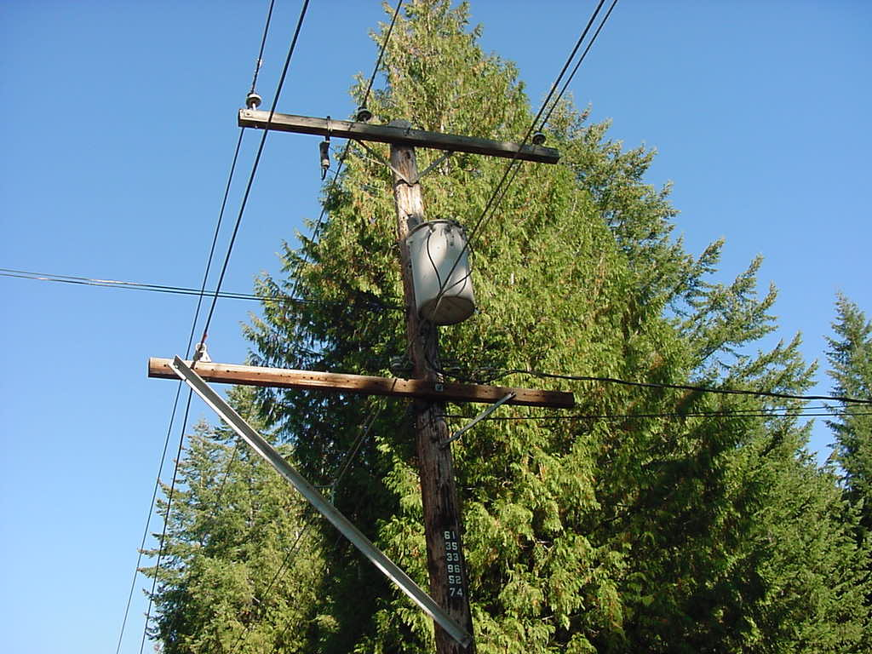

**Too close to power.**

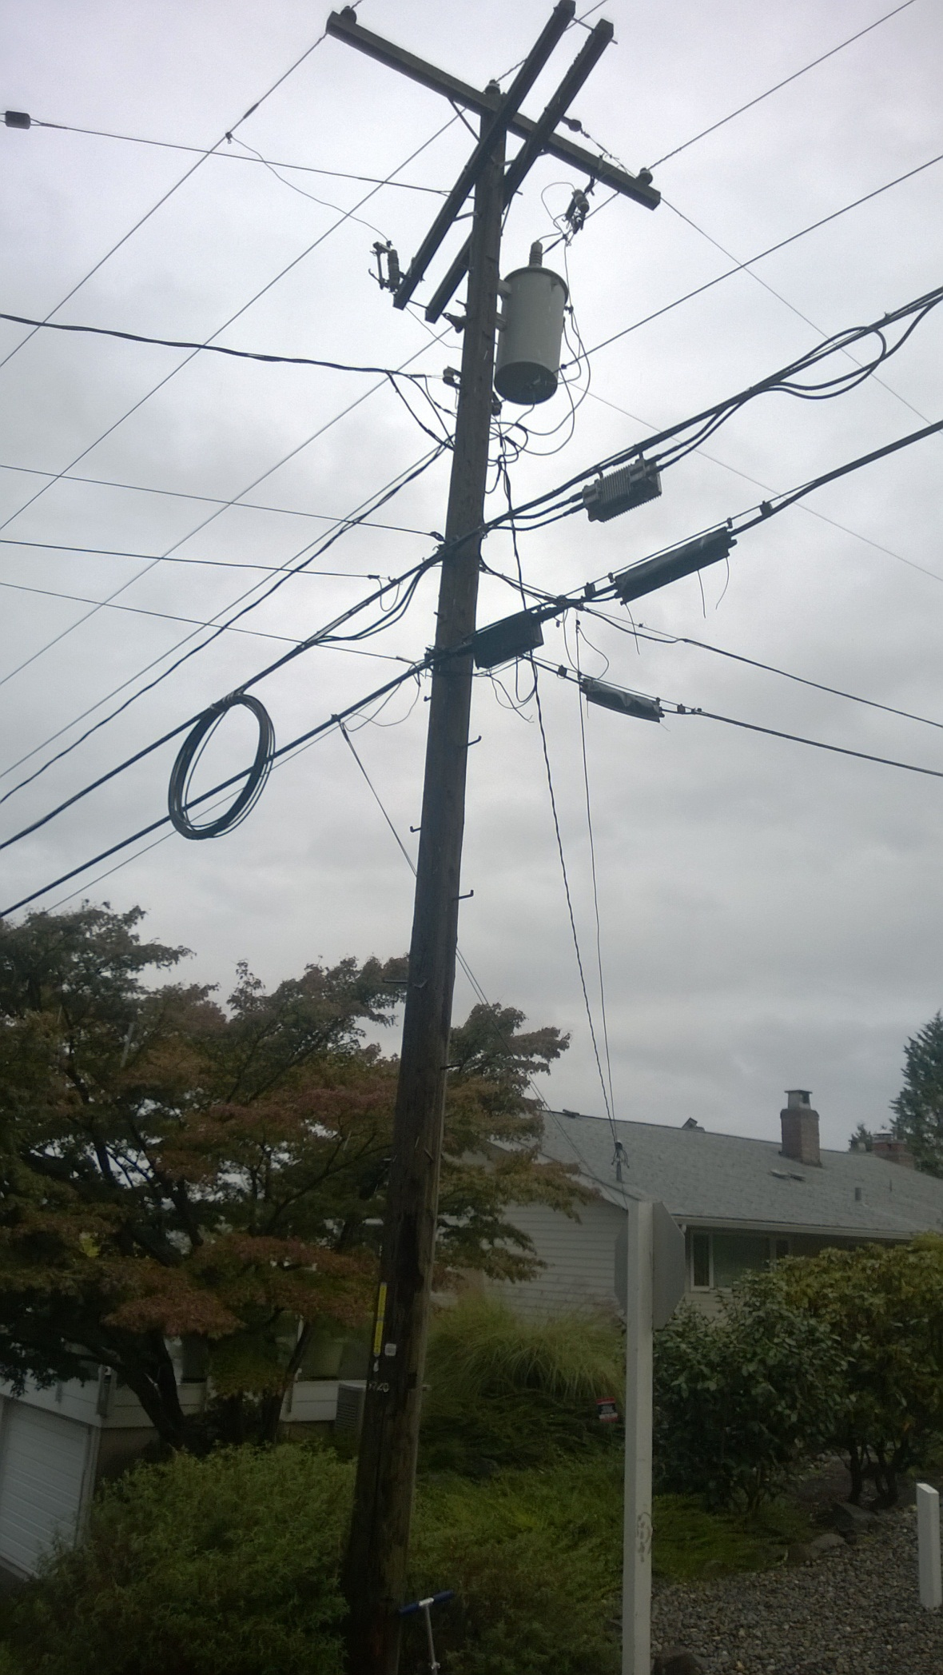

**Too close to power.**

**Too close to power.**

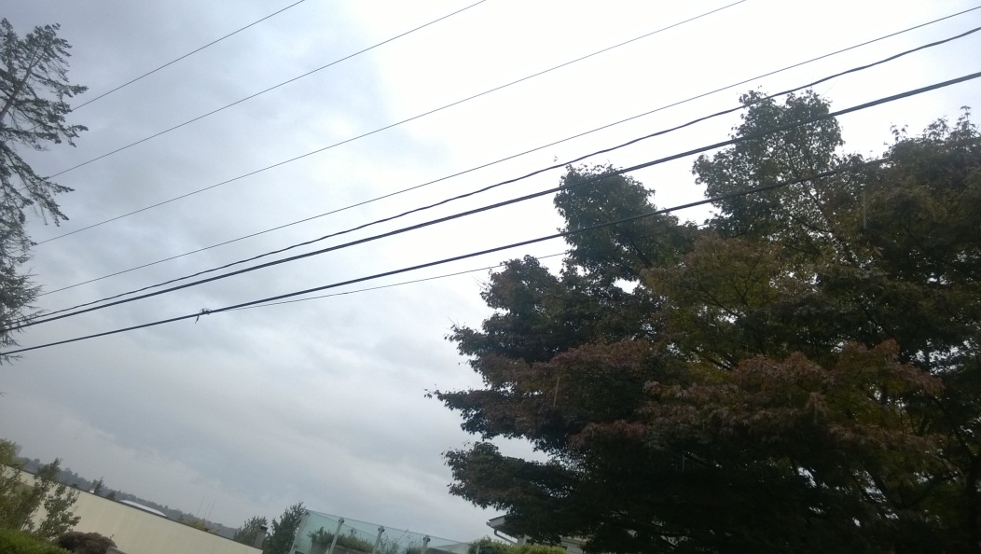

To close to power at mid-span. 30 inch minimum separation required.

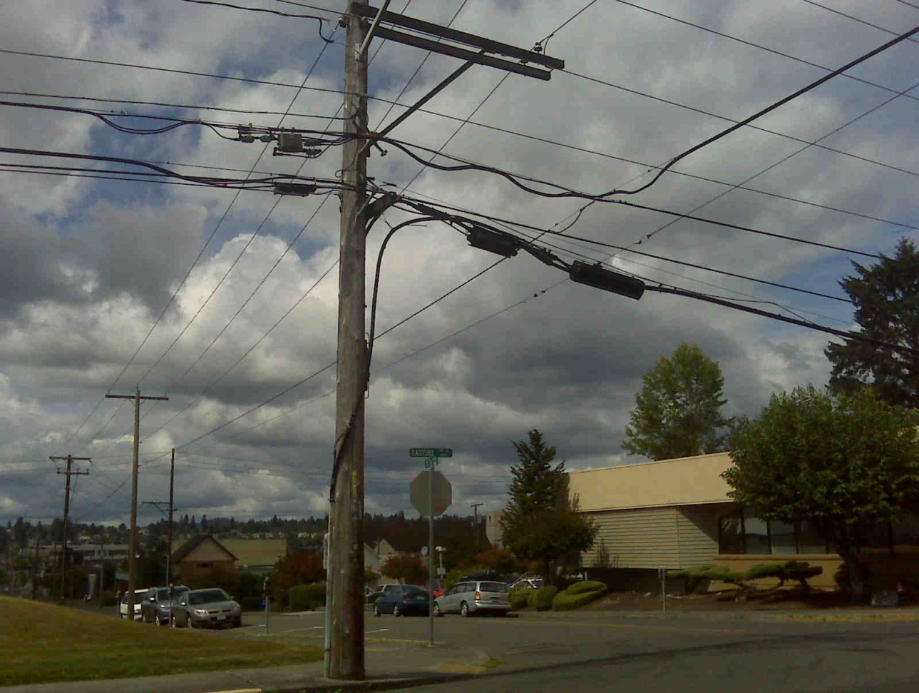

Too close to power. Incorrect build/install.

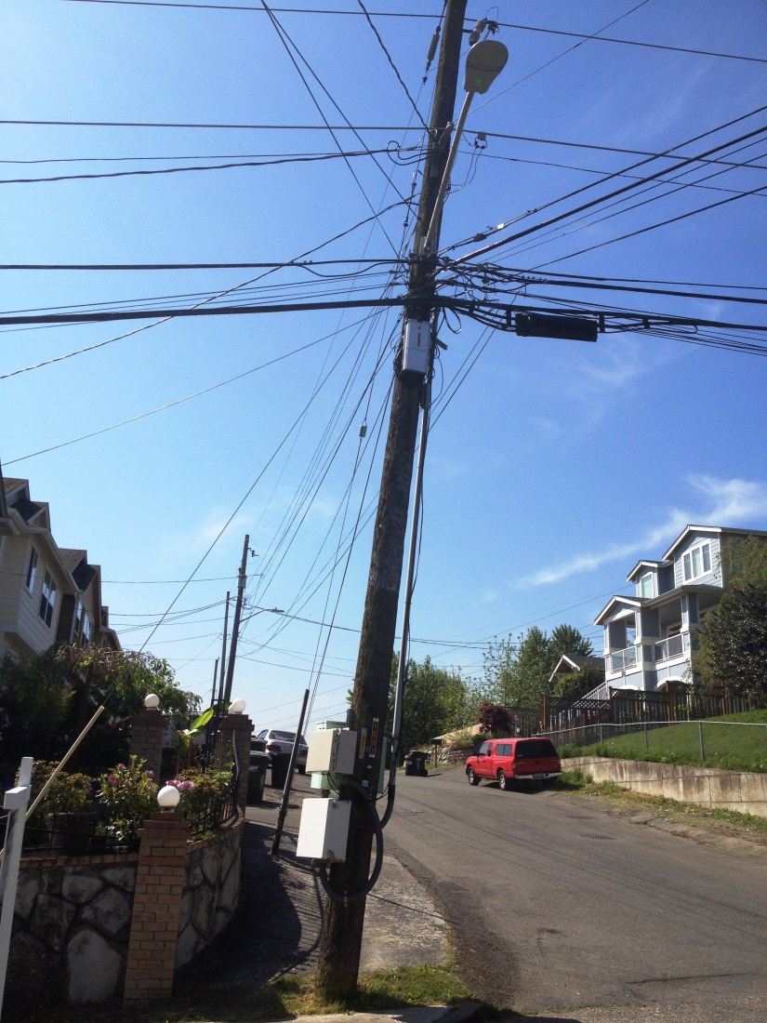

Too close to power.

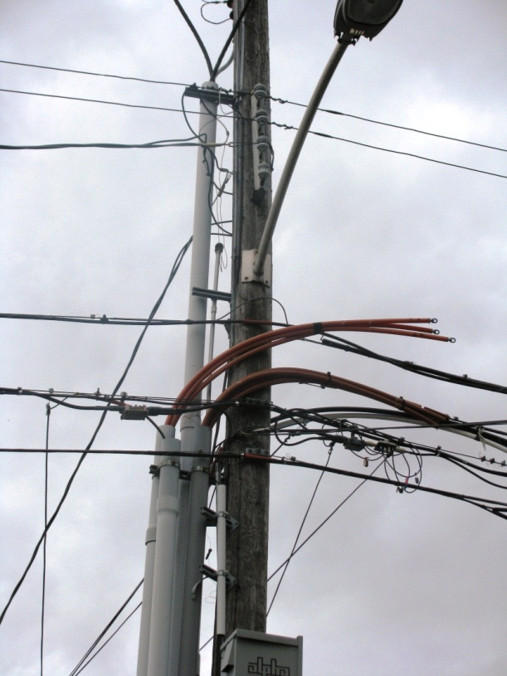

Too close to power.

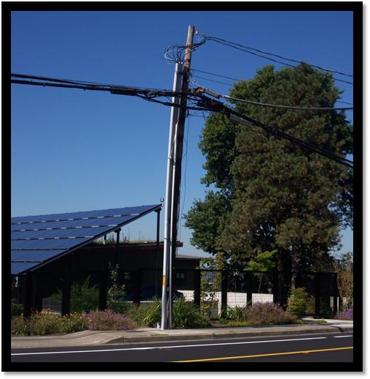

Note how overlashing can impact a pole.

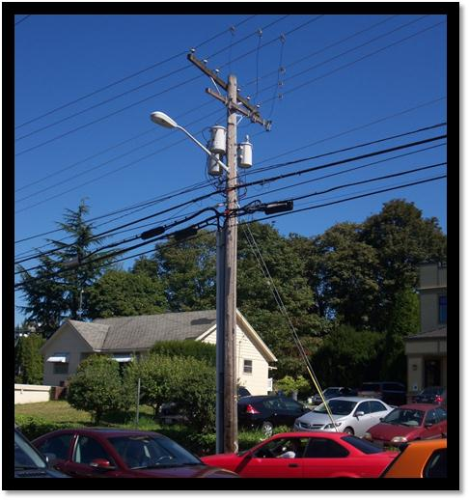

Note size of conductor bundles that are overlashed.

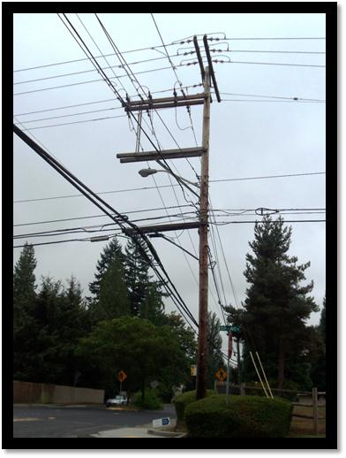

Note amount of overlashing and size of overlashed conductor bundles and installation of stand-off bracket. Also, note the impact on the pole.

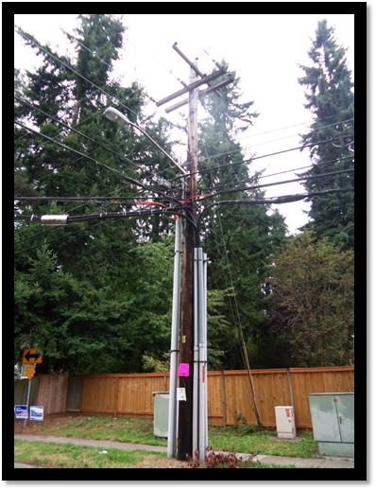

Note amount of overlashing and size of bundles.