**From:** Kevin L. Krueger [mailto:kevin@seatacshuttle.com]   
**Sent:** Thursday, March 31, 2011 9:50 AM  
**To:** UTC DL Records Center  
**Subject:** Public Comment Docket 101661 & Docket 042090

***Whidbey Seatac Shuttle***

Please Docket: T-101661

March 30, 2011

Sirs:

I am the business manager of Whidbey Seatac Shuttle, as such the overall operation of the office, Customer Service Representatives and customer service are my direct responsibility.  I deal directly with our customers on a daily basis and am informed of any customer issues that are dealt with by our CSRs.  There has never been a complaint by a customer to this office regarding fuel surcharges, our customers buy gas for their own vehicles all too frequently and are aware of the rising costs.  They accept and support our current method of dealing with the increased gas costs.

We provide the community with the best service possible at the lowest price, far less expensive that an individual driving their own car to the airport.  Our quality service at a reasonable price is reflected in our being named **BUSINESS OF THE MONTH for May 2010** by the Greater Oak Harbor Chamber of Commerce.  We did not receive this vote of support from the community by over charging them or taking advantage of them through fuel surcharges.  I follow with the text of the award committee:

====================================================================

**May 2010 Business of the Month: Whidbey SeaTac Shuttle**

The Oak Harbor Chamber of Commerce and its Business of the Month Committee are pleased to award the May Business of the Month to Whidbey SeaTac Shuttle.

            Whidbey SeaTac Shuttle is Whidbey Island’s locally owned and operated shuttle to the SeaTac airport and started in December 2003 with two vans and four round trips a day. Today, they have eleven buses and vans, including a stretch limousine. They offer eight round trips per day, year round.  Each of these trips to the SeaTac Airport are approximately every two hours and move many more passengers in one day than they did in a week their first year.

            Whidbey SeaTac Shuttle also offers full service charter services for whatever your group’s transportation need is; and to add a touch of elegance to that special event or trip they now offer first class limousine service.

            As locals serving locals, Whidbey SeaTac Shuttle understands the needs of Island residents. For them customer service is not just a good idea; it is a way of life. They take that extra step to ensure you get the best shuttle/flight combination. They also work hard together to provide you seamless transportation during your special gathering or event. This team work allows them to achieve the highest safety rating the State and Federal governments offer transportation companies.

            Whidbey SeaTac Shuttle also supports all the communities on Whidbey Island by routinely donating shuttle trips to Non-Profit organizations and offering discounted or donated shuttles to our schools & senior centers. They have been providing continuing sponsorships to groups including Whidbey Island Center for the Arts, Djangofest Northwest, Ebey’s Forever Conference, Coupeville Arts & Crafts Festival, Useless Bay Senior Center Golf Tournament, Penn Cove Mussel & Water festivals just to name a few and this year sponsored the Holland Happening Entertainment Stage.

            Whidbey SeaTac Shuttle has some new things happening. This spring they are adding service to downtown Seattle to make it easier to get your doctor’s appointment, cruise ships, the train or just for the fun of shopping & dining in downtown Seattle. Then starting this June Whidbey SeaTac Shuttle is adding a seasonal ninth round trip from Oak Harbor to SeaTac Airport arriving at 5:00 Am., so you can catch those early morning flights. Whidbey SeaTac Shuttle can be reached at (360) 679-4003 and are located at 1751 NE Goldie St Unit A, Oak Harbor.

            Please join the Chamber in once again congratulating Whidbey SeaTac Shuttle, our May 2010 Business of the Month!

Following the receipt of the Chamber’s Business of the Month Award, we were selected, at the close of 2010, as the **BUSINESS OF THE YEAR FOR 2010**.  We were selected from over 460 other businesses here on the Island.  Being selected is not only an honor for us but a validation of the customer service and low prices we provide.  Part of how we have been successful is by having the ability to recover, in part, our varying fuel costs through fuel surcharges.  I know of what I speak, I prepare the WUTC supplied work sheet with its many line item calculations and submit them to you for approval when fuel prices rise above our allowed threshold.  I include a copy of our certificate from the Chamber proclaiming us Business of the Year.  Removing our ability to partially recover our ordinary fuel costs will impact our ability to maintain the kind and level of service that Whidbey Island has come to expect, including impairing our ability to donate shuttle transportation services to the many different organizations that rely on us. Order 2 must remain in place; there is no justification what-so-ever for its discontinuance.

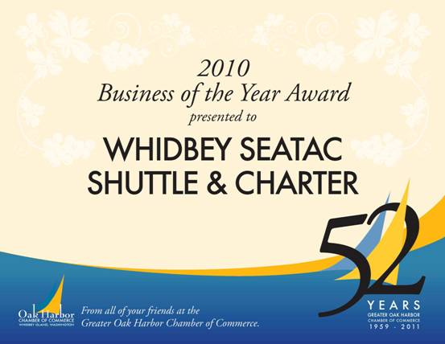

Kevinlkrueger - businessmanager

whidbeyseatacshuttle

po box 2895  oakharbor  wa

w 360.679.4003

f   360.323.8894