April 14, 2015

VIA U.S. MAIL AND EMAIL

Steven King – Executive Director/Secretary

Washington Utilities and Transportation Commission

1300 S. Evergreen Park Drive S.W.

P.O. Box 47250

Olympia, WA 98504-7250

**RE: CROSS EXAMINATION EXHIBITS AND EXHIBIT LIST**

Dear Director King:

This is to advise the Commission and the parties in the above-referenced matters that the Yakama Nation will rely on documents in the record (i.e., prefiled testimony and/or rebuttal testimony) and those exhibits for cross examination identified by Respondent, Yakima County, for Intervenor Yakama Nation’s cross examination(s) of witness(es) at the evidentiary hearings on the above-referenced matters.

This cover letter has been submitted electronically, and copies have been sent to all interested parties via electronic mail and U.S. Mail, and to the presiding administrative law judge via electronic mail.

Sincerely yours,

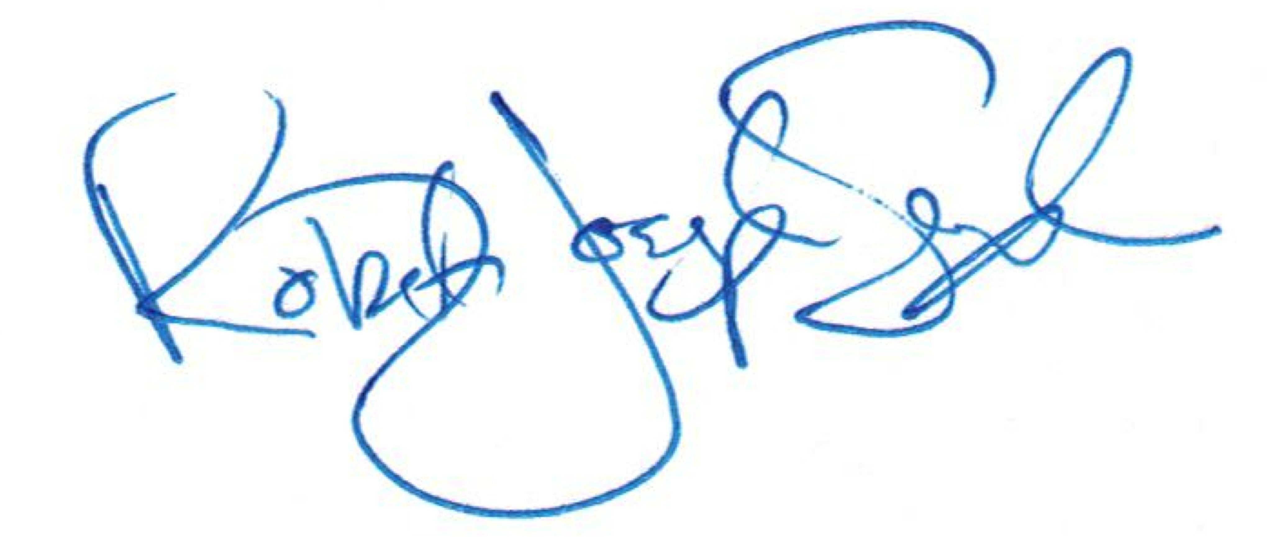

R. Joseph Sexton

Attorney at Law

[joe@galandabroadman.com](mailto:joe@galandabroadman.com)

cc: Yakama Nation Office of Legal Counsel