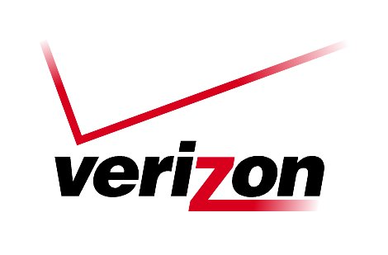 **Verizon Northwest Inc.**

**1800 – 41st Street, WA0105RA**

**P. O. Box 1003**

**Everett, WA 98206-1003**

**Fax: 425-261-5262**

July 1, 2010

Advice No. 3300

Washington Utilities and Transportation Commission

1300 S. Evergreen Park Drive, S. W.

Olympia, Washington 98504-7250

**Re: WITHDRAWAL OF ADVICE FILING; UT-101156**

To whom it may concern:

Per Discussion with the Commission’s Staff, Verizon Northwest Inc. hereby withdraws Advice Letter 3300, which was e-filed earlier today and assigned docket number UT-101156.

Very truly yours,



Richard E. Potter

Director

Public Affairs, Policy & Communications